Team Around the Child


Our Child and Family Progress Plan
Guidance for Professionals


Family Name:

Date this plan was created:

Where did the plan originate?
In Lincolnshire we pride ourselves on genuine muti-agency working, as such this Team Around the Child (TAC) plan has been created by practitioners across the partnership. The first version of this plan came from the staff team at Sibsey Primary School. A group of practitioners came together from LCC’s Health Visiting Service, William Farr School, Sibsey Primary School, Bearhugs Nurseries, Albion House Nursery, Voyage Academies (Haven High, Carlton Rd Primary), John Spendluff Academy and Children’s Services Early Help Consultants to create the version seen in this guidance. A blank copy of the TAC plan is available on Lincolnshire’s LSCP Website in the Early Help section, under resources. Additionally, you can attend our 1-day face to face workshop on EHA/TAC and SoS in Lincolnshire by booking on through the LSCP website.

What support is available for Lead Professionals (LPs)?
This guide has been created to complement the EHA guidance, TAC Handbook (also available on the LSCP website) and to support you in completing TAC reviews and plans. Below you will see, hints, tips and examples of good practice. If you need some support with TAC please contact your Early Help Consultant (EHC). If you don’t know who they are please email the duty TAC service at asktac@lincolnshire.gov.uk where someone will respond to your query on the day. When your TAC plan is complete, please email it to tacadmin@lincolnshire.gov.uk . A copy will be stored on the child’s children’s services record, please make sure the family are aware that this will happen. Being able to view the TAC on a child’s children’s services file is useful for if the family ever need a referral to a specific service within children’s service as it will be used as part of a screening process. Please remember as an LP that you don’t need to do everything, you are there to help co-ordinate the support the family receives. EHCs are available for ongoing support if you are feeling overwhelmed, stuck, worried or need some reassurance about TAC. They can arrange monthly catchups to talk about how the TAC is going and see you in your work environment or on teams if you’d prefer.

Where do TAC plans go once they are complete?
Copies of TAC plans and EHAs should always be created with the family and copies given to the family. With that in mind the language that you use within the assessment needs to be compassionate and factual. Emotive language can create an unhelpful barrier between children and families, as such it’s good practice to avoid the use of emotive language and instead describe the behaviours and highlight what everyone says they have seen and/or heard. A copy should also be emailed to tacadmin@lincolnshire.gov.uk. A copy will then be stored on the child’s Children’s Services file. It’s important to do this so that if the child or family need support in the future children’s services screening teams are able to see whether there is an active TAC and what support has already been tried. Please note that all documents emailed to TAC admin are added to the child’s file by an administrator and are not screened by a children’s services professional.

Guidance for each section:
This section outlines who the children are that the TAC is opened for. Additional columns can be added for each child.
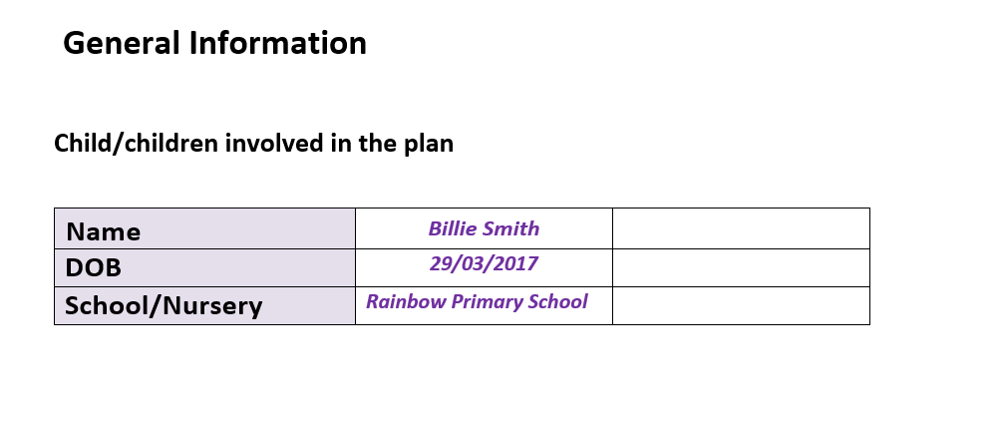

For the table below it could be helpful to separate the family/friends and professionals. You could highlight professionals in one colour and family in another. The key to a successful TAC plan is to involve the wider naturally connected network within the TAC. It can be really difficult for families to feel comfortable enough to talk about who they have in their network in the early stages of a TAC. Additionally, sometimes who parents feel they don’t have any support or help. Many families can become temporarily separated from their loved ones and may be keen to reconnect but just don’t know how or feel strong enough to be able to do this. Your EHCs have produced a family networking toolkit (also available to download on the LSCP website) with a wide range of resources to help you to establish and support families to reconnect or expand their naturally connected network. Additionally your EHCs offer workshops and forums on Family Networks. Please see the LSCP website for more information.
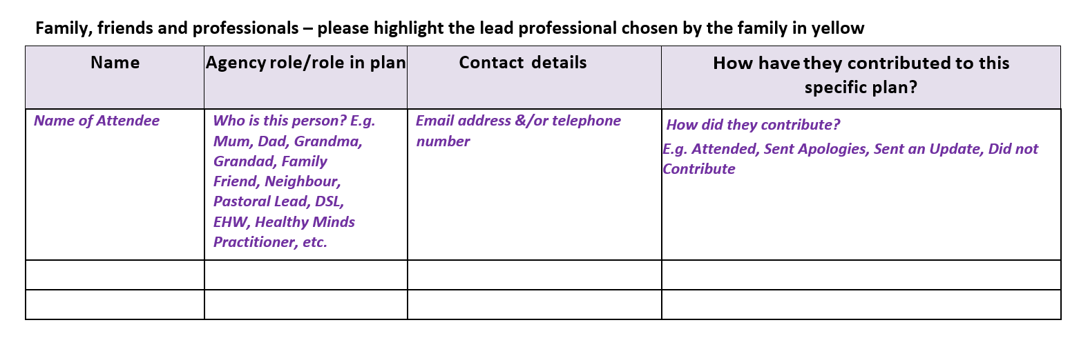

For the section below please add all of your details that you wish to share.
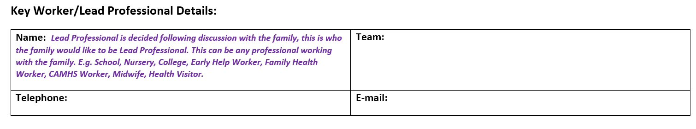

It’s best practice for a TAC meeting to take place every 6-8 weeks in order to keep the momentum going and for everyone to communicate together. This section is useful to think about how many meetings have already happened as well as planning the next meeting.
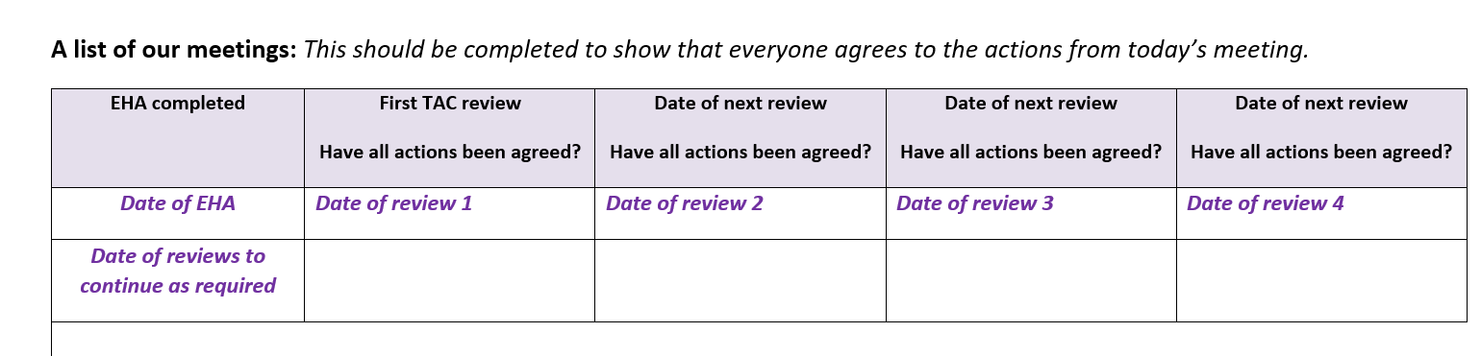

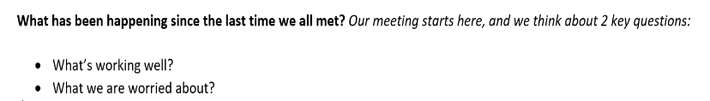
The section below is your progress update. We’re really proud that we don’t have meetings about families without families within Early Help across the partnership, this helps to build trust and for families to see that we’re behind them and want them to succeed. The progress update is for everyone to share what’s been happening (in relation to the worries and goals) since the last meeting, this is where we all share information. It’s good practice prior to the meeting to think about who you ask to share their update first as this can set the tone for the rest of the meeting. It’s usually a good idea to start with the family or the professional they have the best relationship with first, this can help the family feel at ease. This is a chance to celebrate the steps the family and other professionals have taken to moving towards the goals. This section needs to be cleared and freshly updated with current information at every TAC meeting.

The children’s wishes and feelings section is an important part of the plan. Often children’s voices can be lost in a group of adults, as part of the TAC you will need to advocate for children’s wishes and feelings. It is everyone’s role to listen and respond to what children are telling us, either by listening to their words or interpreting their behaviours and observations. Children’s voices in relation to the worries, strengths and next steps can be captured by anyone, for example you could capture a conversation between a midday supervisor and a child, a family health worker observation or a picture drawn by a child. This plan was designed for you to include children’s voices in ways that work, so if you need to delete the speech bubbles below and instead include a photograph, drawing, observation or direct work with children please do so. The EHCs are currently working on creating a Voice of the Child toolkit that includes tools such as the Signs of Safety 3 houses. Whilst this is in creation you may find the resources on this website useful https://www.socialworkerstoolbox.com/category/wishes-feelings-2/ .
Should children be present at their TAC review? The EHCs worked with a group of families to produce an explanation leaflet for children about TAC. You download a copy of this from the LSCP website. Some children like to be present at their TAC and some children even like to chair their own TAC, please use your professional judgement and if you aren’t sure please contact your EHC for advice and support.
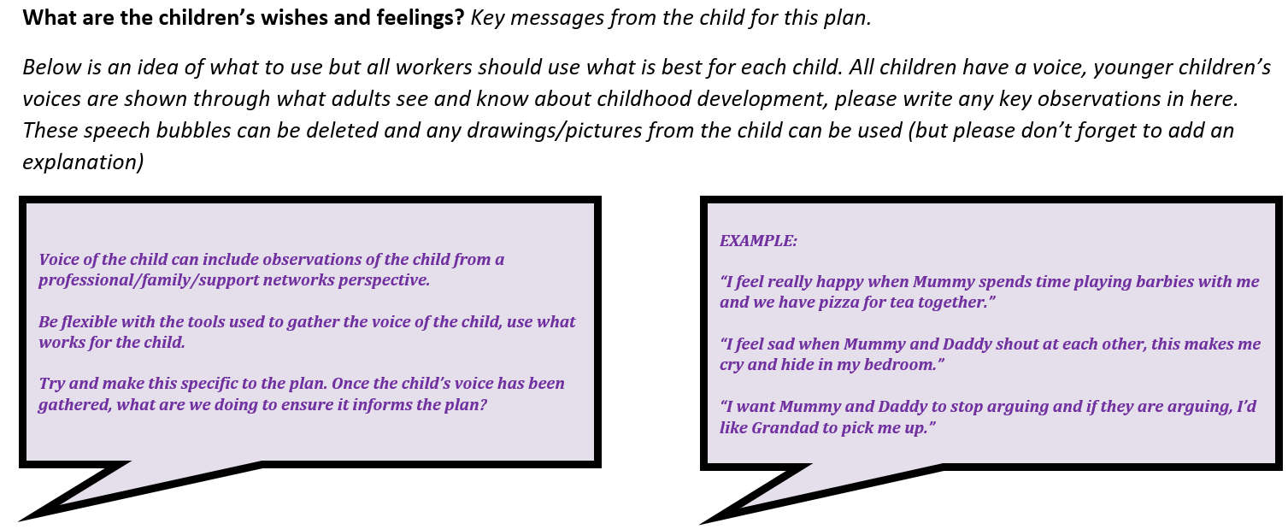

Top Tips for gathering the Voices of Children aged 0-5, from Julie Bayliss on behalf of the Health Visiting Service:

- Write down what you have seen the baby or child do - such as, were they asleep/awake/looking around them?
- Did they smile, if so, who to?
- Did they make noises? if so, describe the noise e.g. grunt, coo, babble sounds, cry
- Did they look at their parent/carer?
- If the parent/carer spoke to the baby/child, what did the baby/child do back? For example, did the baby/child ignore, look away or at parent/carer
- What movements did their body make? - startle/fidget/flap hands/twirl around/keep still/crawl etc.
- How were they dressed? For example, in well-fitting or unclean clothes that are too small.
- What did the child/baby touch?
- Is the baby/child unwell? What makes you think they're unwell? Describe it.

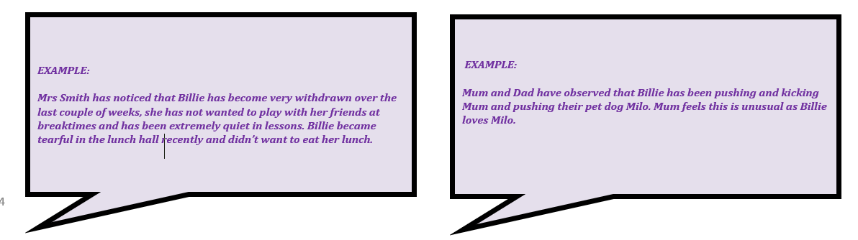

The next section shows your worry statement, goals and scale point. An example is written on the next page and there is further guidance on how to write worry statements in the TAC Handbook. For more support on writing worry statements and goals you can attend our 1-day face to face workshop on EHA/TAC and SoS in Lincolnshire by booking on through the LSCP website (for the Early Years sector evening sessions are available).

Some top tips for this section from the EHCs and current LPs are:
Worry Statements – the language we use is important, avoid jargon and use language the family understand and role model the use of fact based, compassionate language. E.g. the parents may say the child is violent and aggressive, but we would ask “what is the child saying and doing that makes you think that?”. Then we describe the behaviours, for example “When Freddie is cross sometimes, he punches his mum”.
Worry statements can be themed, E.g. Parenting, Health, Safety, Parental Conflict, etc.
Prioritise the worry statements, don’t have more than 3 or this will be overwhelming for families

Goals – Start writing the goal by identifying a positive. Be realistic, the goal is about things being safe enough and realistic enough. The goal has a formula: positive, network, plan, outcome. Use this to guide you.

The goal is always something that is achievable and what the family want too, describe the outcome we want to see and hear, avoid listing tasks/actions. The planning part comes after this.
Think about your goal and what 10 would look like but before writing it pause for a moment. Imagine what the child’s life could look like in 5 0r 10 years’ time if all the problems were resolved. Then draw a stick person picture of this on a piece of paper, this can help us focus on outcomes in the goal.
Don’t be tempted to write the opposite of the behaviours you identified in the worry statement, e.g., Parents will clean the house, Billie will stop hitting people.
Scaling - Use each person’s name or initials if they prefer to identify who has scaled. Ask each person to consider
what has gone well for you to scale at this point? What needs to happen for you to increase your scale by one point? Ask the child or family to scale first and then follow with the people who have the best relationships with the family.

What is the worry? | What’s our Goal? | Scaling Where is the progress on the scale today?
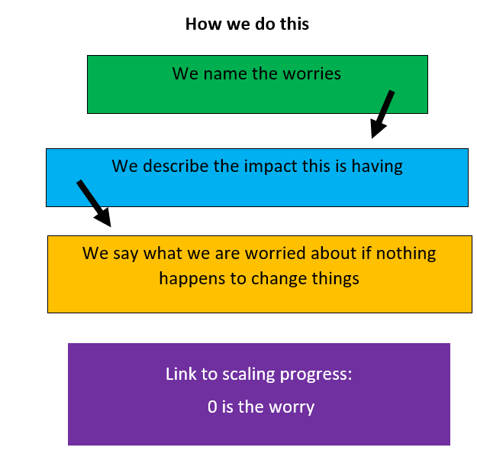 | 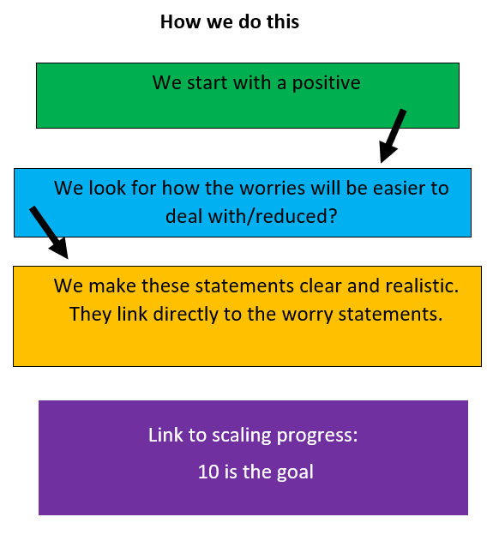 | 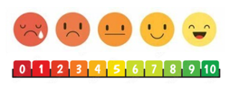  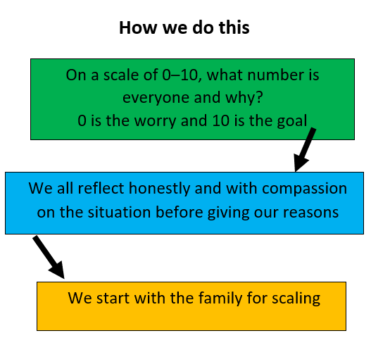
Barry and Rosa, I am worried that your house is unsafe for Emily. There are a lot of items on the bedroom floor such as dirty clothes, empty packets, suitcases and mouldy food. I am worried that you or Emily could get poorly from bacteria or that you could trip and fall with Emily in your arms causing you both to get hurt. | Barry and Rosa, you told me there have been times where you have been able to keep the house clean and tidy. Like right after when Emily was born. So that everyone is no longer worried we need to see that you and all the people who help to care for Emily come up with a plan of how you will keep the house clean and tidy. This is so you and Emily have a safe space to play and live together and so that Emily has a home she will feel proud to bring her friend’s home to when she is older. | TN – 6 I visited 3 times in the last 6 weeks, Barry and Rosa have been trying hard, the house seemed much cleaner.  PF – 3 I haven’t visited the house, but Emily has been coming to nursery every day in clothes that need washing  Barry – 9 Rosa and I are trying our best but some days it’s hard you know  Rosa – 6 some days I am just tired, and our washing machine is broken, we can’t afford a new one

The next section is about planning. Families achieve the best outcomes when they feel empowered to make changes for themselves. We do this by creating hope and influencing/facilitating change. There are 2 parts to this section. The first part is a list of actions that everyone in the naturally connected network (people who see, love and know the children outside of professional support) agreed to take to help the family. The second part is about planning for when things go wrong. In this section we ask lots of questions about what everyone will do if things go wrong. For example if the worries are around self-harm you could ask:
“What are the warning signs that x is struggling? What will everyone around them notice that is different/changing? How can everyone help when they notice this? What’s the best way and who are the best people to help x when this happens? How can x let everyone know they need help without using words? If x is really low and people are really worried about her safety what will everyone do?”
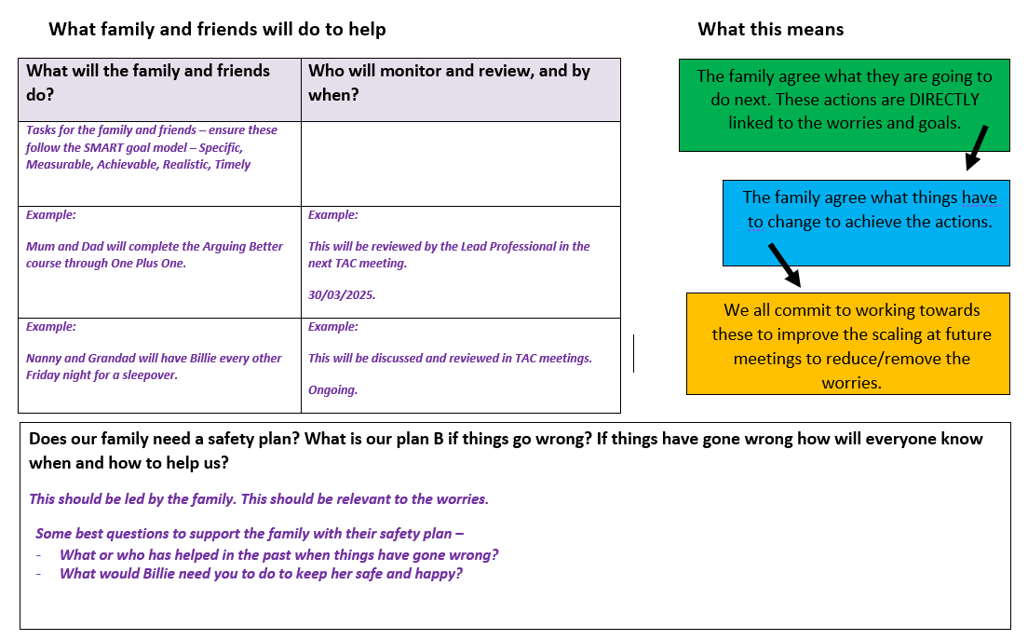

Further support on this section is available through the safety planning workshop available to book on the LSCP website.
The section below is where we record what all of the professionals involved have agreed to do to help, including timescales.
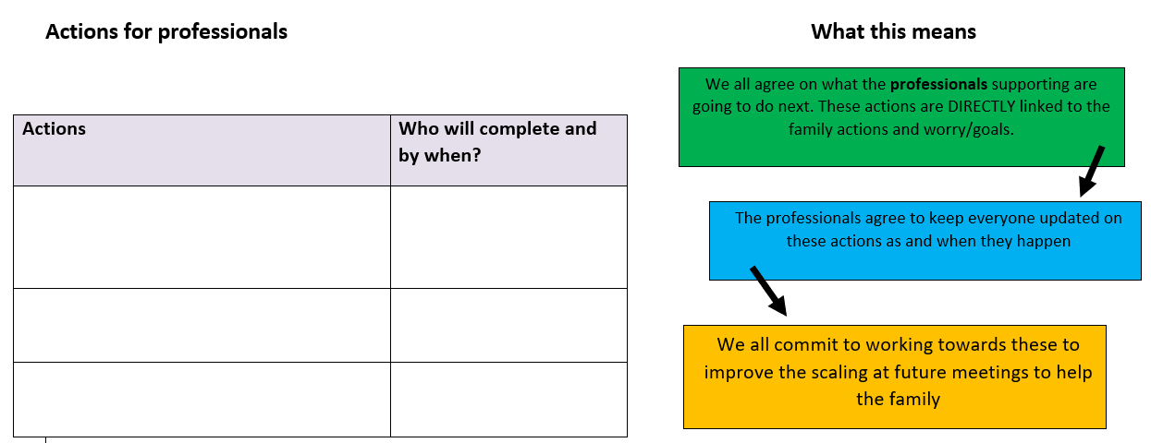

It’s important to check in with the children and family at the end of the meeting on how they feel about the plan, the section below records their thoughts, wishes and feelings. You may wish to ask a scaling question around how successful they think it may be or how achievable/realistic it is.

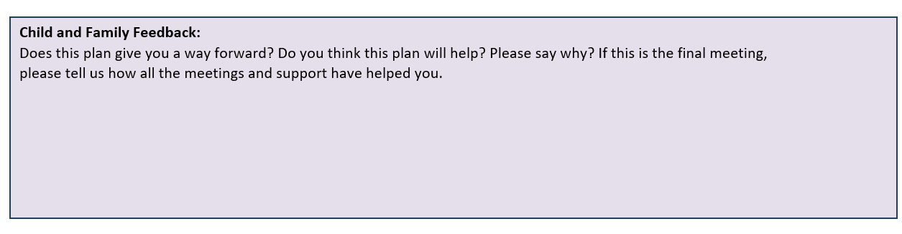

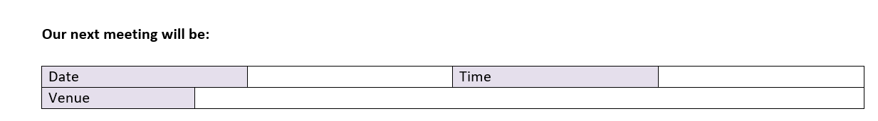

In 2025 we reduced the amount of paperwork within TAC and condensed the closure summary onto the end of the TAC plan. Please only fill the section below in if this is the final TAC meeting. If the TAC ends before the final TAC meeting is able to take place, or a final TAC meeting isn’t needed please copy and paste the final section into an email to tacadmin@lincolnshire.gov.uk along with the child’s name and DoB. A copy will then be stored on the child’s children’s services file. It’s important to do this so that if the child or family need support in the future children’s services screening teams are able to see whether there is an active TAC and the reason why the last TAC ended. Please note that all documents emailed to TAC admin are added to the child’s file by an administrator and are not screened by a children’s services professional.

