Team Around the Child


Our Child and Family Progress Plan


Family Name:

Date this plan was created:

General Information
Child/children involved in the plan
Name
DOB
School/Nursery

Family, friends and professionals – please highlight the lead professional chosen by the family in yellow

Name | Agency role/role in plan | Contact details | How have they contributed to this specific plan?

Key Worker/Lead Professional Details:
Name: | Team:
Telephone: | E-mail:

A list of our meetings: This should be completed to show that everyone agrees to the actions from today’s meeting.
Date TAC started | Date of review  Have all actions been agreed? | Date of next review  Have all actions been agreed? | Date of next review  Have all actions been agreed? | Date of next review  Have all actions been agreed?

What has been happening since the last time we all met ? Our meeting starts here, and we think about 2 key questions:

- What’s working well?

- What we are worried about?

What are the children’s wishes and feelings? Key messages from the child for this plan.
Below is an idea of what to use but all workers should use what is best for each child. All children have a voice, younger children’s voices are shown through what adults see and know about childhood development, please write any key observations in here. These speech bubbles can be deleted and any drawings/pictures from the child can be used (but please don’t forget to add an explanation)

What is the worry? | What’s our Goal? | Scaling Where is the progress on the scale today?
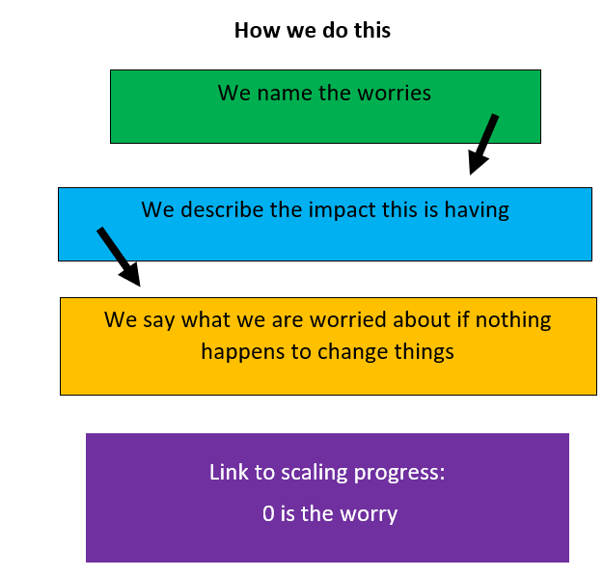 | 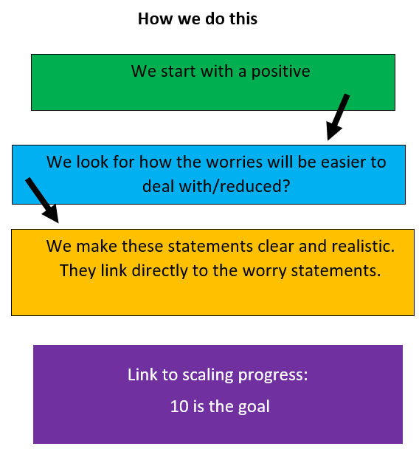 | 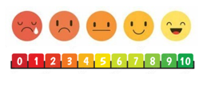  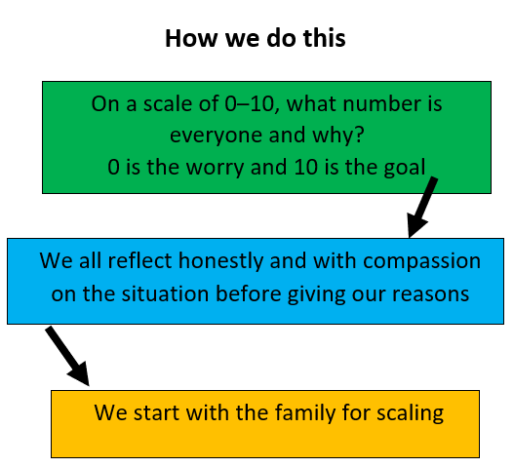

What will the family and friends do? | Who will monitor and review, and by when?
Does our family need a safety plan? What is our plan B for if things go wrong? If things have gone wrong what can we and everyone else do to help us?
What family and friends will do to help What this means
The family agree what they are going to do next. These actions are DIRECTLY linked to the worries and goals.

The family agree what things have to change to achieve the actions.

We all commit to working towards these to improve the scaling at future meetings to reduce/remove the worries.

Actions for professionals What this means
We all commit to working towards these to improve the scaling at future meetings to help the family

The professionals agree to keep everyone updated on these actions as and when they happen

We all agree on what the professionals supporting are going to do next. These actions are DIRECTLY linked to the family actions and worry/goals.
Actions | Who will complete and by when?

Child and Family Feedback:
Does this plan give you a way forward? Do you think this plan will help? Please say why? If this is the final meeting, please tell us how all the meetings and support have helped you.

Our next meeting will be:

Date |  |  | Time
Venue

Is this the final Team Around the Child meeting? If yes please complete the section below Please note if the TAC ends before the final TAC meeting the table below should be copied and pasted into an email (along with the child’s details) and sent to TACadmin@lincolnshire.gov.uk. If your worries begin to occur again, please use this plan to support you. If you need further support, please contact your Lead Professional.

Why did the TAC end? | Yes/No | Comments | Which family members agreed to this?
The plan has helped, and things are much better now
The family needed help from a social worker
The family are moving to a different area
There are still some worries, but the family said they don’t think TAC is helping them anymore/they just don’t want to do it
A different reason (please say what)

