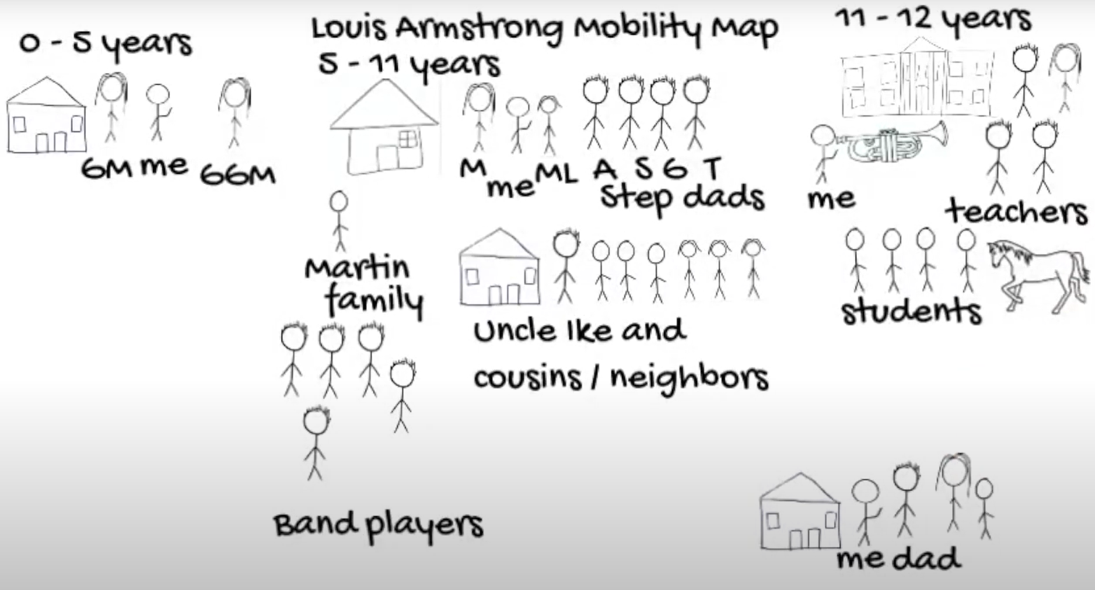
Mobility Mapping- Bing Videos

