IRO Escalation Process
Name of Author: Sarah Jenner
Name of Senior Manager Approving: Leemya McKeown
Date of Issue: September 2022
Updated: April 2024
Date to be Reviewed: April 2027

Contents | Page
Introduction and background | 3
Roles and responsibilities | 4
Practice escalations | 7
Practice resolution | 9
Practice Note – Legal Advice for Independent Reviewing Officers (IROs) | 11
Flowchart | 13
Appendix 1 | 14

Introduction and Background
The procedure outlines the escalation and dispute resolution process that should be followed when concerns about the quality of practice and / or the child’s safety and progress are identified by the Independent Reviewing Officer.
This procedure covers all children and young people looked after by KCC. This procedure covers all multi agency partners involved in a child’s care plan.
Escalations are likely to be avoided when there are positive working relationships. Specifically, when:
- All multi-agency partners are clear about the role of the Independent Reviewing Officer (IRO)
- All multi-agency partners are clear of their role to be accountable within the child’s looked after review meeting
- Agreement is sought at the initial review from the professional network to comply with this escalation and dispute resolution process
- Reliable systems are established to ensure escalations are pursued, if necessary, outside of internal processes
- The IRO has received and shared contact details of all those attending the meeting to direct practice escalations
- The professional network prepares for reviews in good time and ensure actions within the care plan are completed
- IRO’s complete the Outcomes record and decisions within timescale
- IRO’s ensure that children and young people are routinely consulted
- Social workers (SW) and all the professional networks advise IRO’s of any significant change of circumstances
- Midway reviews are used to address and resolve any issues and consider instigation of the escalation process

Roles and Responsibilities
IRO’s should feel confident in their role and understand their responsibilities to monitor and review the child’s care and where necessary challenge poor practice. This is in relation to both the Care Plan as well as considering suitability of where the child is living.

Suitability of Placement
In respect to consideration of where the child is living, there is an expectation that the IRO completes the Purposeful Visiting Form as part of the QA process to evidence their concerns. The Purposeful Visiting Form can be used to evidence shortcomings that can be escalated informally by the Social Worker or their service in the first instance, then by the IRO more formally through the stages of escalation.
For a new placement that is registered the IRO will undertake a Purposeful Visit and complete a Purposeful Visiting Form before the child’s second Child in Care (CIC) Review and annually thereafter.
For a new placement that is unregistered, the IRO will visit prior to the first CIC Review or on the day if at placement and thereafter once every three months, at different times to the Social Worker.
If escalations are not addressed with the placement provider satisfactorily, and the stages of escalation have been exhausted or the concerns around the living provision are of a serious, systemic, and significant nature, the IRO can request a Scoping Meeting.
Scoping Meetings are held to:
- Analyse information around a commissioned service – this could be based on patterns and themes noticed around failure to recognise risk, lack of safeguarding policy and procedure, failure to act or understand allegation management or a notification from a regulator.
- Share contextual safeguarding matters with relevant parties –consider the evidence that is held and what needs to be explored further to mitigate against risk.
- Agree if immediate action to protect children is needed – this includes a decision on whether the provision can continue to be used by Kent.
This meeting will be held by a senior manager. Please refer to separate guidance on scoping meetings in Placements, Purposeful Visiting and Understanding the Child’s Lived Experience.
There may be times when the IRO is advised that obstacles in the way of resolving the issue are outside or beyond the control of the local authority, for example in relation to staffing, inter-agency or resource issues. If these are impacting on the ability of the department to meet the needs of a child as identified in the child’s care plan, the IRO should continue to escalate the issue. This is to ensure that Senior Managers have oversight of the issues raised, allowing them to consider the concern on a systemic level and if needed, consider what additional resources or alternative plan needs to be put in place. However, the IRO raising the escalation should take care to set a clear aim of the escalation and the outcome needed is achievable in a timescale that meets the child’s needs. The IRO needs to ensure that any actions they identify are clearly understood and recorded, allowing for a resolution and closure of concern.
Where a concern is identified as impacting on the child but not within the Local Authority’s control and there is no external partner responsible, the IRO may consider raising the escalation for alert purposes. For example, a child has experienced several unplanned moves due to not being matched with a long term carer despite timely and in-depth searches and a national shortage of homes for children. The escalation for this child may be to raise awareness of the impact this has on the child and be accompanied by requests within the Local Authority’s control, which could mitigate the concerns moving forward. For example, a request to use the Placement Stability Checklist or scheduling of a timely stability, network, or transitions meeting to support longevity in any future homes identified.
The rationale for an escalation being resolved or not needs to be clearly identified and recorded at each level.
If concerns cannot be resolved at level 6 then this will require escalation to Cafcass and consideration of the need to return to Court to request a change in the child’s care plan.

IRO responsibilities
- To ensure that that all professionals attending the review understand their accountability to the child’s care plan and the practice escalation process
- To ensure that contact details of all those attending the meeting are obtained and shared across the network to progress the child’s care plan and if necessary direct practice escalations with external partners
- To be able to demonstrate to children that they are taking action on their behalf and can evidence their own work in resolving the issue
- To ensure that placement suitability is quality assured through completion of purposeful visiting forms
- To ensure when practice concerns arise, they follow the practice escalation process on Liberi to the professional and / or relevant level of management or agency
- To share decision making with senior QA management of any escalations that are directed either inside KCC or outside KCC that require escalation to be above Service Manager level
- To track escalations for outcomes in line with timescales and monitor progress of the actions
- To consider, if appropriate risk management and planning requests from managers for further time to resolve the practice escalation
- To progress practice escalation through the relevant levels until satisfactorily resolution has been achieved if appropriate to do so.

Social Worker and Case-Holding Manager's responsibilities
- To respond within timescale to the actions identified in the practice escalation
- To complete Purposeful Visiting Forms to monitor and check the suitability and safety of the foster or residential home during the child’s stay to ensure that children are thriving and developing.
- To request in writing further time if required, to resolve the escalation including the rationale as to the delay and identify any impact on the child related to delay. A copy of request is to be entered into a case note on child’s file.
- To inform the SW line manager of the practice escalation and seek agreement to approach the IRO to extend the timescale

Multi agency partner responsibilities
Police, Youth Justice, Health, Education, Fostering Services, Residential Staff, Carers, and any other professionals attending as part of the corporate parenting network and in line with the Corporate Parenting Principles, to respond within timescale to the actions identified in the practice escalation.
- To request in writing further time if required, to resolve the escalation including the rationale as to the delay and identify any impact on the child related to delay. A copy of the request to be entered into a case note and recorded on child’s file.
- To inform the line manager of the practice escalation.
- QA Manager IRO Service’s responsibilities
- To support and assist IRO as necessary
- To monitor escalations and report outstanding escalations on a monthly basis
- Incorporate quarterly analysis of escalations into quarterly collaboration meetings with District Social Work Teams
- Have oversight of the quality of practice escalations and consistency of practice across the districts.
- Undertake quarterly dip samples of practice escalations, identifying best practice responses and responses that did not meet the practice standards.

Practice Escalations
The criteria for initiating an escalation is solely related to the needs of the child and how the quality of practice and living arrangements are affecting the child. Issues concerning resources, sickness or other organisational issues will not prevent the IRO from raising escalations.
Where a practice concern is identified, the IRO will initiate a practice escalation with the Social Worker or relevant manager, followed by a phone call if able, and incrementally escalate up until resolution is achieved if it is proportionate to do so.
The IRO can choose to start an escalation at any level if they consider it proportionate and expedient to do. If the Social Worker or the Team Manager do not have the authority / remit to implement the decision, the process should start with the manager with the appropriate authority / responsibility.
In making this decision, it is important that the Department for Education (DFE) guidance is clear of the dual role of the IRO to monitor and evaluate the child’s individual care plan as well as the local authority’s overall competence in being the corporate parent. This means that escalations can be directed at any staffing level and be directed straight to Assistant Director or Director, for example. Conversely, it may be felt that although requiring escalation, responsibility does sit with the social worker in the first instance and a proportionate response is for this to be escalated incrementally if not addressed. What is important in any situation is the need to consider the significance of the escalation as well as whether responsibility lies more with management and strategic decision making as opposed to a practitioner’s individual practice.

Automatic Practice Escalations
Practice escalations are closely related to the QA audit process whereby IRO’s will formally review the quality of the current care planning and progress made against the recommendations agreed at the last LAC review.
Specific sections of the Care Plan will be rated for effectiveness in achieving positive outcomes. These ratings correspond to inadequate, requires improvement, good and outstanding gradings. Where a grading of inadequate has been given constituting a score of 1 to any section of a Care Plan, this will lead to an automatic practice escalation. Similarly, if there are two consecutive requires improvement gradings constituting a score of 2, this will lead to an automatic practice escalation. Therefore, if at the next review any section of the Care Plan is again graded requires improvement, demonstrating that even where a need for improvement has been identified action has not been taken to make the required improvement then this will require the IRO to automatically escalate this as a practice issue.

Process
- The IRO will inform the relevant professional that a formal practice escalation has been raised on Liberi via a telephone call or email

- The practice escalation, captured on the escalation form, will detail the issues of concern, the impact on the child, the recommended resolution and the timescales required for resolution

- A resolution must be recorded in the Escalation Follow Up on the Liberi form. This will be completed by the internal staff and shared with the IRO, however, if the escalation is directed to external staff, then the IRO will complete the recorded resolution / progress themselves as the external professional to close the escalation.

- If the timescale is not adhered to or it is determined that there are ongoing concerns about the proposed resolution, the practice escalation will be escalated to the next stage. The reason for continued escalation needs to be clearly stated and the relevant managers informed accordingly. QA Managers to be consulted at a stage 3 escalation or above.

- The timescale at each stage of the practice escalation process should be viewed as a guide. Each stage is allocated a 5 day timescale to resolve the issues. However, alternative timescales may be agreed to ensure an effective outcome. This might involve waiting until a required person becomes available to undertake the work or the child and / or professionals need time to make a decision.

- The key issue is applying the practice escalation process effectively in resolving an issue that is getting in the way of a child’s needs being met and their Care Plan progressed in a timely manner.

Practice Resolution
There are seven stages to the practice escalation process resolution process.
The IRO has the discretion to proceed directly to stages 2, 3, 4, 5 and 6 in more serious or urgent issues. A response is required within 5 working days. Where this is not achieved, the practice escalation will be escalated to the next stage.
The final stage, a referral back to the Children and Family Court Advisory and Support Service (Cafcass) can only be undertaken following completion of stages 4, 5 and 6. Agreement would be required from the Assistant Director of QA and guidance from the IRO legal counsel sought.
Informal Resolution - Every effort should be made to resolve issues informally
- IRO to escalate to the social worker via the escalation from and set timescale for the work to be completed
Stage 1 - To Social Worker/ relevant professional:
- IRO to escalate to the social worker via the escalation form and set timescale for the work to be completed
Stage 2 - To Team Manager:
- IRO to escalate to the Team Manager and copy the social worker in
- Work to be completed in 5 working days
Stage 3 - To District Service Manager:
- IRO to escalate to the District Service Manager and copy the Team Manager, Social Worker and QA Manager.
- Work to be completed in 5 working days
Stage 4 - To Area Assistant Director:
- Prior to escalating to this level, the QA Manager will inform the QA Service Manager of the need to escalate to the Area Assistant Director.
- IRO to escalate the Area Assistant Director and copy the Service Manager, Team Manager, Social Worker, QA Manager and QA Service Manager
- Work to be completed in 5 working days
Stage 5 - To Director Integrated Children’s Services / Social Work Lead
- IRO to escalate to the Director Integrated Children’s Services and Social Work Lead. Copy Area Assistant Director, Service Manager, Team Manager, Social Worker, QA Manager, QA Service Manager and QA Assistant Director.
Stage 6- To Corporate Director
- IRO to escalate to Corporate Director. Copy Director Integrated Children’s Services and Social Work Lead, Area Assistant Director, Service Manager, Team Manager, Social Worker, QA Manager, QA Service Manager and QA Assistant Director
- Work to be completed in 5 working days
Stage 7 - Referral to Cafcass
- IRO to consult legal counsel and Director of Children’s Social Care to escalation Cafcass and return the care plan to court. Stage 6 escalation is outside the Liberi escalation form. This Stage is recorded using the IRO oversight case note (providing rationale for returning to court) and IRO consultation (detailing senior management conversation including with legal counsel).

Practice Note – Legal Advice for Independent Reviewing Officers (IROs)
IROs, can access independent legal advice (as outlined in the IRO Handbook). They should in the first instance, discuss the matter with the respective QA manager. In the event, that the IRO and QA Manager conclude that legal advice is needed, the QA Manager will approach their service manager to contact corporate legal to trigger the request for legal advice. The service manager will chair the legal planning meeting.
The QA manager should quality assure the IRO’s subsequent statements with the service manager having final approval before submission to the Court.
Cafcass Legal also operates a duty helpline https://www.cafcass.gov.uk which is available to IROs for the discussion of possible referrals to Cafcass. These may also be in relation to conflicts/disputes with KCC.
The Practice Escalation process should be followed to highlight any concerns and includes the matter being escalated with the Corporate Director if unresolved. While the lawyers at Cafcass Legal cannot give IROs legal advice, they may discuss with the IRO whether any other steps can be taken before a referral is made.

Flowchart
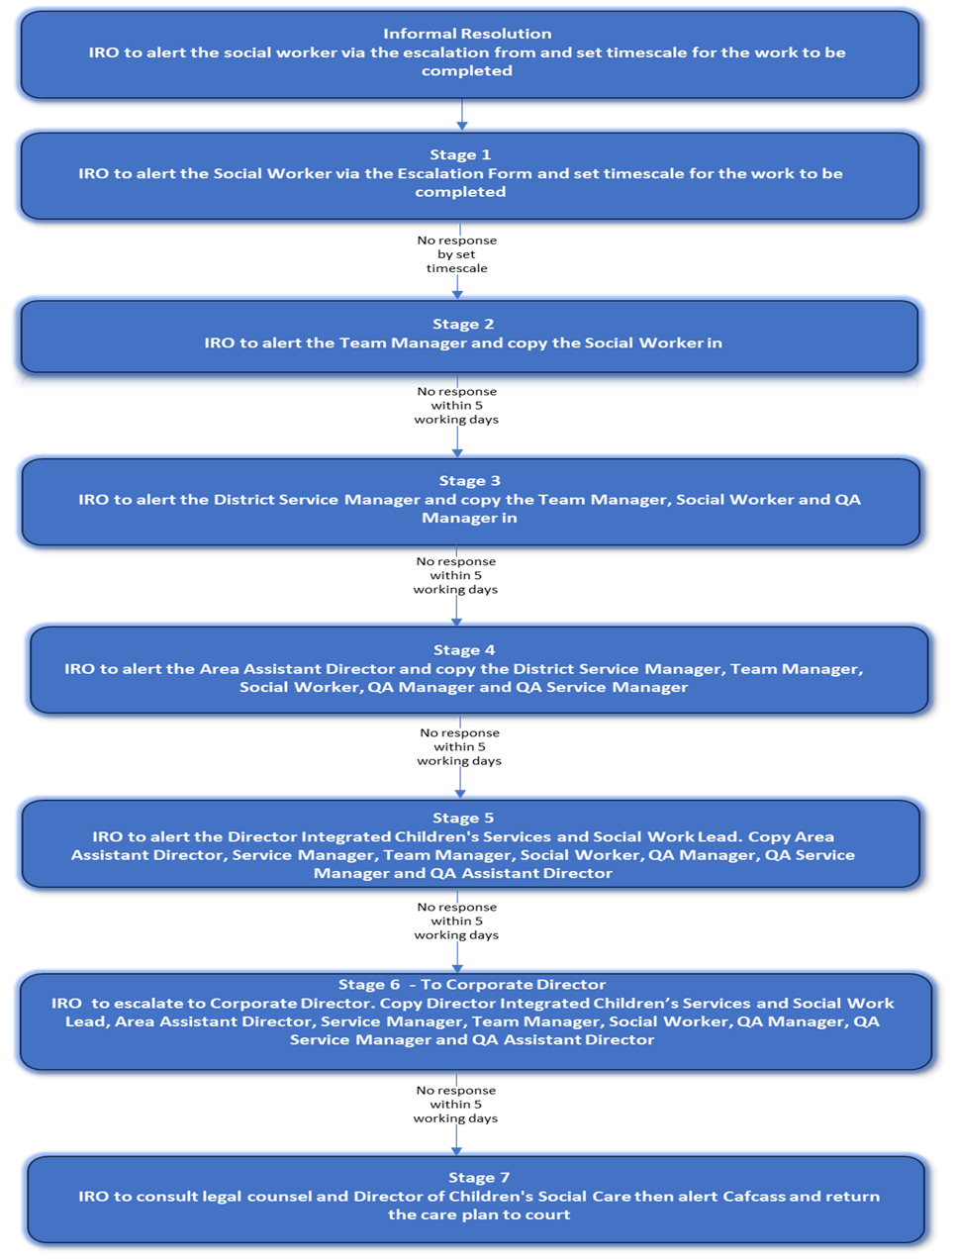

Appendix 1
Examples and reasons for practice escalations which will always link back to practice that negatively impacts achieving best outcomes for children and young people which may include but not limited to:

General issues
- Report not prepared for review meetings
- Reports not prepared and shared in timescales
- Report not shared with child / other professionals
- Purposeful visiting form not undertaken
- Insufficient evidence of the child’s voice and inclusion within the assessment, planning and review process
- Non completion of decisions / failure to meet timescales
- Assessments not progressed and / or completed in a timely manner / poor quality
- Unsuitable / inadequate family time
- IRO not notified of significant event in the child’s life
- Poor preparation by the social worker for the review
- Repeated absence or late arrivals at meetings
- Inadequate management oversight / supervision of a social worker
- Concerns about lack of effective partnership working with parents and or professionals’ network
- Key documents not completed or uploaded to child’s file
- Non-completion of actions within timescales
- Social worker visits to the child/ren not being within the expected timescales
- Concerns about the quality of risk assessments
- Workers not following KCC policy and procedures
- Discriminatory practice
- Evidence of poor partnership working amongst agencies which has compromised the effectiveness of the care plan
- Concerns about lack of child participation
- Avoidable drift and delay in care plans
- Lack of permanency planning
- Significant safeguarding concern or escalated risk that has not been re-assessed
- Lack of invites to family and professionals
- Minutes not shared with family and professionals
- Non-implementation of care plan actions by family or other professional (state which agency) that has not been challenged or addressed in a timely way

Failure to Meet Statutory Requirements
- Lack of appropriate placement matching / no up to date / poor quality assessment
- Lack of appropriate mitigation around placement risks
- No up to date / poor quality Safety Plan
- Statutory visits and life story work not being completed, or children not being seen alone, where appropriate, by the social worker
- Family time and connections not being promoted or in line with children’s best interests

Plan implementation
- Lack of mitigation plan and visiting to support unregulated provision
- Delay in progressing a care plan
- Failure to implement significant elements of the child’s plan
- Failure to notify the IRO of potential significant changes to the child’s plan
- Delay in progressing a Family and Friend Network meeting / Family Group Conference

