****Integrated Children’s Services

**Practice Guidance**

**Handbook for**

**Early Help**

**Document Author: Jane Caldwell**

**Approved by: Hayley Bodiam**

**Date of Issue: November 2023**

**Date to be Reviewed: November 2024**

|  |  |
| --- | --- |
| **Contents** | **Page** |
| Aim | 3 |
| Principles | 3 |
| Allocation and First Contact | 5 |
| Case Summaries | 6 |
| Chronologies | 6 |
| Early Help Assessment | 6 |
| Principles Underpinning a good assessment | 7 |
| When should I complete an Early Help Assessment? | 9 |
| What does Lighter touch assessment involve? | 10 |
| Recording on the child’s file | 10 |
| Management Oversight and Case Supervision | 11 |
| Consent | 13 |
| Working with resistance | 16 |
| Step Down | 17 |
| Step up | 20 |
| Reviewing the Early Help Family Plan | 21 |
| Ending Intensive Work | 21 |
| Supporting Families | 22 |
| Quality Assurance | 23 |

|  |  |
| --- | --- |
| **Appendices** | **Page** |
| Front Door Script | 24 |
| Integrated Children’s Services – Step Down Process Flowchart | 25 |
| Integrated Children’s Services – Proportionate C&F to Step Down Flowchart | 26 |
| Purposeful Case Notes | 27 |

# Aim

The Early Help Handbook provides practice guidance to enable Early Help Workers to support families and children who require intervention at level three as defined by the Kent Support Level Guidance. [(Kent Support Level Guidance)](https://www.kscmp.org.uk/guidance/kent-support-levels-guidance)

Early Help support means taking action to support a child, young person, or their family early in the life of a problem or as soon as it emerges. It can be required at any stage in a child’s life from pre-birth to adulthood and applies equally to safeguarding or complex needs that the family cannot deal with or meet on their own. Early Help reflects the widespread evidence base that it is better to identify and deal with problems early rather than respond when difficulties have emerged, when intervention can be less effective and often more expensive.

Early Help support requires agencies to work together to ensure a child and their family receives support in a timely and responsive way, so that children are safeguarded, their educational, social and emotional needs are met, and outcomes are good.

Early Help assessments and intensive support are currently offered through the Early Help units, whilst Open Access services provide universal, targeted and additional support.

This handbook has been updated in consultation with the Early Help Service Managers.

# Principles

The guiding principles of the work with families and children within Early Help intensive units are:

* Building on families existing resources with a culture of high aspiration and empathy.
* Building family wellbeing and resilience that leads to sustained change.
* Listening to the voice of children and families and using their voice to shape our support.
* Joining up services to support families at the right time and in the right place, with a focus on ensuring timely transitions.
* Supporting families to work together in the child’s best interest.
* Working with consent.

The Early Help pathway is shown below.

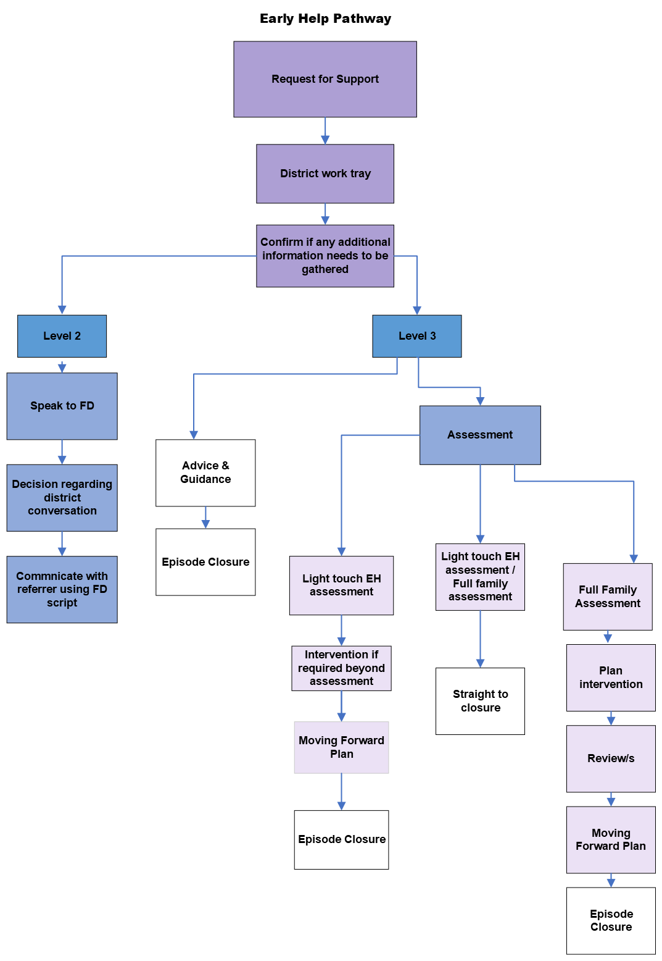

# Allocation and First Contact

The Unit Lead is responsible for ensuring that all requests for support are allocated to an Early Help Worker within 2 working days of receipt within the district. Prior to allocation, the Early Help Unit Lead will confirm if further information is required. If more information is gathered and the child or family’s needs are revised as meeting Level 2 (Kent Support Level Guidance), the referrer will be offered the same advice that is given by Front Door Service colleagues to remain consistent with Level 2 guidance (See appendix 1 – The Front Door script). This decision and rationale should be clearly recorded.

Once allocated the Early Help Worker will review the Request for Support information and contact the referrer to gather any additional information. They should contact the family within 2 days of the allocation to introduce themselves and the service; request permission to contact any other agencies supporting the family including early years settings, schools and health; and make arrangements for suitable time, date and place to meet to undertake the assessment and agree the Early Help Family Plan. All children need to be seen within 10 days, where this is not possible the focus child must be seen within 10 days. If possible, it is important to let the child decide when and where additional meetings will take place, who will attend and record this on EHM. The following details should be clarified as part of the first contact:

* Family address
* Who lives in the family home, including Dates of Birth.
* Contact details for non-resident parents/carers to gain their views and include them in the support for their child/ren
* Which schools/nurseries the children attend
* Any other professionals involved with family
* Family’s view on support needed (This is important to confirm the need for an Early Help Assessment)
* Completion of genogram
* Sharing the privacy notice

On the initial visit, consent must be obtained from parents to gather information/ share information with other agencies, see agency check form and consent form for further information [Click Here](https://www.proceduresonline.com/trixcms2/kentcs/formspractice-guidance#collapse1)



# Case Summaries

All files should include a case summary. The case summary should provide the reader with an outline of the history of involvement with Children’s Services, the reasons for current involvement and the purpose of that involvement. It should also include any crucial information and/or key safety features to be noted by the reader. The case summary recording should provide a succinct summary of significant information about the child or young person and should also consider the most recent plan, next steps, family progress, past harm and risk alongside family strengths and safety.

Case summaries must be updated as an absolute minimum every 3 months or following a significant incident. Additionally, the case summary should be updated upon transfer to another worker or team, or prior to closure, and should always include the final agreed plan.

Further information on case summaries can be found here [- Guidance for the use of case summaries, chronologies and genograms](https://www.proceduresonline.com/trixcms2/media/20457/case-summaries-chronologies-and-genograms-final-oct.docx)

# Chronologies

A chronology seeks to provide a clear account of all significant events in a child or young person’s life to date, drawing upon the knowledge and information held by agencies involved with the child, young person and family, the essential purpose of the chronology is to draw together important information and assist understanding, highlighting early indications of emerging patterns of concern.

Chronologies are an essential part of any good assessment, a vital foundation for analysis, and a useful tool to help practitioners develop rapport and should be viewed as the start, and heart, of a good assessment.

Every child currently open to Early Help must have a chronology and it must be updated every three months. This is an indication of good practice and should start from the day that the period of involvement starts. The previous history of significant events should be included too.

For more information about writing chronologies please refer to the guides below:

Early Help Module - [​pdf icon Chronology - How to Create a Chronology.pdf](https://eur01.safelinks.protection.outlook.com/ap/b-59584e83/?url=https%3A%2F%2Fkentcountycouncil.sharepoint.com%2F%3Ab%3A%2Fr%2Fsites%2FCYPEMII%2FUser%2520Guides%2FChronology%2520-%2520How%2520to%2520Create%2520a%2520Chronology.pdf%3Fcsf%3D1%26web%3D1%26e%3Dt2VRJr&data=05%7C01%7CMarie.Boniface%40kent.gov.uk%7Ced45ed72b92641d3c52c08db23ac49dd%7C3253a20dc7354bfea8b73e6ab37f5f90%7C0%7C0%7C638142995106015324%7CUnknown%7CTWFpbGZsb3d8eyJWIjoiMC4wLjAwMDAiLCJQIjoiV2luMzIiLCJBTiI6Ik1haWwiLCJXVCI6Mn0%3D%7C3000%7C%7C%7C&sdata=hl5h8LZsOA5reUDZAMe3h1YOXUgmH0jGpx0MO7WYOIA%3D&reserved=0)

[Guidance for the use of case summaries, chronologies and genograms](https://www.proceduresonline.com/trixcms2/media/20457/case-summaries-chronologies-and-genograms-final-oct.docx)

# Early Help Assessment

The Early Help Assessment is used to help ensure that children and their families get the right help, at the right time. In order to intervene at the earliest point, and target help and support in a way that makes a difference to the lives of families, a good quality assessment and Early Help Family Plan is required.

The Early Help Assessment is part of Kent’s Early Help Strategy to provide help to families at the earliest point of identification, and to reduce the need for more specialist or statutory service interventions at a later stage. The Early Help Strategy introduces a new streamlined assessment using a strengths-based approach to work with children and families.

Remember - Not all assessments need to lead to a plan or intervention, it may be that your use of questions, support and guidance may be enough to enable the family to develop their own safety plan and network.

# Principles Underpinning a Good Assessment

The basic principle of an effective assessment is the gathering and analysis of information, identifying strengths and worries, to generate a plan of action which focuses on achieving a positive outcome, completed in a collaborative way alongside the child and family with their full engagement. If possible, it is important to let the child have a say on when and where the meeting(s) will take place and who will attend so they feel comfortable and record this within the assessment.

The purpose of the Early Help Assessment is not to make a child and/or family dependent on a professional and/or a service intervention, it is to empower the child, family members and services to achieve positive outcomes for themselves.

Strengths-based assessments

A good assessment should be flexible and perceptive of an individual’s situation and needs around the assessment process; follow a holistic and whole-person approach; and be professional, honest, open, and approachable. A good quality assessment provides a holistic analysis of the family’s strengths and needs and should be:

* **Accurate** – The assessment provides an accurate and factual representation of the strengths and needs of the child and their family.
* **Clear** – The assessment is concise and understandable by all those involved, particularly the family and any professionals who may be involved, or who take responsibility for the case at a later stage.
* **Inclusive** – The assessment ensures that the child and their family are fully involved, and their voices are evident throughout. If possible, it is important to let the child have a say on when and where the meeting(s) will take place and who will attend so they feel comfortable and record this within the assessment.
* **Promote equal opportunities/views** – The assessment is not biased and gives positive expression to the opinions and experiences of the child and their family without prejudice or discrimination.
* **Authentic** – The assessment is an accurate and evidence-based record of the discussion.
* **Professional** – The assessment is non-judgemental and follows organisational codes of practice for recording/writing public documents.
* **Solution-focused** – The assessment focuses on what the child and their family want to achieve and builds on their existing strengths.
* **Systemic** – The assessment focuses on the various systems within which the children or young people operate (e.g., home, school, community, etc.).
* **Practical** – The assessment clearly identifies the strengths and needs of the child and their family and there is an appropriate Early Help Family Plan to address those needs, as well as information on what could happen if no action is taken.
* **Child Centred** – The child is seen and kept in focus throughout the assessment, they are listened to, and their voices are heard and acted upon.

If at any point you are concerned about the safety or welfare of the child or young person, seek immediate advice from your Unit Lead and ensure the information is added to the child’s file. The Early Help Assessment is a structured framework to record the conversation with a child and their parents/carers/family about circumstances, issues, risks, strengths, and difficulties. The fundamental purpose is to identify and agree a **SMART** (Specific, Measurable, Achievable, Relevant, Timely) plan. It should be focused on positive progress and impact on the future development and wellbeing of the child, as well as the parental goals and family changes that will support and facilitate this. New [Safety Planning Guidance](https://eur01.safelinks.protection.outlook.com/?url=https%3A%2F%2Fwww.proceduresonline.com%2Ftrixcms2%2Fmedia%2F18261%2Fsafety-planning-guidance.docx&data=05%7C01%7CJane.Caldwell%40kent.gov.uk%7C77dd6796853d437eeade08db15b6a643%7C3253a20dc7354bfea8b73e6ab37f5f90%7C0%7C0%7C638127646433078382%7CUnknown%7CTWFpbGZsb3d8eyJWIjoiMC4wLjAwMDAiLCJQIjoiV2luMzIiLCJBTiI6Ik1haWwiLCJXVCI6Mn0%3D%7C3000%7C%7C%7C&sdata=8NN8cdqYV7Guk%2BBiPbnh0kTiPrSojuMntDyFF1JSblk%3D&reserved=0) and [SMART Plans Guidance](https://eur01.safelinks.protection.outlook.com/?url=https%3A%2F%2Fwww.proceduresonline.com%2Ftrixcms2%2Fmedia%2F18262%2Fsmart-plans-guidance.docx&data=05%7C01%7CJane.Caldwell%40kent.gov.uk%7C77dd6796853d437eeade08db15b6a643%7C3253a20dc7354bfea8b73e6ab37f5f90%7C0%7C0%7C638127646433078382%7CUnknown%7CTWFpbGZsb3d8eyJWIjoiMC4wLjAwMDAiLCJQIjoiV2luMzIiLCJBTiI6Ik1haWwiLCJXVCI6Mn0%3D%7C3000%7C%7C%7C&sdata=GPVyVL6dXHvkXuxLDptun%2F0mGha0z5e%2FdBdN6MVDdrw%3D&reserved=0) has been produced to support practitioners which highlights that families should have one plan, which is the safety plan. The safety planning process is a change process, which invites family members, safety and support network members and practitioners to meet, identify the worries for the children, and to work out realistic and meaningful solutions to address these dangers. Safety planning is about helping people to make the shifts that are required in a change process:

1. Understanding the need for change
2. Visioning a different future
3. Acknowledging that real change requires changes in their own thoughts, attitudes, and behaviours.

It is important to work alongside the children and their parents/carers and family in the assessment process. Therefore, the Early Help Assessment must lead to a shared understanding by the child, parents, family, and practitioners of how needs of the child will be met through the actions of the professionals, the actions of their parents/carers, and the actions of the child.

It should include information about the child’s identity and culture and how these impact on their lived experience. That is, what a child sees, hears, thinks, and experiences on a daily basis that impacts on their personal development and welfare whether that be physically or emotionally. Early Help Workers need to actively hear what the child has to say or communicate; observe what they do in different contexts; hear what family members, significant adults/carers and professionals have said about the child; and think about history and context. Ultimately, we need to put ourselves in that child’s shoes and think ‘what is life like for this child right now?’.

Further resources on identity and culture can be found on The Kent Academy**.** [Course: Identity, Diversity, and Inclusion](https://www.delta-learning.com/course/view.php?id=1861)

# When Should I Complete an Early Help Assessment?

Here are some examples of situations when you may want to consider completing an assessment. This is not an exhaustive list, but gives you examples of things to consider, click on this link for further details [(Kent Support Level Guidance)](https://www.kscmp.org.uk/guidance/kent-support-levels-guidance)

* A child or young person, their parent/carer, or a practitioner is worried that the needs of a child are not being met.
* Someone in the family or social network is experiencing issues (such as substance abuse/misuse, violence, physical or mental health problems, crime) that might impact on the child but are not so significant that the child is at risk.
* There is a concerning change in a child’s appearance, demeanour or behaviour. This could be due to a significant family event, such as, bereavement, family breakdown, or worries at home such as additional caring responsibilities.
* A child with significant dental decay that has not been treated.
* A child is missing developmental milestones or making slower progress than expected at an early year setting, school, or college.
* A child is persistently arriving late or absent from attending an early year setting, school or college.
* A child that is at risk of suspension or permanent exclusions.
* A child is experiencing physical or emotional ill health or disability.
* A child is presenting with challenging or aggressive behaviours, is suspected of abusing/misusing substances or committing offences.
* A child is being bullied or is a bully themselves.
* A child is experiencing other disadvantages for reasons such as race, gender, sexuality, religious belief, or disability.
* Where it is identified, either at assessment stage or at a later stage of Early Help involvement, that the child has a disability or disabilities that may require additional support, including autism, it may be appropriate to consult with the Strengthening Independence Service.
* The Early Help Worker will need to consider the Strengthening Independence Service’s criteria and ensure there is consent from the family before a referral is completed. Referrals can be made via the Kent Children’s Portal. However, if it is unclear or you are unsure whether criteria will be met for assessment, further advice can be sought directly from the relevant area’s Team Manager within the Strengthening Independence Service.
* A child is homeless, being threatened with eviction, or living in temporary accommodation**.** See [joint working protocol for complex and vulnerable families and those at risk of intentional homelessness](https://www.proceduresonline.com/trixcms2/media/18907/joint-working-protocol-for-complex-and-vulnerable-families-and-those-at-risk-of-intentional-homelessness.docx)for further information.
* A child over the age of 13 is having a baby. (A child under 13 who is pregnant must be subject to a Strategy Discussion)
* A child is at risk of not being ready to make a successful transition.

The assessment must be proportionate, which means that the assessment is only as intrusive as it needs to be to establish an accurate picture of the needs of the child/family. This will involve:

* both hearing and understanding the initial presenting problem
* not taking this at ‘face value’ (professional curiosity)
* ensuring any underlying needs and complicating factors are also explored and the impact understood.
* exploring whether needs may differ in their breadth and depth, meaning there may need to be additional exploration of underlying needs.

The aim of carrying out an assessment proportionately is to ensure that assessment is not overly burdensome and recognises the child/family strengths.

# What does a lighter touch assessment involve?

If a lighter touch assessment is indicated, this will be guided and documented by the Early Help Unit Lead as part of their management oversight. The lighter touch assessment needs to be completed within 20 days.

The assessment should include:

* All Early Help Assessment sections to be completed concisely to outline the strengths and worries.
* An expectation that children are seen, and views are incorporated into the assessment.
* One worry statement to be developed with the family.
* The Early Help Family Plan details any interventions and referrals required. All referrals to be made immediately and followed up to ensure that service is in place prior to closure wherever possible.
* A robust Moving Forward Plan is developed based on the Early Help Family Plan.

# Recording on the child’s file

Case recording needs to be clear, concise and understandable to a person reading it who does not have prior knowledge of the child. Practitioners may find the following structure useful for recording meetings with children and their families.

1. Aim of meeting/event
2. Who was present?
3. Main discussion points - set the scene
4. Observations
5. Reflections and analysis
6. Actions/next steps

Case recording is a routine good habit, the list below details expectations of what “good case recording” needs to feature:

* Children’s views, wishes and feelings.
* Parents’ /carers’ views and wishes are fully sought and recorded.
* Language that is understandable and not discriminatory, labelling or blaming (the people being written about are entitled to see their records).
* Emails should **not** be copied and pasted into contact records. Contents should be summarised and if appropriate the email attached as a document.
* All case notes should be written to the child, see [Writing directly to the child in case recording](https://www.proceduresonline.com/trixcms2/media/19826/writing-directly-to-the-child-in-case-recording-updated-july-23.docx) for further information and situations when you do not write directly to the child.

See Appendix 4 and [Purposeful Recording Guidance](https://eur01.safelinks.protection.outlook.com/?url=https%3A%2F%2Fwww.proceduresonline.com%2Ftrixcms2%2Fmedia%2F14929%2Fpurposeful-recording-guidance-and-template.docx&data=05%7C01%7CSophie.Stevens%40kent.gov.uk%7Cfe44d5a521694acb8ad008daadf4133c%7C3253a20dc7354bfea8b73e6ab37f5f90%7C0%7C0%7C638013561043372399%7CUnknown%7CTWFpbGZsb3d8eyJWIjoiMC4wLjAwMDAiLCJQIjoiV2luMzIiLCJBTiI6Ik1haWwiLCJXVCI6Mn0%3D%7C3000%7C%7C%7C&sdata=D%2FN9d3iTdlm%2FtGLjWA9bLb4z2dNm8GwDGA2OkL9Cayc%3D&reserved=0)

# Management Oversight and Case Supervision

Management oversight is the footprint found at various stages, where a manager has oversight or makes decisions throughout the child’s journey. It should be seen as the overarching process that encompasses a variety of leadership and management activities.

Good management oversight will improve the quality of the decisions we make and help to drive the progress of the plan and prevent drift and delay. It should support practitioners to think critically, to analyse and assess risk, and take any action/urgent action required.

Management oversight on the child’s file should be written directly to the child. This will focus thinking on the impact for the child and will support an adult, who has requested their file as a child, to understand the rationale behind the decisions made on their behalf.

There are specific points within the family’s journey at which supervisors and managers must record management oversight on the respective systems either on the supervision form or on a management oversight case note. These include:

|  |  |
| --- | --- |
| Point of allocation | A discussion between the Manager and practitioner regarding newly allocated work must take place within 24 hours or sooner. A Management Oversight or initial Supervision Form to include detailed direction, including analysis and rationale will be added to the child’s file. |
| Assessments and plans | The assessment should be quality assured and authorised before being shared with the family. This should include speaking to the referrer about the outcome. |
| Reviews including CIN plans | Reviews should be specific to each child and written to them. CIN plans should be signed off by managers. |
| Supervision including joint or group | All formal supervision discussions should be recorded on the supervision form with clear indication whether this is one-to-one or group supervision. |
| Joint supervision across services | Where joint supervision occurs, the decisions should be recorded on the child’s file on the supervision form. |
| Informal/unplanned supervision (sometimes known as ad hoc supervision) | This would be added at the point of discussion, usually on a Management Oversight case note but managers may wish to record on the Supervision form if this is very detailed. Oversight should include a summary of the discussion, analysis and a clear rationale about decisions made, and SMART actions. |
| Case Progression Meetings | Meaningful case progression discussions, when there has been a detailed conversation within the team, should be recorded in a Management Oversight case note, so there is a record of discussions and decisions which impact on the trajectory of the child’s journey/outcomes. |
| Step downs/across/up | Decisions should be evidenced by a joint discussion with both team managers and a clear rationale entered on the respective systems. |
| Strategy discussions | Strategy Discussion minutes should be approved by Team Managers and Outcome Strategy Discussions must be approved by Service Managers. It is important to note Strategy Discussions provide the formal view of partnership agencies and in this way provides important multi-agency oversight and review of decision making and actions. |
| Transfers and transitions | Oversight should be added on the respective systems and will discuss the rationale about decisions made. |
| Appreciative Inquiry | Appreciative Inquiry is a key aspect of the audit process. The A.I. firmstep form should be uploaded to documents with a case note added to the respective systems and any actions followed-up. |
| Audits and moderations | PDFs to be uploaded to ‘Documents’, a case note added to the respective systems, and any actions followed-up in supervision, or sooner if there is a significant risk to a child. |
| Closures | Management oversight of closures should include a clear rationale about the decision to close. It should analyse the work undertaken prior to closure and consider the history, including repeated referrals. It should record the thoughts and feelings of the family about progress and closure.  Learning from safeguarding reviews highlighted that there were times when children had multiple transitions between services where the time period did not meet the 90 day threshold in any service before transitioning to the next service. Therefore, a formal supervision should be held by the service who is closing their involvement with the child **before** closure. An example would include: A child who has transferred from the Front Door Service to Early Help for a proportionate assessment, stepped up to Children’s Social Work Service and stepped back down to Early Help before closing some time later. The period within each service is under 90 days so no formal supervision has been held before closing. |
| Practice observation | The observation should be uploaded to the practitioner’s professional support supervision folder. |

See Integrated Children’s Services Management Oversight and Supervision Policy for further information.

# Consent

Gillick competence/Fraser guidelines

Gillick competency and Fraser guidelines help people who work with children to balance the need to listen to children's wishes with the responsibility to keep them safe. When practitioners are trying to decide whether a child is mature enough to make decisions about things that affect them, they often talk about whether the child is 'Gillick competent' or whether they meet the 'Fraser guidelines'. Although the two terms are frequently used together there are distinct differences between them. The Fraser guidelines apply to advice and treatment relating to contraception and sexual health. Gillick competency is often used in a wider context to help assess whether a child has the maturity to make their own decisions and to understand the implications of those decisions. Gillick competency can be considered in situations where consent is an issue, and the guidelines can support you to balance the need to listen to children's wishes with the responsibility to keep them safe. There is no lower age limit for Gillick competence to be applied. A child over the age of 16 can consent in their own right and make their own decisions.

There is no set of defined questions to assess Gillick competency. Professionals need to consider several things when assessing a child's capacity to consent, including:

* the child's age, maturity, and mental capacity.
* their understanding of the issue and what it involves - including advantages, disadvantages, and potential long-term impact.
* their understanding of the risks, implications and consequences that may arise from their decision.
* how well they understand any advice or information they have been given.
* their understanding of any alternative options, if available.
* their ability to explain a rationale around their reasoning and decision making.

For work to be as effective as possible Early Help Workers need the support from parents, so agreement should be negotiated. However, this does need to be balanced with the child’s rights.

If Gillick competency is used, ensure there is a conversation with the parents to make them aware their additional consent is not required, and record details of this conversation as well as your rationale under Management Oversight. See [Working together to safeguard children 2018](https://assets.publishing.service.gov.uk/government/uploads/system/uploads/attachment_data/file/942454/Working_together_to_safeguard_children_inter_agency_guidance.pdf) for further information and support**.**

The Early Help Assessment is completed with the consent of the child and their parents/carers. Early Help seek to engage the parents/carers regardless of the age of the child. If parental engagement goes against their wishes, this needs to be factored into the assessment and take it into account when determining the support, the child requires and undertaking a risk assessment.

Front Door Service will ensure there is consent prior to sending the Request for Support through to the appropriate district. On the initial visit to the family the Early Help Worker will obtain consent from the parents/carers to contact other agencies as part of the assessment (as detailed in the allocation and first contact section).

What happens if Consent is refused?

When a family or child are reluctant to speak with or work with Early Help, this can often be resolved within a short space of time. In a few instances, practitioners in all agencies will come across families who prove to be reluctant, resistant, and sometimes angry or hostile to their repeated efforts to work with them. The adults may also be focused on their own needs which can divert practitioners from a focus on the child. If this arises, Early Help Workers must seek advice from their Unit Lead to explicitly identify in a timely manner whether this parental behaviour is having a detrimental impact on the child/young person and together consider if other action might be necessary. The behaviour may prevent or restrict opportunities to assess and observe the child in their own home. It may also restrict other sources of information from other practitioners or family members. It is important to explicitly work out and record what areas of assessment are difficult to achieve and why. The presence of violence or intimidation needs to be included in any assessment of risk to the child living in such an environment.

In these circumstances, the Early Help Worker should deploy a respectfully persistent approach to support the family and gain their trust. Where the Early Help Worker is unable to achieve this outcome and concerns remain for the welfare of the child, these concerns should be explicitly analysed, particularly where there has been two episodes or more of declining support. This should include the use of chronologies to identify whether a Request for Support should be made to the Front Door Service.

Safeguarding procedures should be followed where a child is at risk of harm or likely to be at risk of harm due to their parents/carers not consenting to support. In instances of withdrawn consent where there are no safeguarding concerns, the family will be closed to Early Help with a rationale for the reason.

As part of the initial contact an Early Help Worker will obtain contact details for any non- resident parents, to ensure their views are obtained and they are included in the plan. At times there may be safety concerns a parent is worried about, for example, in cases where there has been domestic abuse. It is important to take account of this, to ensure no one is placed at risk, but the Early Help Worker must still contact the non-resident parent.

There may be times where one parent refuses to give consent for Early Help to support their child/children. For example, a father gives consent and mother does not give consent. In these circumstances, it is important to keep the child at the centre and work alongside the parent to encourage involvement.

There may also be times when a parent does not give consent for Early Help to contact the other parent. For example, when parents are separated and there is a history of domestic abuse. Again, in these circumstances it is important to keep the child at the centre and work alongside the parent to encourage engagement.

It is not possible to give specific advice on a range of situations and scenarios. The information detailed below is to support your considerations on a child-by-child basis.

|  |
| --- |
| **Top tips** |
| Work collaboratively in the best interests of the children. Support the parents to understand the benefit to the children. |
| Be proactive in contacting parents to have discussions. Ensure you remain persistent and patient and record all contact attempts. |
| Explore parents’ worries around the reasons for refusal, provide reassurance and clarification of the support. |
| Respect all viewpoints, understand the perspectives of others including any cultural or learning needs and work in a strengths-based way to support engagement. |
| Consider who else has a good relationship with the parent(s) e.g., school, they may be able to offer support in the way of a joint conversation. |
| Check information which one parent tells you. |
| The reason for denying consent maybe linked to the parents’ relationships, be mindful and considerate of this during conversations. |

If after offering support to allay parents worries and fears, a parent continues to refuse for Early Help to support their child/children, the Early Help Worker and Unit Lead will need to hold a reflective discussion and consider the impact on the child.

Following the discussion, a decision about safeguarding should be made agreeing whether to go ahead and provide support to the child without consent of the other parent. If the decision is to go ahead, a conversation with the non-consenting parent needs to take place, detailing a clear rationale for the decision as well as providing reassurance.

This process would be the same when a parent does not give Early Help consent to contact the other parent.

All conversations need to be framed in a way that respects both parents’ views, any reasons for us disagreeing and ensuring the focus remains on the child. Once the conversation with the parent(s) has taken place record this under Management Oversight and include the rationale and analysis for the decision.

# Working with resistance

Disguised compliance involves parents and carers appearing to co-operate with professionals in order to allay concerns and stop professional engagement (Reder et al, 1993)1.

Disguised compliance and denial are common features of families with support needs at tier 2 and 3. Apparent resistance may be the result of fear, stigma, shame, denial, ambivalence, the parent’s lack of confidence in their ability to change, or lack of insight into their parenting capability and the impact on their children.

* Indicators of disguised compliance can include: a lack of measurable progress at reviews, despite apparent effort and co-operation from parents; parental agreement to change but not completing agreed actions to achieve it; change occurring due to the efforts of other agencies rather than the parents; inconsistency in the areas where change is achieved with parents opting to work with some professionals and not others or on some actions and not others; children’s views differing significantly from that of the parents.
* Look out for missed appointments; exaggerated co-operation and compliance; attempts to minimise professionals’ concerns or denial of the impact of the lived experience of the child; aggressive or threatening behaviour when challenged; unjustified claims of progress being made, or actions carried out and a refusal to discuss key issues whilst focussing on others that have less or no impact for the child.
* Some parents may be resistant to the involvement of professionals, rather than resistant to change, particularly where they feel professionals are powering over them instead of working with them in a supportive manner. Consider the professional relationship with parents and ensure parents feel respected and avoid judgmental language or assertions about their behaviours or motivation.
* Be alert to the risk of collusion with parents. Where parents appear co-operative, remain open to hearing the voice of the child throughout the process and always measure parents’ assertions there has been progress against the child’s lived experience. See and speak to the child regularly.
* Ensure there is evidenceof improvement by using assessment tools and do not rely solely on the parents’ views to measure success. Cross check against the evidence, maintain ‘respectful uncertainty’ and check what parents say with other professionals.
* Without good evidence, do not be over-optimistic about progress. Share information with other professionals regularly and check on their view of progress made to challenge your assumptions.
* Challenge your approach with the family through supervision. With your supervisor, hypothesise about possible underlying issues that parents may not want to face, consider evidence carefully and reflect on the quality of parental engagement and motivation to change when progress is not being achieved.
* Where parents are openly hostile or aggressive, consider risk to the worker (and impact on the child, including witnessing this towards a worker) and discuss in supervision the strategies needed to overcome this. Re-evaluate risk to the worker and the child regularly.

# Step Down from Children’s Social Work Teams

This guidance should be read in conjunction with the Transfer Policy and procedures for Integrated Children’s Services Teams and should be shared across Integrated Children’s Services.

The Early Help Unit Lead and Children’s Social Work (CSW) Team Manager should systematically plan and discuss all Step Downs on a weekly basis. There should also be the opportunity to review and update previous Step Down families and to make decisions if families need to be stepped up to Children’s Social Work Teams (CSWT) or there are worries around disengagement or drift. All discussions should be recorded as a case note on both EHM and Liberi. The recording format should be:

* Decision
* Rationale
* Next Steps
* The Social Worker should organise the joint Step Down visit with the family.
* The Social Worker and the intended Early Help Worker should have a discussion prior to the visit to decide how the transition conversation is managed jointly between staff members. Joint visits should be seen as planning meetings that are critical to promote engagement, understand expectations, build the plan and develop contingency measures. Therefore, both workers need to arrive with a clear and common understanding of how the conversation with the child and family will be managed. Non-resident parents and carers should also be considered prior to the visit and how they will be engaged. The visit should take place face to face, consideration can be given to a virtual visit in exceptional circumstances.
* The joint conversation or visit with the child and family should take place with the Social Worker and the Early Help Worker **before** the case transfer is recorded on Liberi/EHM. This is to factor in any changes agreed with the child and family. The stepdown process should be completed no longer than 10 days after the joint visit**.** If the process is not completed within 10 days, the Social Worker should complete another visit and the Team Manager and Unit Lead should have a further discussion and agree whether the family will still Step Down.
* During the visit/conversation, there should be a focus on the agreed plan for Early Help going forward that outlines the details and expected length of intervention with the family. This needs to be focused and structured so that the child and family knows what to expect and has an idea of what Early Help involvement will include. The plan should be strengths based, co-produced with the family and include the voice of the child and family as much as possible. It should provide clarity, via a contingency plan, about how potential incidences of concern will be managed, including the possibility of the family being stepped back up to CSWT. All joint visits should be recorded on Liberi and EHM by the Social Worker and Early Help worker.
* Any incidences that occur at the joint visit that could alter or affect the decision to step down need to be evidenced, and the rationale for continuing to proceed or cancel needs to be demonstrated as a joint discussion and decision between the Unit Lead and CSW Team Manager. This should be recorded on both systems.
* Wherever possible, the Early Help assessment should utilise the Child and Family assessment (C&F) and the co-produced plan, to speed up the time to intervention and reduce duplication. This will need to be clearly identified and marked in the Early Help assessment by the worker. There may be occasions where this is not possible or appropriate. In these instances, a rationale should be evidenced through the discussion with the Team Manager and Unit Lead, and as part of case direction.
* It is possible for some C&Fs and the Early Help assessments to be completed at the same time where it is clear that the family can step directly down to Early Help. Where it is logistically possible, aligned teams and approaches can assist with the responsiveness of both services. More in depth guidance is provided on the next page.

* Children should be seen within 10 working days of the step down. If an Early Help Worker is off sick or on annual leave the Unit Lead must ensure the children are still seen within 10 days.
* Contingency planning should include detailed risk management and clarity on when Early Help need to trigger a conversation with the Team Manager. A decision should then be made (and recorded on both systems) whether the family will remain with Early Help or escalate back to CSWS.
* The Social Worker should communicate with partners prior to the family stepping down and their views sought to inform the development of the plan.
* For Step Down discussions the following headings must be used and recorded in the Step Down form in Liberi in the tab “For completion following Transfer meeting”.

|  |
| --- |
| **1.What we are worried about / Needs**  **2.Agreed plan**  This should include: -   * The Role and function of Early Help * The intended outcomes and the key focus * Any engagement strategies * The agreed number of sessions and what they pertain to e.g., three x sessions on anger management and the expected length of time that Early Help will be involved. * Method of delivery * Role of other agencies and any referrals to other agencies in place   **3.Contingency plan**  (Specific plan required should worries escalate or where there is non- engagement) This should be very specific and discussed with the family at the joint visit/conversations |

# Cancelled assessments

There may be times when a Child and Family assessment is cancelled. If step across to Early Help is requested at time of cancellation a discussion should take place with the Early Help Service Manager prior to the assessment being cancelled. The discussion should be recorded on EHM (in general notes) and Liberi and include whether the step across has been agreed/disagreed, the rationale for the decision and next steps including information around mitigating risk and consent from the family to work with Early Help.

In circumstances where the family are already open to Early Help and a decision has been made to refer in for level 4 services the same process will apply.

## Joint Proportionate C&F assessment and Early Help assessment

This section is specific to families that come in to CSWS from the Front Door Service and there is a view by the Duty Team Manager that the family is likely to require a proportionate C&F leading to an immediate Step Down. In these instances, the Social Worker and Early Help Worker must work together to gather the information required for the proportionate C&F assessment and the Early Help assessment, e.g., agency checks.

The Social Worker will identify the tasks that they must undertake as part of their statutory role (e.g., seeing the children) but there may be tasks that the Early Help Worker can undertake that would speed up the assessment process and ensure that all the information required for the Early Help assessment is simultaneously collected. This will ensure that Early Help will not duplicate the conversations with the children and family and other agencies but will copy and paste the relevant information from the C&F assessment into the Early Help assessment. It is possible for these assessments to be achieved in 10 days.

The process is as follows:

* Potential families that “could be” Early Help or CSWT agreed with Unit Lead and Team Manager and joint visit agreed.
* Duty Team Social Worker and Early Help Worker plan the firstvisit and how they will collectively support the gaining of information for the C&F assessment and the Early Help assessment. Statutory guidelines must still apply.
* Visit with children and/or family completed and feedback to Unit Lead/ Team Manager as to which service is best placed to provide support.
* If the family are not suitable for Early Help at this time, the joint information gathering will not be completed and the C&F will proceed. A co-produced plan will be developed as per normal Step Down guidance.
* If a proportionate C&F assessment is required with agreement that the family will then Step Down to Early Help, joint information gathering will proceed and both assessments will be completed with ten days. Once complete, the family can step across immediately.
* At Step Down, no joint visit will be required.
* Information gained as part of the process including the co-produced plan will be immediately transferred into the Early Help assessment and authorised so that direct work can swiftly take place.

See Appendix 2 and Appendix 3 for further information.

# Step Up

There are times when third parties have child protection concerns for the families already open to Early Help, where a third party has an immediate child protection concern for a child, they need to make an urgent Request for Support.

If a professional calls Early Help with a child protection concern for a family, they should be directed to make a Request for Support to ensure the appropriate next steps take place, e.g., a Strategy Discussion.

The Front Door Service may call the Unit Lead/Early Help Worker as part of agency checks to gain more information and analysis of the family’s situation; this is to support their decision making around next steps. It is the responsibility of the Front Door Service to make threshold decisions following their checks.

If an Early Help Worker has child protection concerns for a family, they need to discuss the concerns with their Unit Lead and agree whether a Request for Support needs to be completed. If the concerns are not urgent the usual step-up process can be followed.

# Reviewing the Early Help Family Plan

The Early Help Family Plan must be reviewed at least every 6 weeks, ensuring the family and other partner agencies supporting the plan are involved and discuss progress and issues, any changes in circumstances and agree next steps. They will formally evidence the progress and sustainability of change and any impact it is having on the family. The family’s views must be recorded, and if possible, the views of the child must be recorded, and the Early Help Worker must ensure the family receive a copy of the review form. Subsequent reviews should follow the same approach. See The [Early Help Review Guidance](https://www.proceduresonline.com/trixcms2/media/19697/early-help-review-guidance.docx) for further information.

# Ending Intensive Work

As the aim of Early Help is to promote resilience, not reliance, Early Help Workers and families should be seeking to end their support as soon as the outcomes have been achieved and there is confidence that the progress can be sustained.

At the final review, Early Help Workers must discuss next steps with the family and agree what needs to happen when the intensive support ends. This will form the content of the Moving Forward Plan which is shared with the family to enable progress to be sustained and to aid their own capacity to resolve any future difficulties.

The Moving Forward Plan must be shared with the family, and with consent it should be shared with the partner agencies who continue to be involved with the family to ensure continued support. Prior to closure the case summary should be updated to reflect the Moving Forward Plan.

As part of information sharing all agencies involved with the family must be informed at the point of Early Help closure. This includes agencies working with the adult (e.g., Probation Service). The information should include the rationale for closure. All communication with agencies should be added to the case file, ideally within the closure information and final case summary.

**There must be a formal supervision completed prior to closure if there have been several transitions between services and the period of involvement in any of those services has been less than 90 days so no formal supervision has been held.**

# 

# Supporting Families

The Supporting Families framework (formerly Troubled Families)underpins the work with families intensively in Early Help. The information below is specific to this and comes from The Supporting Families Outcome Plan for Kent and was agreed as part of the Supporting Families Best Practice meetings.

The work with families does not change, although there are some additional recording functions to fulfil the requirements of our quarterly statutory return to government.

The framework describes this and provides a way to demonstrate how we are working with families to build resilience and improve outcomes.

The outcomes framework has 10 headlines seen below and within each headline there are related outcomes identified.

* Getting a good education
* Good early years development
* Improved mental and physical health.
* Promoting recovery and reducing harm from substance use
* Improve family relationships.
* Children safe from abuse and exploitation
* Crime prevention and tackling crime.
* Safe from domestic abuse
* Secure housing
* Financial stability

From these 10 headlines, 3 outcomes that best align with the wellbeing goals within the family plan should be selected. The 3 outcomes selected should be those which can evidence impact and positive change for the family and should be from 3 different headlines. See example below-

This would not count as selecting 3 outcomes as they are under the same headline.

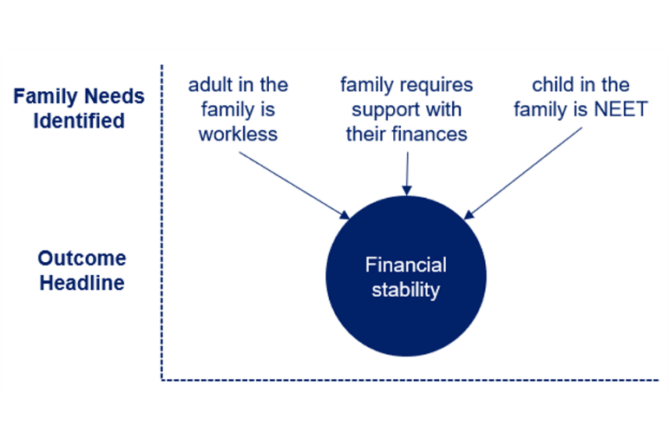

This would count as selecting 3 outcomes as they are across 3 different headlines.

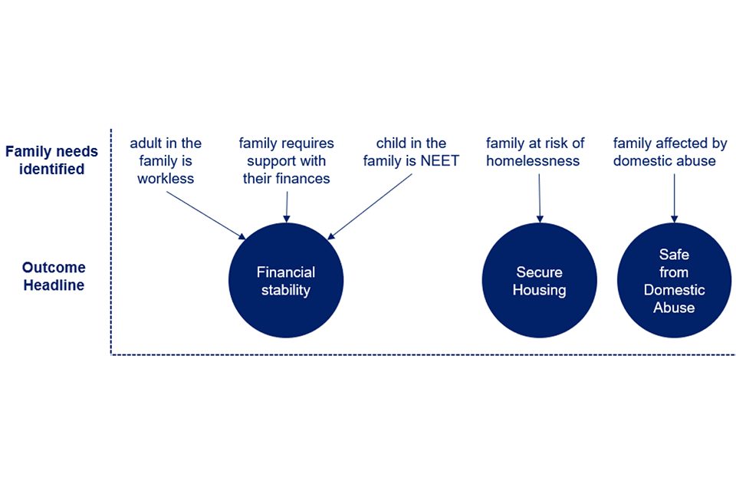

To support understanding of the headlines and outcomes print the quick reference guide, please see [Supporting Families Outcomes Plan for Kent](https://eur01.safelinks.protection.outlook.com/ap/x-59584e83/?url=https%3A%2F%2Fkentcountycouncil.sharepoint.com%2F%3Ax%3A%2Fr%2Fsites%2FChildrenYoungPeopleandEducation%2FShared%2520Documents%2FSupporting%2520Families%2520Outcomes%2520Plan%2520for%2520Kent.xlsx%3Fd%3Dwbfe3acc8a4e54c24ae74ff43ec1fdf2d%26csf%3D1%26web%3D1%26e%3DXNFtZB&data=05%7C01%7CSophie.Stevens%40kent.gov.uk%7C0a8fb525606c45514bd508db93528181%7C3253a20dc7354bfea8b73e6ab37f5f90%7C0%7C0%7C638265754787292267%7CUnknown%7CTWFpbGZsb3d8eyJWIjoiMC4wLjAwMDAiLCJQIjoiV2luMzIiLCJBTiI6Ik1haWwiLCJXVCI6Mn0%3D%7C3000%7C%7C%7C&sdata=qO%2BtM4kw5GpY%2BNIpe5Hm8%2Fin9WNUlUVWJ5Y9HWt%2BCLY%3D&reserved=0)

At the point of allocation Unit Leads can identify which outcomes may be able to be achieved, these outcomes can then be added into the initial case direction.

Identifying outcomes at the assessment stage is key, we can be selective in which ones we use and consider the work our partners may be doing with the family, to record this in the family plan.

As part of approving the assessment a Unit Lead may recommend additional or different outcomes.

When completing a review, consider the current outcomes and whether additional ones are needed. It is important for any changes to the plan to be recorded.

Remember the plan needs to reflect the work being completed and to make a claim there must have been at least one review and evidence of the impact for the family. For final reviews, ensure all the successful outcomes have been marked as achieved. Circumstances can change quickly for the families who Early Help works with, and ad- hoc/ responsive/ unplanned supervisions and case progression meetings support with the direction of work with a family. This case direction then needs to be reflected in reviews and plans.

When completing the closure there is another opportunity to update outcomes, which allows Unit Leads to make changes. Through this, outcomes will be checked alongside the evidence and impact of the work completed.

# Quality Assurance

The Supporting Families programme provides funding for Early Help services and as part of the claims process there is an element of quality assurance that takes place.

Area Partnership Managers complete quality assurance including -

* Reviewing the family plan and ensuring it links to identified needs and subsequently outcomes.
* Ensuring the correct indicators have been selected based on assessed needs and agreed outcomes.
* Ensuring there is evidence of intervention and positive progress for each outcome.
* Ensuring there is appropriate recording and that it is consistent in the plan, closure and case notes.

# Appendix 1

**Front Door Service Script**

Dear *{insert name of referrer or greeting}*

Thank you for your Request for Support Form in respect of *{insert name of child and their Case ID or FSC case number}*

This has now been assessed by *{insert name of Team Manager/Senior Practitioner*} at the Front Door Service and it does not meet the criteria for support at level 3 or 4.  Please see information below,

*{INSERT INITIAL DECISION/TRIAGE COMMENT HERE}*

Please refer to the Support Level Guidance for further information:

[https://www.kscmp.org.uk/guidance/kent-support-levels-guidance](https://eur01.safelinks.protection.outlook.com/?url=https%3A%2F%2Fwww.kscmp.org.uk%2Fguidance%2Fkent-support-levels-guidance&data=05%7C01%7CJane.Caldwell%40kent.gov.uk%7Ccf3da1f0322b4683f0db08db8c644864%7C3253a20dc7354bfea8b73e6ab37f5f90%7C0%7C0%7C638258134560398273%7CUnknown%7CTWFpbGZsb3d8eyJWIjoiMC4wLjAwMDAiLCJQIjoiV2luMzIiLCJBTiI6Ik1haWwiLCJXVCI6Mn0%3D%7C3000%7C%7C%7C&sdata=dRz%2BkGi41OZK2jgT592ylHu5qdiiB%2B%2Fpf7oFklllfLc%3D&reserved=0)

If you require help for a child or family at Support Level 2, and you have considered all of your in-house resources, please check for other suitable resources that may be appropriate. The following links may be helpful.

**kent.gov.uk**

[https://www.kent.gov.uk/education-and-children/early-help-support-for-families](https://eur01.safelinks.protection.outlook.com/?url=https%3A%2F%2Fwww.kent.gov.uk%2Feducation-and-children%2Fearly-help-support-for-families&data=05%7C01%7CJane.Caldwell%40kent.gov.uk%7Ccf3da1f0322b4683f0db08db8c644864%7C3253a20dc7354bfea8b73e6ab37f5f90%7C0%7C0%7C638258134560398273%7CUnknown%7CTWFpbGZsb3d8eyJWIjoiMC4wLjAwMDAiLCJQIjoiV2luMzIiLCJBTiI6Ik1haWwiLCJXVCI6Mn0%3D%7C3000%7C%7C%7C&sdata=UsKV7d2w3BMUKM9iSKDKBV5nM6j9kc5BXJSbJQW%2FIgg%3D&reserved=0)

**Kelsi**

[https://www.kelsi.org.uk/special-education-needs/integrated-childrens-services/front-door](https://eur01.safelinks.protection.outlook.com/?url=https%3A%2F%2Fwww.kelsi.org.uk%2Fspecial-education-needs%2Fintegrated-childrens-services%2Ffront-door&data=05%7C01%7CJane.Caldwell%40kent.gov.uk%7Ccf3da1f0322b4683f0db08db8c644864%7C3253a20dc7354bfea8b73e6ab37f5f90%7C0%7C0%7C638258134560554503%7CUnknown%7CTWFpbGZsb3d8eyJWIjoiMC4wLjAwMDAiLCJQIjoiV2luMzIiLCJBTiI6Ik1haWwiLCJXVCI6Mn0%3D%7C3000%7C%7C%7C&sdata=ZA906yQlQa1Sto8vbpTi0ehqttA7PRCxiNRjiY5p82c%3D&reserved=0)

**Headset resilience hub**

[https://www.headstartkent.org.uk/](https://eur01.safelinks.protection.outlook.com/?url=https%3A%2F%2Fwww.headstartkent.org.uk%2F&data=05%7C01%7CJane.Caldwell%40kent.gov.uk%7Ccf3da1f0322b4683f0db08db8c644864%7C3253a20dc7354bfea8b73e6ab37f5f90%7C0%7C0%7C638258134560554503%7CUnknown%7CTWFpbGZsb3d8eyJWIjoiMC4wLjAwMDAiLCJQIjoiV2luMzIiLCJBTiI6Ik1haWwiLCJXVCI6Mn0%3D%7C3000%7C%7C%7C&sdata=BSkBubOpgBddJtXfxxeeNdSZ6BENH8SoUZfFo4EMWtI%3D&reserved=0)

**School Nursing Service** (Includes referral pathway for the emotional health and wellbeing service)

[https://www.kentcht.nhs.uk/service/school-health/](https://eur01.safelinks.protection.outlook.com/?url=https%3A%2F%2Fwww.kentcht.nhs.uk%2Fservice%2Fschool-health%2F&data=05%7C01%7CJane.Caldwell%40kent.gov.uk%7Ccf3da1f0322b4683f0db08db8c644864%7C3253a20dc7354bfea8b73e6ab37f5f90%7C0%7C0%7C638258134560554503%7CUnknown%7CTWFpbGZsb3d8eyJWIjoiMC4wLjAwMDAiLCJQIjoiV2luMzIiLCJBTiI6Ik1haWwiLCJXVCI6Mn0%3D%7C3000%7C%7C%7C&sdata=iyllG%2BJKW61cMhxEuWYlLYh5B1Z1cvIERzMy%2FbU3kbg%3D&reserved=0)

If you need further information and advice regarding what support might be appropriate in your district, please contact your local Early Help Team for a’ District Conversation’. Your request for advice will be responded to by an Early Help Manager and you will then be able to discuss the needs of the child, young person or family and be provided with advice about the most appropriate type of support available within the community at Support Levels 1 and 2.

Please follow this link to find the contact details for key staff in your district; [https://www.kelsi.org.uk/special-education-needs/integrated-childrens-services/early-help-contacts](https://eur01.safelinks.protection.outlook.com/?url=https%3A%2F%2Fwww.kelsi.org.uk%2Fspecial-education-needs%2Fintegrated-childrens-services%2Fearly-help-contacts&data=05%7C01%7CJane.Caldwell%40kent.gov.uk%7Ccf3da1f0322b4683f0db08db8c644864%7C3253a20dc7354bfea8b73e6ab37f5f90%7C0%7C0%7C638258134560554503%7CUnknown%7CTWFpbGZsb3d8eyJWIjoiMC4wLjAwMDAiLCJQIjoiV2luMzIiLCJBTiI6Ik1haWwiLCJXVCI6Mn0%3D%7C3000%7C%7C%7C&sdata=8NOdk6fk4EKgjFEkSx6ydgNc38%2BstDKaY6eQ%2BwrKydw%3D&reserved=0)

I have also attached/enclosed an information leaflet with further details.

Kind regards

# Appendix 2 Integrated Children’s Services Step-Down Process

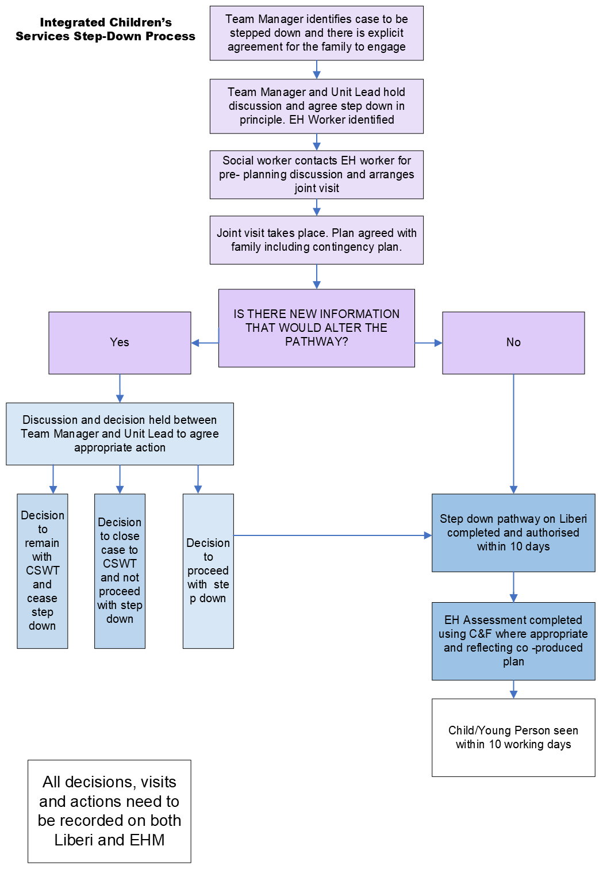

# Appendix 3 Integrated Children’s Services Proportionate C&F to Step Down

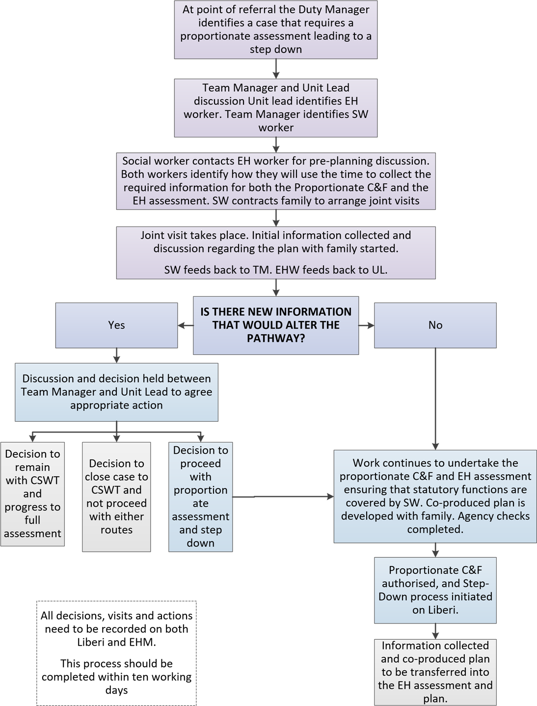

# Appendix 4 Purposeful Case Notes

|  |
| --- |
| **Reason for CONTACT:**  Identify the aim and purpose of the home visit.  Is the AIM of the home visit LINKED to the PLAN? |
| **DETAILED NOTES:**  Who was present, seen and where?  Was the child seen, seen alone and if not, why not?  Wishes and feelings obtained.  What did you discuss and observe in the home visit?  Progress of the plan |
| **ANALYSIS:**  This is the “making sense of” or drawing out the “meaning” of all the information available for the child or young person and their family.  The critical thinking involved in analysis enables you to move beyond a list of issues to examine the interaction between them, any cumulative effect and the protective factors and determine the risks and needs to be addressed. |
| **ACTIONS:**  What action is to be taken?  By whom, by when and how is this to be measured.  Any changes to the agreed plan? |