Placements, Purposeful Visiting and

Understanding the

Child’s Lived experiences

Name of Author: Anita Hiller
Name of Senior Manager Approving:
Leemya McKeown
Date of Issue: January 2024
Date to be Reviewed: January 2025

Contents | Page
Introduction | 3
Regulated Placements | 3
Unregistered placements concern about placement | 7
Assessing the child’s lived experience in placements | 9
Visiting timescales for ALL regulated placements | 11
Visiting timescales for unregistered placements | 12
Triangulating evidence regarding the child’s lived experience | 13
Safeguarding and Provision of care concerns | 16
IRO escalation | 18
Risk Assessment and Scoping Meeting | 18
Purposeful Visiting Form Template | 21
Risk Assessment Template | 24
Risk Management Scoping Meeting Template | 28

Acknowledgements
Strategic Commissioning
Total Placement Service
Corporate Parenting, Integrated Children’s Services
County LADO Service

Accessibility Statement
https://www.kent.gov.uk/about-the-council/about-the-website/accessibility-statement

Introduction
This guidance defines the different types of placements that are available to our children and young people who are in care and care leavers. It details how we can monitor and check the suitability and safety of the placement during the child’s stay and helps us to ensure that children and young people are thriving and developing in their placement. It gives details on what tools to use to help us understand the quality of placement and what to do if there are concerns that the placement is not meeting the required standards, and the child or young person’s needs. It also gives guidance around actions that should be taken if there are care or safeguarding concerns and if a regulator; Ofsted or the Care Quality Commission deem that the placement is rated as Inadequate.
Kent’s Total Placement Service can help with more in-depth questions regarding placements.

Regulated Placements
A regulated placement is one that is regulated by either Ofsted or the Care Quality Commission. The following placements are regulated.

Fostering
- Description - Foster care is a way of offering children and young people a home while their own family are unable to look after them. This can be for a variety of reasons. Foster carers are childcare experts working alongside a team of professionals providing children with the highest standard of foster care.
- Eligibility - Fostering services are available to children and young people aged 0-18. This will include Parent and Child placements where the parent is over 18. Foster carers also provide “Staying Put” arrangements for young adults from the age of 18 years. Kent has a range of fostering families including caring for siblings, adolescents, Step Across from residential care, emergency bed scheme, permanency, short breaks for disabled children and respite care.
- Arrangement - Kent has both an in-house service where we directly recruit Foster Carers and use Independent Fostering Agencies who are contracted to us and manage the recruitment of their foster carers. If we are unable to find a good match with our in-house carers, we will approach the Independent Fostering Agencies. These services are regulated by Ofsted.

Residential Children’s Homes
- Description - Residential Children’s Homes are where children living together in single bedrooms, with shared communal living areas.
- Eligibility - Residential Children’s Homes are available to children and young people aged 5-18. In addition, Kent approves a small number of residential Parent and Child arrangements.
- Arrangement - Spot Purchased (immediate purchase of goods or services without going through the traditional sourcing and bidding process). These services are regulated by Ofsted.

Residential Special Schools
- Description - Residential Special Schools provide care for children with physical disabilities, learning disabilities or emotional difficulties. These schools focus on education and provide teaching on-site. In some cases, there are homes for children which offer transitioning support for young people until they reach their early 20’s.
- Eligibility - Residential Special Schools are available to children and young people aged 5-18.
- Arrangement - Spot Purchased. These services are regulated by Ofsted.

Secure Accommodation
- Description - This accommodation provides a secure environment where children and young people are placed to mitigate significant risk and to safeguard them. A court order is required to place a child in this provision. The provision is also used to accommodate young people aged 10 -17 who are identified to have vulnerabilities and have been remanded or given a custodial sentence via the criminal courts, to be served in secure accommodation.
- Eligibility - Secure accommodation can be used for children aged 10-17yrs dependent upon circumstances and ensuring the correct statutory authorisations are in place.
- Arrangement - Spot Purchased. These services are regulated by Ofsted.

Shared Lives (18+ only)
- Description - If a young adult is disabled and/or needs more support than can be offered through Staying Put, Shared Lives might be a possible option, either with the current carers if they apply to become Shared Lives carers or an alternative carer.
- Eligibility - Shared Lives can only be accessed through Strengthening Independence Service or one of the Adult Social Care Teams in Kent County Council and will be considered by the Children in Care or the Young People’s teams before the young person turns 18 years of age.
- Arrangement - This provision is regulated by the Care Quality Commission and is an in-house service.

Previously known as ‘Unregulated Placements’ – now must be regulated
In July 2022, the Government laid out the first set of regulations required to introduce the reforms to supported accommodation for 16 and 17-year-old children in care and care leavers. These reforms require providers of supported accommodation to register with Ofsted and comply with the regulations and quality standards -

The Supported Accommodation (England) Regulations 2023 (legislation.gov.uk)
Since October 2023, it has been a legal requirement to register all provision. . Providers who did not submit an application, are not legally able to offer supported accommodation.
Part 8 amends the Care Planning Regulations to prohibit the placing of children in care, who are aged 16 and 17, in “other arrangements” accommodation unless it is supported accommodation where the provider is registered with Ofsted. This is subject to some limited exceptions such as hospitals and education institutions.
The regulations also amend the meaning of “suitable accommodation” for 16 and 17 year old care leavers in the Care Leavers (England) Regulations 2010. This will mean that suitable accommodation can only be supported accommodation where the provider is registered with Ofsted. This is subject to some limited exceptions such as accommodation in Wales or Scotland.

Semi-Independent Accommodation
- Description - This is a house in which a number of young people will live with their own bedroom and shared living space. A support worker will be on-site as required; the length of time and frequency will vary depending on the levels of need the young people have and provide life and independent skills support.
- Eligibility - This service is available to young people aged 16+.
- Arrangement - Spot Purchased. This service must be regulated for all accommodation for 16/17-year-olds.

Young Persons Supported Accommodation and Floating Support Service (YPSAFS)
- Description - This service provides an accommodation and support package with a support worker being on hand to support and guide young people. Support is tailored to each individual young person to support them to maintain their tenancy and positively participate in their local community. In Kent there is a range of housing with support, so accommodation might be in shared houses or single flats. There is also a floating support service for those young people moving into their own independent accommodation.
- Eligibility - YPSAFS is available to children and young people aged 16-21, up to 25 if in education or working and it is also available to 16/17-year-olds children in need who are homeless and have additional needs. All children in need will require a Joint Housing Assessment to be able to access this service.
- Arrangement – This service must be regulated for all accommodation for 16/17-year-olds.

Shared Accommodation
- Description/Purpose - Shared Accommodation is similar to semi-independent accommodation, although this is for young people with independence skills and who require minimum support.
- Eligibility - This service is available to young people aged between 16 and 21.
- Arrangement - This service must be regulated for all accommodation for 16/17 year olds.

Reception Centre and Safe Care Service Description
The Reception Centre provides accommodation and support for male Unaccompanied Asylum-Seeking Children (UASC) entering Kent aged 16-18. Other new arrivals of young people, who are under the age of 16 years, female, or those with clear safeguarding concerns, are placed in Foster Care. The Reception Centre provides a routeway for the National Transfer Scheme (NTS), whilst they await transfer to another Local Authority.

Case Law in relation to UAS
It is illegal to place children under the age of 18 in hotels. The High Court ruled on 27th July 2023 ECPAT -v- Kent Council judgment (judiciary.uk) that the Home Office policy of placing unaccompanied asylum seeking children (UAS) in hotels became unlawful when it became “systematic and routine”.
The judgement was clear that the routine housing of UAS children in hotels is unlawful with local authorities holding the statutory duty to provide accommodation to children who are looked after, regardless of where they come from, and therefore the regulations in respect of supported accommodation apply equally to all children, including children who are unaccompanied and seeking asylum.
- Arrangement: This service must be regulated for all accommodation for 16/17 year olds.

Staying Put
- Description - Staying with foster carers past the age of 18 is referred to as ‘Staying Put’ where young people can stay with their foster carer until the age of 21, if agreed. The young person will be a lodger in their home, in that they will be renting a room from them, and the young person will be expected to pay a contribution for their keep. The young person will be supported to develop their independent living skills further with their carer.
- Eligibility - This service is available to young people aged 18 that are Staying Put with their Foster Carer.
- Arrangement - To facilitate this arrangement, foster carers become Hosts when the young person turns 18 under Kent Supported Homes inhouse service.

Supported Living (18+ only)
- Description - Supported Living Services are care and support services that are usually delivered through self-contained flats or shared housing occupied by more than one tenant, with a combination of individual one to one support and shared support.
- Eligibility - This service is available to 18+ adults only. This includes adults who have assessed care and support needs associated with sensory impairment, learning disability, physical disability, physical ill health, substance misuse and mental illness.
- Arrangement - Framework contract.

Unregistered Placements
- Description - Unregistered provision is when a child who is being provided with some form of ‘care’ is living somewhere that is not registered with Ofsted or the Care Quality Commission. This is illegal. Once a provider delivers a care element as well as accommodation, they must register as a children’s home. It is an offence not to register. Both the care and the setting must be registered. It is illegal to place a child under 16yrs of age in this type of setting.
- Eligibility - Where, in exceptional circumstances this type of provision needs to be considered authorisation is required from the relevant Director. Full details are provided here.
- Arrangement - Spot Purchase.
NB. For the compliance process before placement in a new regulated spot-purchased provision, please speak to CIC Commissioning.

Care as a continuum for 16 and 17 year olds
For many young people aged 16 or 17, living in supported accommodation can be the best option to meet their needs, with the aim of supporting them to develop their independence as they approach adulthood, ahead of leaving the care system. However, this type of provision is not automatically the right choice for every 16 and 17 year old. Where young people of this age have needs that would best be met in a children’s home or foster care placement, that is where they should be placed.
For children living in supported accommodation prior to the recent changes in regulation, Social Workers would have considered the Annex A to identify whether the accommodation identified for them provided either care or support. Since the change in regulation, the Annex A no longer exists. It has been replaced by a new emphasis on the allocated Social Worker’s assessment of the child’s needs and where these will be best met.
The changes in regulation denote a shift from a rigid distinction between a placement providing either ‘care’ or ‘support’ to seeing this along a continuum that will change according to an individual child’s needs. This will also require a shift in thinking for workers who will need to take a more nuanced and bespoke approach when considering placements.
Care, insofar as it describes a ‘service’, is delivered in children’s homes and ‘support’ is delivered in supported accommodation. However, everybody delivering supported accommodation should care about young people and create a caring environment. Even though the service provided in supported accommodation is called ‘support’, this provision remains an important part of the children’s social care system. As such, supported accommodation is part of the continuum of care and support for children in care and care leavers as they grow up, and are ready for increased independence on the path to adulthood. A rigid distinction between ‘care’ and ‘support’ would fail to capture the nuance of the varying needs and transitions that are a normal part of a child growing up.
When local authorities and providers engage in matching a young person with the right provision, they must consider the individual’s specific needs and level of autonomy so they live in a place that delivers a service that safeguards and empowers them, as well as facilitates their growth and development.
When inspecting supported accommodation Ofsted will be measuring the provision against the new Quality Standards.
The Quality Standards are four standards that providers of supported accommodation must meet. These standards cover leadership and management, protection, accommodation, and support. Each standard contains an overarching outcome statement with young people at its heart, followed by a set of measurable requirements that providers must achieve in meeting each standard.
- The Protection Standard (Regulation 5) sets out the requirements to protect young people from harm and abuse. This includes having policies and procedures to safeguard young people, providing appropriate training for staff members, and ensuring that young people have access to advocacy services.
- The Accommodation Standard (Regulation 6) sets out the requirements for ensuring that young people can access safe and suitable accommodation. This includes providing a clean and comfortable living environment, ensuring that accommodation meets health and safety standards, and provides appropriate cooking, washing, and personal care facilities.
- The Support Standard (Regulation 7) sets out the requirements for ensuring that young people receive the necessary support to achieve positive outcomes. This includes providing access to education, training, and employment opportunities, as well as help with managing finances, developing life skills, and accessing healthcare services.
- The Leadership and Management Standard (Regulation 8) outlines the requirements for effectively managing supported accommodation. This includes having clear policies and procedures in place, providing appropriate training for staff members, involving young people in decision-making around their care, and regularly monitoring and evaluating the quality of support offer.

Assessing a Child’s lived experience in placement
It is the duty of those who work with children and young people in care provisions to ensure that they are safeguarded. However, it is everyone’s duty to ensure the care and support afforded to the child/young person is safe and meeting their needs. This includes raising concerns around the standard and protection of care.
As corporate parents, it is our duty to ensure every part of the child’s lived experience is at a level we would expect for our own children. There must be checks and balances and the evidence provided by the provision must triangulate with what the child or young person is telling us.
The Purposeful Visiting Form is a tool to cross reference evidence of the provider’s ablity to meer the child’s care plan. Understanding how all aspects of the child or young person’s care is being met should be standard practice as part of visiting the child/young person. The Social Worker and Independent Reviewing Officer have a duty to ensure the level of care and safety for that child is monitored. These checks must be completed on the Purposeful Visiting Form and the schedule of visits below are MANDATORY for regulated placements with the exeption of in-house foster placements.
The Purposeful Visiting Form can be used to evidence shortcomings that can be escalated informally by the Social Work/Personal Advisor or their service in the first instance, then by the IRO more formally through stages of escalation.
As well as speaking to the child/young person in placement, the Social Worker/ Practitioner/IRO/Team Manager/Service Manager and any other professional within the network (such as health professionals, Youth Justice, Commissioning) should be curiious and seek out conversations with staff and enquire about risk assessments; staff training; safeguarding policies; use of rewards and sanctions; activities with the child; and provision of support. Information should be triangulated by looking at logs, policies and other recording.
Health professionals can complete their own tool, the Placement Assurance Tool, which is health focused but captures safeguarding and placement concerns. The IRO can request the health professional completes this during their visit and ask for this to be shared with the Social Work

Visiting timescales for ALL regulated placements (not in-house or IFAs)
ROLE | VISITING SCHEDULE | ACTION
Social Worker | Initial visit prior to placement  NB. Below schedule may change at first LAC Review if considered not frequent enough  Within every 12 weeks  If permanent care plan, 3 monthly  Follow up of actions after completing form – It is the SW’s responsibility to ensure all actions by the provider are completed and reminders or escalations completed if not. | At each visit:  Speak to child/young person alone and see where they sleep, the quality of the room and facilities  Ask child/young person to take you around provision  Check care plan  Check logs  Check certificates  COMPLETE PURPOSEFUL VISITING FORM ON LIBERI
Independent Reviewing Officer | Before LAC Review –  First LAC Review –  Before second LAC Review –  Ongoing throughout placement -  minimum of 2 visits per year  If SW is not completing Puposeful Visiting Form  Follow up of actions following completing the form – The IRO should check that recommended actions have been completed and reminders or escalations completed if not. | Review first Purposeful Visiting Form completed by SW  Consider professional network’s visiting schedule, including the social work team, Youth Justice, health professionals, Commissioning, and any other appropriate professionals. Should visits be completed more frequently than the schedule above.  Visit child/young person in provision  See child/young person alone  Ask child/young person to take you around provision  Check care plan  Check logs  Check certificates  COMPLETE PURPOSEFUL VISITING FORM ON LIBERI  As above  IRO Escalation on Liberi Form

Visiting timescales for unregistered placements
When a child is placed in an unregistered placement, the checks and balances are even more important as there is no oversight by the regulator. These placements must be approved by the Director and visits to the provision must be undertaken within the following timescales and recorded on the Purposeful Visiting Form.
Role | When | Timescale | Action
Social Worker/  Personal  Assistant | New unregistered provision | - Prior to placement  - Within 24 hours of placement  - Twice weekly for first 3 months (one of these visits can be undertaken virtually).  - Visiting requirements post 6 weeks to be discussed and agreed at LAC Review | - Semi-Independent Accommodation – Allocated Case Worker Checklist  - As above, if not done already Purposeful Visiting Form  - Purposeful Visiting Form  - Purposeful Visiting Form
Health Professionals | As directed by the IRO | As directed by the IRO | Health form – Placement Assurance Tool
CIC Commissioning | New unregistered provision | Within 10 days of placement
Service  Manager | New unregistered provision | Visit child within 1 month of placement | Purposeful Visiting Form
Independent Reviewing  Officer | New placement | If concerns - within 2 weeks  If no concerns -prior to 1st LAC Review | Purposeful Visiting Form
Independent Reviewing  Officer | During placement | Prior to each LAC Review for every placement whether there are concerns or not. | Purposeful Visiting Form

Triangulating evidence regarding the child’s lived experience
Although each provision may be slightly different, there are a number of checks and balances you can complete, as well as information you can request from the provider. IT IS YOUR DUTY TO DO THIS. Below is not an exclusive list but some suggestions of where to look and what to ask.
The IRO, SW and professionals from the child’s network should liaise prior to any visit. This will ensure that any specific concerns are communicated and can be checked but also, to ensure visits undertaken are spread out and not planned for the same week/time.
Each visit should be guided by the child’s Care Plan and evidence should be sought to ensure the child’s Care Plan is being met. This is the first document which should be checked and triangulated with the child. This information will then be recorded on the Purposeful Visiting Form. It is not possible to check every aspect of the points below, but the placement must be meeting the child’s needs and keeping the child safe.

Placements Standards Evidence and Location

Standard | Location | Questions
Internal care plan- the homes care plan for the child which absolutely must link to the agreed LAC Care Plan of the LA. This should link to a weekly, monthly (or agreed reporting timescale) report on key dimensions of the child’s development to the LA SW. | Establishment case records/ Placement Manager  Young person copy | Who has a copy of the child/young person’s support plan? Who is responsible for implementing the support plan? Who and how often is the support plan reviewed? How are a child/young person’s achievements celebrated?
Risk Assessment/Safe Care Plan – which outlines risks to and from a child and how these will be managed and mitigated | Placement Manager | Does a child/young person have a risk assessment/Safe Care Plan? Who has a copy? When is this reviewed?
Daily log – a record of all activities completed daily which should include staff on rota, brief statements and links to other recording e.g., if there has been an incident there will be a brief entry and the incident recorded more fully on an incident report.  Incident Log – will list incidents that have taken place and link these to the relevant Incident report that should also be seen.  Restraint Log – will list restraints that have taken place and link these to the relevant Incident report/Restraint report. | Placement Manager | Who can access the logs? How would increasing concerns be recognised? How would increasing concerns be addressed or escalated?
Staff rota – will give details of which staff and the number of staff that are on shift at any one time. | Placement Manager | Who has access to staff rotas? Are any amendments or changes recorded?
Visitor log – gives details of who visits the home.  Regulation 44 report – this is a visit, culminating in a written report, undertaken by an independent person each month to the home to report to comment on the care of the children resident and the running of the home. | Placement Manager | Who checks if visitor logs have been completed and are accurate?  Who ensures that Regulation 44 Reports are completed within timescale? How is the and bias or accuracy checked? How are any identified issues raised or escalated?
Risk assessments including fire/health and safety/PAT testing. | Placement manager | What current risk assessments have you in place and who and how can they be accessed. How often are they updated?
Staff training and first aid qualifications.  Medications log (for all prescribed medication and home remedies) | Placement Manager | Does the Manager hold a Level 4 or 5 qualification? How are staff trained and developed?  How many staff have first aid training?
Safeguarding policies.  Statement of Purpose | Company website | What safeguarding polices do you most access? How is staff understanding of policies assessed and monitored?
Sanctions log (for all sanctions, what they are, why have they been put in place)  Use of rewards. | Establishment case records/Placement Manager  Young person copy | How are rewards used to motivated children and young people? How are these agreed with children and young people? How are rules and consequences agreed with children and young people?
Activities with child/young person. | Establishment case records.  Young person copy | How are suitable activities for individual children/young people identified? How are children/young people encouraged or motivated to attend activities and how are they funded?
Insurance with expiry/renewal date. | Placement manager | What insurance policies do you hold, where are they kept and who has access to these?

Safeguarding and provision of care concerns
A concern regarding a provision may be made by Ofsted/CQC following an inspection; by any professional within the child’s network; by the Social Worker/ Personal Assistant/ social work team; or by the IRO.

Concerns raised by Ofsted/CQC
If a Provision is graded Inadequate by Ofsted/CQC, CIC Commissioning will be notified, and they will initiate the following process with Total Placement Service (TPS).
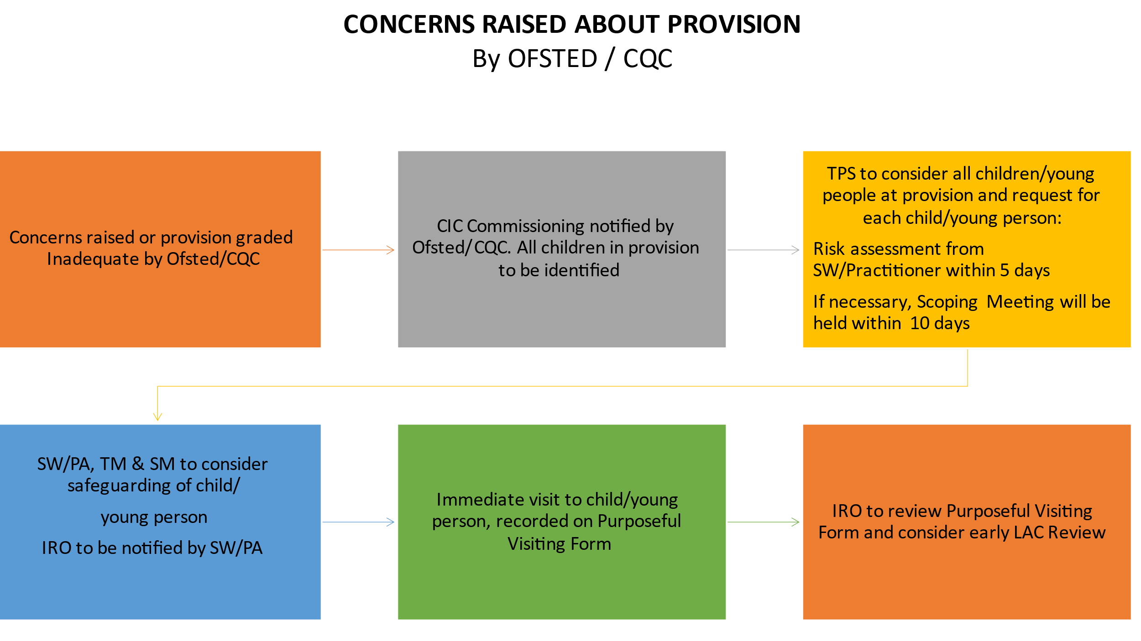
See Risk Assessment and Scoping Meeting section for more information.

Concerns raised by a professional
If the visiting Personal Advisor or Social Worker is not satisfied with the day-to-day support of the child or young person, or adherence to the Care/Pathway Plan and agreed outcomes, the Team Manager and Service Manager must be alerted to the concern(s), in addition to the IRO. The visit should be recorded on the Purposeful Visiting Form. This must lead to an agreed course of action and a plan for the allocated worker to liaise with the provider directly in the first instance. The provision should be clear about the issue, how this should be rectified, and the timescales for when this should be rectified. There should be no delay in this action.
The IRO will review the Purposeful Visiting Forms completed by the Social Worker/Personal Advisor and consider whether:
- the appropriate actions have been completed to ensure the child/young person is safe and their needs are being met
- an early LAC Review is required
- a formal IRO Escalation is required
Practitioners should note on the form that escalation to Line Manager is required so this can be completed by the Social Worker/Personal Advisor.

Dealing with Standards of Care and Practice Concerns relating to External Providers
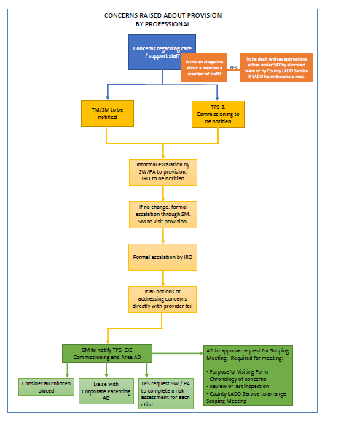
If, as a result of the visit, the assessment concludes that the child or young person’s welfare is not adequately safeguarded and promoted by the placement, the Personal Advisor or Social Worker will be required to undertake the relevant steps to safeguard the child, in consultation with their manager.

IRO Escalation Process
In respect to consideration of where the child is living, there is an expectation that the IRO completes the Purposeful Visiting Form as part of the Quality Assurance process to evidence their concerns. The Purposeful Visiting Form can be used to share escalation concerns about placements to providers and the social work teams. The IRO will complete the form at the point of every new placement for a child when there are concerns about the placement, for example when a child is placed in an unregulated setting. In these situations, then a Purposeful Visiting form is expected to be completed within 2 weeks of the child moving to the said placement. If the move is planned however and there are no concerns, then a Purposeful Visiting Form can be completed by or on the next review.
If escalations are not addressed with the placement provider satisfactorily, and the stages of escalation have been exhausted or the concerns around the living provision are of a serious, systemic, and significant nature, the IRO can request a Scoping Meeting.
The full escalation process can be found in the IRO Escalation Process (November 2022).

Risk Assessment and Scoping Meeting
Scoping Meetings are held when there are provision of care and safeguarding concerns which can include wider contextual safeguarding and systemic concerns arising from the care that is being provided. They are not held to address children’s individual care plans or allegation management against a member of staff.

There are three possible routes to Scoping Meetings
- If CIC Commissioning receives an Inadequate notification by the regulator and/or if there has been a pattern of concern regarding the provision. The County LADO Service will initiate a Scoping Meeting.
Example – the provision has failed to learn lessons through allegation management and update the safeguarding knowledge, training, and policies to prevent further allegations. Safer recruitment processes are not in place leading to unsuitable staff members.
- A Scoping Meeting can be requested by any professional, but the most common route would be through the Social Worker/ Personal Advisor. Only when all options of addressing concerns directly with the provider have been exhausted should a Scoping Meeting be requested. Agreement is required from the AD (Assistant Director) of the service. The request for a Scoping Meeting is submitted using the Liberi form.
- The Assistant Director for Corporate Parenting can also raise a request when they have concerns about a provision/setting.
Meetings are organised by the County LADO Service and invitations are sent by them. Health professionals should be invited to Scoping Meetings where concerns for the provider are related to the health care provided.
These meetings are for Kent County Council to collate the concerns and form a plan of action. The Provider delivering the commissioned service is therefore not invited to the meeting and a decision will be made at the meeting if, when and how to inform them. The provider would be aware of the concerns and have been given past opportunity through informal and formal escalation processes to resolve the identified issues.
TPS will initiate a Risk Assessment and an alert will be sent to the Social Worker/ Personal Advisor to complete this on Liberi within 5 days.
The single and most important consideration is the safety of the child/young person.

Scoping Meetings are held to:
- Analyse information around a commissioned service – this could be based on patterns and themes noticed around failure to recognise risk, lack of safeguarding policy and procedure, failure to act or understand allegation management or a notification from a regulator.
- To share contextual safeguarding matters with relevant parties – what evidence is held and what needs to be explored further to mitigate against risk.
- To agree if immediate action to protect children is needed – this includes a decision on whether the provision can continue to be used by Kent.

Scoping Meetings are not held to:
- Discuss individual care planning for children.
- Raise individual allegation management against staff members.

Purpose/agenda for the meeting:
- To assess the information known to date
- Decide what further information is required.
- Arrange for its gathering.
- Undertake an initial mapping exercise to determine what interventions are needed
- To offer any interventions to the provision in the short, medium and long term
- Contingency planning if the regulatory body re-visit the provision and make the decision to give notice
- Any media interest
The Scoping Meeting is chaired by the County LADO Service Manager.

Scoping Meeting Process (AD approval required)
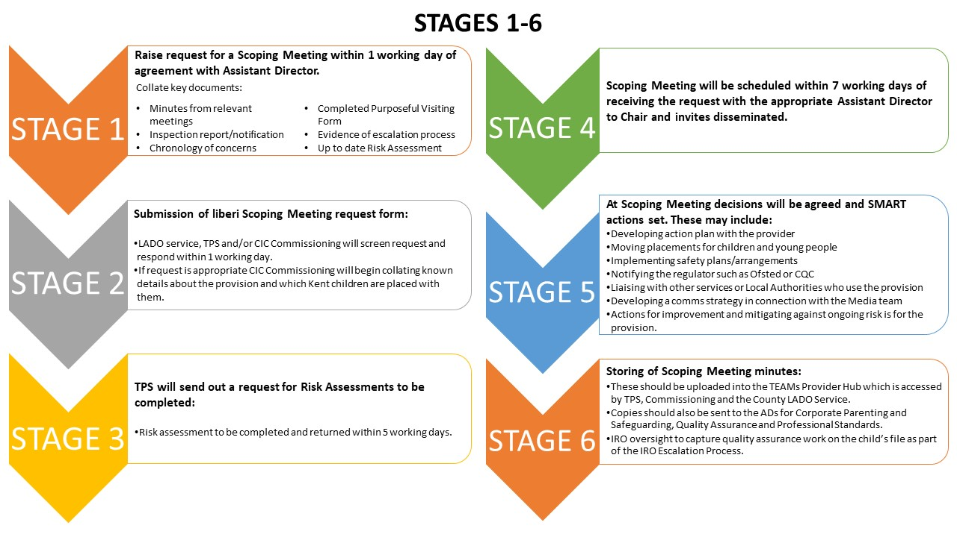

Purposeful visiting Form (example, form on Liberi)
Name and role of visiting professional | Date
Child or young person name | Time
Overview of visit | Venue

Visit within timescales? | Yes☐ ☐ No

Where was the child or young person seen? E.g., bedroom, lounge, taken out, etc.
If no, state reason

Was the child or young person seen alone?
If there were other people present during the visit, please state whom and job positions, if applicable
Communication

How are the staff communicating with the child or young person?

Are they using their preferred method of communication?

What is their preferred method of communication?

Is their preferred method of communication successful?

Do you have any identified areas of concern?

Visit record

What issues were discussed?

What is the child or young person’s views, wishes and feelings?

Observations of the child or young person, staff and environment?

How does the child or young person present; are they healthy, clean, happy?

Any non-compliance, engagement issues with the child or young person?

Any additional information? Such as activities they undertook since last visit

Analysis of the visit and the impact on the child or young person’s lived experience and care planning

What is working well?

What are you worried about?

What needs to happen?

Overview of setting or provision from the visit

Comment on rooms, environment, meals etc.

Any comments made by the children or young people about the staff or environment?

Is the recording of records up to date and available to review on visit? Please note the time they were last reviewed

Is medication being administered appropriately? If medication is being administered covertly e.g., put into the child’s food/drink is there the correct authorisation for this.
(Please ask to see the written evidence from the named medical practitioner if this is a medical decision.)

Reviewing of documents
Document name | Seen | Not seen
Individual care plan | ☐ | ☐
Daily logs | ☒ | ☐
Incident reports | ☐ | ☐
Medical logs | ☒ | ☐
Regulatory reports | ☐ | ☐
Risk assessment | ☐ | ☐
Visiting log | ☐ | ☐

Additional information
If you have seen the regulatory reports, please specify which reports and the quality of information

Any identified risk factors or vulnerabilities highlighted on this visit for either the child, young person or the provision?

If, as a result of the visit, the assessment concludes that the child or young person’s welfare is not adequately safeguarded and promoted by the placement, please record the next steps

Does it need to be escalated to your line manager?

Please refer to the children’s home regulation guidance where appropriate

Visiting professional’s signature

Date of signature

Risk assessment
**This form is to be completed when there are concerns regarding external placements or where the provider has received an inadequate Ofsted judgement.**
This risk analysis tool provides a framework for reviewing critical components of risk that have been highlighted as a concern within this provision. In completing this tool, you are asked to form a professional view (as you are likely to be one of the professionals that best knows this child/young person) and to identify, whether the risk directly impacts on them currently or is likely to impact on them in the future if not addressed. All risk assessments are an ongoing process, therefore there is an expectation that you will continue to have on-going oversight, where required, to ensure the needs and best interests of the child/young person is paramount. The emphasis is on the child’s safety and wellbeing, to ensure intervention, decision-making and the service provision meets the needs of the child/young person.
The feedback you provide through your risk analysis will inform relevant commissioning processes, strategic analysis of the provider and possible feedback to regulatory bodies such as OFSTED or the Care Quality Commission.
Completed by | Lead professional
Date of completion
Child or young person’s name
Child or young person’s date of birth

Placement information
Placement information | Placed with | Carers and agency
Placement Date: | Start: | End:

Assessment
Context of the reported risk of concern

Date and the agency/individual who provided concerning information

Relevant information contributing to the risk assessment

Individual risks identified for this child or young person

Known indicators of a pattern of cumulative harm, e.g., seclusion practices and physical interventions
Risk analysis

Risks should be described in a way that demonstrates what they mean for the child or young person and their vulnerability

Contextualised safeguarding risks identified for any other children or young people within the setting

Frequency of harm, knowledge or risk. Please consider the number of incidents that may have occurred over time and any knowledge of prior unreported incidents and evidence in logbooks and incident reports

Explanation of harm and risks from the provider, e.g., perceptions, expectations and setting culture

Classify the harm and risks. What are they and what evidence do you have?

Predicting the likelihood of harm from the risk identified, e.g., the impact on the child or young person’s development and wellbeing
Protective and mitigating factors
Factors which provide immediate safeguarding but may not reduce the overall risk

Factors which reduce the overall risk of harm for the child or young person and therefore influence the decision about intervention

If referring to interventions in place, please confirm that they have been verified and assessed as mitigating or reducing the identified risks, e.g., daily reports, waking night staff, regular review of safeguarding logs and care planning

Have additional safeguards been put in place which are reducing the risks? If so, please detail them

Identifying strengths and resources
Voice of the child or young person and professional observations

Please describe the lived experience for the child or young person in the context of the reported risk, such as use of physical interventions

Analysis of the child or young person’s views, how they were obtained and when

Child or young person’s understanding of the risk reported
Observations, e.g., physical appearance and behaviours

Child or young person’s network and advocacy to be considered where appropriate

Strength and resilience, e.g., coping mechanisms
Analysis

Does anything need to change for the child or young person to ensure the reduction of risk or harm?

Impact on the child or young person, such as how does it feel for them to live in this environment?

What does the child or young person want to happen?

Probability of harm or impact on the child or young person?

Estimated level of risk, e.g., does the child or young person reside here full-time or is it respite care only?

Appropriate interventions

Are the protective factors reducing the identified risks?

What is it you are doing to make this situation safer for the child or young person?
What is your plan?
What will tell you the child or young person is safe?

Signatures
Name | Job title | Date
Lead professional
Team manager
Service Manager

Risk Management Scoping Meeting
THIS DOCUMENT IS STRICTLY PRIVATE AND CONFIDENTIAL, DO NOT READ OR DISTRIBUTE IF YOU ARE NOT THE INTENDED RECIPIENT

Date |  | Time
Location |  | Chair

Attendees present

Apologies received

IMPORTANT - NOTE BEFORE
Due to confidentiality, no names for the children and young people in discussion have been included. They have been referred to as Child 1, Child 2 and so on with initials used at the beginning for first identification.

Introduction
Confidentiality statement to be read out:

In all investigations of organised or complex abuse, it is essential that staff involved maintain an elevated level of confidentiality in relation to the information in their possession without jeopardising the investigation or the welfare of the children involved. Subsequent information generated throughout the investigation should only be shared on a ‘need to know’ basis.
If necessary, any decisions may be implemented in conjunction with the procedures on Allegations against People who Work with Children.

In reconciling the difference between the standard of evidence required for child protection purposes and the standard required for criminal proceedings, emphasis must be given to the protection of the children as the prime consideration.

The investigation and enquiries must also address the racial, religious, cultural, language, sexual orientation and gender needs of the child, together with any special needs of the child arising from illness or disability.

(You can also add: This Scoping Meeting is being held due to the worries about this provision and the recent “Inadequate” rating for the residential provision at ________________ . . . . . . complete a summary here)
WE WILL
Use these below prompts where required:
- Assess the information known to date including the compliance notices and any themes arising from the risk assessments of individual children.
- Decide what further information is required at this stage.
- Arrange for its gathering.
- Undertake an initial mapping exercise to determine what interventions we need to utilise to ensure that the concerns regarding CP/Safeguarding have been addressed.
- Are we able to offer any interventions to the provision in the short, medium and long term?
- If the regulatory body re-visit the provision and make the decision to give notice - what plans do, we need to have in place for individual children? Consider any immediate protective action required.
The single and most important consideration is the safety and well-being of the child or children.

Discussions

SCOPING OF ALL CHILDREN AND YOUNG PEOPLE

Child 1 – INSERT INITIALS HERE

Review of risk assessment
Wishes and feelings of the child or young person
Views of others

Child 2 – INSERT INITIALS HERE

Review of risk assessment
Wishes and feelings of the child or young person
Views of others

ACTIONS AND AGREED TIMESCALES

Child 1 – INSERT INITIALS HERE

Child 2 – INSERT INITIALS HERE

TIMESCALE AGREED TO COMPLETE ALL INDICATED ACTIONS BY

Review date
Location
Time

Chair’s signature
Job title

See Allegations Against Person’s Who Work with Children Procedure

