Need to Know
Notifications
and Alerts
Name of Author: Amy Lawes
Name of Senior Manager Approving:
Hayley Bodiam
Date of Issue: January 2024
Date to be Reviewed: January 2025

Contents | Page
Introduction | 3
Policy Statement | 3
Procedure | 3
Category of incidents to be escalated to Area or Service Assistant Director as a Need to Know notification | 4
Category of incidents to be escalated via an Alert by Assistant Director to Safeguarding, Professional Standards and Quality Assurance Unit. | 5
Action to be taken by Safeguarding, Professional Standards and Quality Assurance Unit following the receipt of an Alert | 6
How to Complete and Need to Know Notification/Alert | 8
National Alerts | 9
Safeguarding Reviews | 11
Performance Monitoring of Alerts and its Relation to Wider District Risk Assessment Procedures | 12
Review and Updating Need to Know Notification/Alert | 12
Practice Consultation | 12
Appendices: | Page
Appendix A- Need to Know and Alert Procedure | 14
Appendix B- Need to Know: Notification/Alert Form | 15
Appendix C – National Alert Template | 18

Relevant Guidance
Revised Statutory Guidance concerning Children Who Run Away or Go Missing from Home or Care Department for Education January 2014.
Working Together to Safeguard Children 2018 (publishing.service.gov.uk)

Introduction
This policy sets out the expectations for Integrated Children's Services reporting significant concerns about children to senior managers. It aims to provide a clear process for enabling managerial accountability and supporting decision-making in respect of children and young people who have experienced significant harm or may have caused serious harm to others.

Policy Statement
The importance of sharing information and decision-making where there are incidents of concern should not be underestimated. It is fundamental for children where there is a significant concern to be reported to senior managers at the earliest opportunity. Alerting ensures a level of shared accountability, enhances knowledge and practice as well as enabling actions to be developed and implemented.
In addition, teams across Integrated Children’s Services need the opportunity to request practice advice regarding complex situations impacting on the welfare of children.

Procedure
It is the responsibility of managers and practitioners to ensure all incidents of concern involving children are reported to the relevant senior manager within Integrated Children's Services. This procedure has been designed to support staff to identify which children meet the criteria for reporting to a senior manager through the ‘Need to Know’ notification process and which children meet the criteria for an ‘Alert’ to the Safeguarding, Professional Standards and Quality Assurance Unit.
This procedure also applies to staff across Integrated Children's Services, including the Strengthening Independence Service (formally Disabled Children's and Young People's Service (DCYPS) and Care Leavers Service). Reporting ‘Need to Know’ notifications will be through the relevant operational and County Manager within those services, alongside the Safeguarding, Professional Standards and Quality Assurance Unit if criteria is met for an ‘Alert’.
NB: For children open to multiple Integrated Children’s Services (i.e., Children’s Social Work Team in addition to Youth Justice Team) any Need to Know notifications should be completed by the allocated Social Worker, unless the notification is linked to the need to Alert the Youth Justice Board (see below); when the Need to Know notification should be completed by the allocated Youth Justice Worker.
Diagram: Need to Know notification and Alerts procedure is outlined in Appendix A.

Category of incidents to be escalated to Area or Service Assistant Director as a Need to Know notification.

Serious incidents and significant harm are managed every day within districts. However, there are times when this needs to be escalated to senior managers within the service or the Area AD.

The categories set out below are not exhaustive and must not preclude the reporting of other incidents which are not outlined, which require Senior Management oversight in order to support with decision making and practice guidance. Using the Liberi/Core Plus electronic form, the Service Manager will use the following criteria and their professional judgment to immediately inform the Area Assistant Director of serious safeguarding incidents when:

A looked after child has died, whether or not abuse or neglect is known or suspected.
  - A child has died and there is known or suspected abuse and neglect
  - A child/young person is open to Integrated Children’s Services has suffered severe injury, and there is known or suspected abuse and neglect (severe injury may include brain, bone or bodily trauma caused by the non-accidental injury to a child or young person, by a parent or carer)
  - A child/young person is open to Integrated Children’s Services has suffered severe injury and the cause is known to be or suspected to be contextual/extra familial harm (serious injury may include large scale organised abuse and/or exploitation)

A child is open to Integrated Children’s Services who has attempted to or taken their life and/or there has been a serious and/or life-threatening incident of self-harm
  - A child has died and is open to the Youth Justice Service (YJS) or up to 20 calendar days following the end of YJS supervision
  - A child/young person is charged with committing one of the following notifiable incidents; attempted murder, murder/manslaughter, rape, grievous bodily harm or wounding with or without intent – section 18/20 and/or a terrorism related offence (NB: Section 18 which is to intentionally cause grievous bodily harm and Section 20, which is to cause GBH level injuries without the intention to cause such severe harm, OAPA 1861)
  - There has been a serious incident/accident or illness involving child/young person in a residential/foster placement/Safe Care Reception Centre (examples of incidents that are likely to be considered serious include a situation which requires significant Police involvement. A serious illness or accident would include matters such as broken bones, when a child loses consciousness or situation that require admittance to hospital for more than 24 hours or accident What Ofsted means by a serious incident )
  - A Kent Child with a significant and serious missing episode or significant and serious pattern of missing episodes (if a child is missing and subject to a Child Protection Plan, is a Child in Need, a Child in Care or currently known to the Safe Care Reception Centres and Unaccompanied Asylum Seeking Children’s social work teams, then a Need to Know notification must be completed where there is either a significant missing episode (48 hours or longer or may be a shorter period if the child is particularly vulnerable to abuse/exploitation etc) or a pattern of missing episodes. Likewise, a Need to Know notification should be completed for any Child in Care who is classified as an ‘unauthorised absence’ for 24 hours to notify Senior Management to consider actions.
  - There is complex abuse - organised or multiple incidents of abuse (children can experience organised, large-scale abuse or exploitation. This might involve being trafficked, internationally and/or locally for the purposes of sexual or criminal exploitation.
  - An incident that may spark local, national, media and/or political consideration (this might involve any incident as stated above which may be considered of interest to wider media and/or may have a particular political impact)

Category of incidents to be escalated via an Alert by Assistant Director to Safeguarding, Professional Standards and Quality Assurance Unit.
When an incident is exceptional, significant, serious and prolonged, an alert will be required to the Safeguarding, Professional Standards and Quality Assurance Unit. This would be agreed and forwarded on by the Service/Area Assistant Director. These significant and serious incidents may require further reporting through other national and/or local mechanisms. Therefore, within 48hrs of receiving a Need to Know notification, the Service/Area Assistant Director MUST inform the Safeguarding, Professional Standards and Quality Assurance Unit via an Alert when:
- A looked after child has died, whether or not abuse or neglect is known or suspected.
- It is known or suspected that a child has been abused or neglected and
  - The child dies or is seriously harmed in the local authority’s area; or
  - While normally resident in the local authority’s area, the child dies or is seriously harmed outside England.
- A child has died and is open to the Youth Justice Service (YJS) or up to 20 calendar days following the end of YJS supervision.
- A child/young person is charged with committing one of the following notifiable incidents; attempted murder, murder/manslaughter, rape, grievous bodily harm or wounding with or without intent – section 18/20 and/or a terrorism related offence.
- A child, who is subject to a Child Protection Plan or looked after, with a significant and serious missing episode or significant and serious pattern of missing episodes (significant and serious may mean where the child is considered to be at grave risk). NB: The need for a National Alert should be considered when a child subject to a CP Plan is missing.
- There has been a serious incident involving child/young person in a residential/foster placement/KCC unit.
- A Care Leaver has died before their 25th birthday.
In all other circumstances the Service/Area Assistant Director should use their professional judgement as to whether the information shared via the Need to Know notification needs to be shared with the Safeguarding, Professional Standards and Quality Assurance Unit
In addition, there may be circumstances where practice advice or support with guidance may be required and the alert process can be used for this. The service should always consult the Independent Reviewing Officer or Child Protection Chair before considering a safeguarding alert in this circumstance. Examples which may be appropriate for practice advice include:
- Repeated missing periods and/or concern about extrafamilial harm.
- Significant and complex mental health concerns.
- Significant risks to siblings where there are multiples services involved with different siblings,
- Longstanding concerns where an independent view may support planning moving forward
The level of concern would need to be significant and in some circumstances a Practice Consultation may be more appropriate.

Action to be taken by Safeguarding, Professional Standards and Quality Assurance Unit following the receipt of an Alert
A looked after child has died, whether or not abuse or neglect is known or suspected
The local authority must notify the Secretary of State and Ofsted (as cited in Working Together 2018).
This process will be led by the Principal Social Worker (within 5 working days) in consultation with the Assistant Director of Safeguarding, Professional Standards & Quality Assurance and Director of Integrated Children’s Services, who will be notified following the Alert being received by the Safeguarding, Professional Standards and Quality Assurance Unit.

It is known or suspected that a child has been abused or neglected and the child dies or is seriously harmed in the local authority’s area; or while normally resident in the local authority’s area, the child dies or is seriously harmed outside England.
The local authority must notify any events that meet the above criteria to Child Safeguarding Review Panel (as cited in Working Together 2023). The local authority should also report the event to the safeguarding partners in their area (and in other areas if appropriate).
When a child from another local authority, placed in Kent, suffers significant abuse or neglect and meets the criteria for a National Panel notification, the placing local authority will be invited to make a notification and confirm this within 24 hours. If this is not confirmed, Kent will make the notification.
This process will be led by the Principal Social Worker (within 5 working days) in consultation with the Director of Integrated Children’s Services, who will be notified following the Alert being received by the Safeguarding, Professional Standards and Quality Assurance Unit.
A child has died and is open to the Youth Justice Service (YJS) or up to 20 calendar days following the end of YJS supervision.
or
A child/young person is charged with committing one of the following notifiable incidents; attempted murder, murder/manslaughter, rape, grievous bodily harm or wounding with or without intent – section 18/20 and/or a terrorism related offence.
The above incidents must be notified to the Youth Justice Board within 24 hours of the charge being made or, in the case of the death of a child, the date the service became aware of that death (as cited in Serious incidents notification: standard operating procedures for YJSs, 2022). The notification must be sent to the Safeguarding Unit too.
This process will be led by the Assistant Director for Adolescents and Open Access, in consultation with the Director of Integrated Children’s Services, who will be notified following the Alert being received by the Safeguarding, Professional Standards and Quality Assurance Unit.

A child subject to a Child Protection plan and LAC with a significant and serious missing episode or significant and serious pattern of missing episodes. NB: The need for a National Alert (section 7) should be considered when a child subject to a CP Plan is missing.
National Alerts are issued on children (including unborn babies) who are subject to a Child Protection Plan who go missing from their Local Authority area.
This process will be led by the Service Manager within the Safeguarding, Professional Standards and Quality Assurance Unit who will request the allocated SW complete the necessary form (NATIONAL ALERT NOTIFICATION OF A MISSING CHILD) following being notified by the Alert.

There has been a serious child safeguarding incident which raises issues of importance in relation to the area (where there has been good practice, poor practice or where there have been ‘near miss’ events).
The Safeguarding partners (Kent Safeguarding Multi Agency Partnership) should be informed when there has been a serious child safeguarding incident which raises issues of importance in relation to the area. When a serious incident becomes known to the safeguarding partners, they must consider whether the case meets the criteria for a local review. This process will be led by the Principal Social Worker (within 5 working days) in consultation with the Director of Integrated Children’s Services, who will be notified following the Alert being received by the Safeguarding, Professional Standards and Quality Assurance Unit.
A Care Leaver has died before their 25th birthday
From January 2024 local authorities should notify the Secretary of State for Education and Ofsted of the death of a care leaver aged up to their 25th birthday as per the revisions to Working Together to Safeguard Children.
Notifications for care leaver deaths will allow the Department for Education to understand and learn more about what happened to make better informed policy decisions to prevent future deaths.
The process will be the same as for a Child Serious Incident Notification, via the
Child safeguarding incident notification system.

How to Complete a Need to Know Notification/Alert

The Need to Know/Alert form is available on Liberi. A flowchart of the process is shown below.

For alerts which are updates, copy forward and tick yes to the update question.

For Liberi guide see Appendix B.

National Alerts
National Alerts are issued on children (including unborn babies), who are subject to a Child Protection Plan or looked after children who go missing from their residing area.
Each National Alert notification should be subject to the simple threshold test outlined below:
Are the family really missing? - If they are known to be in a particular locality, but their address is not known, this does not constitute a National Alert.
How do you know the child/family is missing, and for how long? – A National Alert cannot be completed until the child has been missing for 3 weeks. However, key questions should be considered and answered first:
- Are the family temporarily absent/ missing from their address?
- Are they staying with family/friends or away on holiday?
- Do friends/neighbours/family believe that they are “missing”?
- Do any of the key agencies have any knowledge of the family’s whereabouts?
- Does the Police have any information?

Exceptional alerts
Exceptional alerts may be appropriate in the following circumstances and when all the threshold information above has been satisfied first:
- Children who have disappeared immediately before, during or immediately following a section 47 investigation of serious allegations of significant harm where Social Care considers that there is evidence of sufficient danger to justify a National Alert.
- Children on a Care Order who are deemed to be in danger because they have been abducted by a parent/individual who poses a significant risk of harm to the child and whose whereabouts are not known.
- Children accommodated following significant child protection concerns who are deemed to be in danger because they have been removed without notice by a parent/individual who poses a significant risk of harm to the child and whose whereabouts are not known.

Sending a National Alert
Given the child is subject to Child Protection procedures or is LAC, the level of risk will be categorised as medium or high. The level of risk will be clearly stated within the National Alert and should be aligned with the decision made by the police in accordance with the national decision model (NDM). The NDM is used by everyone in policing and therefore will ensure continuity of risk assessment across all local authorities.
The National Alert must identify if a media strategy has been considered or is necessary and appropriate, given a family’s right to privacy. If the media are going to be informed, an updated alert will need to be sent.
Consideration should be given to whether the child or their family has links to areas either within the UK or abroad. This should be clearly documented within the National Alert.

Updating National Alert
An alert update should be completed four weeks after an initial National Alert has been issued. Strategy Discussions regarding the missing child and planning regarding this would need to continue throughout the missing period until the child is found.
However, an alert update can be sent and distributed at any time. Each situation should be treated on a case-by-case basis. Examples an alert update should be sent may be the child/young person or unborn has been sighted/linked to a particular area or the level of risk has changed.
At a minimum, an alert update should continue to be sent every three months.

De-alerts
A de-alert should be completed and sent to the National Alerts Database in the following circumstances:
- If the child/young person or unborn has been located, physically seen, and is no longer classed as missing.
- If the child/young person or unborn passes away.
The de-alert should be sent within 3 working days of one of the circumstances being considered.
National Alerts are issued on children (including unborn babies) who are subject to a Child Protection Plan or are the subjects of formal inter-agency Child Protection plans and who go missing from their LA area. Each National Alert should be subject to the simple threshold test outlined below (see notification threshold).
The National Alerts notification system is from Child Protection Custodian to Child Protection Custodian (or Designated Officer). It should not simply be an administrative task. When issuing a National Alert, it is essential for an Alert to have already been raised through the Need to Know/Alert notification procedure.
The national child protection alerts system should NOT be used as a missing person alerts process for vulnerable adults, unaccompanied asylum seekers or Children in Care who go missing. However, in exceptional circumstances notifications of missing Children in Care can be issued, subject to the test below.

The Process to follow to Issue a National Alert
- Using the Liberi/Core Plus electronic form, the Service Manager will use the following criteria and their professional judgment to immediately inform the Area Assistant Director if a child if they are subject to a Child Protection Plan and meet the notification threshold below.
- Within 48hrs of receiving a Need to Know notification, the Area Assistant Director MUST inform the Safeguarding, Professional Standards and Quality Assurance Unit via an Alert using the Liberi/Core Plus electronic form if they agree that the notification threshold has been met. The Area Assistant Director must inform the allocated SW/TM that they have agreed that the notification threshold has been met and request that they complete the Notification form below in Appendix C and found on KPON - National Missing Alert template.
- Completed Notification Form should be sent to the Safeguarding Professional standards and Quality Assurance Service Manager by email to safeguardingunitalerts@kent.gov.uk. The Service Manager will quality assure the completed notification and send to Management Information (MIIntensiveEH&SocialCare@kent.gov.uk) so that it can be cascaded across the national Custodian/Designated officer list.

9. Safeguarding Reviews
The completion of an alert may be of local and national significance requiring a safeguarding a review of the learning and consideration for any recommendations.
For guidance on the different types of reviews and processes, please see ‘Guidance on Safeguarding Reviews for Children and Adults’ on KPON.

10. Performance Monitoring of Alerts and its Relation to Wider District Risk Assessment Procedures
On receipt of an Alert completed using the Liberi/Core Plus form, the Social Work Standards Officer will contact the PSW/ Service Manage Unit to discuss the content. If it is agreed the information contained within the Alert requires further reporting through other National and/or Local mechanisms, they will be raised immediately to the appropriate managers for action.
The Safeguarding Unit will review alert trends and themes and report on these on a triannual basis. Area Assistant Directors should review their Need to Know notifications and track local trends and themes.

11. Review and Updating Need to Know Notification/Alert
It is important to recognise that Alerts may need to be re-assessed by the allocated worker in the context of ongoing changes. On this basis, all Need to Know notifications and Alerts should be kept under continuous review and form part of the usual risk management process within teams.
Significant developments, which result in changes to the level of risk (such as an increase or reduction in risk, or perhaps resolution in relation to the risk), should be reflected in an updated Need to Know notification and/or Alert.

12. Practice Consultation
For Practice Guidance and Policy Support, Practitioners can contact safeguardingadmin@kent.gov.uk order to have a practice conversation with a Social Work Standards Officer. Request emails will normally be responded to within 3 working days, unless marked ‘urgent’, when they will be responded to within 24 hours. Children subject to CP plans and/or who are Looked After should always be discussed with either the CP Chair or IRO in the first instance. Any practice support will be recorded by the Social Work Standards Officer on the child’s electronic file.

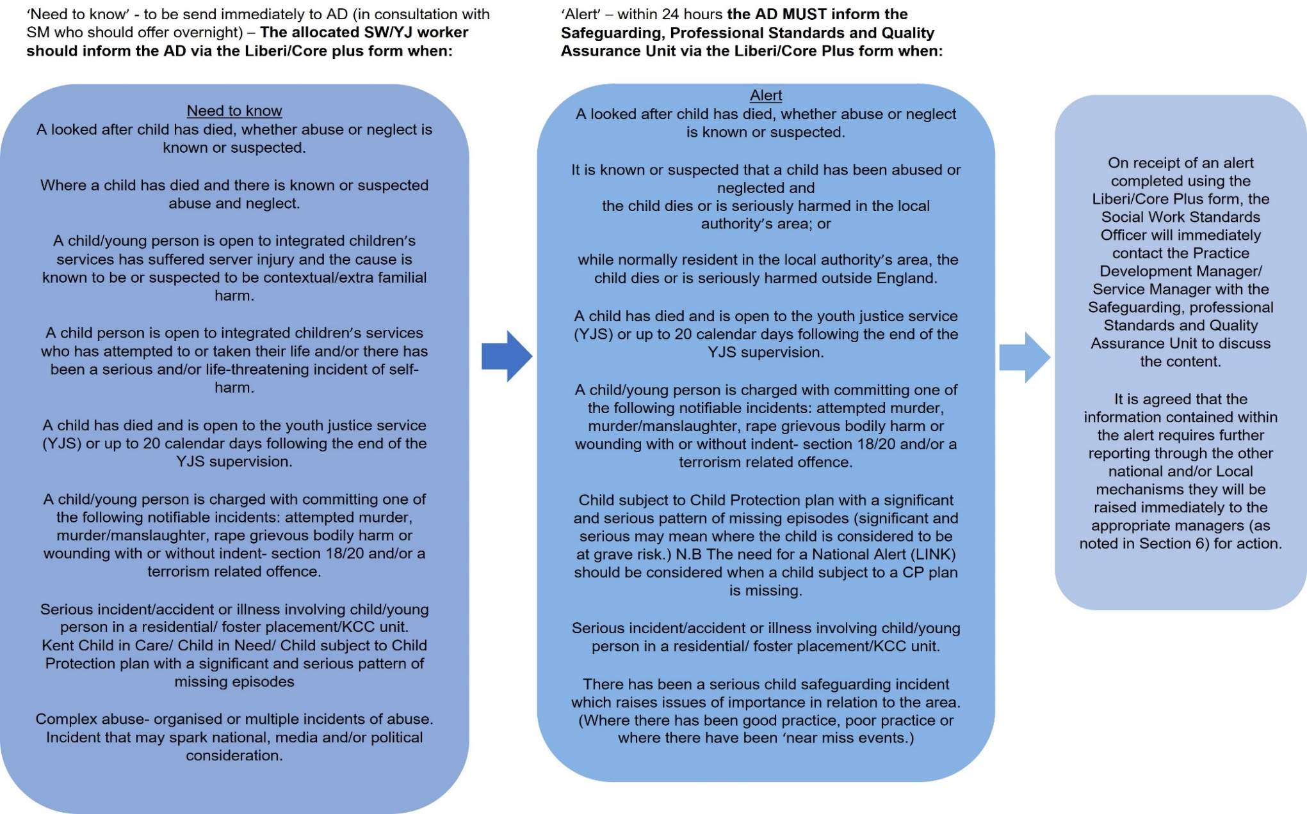

Appendix A: Need to Know and Alert Procedure

Appendix B- Need to Know: Notification/Alert Form

The Need to Know: Notification/Alert Form is now LIVE in Liberi and can be found in the Forms Tab of a child’s record.
The Form has the following four stages:
Stage 1 – Team Manager: To be started and completed by Team Manager and sent to Service Manager (NB: it is important to record the AD, Service Manager and Team Manager at this stage to ensure the form stages flow as required)

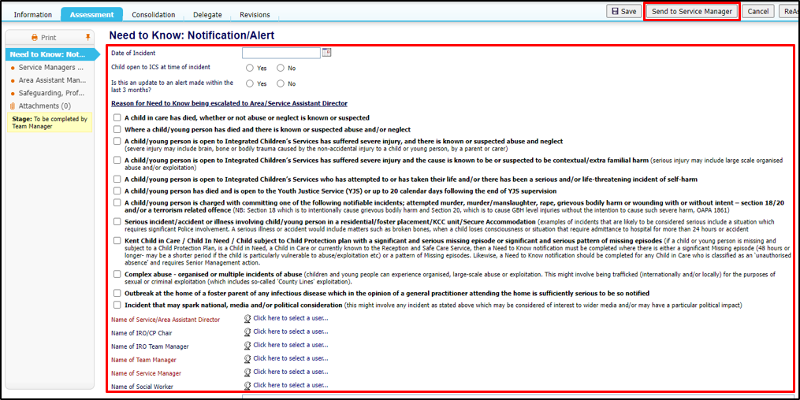

Stage 2 – Service Manager: The Service Manager receives the form in their Liberi Work Tray, adds Comments and sends to Assistant Director

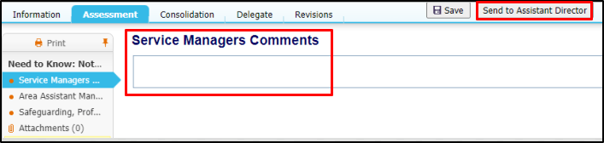

Stage 3 – Assistant Director: The Assistant Director receives the form in their Liberi Work Tray. Depending on decision made at this stage, the Form can either be finalised by the AD or completed with AD request(s) and sent to the Safeguarding Alert group tray (if escalation to the Safeguarding, Professional Standards and Quality and Assurance Unit required).

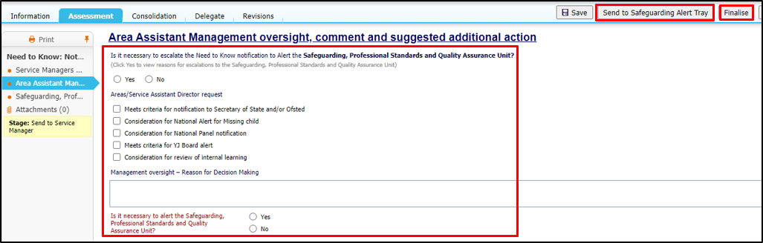

Stage 4 – Safeguarding Unit: The Safeguarding, Professional Standards and Quality and Assurance Unit receive the form in their Liberi group tray. Form is picked up from Safeguarding Alert group tray and Source of alert, response and necessity to escalate Alert through National and/or Local mechanisms recorded. Form is then reassigned to Safeguarding lead for finalisation

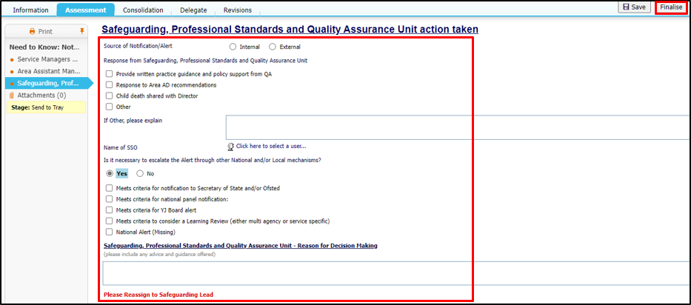

Once the form is finalised, the Team Manager, Service Manager, IROs and Social Worker (if entered in the User Chooser fields at Stage 1 of the form) will receive an alert in their Liberi Work Tray, advising of this. The form can be viewed via the Liberi Alert received. The Alert should then be completed to remove it from the Liberi Work Tray
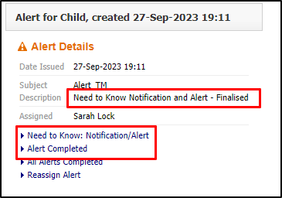

Appendix C – National Alert Template

NATIONAL ALERT
NOTIFICATION OF A MISSING CHILD

Rationale for de-alert including date the child/young person/unborn was found.

INITIAL ALERT ☐ DE-ALERT ☐
ALERT UPDATE ☐

PERSON COMPLETING ALERT
Name | Role | Phone | Email | Local authority

DATE ALERT SENT: Click or tap to enter a date.
RISK LEVEL (in accordance with Police National Decision Model NDM): Choose an item.
CP Category: Choose an item.

CHILD/YOUNG PERSON’S DETAILS
First name | Surname | DOB/EBB | Gender/assigned sex | Ethnicity

First Language
Provide details if interpreter is needed
Do they have a disability
If yes, provide more information

Home address
Postcode
Telephone number
Person(s) with PR Include any relevant information e.g., contact details, if they are safe individuals.

PHYSICAL DESCRIPTION
A brief physical description of the child/young person or mother if unborn, including any tattoos, scars, birthmarks, etc., and what they were wearing at the time of the disappearance. An up-to-date photograph should also be provided for initial alerts.

LAST KNOWN LOCATION
A brief explanation of the last known location where the child/young person, or mother if unborn, was sighted and details of who they were last seen with.

LINKED LOCATIONS
Stipulate any known areas/locations the child/young person or unborn has connections to and the nature of the connection. This should include the UK but also aboard.

REASON FOR ALERT
A brief explanation of why the alert has been sent and reason the child/young person or unborn is subject to a Child Protection Plan.

MEDIA INVOVLMENT
If there is media involvement, please provide further information.

PLAN
Outline the key steps being taken to locate the child/young person or unborn and any relevant information needed if they are located including any specific requests around how the child/family should be approached (if at all) if found.

IF THE CHILD/YOUNG PERSON IS LOCATED IN YOUR LOCAL AUTHORITY, PLEASE CONTACT THE BELOW

 | Local Authority | Police Force
Name
Designation
Tel number
Out of Hours

