Practice Guidance

Undertaking Effective Return Interviews

Name of Senior Manager Approving:
Dan Bride

Date of Issue: March 2023

Date to be Reviewed:
December 2024

Contents | Page
Starting the Missing Person Episode in Liberi | 3
Recording of Risk Factors within the Missing Person Episode | 4
Return Interviews | 4
What is the purpose of a return interview? | 4
When should a Return Interview be undertaken? | 5
What if a Return Interview is declined by the young person? | 6
What about children or young people who go missing before a Return Interview can take place? | 6
Absent from Placement without Authorisation | 7
Professional attitudes | 8
Where should a return Interview take place? | 8
Tools and Communication Styles | 8
Return Interview Prompt Sheet | 8
Push and Pull factors | 10
After the Return Interview | 11
The return interview and actions that follow from it | 11
CSE Toolkit/Trafficked Children Toolkit | 12
Leaflets | 12

Introduction:
Statutory Guidance on children who run away or go missing from home or care - January 2014 highlights that when a child goes missing or runs away they are at risk. Children may run away from a problem, such as abuse or neglect at home, or to somewhere they want to be. They may have been coerced to run away by someone else. There are particular concerns about children running away and the risks of sexual exploitation. Missing children can also be vulnerable to other forms of exploitation, to violent crime, gang exploitation, or to drug and alcohol misuse.
When a child goes missing Runaway and Missing From Home and Care (RMFHC) Protocol 2011 (under review) should be followed. This contains details of how the local authority works with the local police and other partners when children run away or go missing.
For children and young people who repeatedly going missing this should not be viewed as a normal pattern of behaviour. Repeat episodes of a child going missing can, for example, indicate sexual exploitation. If a child has run away discussions should be held with the child, their family (or carer), or both, to offer further support and guidance. Actions following earlier incidents should be reviewed and alternative strategies considered.
When a 16 or 17 year old runs away or goes missing they are no less vulnerable than younger children and are equally at risk, particularly of sexual exploitation and involvement with gangs.
Safe and well checks are carried out by the police as soon as possible after a child reported missing has been found. Their purpose is to check for any indications that the child has suffered harm, where and with whom they have been, and to give them an opportunity to disclose any offending by or against them.

Starting the Missing Person Episode in Liberi:
Liberi should be updated using the Missing Child – Kent CIN/CP or CLA Child Missing/Away from Placement without Authorisation
Missing Child - Kent CIN CP :
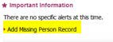

Child CLA Missing or Away from Placement without Authorisation:
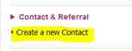

Recording of Risk Factors within the Missing Person Episode:
Risk Factors should be considered and recorded for any Missing Episode. These factors can also be updated when a child / young person is found as the risk factors may then have changed:
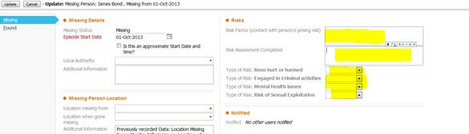

Return Interviews
What is a ‘return interview’?
The statutory guidance explains that a return interview is: ‘an in-depth interview and is best carried out by an independent person who is trained to carry out these interviews and is able to follow up any actions that emerge’. It states that in addition to police ‘safe and well checks’, local authorities should make sure young people ‘have the option of a return interview”, with the child/young person based on their individual needs.

What is the purpose of a return interview?
- Identify and deal with any harm the child has suffered either before they run away or while they are missing.
- Understand and address the reasons for running away.
- Help the child understand that they have options and provide them with information on how to stay safe if they run away again.
Return interviews provide an opportunity to place the child’s needs and experiences at the centre, gives them an opportunity to talk and to be listened to, and to have their feelings and experiences taken seriously.

When should a Return Interview be undertaken?
When a child is found, the child/ Young Person should be recorded as found within the Missing Person Episode in Liberi:

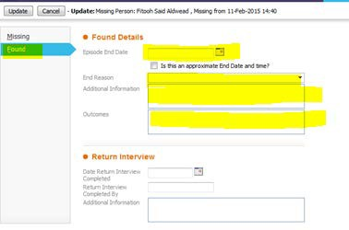
The child must be offered an independent return interview. For children not known/open to SCS, these will be undertaken by trained Early Help staff.
Statutory Guidance (pt. 32) says that a return interview should be carried out within 72 hours of the child returning to their home or care setting. This should be an in-depth interview and the Return Interview Form completed on Liberi:
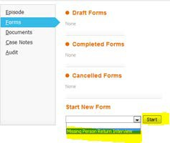
For children open to SCS, the return interview will normally be conducted by the child’s social worker and based on an individual assessment of need.
A case note should record the steps undertaken to arrange and plan the return interview:
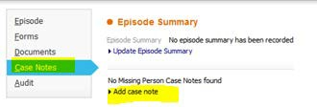
There may be occasions when it is felt that the allocated social worker should not conduct the return interview (for example, the child/young person requests it or the social worker has not yet developed a relationship with the child/young person) and it is assessed that a better outcome would be achieved by someone else conducting the return interview. Good practice states that the young person may be the best person to indicate who they would like to undertake the return interview.
A return interviews should be conducted for all children open to SCS whichever plan they may be on i.e. CIN; CP; Looked After Child. Return Interview training should be undertaken by any staff undertaking return interviews.
Some young people may go missing for short periods of time. The length of being missing does not necessarily equate with a lower level of risk. Each missing incident should be assessed and “push and pull factors” considered.

What if a Return Interview is declined by the young person?
There may be occasions when a young person chooses to decline a return interview.
In cases where a Return Interview has been offered but then subsequently refused i.e.: child/ Young Person spoken to and Return Interview booked but Child / young person declined the meeting or did not turn up, the Refused option in the Return Interview Form can be selected and mandatory questions only completed:
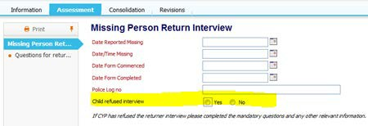
The actions being taken to try and engage with the young person should be outlined within the records. It may take them time to come forward and engage in the return interview.
It is important that children and young people are helped to understand the purpose of the return interview and social work communication skills and tools are used to communicate effectively with them.

What about children or young people who go missing before a Return Interview can take place?
Some young people may go missing again before a return interview has taken place. For example, they may have returned for a short period and gone missing again within 72 hours.
The efforts to arrange the return interview should be recorded noting the reasons why the return interview did not take place i.e. child has gone missing again.
When the return interview does take place it should consider all the episodes the young person has gone missing from when the return interview was originally planned and not just the latest incident.
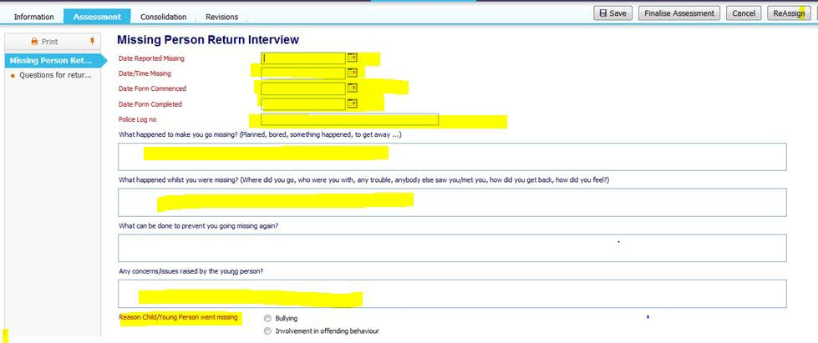
The Return Interview Form for each Episode can be completed with mandatory questions only – with an explanation in the free text box to the reasons why a full Return Interview has not been possible and reference to the next Return Interview form for full details.

Absent from Placement without Authorisation:
Absent from Placement without Authorisation should be considered alongside any missing episodes for Looked after Children. Children / Young People who are absent from placement without authorisation maybe equally as vulnerable, therefore a risk assessment should be completed, and a return interview also considered if appropriate.
The Missing Status can be updated from Missing to Absent from Placement without Authorisation within the same Missing Person Episode, whenever a Child / Young Person has not returned to their Placement but their whereabouts is known:
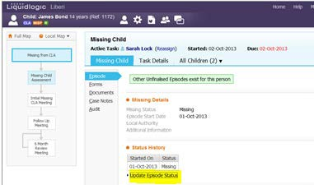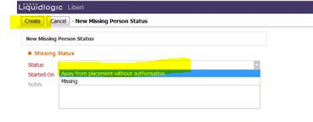

Professional attitudes
When a child is found, the attitude of professionals towards a child who has been missing can have a big impact on how they will engage with subsequent investigations and protection planning. Consideration to the most appropriate person to undertake the return interview must be given as a supportive approach, actively listening and responding to a child’s needs, will have a greater chance of preventing the child from going missing again and safeguarding them against other risks.

Where should a return Interview take place?
The return interview should be held in a place the child feels safe and a neutral place considered. The interview provides an opportunity to hear from the child about why they went missing and to understand the risks and issues faced by the child while missing. The need for persistence and building up the relationship with the child/young person will facilitate achieving the best information.

Tools and Communication Styles
Consideration should be given about the most appropriate way to conduct the return interview including the child’s age, understanding and development. Tools such as the “Blob Tree”; Flip Chart journey or Focus Cards, for example, could be used to help the child/young person share with you why they went missing, what happened and how they returned.

Return Interview Prompt Sheet
The Return Interviewer Prompt Sheet (KSCB) can be used to engage with the young person. It is not intended to be a list of questions to ask but a prompt sheet to encourage dialogue. Suggestions for areas to cover include:
Does the young person know the reasons why they ran away? What are the key Push and Pull Factors?
- Was this the first time the young person has run away or has this happened before?
- Did the young person run away alone or with others?
- What caused them to run away?
- Did they try and speak to family or friends before running away?
- Did they try and speak to an agency or professional before running away?
- Are they aware of a trigger for them to run, e.g. were they running away from something or running to something?
- Does this trigger still exist?
Events during missing episode (if appropriate)
- Where did the young person stay?
- Who were they with?
- How did they get food, washed, clothing, etc.?
- Did they get help from anyone whilst they were missing?
- How long did they stay away for?
- What led them to return or be found?
Safeguarding
- Did the young person feel scared at any time for their own safety or the safety of others? Were they harmed in any way?
- Did they need any medical help at any time and if so did they get this and where from?
- Did they feel pressurised or bullied into doing things they were not happy about?
- Did they offend or be a victim of crime whilst they were away?
What next:
- Do the things that caused the young person to run away still exist?
- What support do you need now to help prevent you from running away again?
- Would this have helped you if you knew about any support you could get before you ran away?

Push and Pull factors
The return interview should not be conducted in isolation and include information known about the child and their circumstances. It should also consider any episodes of away from placement without authorisation and previous missing episodes. Some children and young people go missing because they are running from something or being drawn to something.
Push and Pull factors should be considered when children run away or go missing.
Push Factors may include:
- Being bullied, threatened, abused (including through social media)
- Drug/alcohol use within the family or by the young person
- Being let down by “trusted” adults.
- Lack of friends/peer relationships.
- Living with domestic violence.
- Homelessness/sofa surfing
- Sibling difficulties (older sibling involved with CSE).
- Associating with older adults (or young people).
- Being alienated from family or community.
- Looked after child.
- Friendships/living with other young people that are victims of CSE.
- Offending behaviour/criminality.
- Mental health issues.
- History of previous abuse.
- Peer violence.
Pull Factors may include:
- Meeting someone who thinks they are special.
- Being taken to clubs or adult venues.
- Receiving alcohol, drugs, money or gifts.
- Being part of an alternative scene, e.g. criminal gang or music scene.
- Being liked/accepted.
- Being offered somewhere to stay with no/different rules.
- Opportunity for new adventures.
- The thrill from doing something risky or forbidden

After the Return Interview
Once the Return Interview Form has been completed in Liberi, the Missing Person Episode can be finalised:
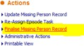
The return interview should not be an end in itself but an opportunity to assess what intervention is required to support the child/young person.

The return interview and actions that follow from it should:
- Identify and deal with any harm the child has suffered – including harm that might not have already been disclosed as part of the “safe and well check” – either before they ran away or whilst missing.
- Understand and try to address the reasons why the child ran away.
- Help the child feel safe and understand that they have options to prevent repeat instances of them running away.
- Provide them with information on how to stay safe if they choose to run away again, including helpline numbers.
There should be close liaison with the police (Missing person’s Liaison Officers) and other agencies following the safe and well check and return interview to build up a comprehensive picture of why the child went missing; to understand what happened while they were missing; to understand who they were with when they were missing and found; and, what support they require upon returning to home or their care placement.
The response of care givers should also be considered including, for example, foster carers and their role in supporting the young person not to go missing.
Return interviews may lead to the identification of abuse, neglect or exploitation for an individual child or for a number of children.

CSE Toolkit/Trafficked Children Toolkit
Consideration should be given to completion of the CSE Toolkit CSE Toolkit and/or the Kent and Medway Safeguarding Trafficked Children Toolkit 2014.
If a child has run away discussion should be held with the child, their family or both, to offer support and guidance. Actions following earlier incidents should be reviewed and alternative strategies considered. For looked after children, discussion should also take place with their carers including their role in preventing the child running away and their response and support for the child upon their return.
Details of the completed return interview forms will be shared with KSCB who will forward to the Police.

Leaflets
See CSE leaflets “Child sexual exploitation” and “Are you worried about a relationship” (once finalised by KSCB)
See ‘When your child is Missing - a guide for parents and Carers’ and “Thinking of Running Away” – KSCB

