Child and Family Assessment Cancellation Guidance

Author: Christine Stanbridge

Name of Senior Manager approving: Gavin Swann

Date of Issue: December 2023

Date for review: July 2024

Child and Family Assessment Cancellation Guidance

This guidance sets out the procedure for cancelling Child and Family Assessments.

Contents | Page
Purpose | 3
Principles | 3
Criteria for cancelled assessments | 3
Process | 4
Timescales | 5
Cancellation approval | 5

This guidance sets out the procedure for cancelling Child and Family assessments.

Purpose

The purpose of this practice guidance is to establish the agreed process for cancelling Child and Family Assessments (C&F assessments) and subsequent actions for children across different services within Integrated Children’s Services.

It is essential KCC Children’s Social Care have a consistent, measured approach when children are referred into Integrated Children’s Services, they are provided with the correct service to ensure effective transition points that reduce drift and delay for children.

Principles

All new referrals for children and young people who progress to a C&F assessment have been subject to an appropriate threshold application and therefore, the decision to cancel a C&F assessment should not be taken likely.

Cancelling C&F assessments supersedes previously made decisions. The authority to cancel C&F assessments is held at Service Manager Level.

C&F assessments should not be cancelled unless there are specific reasons to do so, and the rationale is evidenced via Management Oversight, as to why the child no longer achieves threshold, in conjunction with the specific reason within the cancelled assessments drop down list on Liberi.

Cancelling C&F assessments should always be concluded within a timely manner.

Any further actions recommended because of cancelling a C&F assessment should be progressed in a timely manner, such as a step across to Early Help.

Families must be informed of the decision to cancel a C&F assessment and any further actions unless there is a specific reason to not do so outlined within the Management Oversight.

If the child is seen, it is recommended C&F assessment must be completed where there is consent.

Criteria for Cancelled C&F Assessments

All Teams
Should a C&F assessment need to be cancelled which is not outlined on the list, below, it should be discussed through appropriate line management.

- No consent and threshold not met for strategy discussion.
- No consent and initial strategy meeting held, and threshold not met for s.47.
- Parents agreed to step across to EH.
- Parents agreed to continue receiving a service from EH.
- After further enquiries, additional information indicates the threshold for C&F is not met.
- Child/Young person not ordinarily resident in Kent
- Child/Young Person from Other Local Authority (OLA) or on a plan to another Local Authority
- Pregnancy not progressing.
- Child has died.
- Young Person is already 18.
- The most recent plans (safety, moving forward plan or other) is being adhered to and there are no new risks.
- Assessment opened in error.
- Assessment automatically generated but not needed (for example following s.47 where an assessment has been completed in the past twelve weeks.
- Assessment not required for sibling.
- Cancelled by Referrer. C&F assessment completed recently.
- Superseded by ICPC Report (There must be a C&F but if there is a C&F, completed in the previous twelve weeks, an updating assessment can be cancelled)
- The Service Manager agrees the family’s circumstance remained as detailed in most recent assessment.
- Strengthening Independence Service - screening determined that criteria of severe and profound disability not met.
- Strengthening Independence Service - no safeguarding/welfare concerns raised in referral and parent no longer wishes to proceed with assessment.
- Other please specify.

Process

Social Worker

If a C&F assessment is allocated to a Social Worker, and they conclude, following further enquiries that threshold for a C&F assessment is no longer met they are to discuss with their line manager. This conversation should not wait until formal supervision. The Social Worker should keep the family up to date of any changes throughout the process.

Team Manager

The Team Manager is responsible for recording the cancellation discussion with the Social Worker and recording their rationale within a case note on Liberi as Management Oversight.

When the Team Manager receives the C&F Assessment and if they agree to cancel it, the Team Manager should select a reason for cancellation from this guidance and copy and paste this into the Comments field and reassign the C&F Assessment Pathway to the Service Manager. (Liberi will be updated with the drop-downs detailed p4 but in the interim, please use this method). The Team Manager should not cancel the assessment. The Team Manager will ensure the case file is fully updated prior to reassigning this task to the Service Manager.

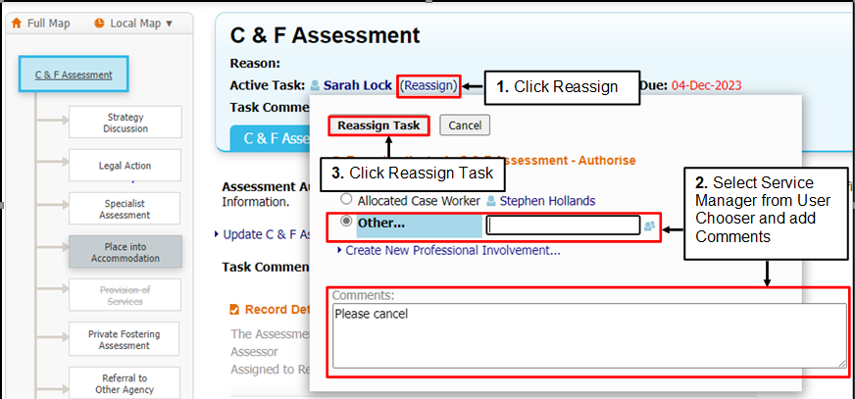

Service Manager

The Service Manager will then receive the task in their work tray and can click on the Assessment to cancel it, adding the reason in the Cancellation Reason text box from this guidance p4.
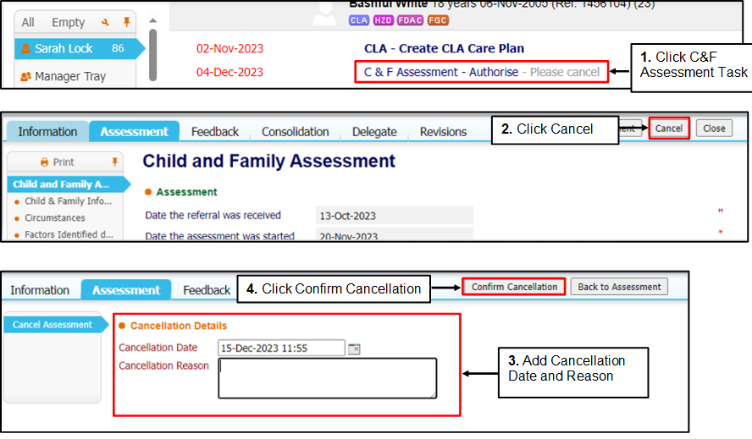

Within the cancellation reason box, the Service Manager should also record that they have read all relevant information and record whether they agree/disagree with the request and rationale. They should then confirm the cancellation. If the Service Manager disagrees with the decision to cancel the assessment, they should add a case note under Management Oversight explaining why the assessment should be completed and reassign the task back to the Social Worker for completion.

Timescales

All C&F assessment cancellations should be completed in full within 10 days of the referral. To ensure this can happen, Team Managers should initiate the C&F assessment cancellation process as soon as they have the information. Service Managers should then review and complete the cancellation within 48 hours.
However, there may be exceptional circumstances for example where children or parents cannot be located, and a C&F assessment may need to be open for longer before cancellation is agreed by the Service Manager. These circumstances need to be evidenced in a Management Oversight case note and be made on a case by case basis.

Cancellation Approval

All children and young people who have a C&F assessment cancelled should have the following actions taken:
- Social Worker/Team Manager to communicate with the family and relevant professionals to inform them of the outcome.
- Chronology to be updated.
- Case Summary to be updated.

If the child/young person is stepped across to Early Help, the child’s/young person’s record should be closed when all outstanding actions have been completed and approval authorised to step across to Early Help. See Practice Guidance Handbook for Early Help. Kent Childcare Proceduresonline.com/contents

