Table of Contents
1. Introduction 1
2. Purpose and Scope 1
3. Performance Management in Summary 2
4. Quality Assurance in Summary 2
5. Outcome and Success Measures 5

1. Introduction
This document sets out the Quality Assurance and Performance Management Framework for Multi Agency Child Exploitation (MACE) arrangements in Lincolnshire to ensure there is a clear and succinct approach to understanding how well our arrangements are working, checking the impact of services for children, and learning from what we find to guide our improvement actions.

2. Purpose and Scope
The primary purpose of this framework is to set out clear expectations of MACE to provide support, guidance, and the tools with which to understand how MACE can operate successfully. In turn, this process will support continuous sustained improvements to services; ultimately achieving better outcomes for children, young people, parents, and families across Lincolnshire.

The framework will enable services to be jointly accountable for quality, performance, and impact; allowing any other person or organisation to see and understand how we can work together to improve outcomes for children and young people, and how they can contribute. In a continuously improving system, what we identify from interrogating data and providing intelligence must be tested out in practice to truly assure ourselves of the quality and impact of work across the system that aims to improve outcomes for children, young people, and families.

The framework sets out how performance management will operate across the partnership in Lincolnshire. A systems approach to performance management designed to ensure that all stakeholders are fully informed and can robustly engage in support, challenge, and oversight of MACE. The below graph demonstrates how information from operational weekly MACE feeds up to senior managements oversight in the CEM and MACE sub-group:

To be effective, this Quality Assurance and Performance Management Framework includes:

- Cycles for the regular reporting and analysis of comprehensive, accurate and reliable performance data,
- A single approach to assuring data quality, beginning with a practitioner understanding of key data and feeding up to assurance reporting for Senior Leadership Team and Members, ensuring appropriate familiarity with data and KPIs with the aim of improving practice,
- Clear monitoring and quality assurance arrangements that aim to build the competence and confidence of staff at all levels to know what ‘good’ looks like,
- How we will use the outcomes of performance analysis and reporting, monitoring, case audits, complaints, Rapid Reviews/Local Child Safeguarding Practice Reviews/ National Child Safeguarding Practice Reviews and multi-agency audits to drive service improvements, closing the gap between evaluation, learning and the actions we take as a result,
- Staff training and development activities to ensure ownership and understanding of quality assurance and performance management by staff at all levels across the organisations,
- An immediate response to identified concerns for children's safeguarding or welfare.

3. Performance Management in Summary
Performance management is everybody's business. It is about improving outcomes for our children, young people, and their families. It means taking action in response to actual performance at an individual, team, service, department, corporate, or community level.

All staff and managers are responsible for their own work and their contribution to the work of their team and service, including performance management and quality assurance. Managers have additional responsibilities to understand, monitor, and address performance issues within their service area, team, and with individual staff members. Through implementing this framework, all managers will be equipped with the skills, knowledge, and tools to access, understand, interpret, and use performance and quality assurance information.

Lincolnshire’s performance management arrangements will enable managers to:

- Use performance data e.g. Power BI to help maintain, develop and improve services by responding to identified needs,
- Understand the direction of travel, decide where to target action and evaluate the impact of these actions,
- Identify trends and variances so that early action can be taken,
- Hold services and individuals to account for their contribution to improving outcomes for children and young people,
- Forecast and predict future issues and needs, informing decisions about where to deploy staff and resources.

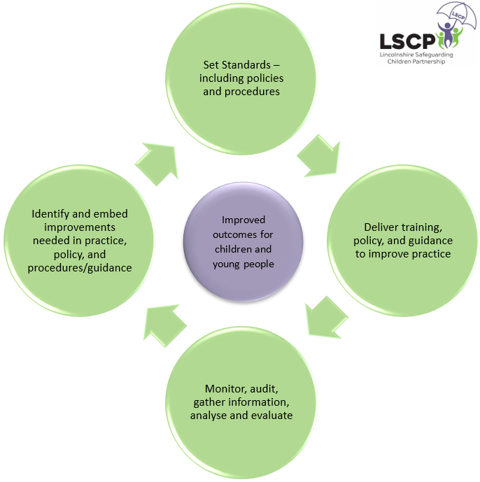
4. Quality Assurance in Summary
The Quality Assurance Framework for MACE across Lincolnshire ensures all activities are carried out to the highest quality. It aims to improve our understanding of whether we are supporting the right children, in the right way, at the right time, to check if we are making a difference to their lives and to identify areas where improvements need to be made. The framework is designed to support a journey of continuous improvement through a strong focus on ensuring the learning from quality assurance informs and shapes our daily practice.

Framework Cycle | Outcome | What we do | How we measure
Set Standards – including policies and procedures | Our processes and tools aid practice rather than drive practice. | - Operational processes and procedures  - Risk and interventions document  - CE screening tool and guidance  - Regional CE Standards  - Best practice guidance – including disruption national and local guidance/toolkits | - Data Reports  - Audits activity
Deliver training, policy, and guidance to improve practice | Our training, policies and procedures promote a greater understanding of the risks and vulnerabilities of children experiencing (or at risk of) exploitation.  Practitioners say the training and guidance equips them sufficiently to support children experiencing (or who are at risk of experiencing) exploitation.  All key stakeholders are engaged in how to promote the safety of children experiencing (or at risk of) exploitation.  The purpose and function of Operational MACE is understood along with an understanding of what needs to happen to disrupt exploitation in the community. | - LSCP training pathways  - LSCP policies and procedures  - In house agency training  - Sharing best practice – communication  - Campaigns and wider communication – i.e. social media to raise the profile  - Guidance to parents/carers  - Stay Safe Partnership (YP)  - Intervention tools & resources  - Dedicated MACE training for core panel members | - Training records for multi-agency training – including evaluation forms  - Audit activity  - Stakeholder engagement survey  - Policy Impact Assessments
Monitor, audit, gather information, analyse and evaluate | We understand the processes and rationale which contributes to the identification and disruption of exploitation. This includes:  - Understanding from practitioners why they have completed CE Screening tools, how they identify the concerns, and who do they consult,  - What steps are taken to safeguard the child during the referral process,  - Where do the concerns come from – observed behaviours, intelligence, mapping, disclosures,  - Where does practitioner knowledge on CE come from.  We collect and analyse data to build a multi-agency picture of exploitation in Lincolnshire and monitor performance.  Our data sets are amalgamated form across the partnership to build a clear picture of prevalence.  Analytical reports are shared across the partnership to support frontline teams in safeguarding and disrupting against exploitation. | - LSCP Data Analyst appointed  - Children’s Society – missing children audit tool  - Meetings and joint working with networks  - Data sharing in terms of data collection and analysis tools  - Case studies (what tools do we have specific to CE/Missing) looking at positive practice  - Use of ‘mapping’ tools and approaches  - County lines vulnerability tracker  - LSCP Performance Scorecard | - Attendance and MACE action tracking  - Return Home Interview and Missing Episodes Meetings (3 in 90) are tracked  - Multi-agency audits  - Practitioner feedback/survey – those referring to MACE  - Wider stakeholder feedback/survey  - Data and performance reports
Identify and embed improvements needed in practice, policy, and procedures/guidance | Improvements are identified through robust quality assurance processes including a range of qualitative and quantitative sources.  Improvements and developments draw on current research and best practice guidance.  The LSCP is assured that improvements and developments are embedded fully and effectively. | - Policy impact assessments  - Operational CEM Steering Group & Strategic CEM Sub-Group  - Data and live reporting  - Clear lines of accountability  - Maintain a communication strategy to disseminate information across the partnership  - Active monitoring of action plans – LSCP | - CEM Development Plan  - LSCP Performance Scorecard Action Tracker

5. Outcome and Success Measures
- A measurable reduction in the prevalence and impact of sexual and criminal child exploitation in Lincolnshire.
- A measurable increase in the identification and disruption of child exploitation.
- A measurable balance of referrals to MACE being made across the partnership.
- Ensure all cases referred and progressed within MACE are discussed in a timely manner.
- Ensure all actions identified within the MACE arena are completed in a timely manner.
- Measurable outcomes to ensure the focus in MACE is on disruption.

The MACE Outcomes Report app is available via the following link – MACE Outcomes Report - Power BI

Access to this app is restricted which is rigorously monitored and managed by the Operation CEM Steering Group. Access can be requested to the app via the e-mail address - LSCP@lincolnshire.gov.uk

This report focuses on the monitoring of performance, KPIs, attendance and the status of actions amongst many other areas.

This report is reviewed at every Operational CEM Steering Group Meeting and Strategic CEM Sub-Group to ensure all senior representatives from each agency have oversight and ownership of this data.

