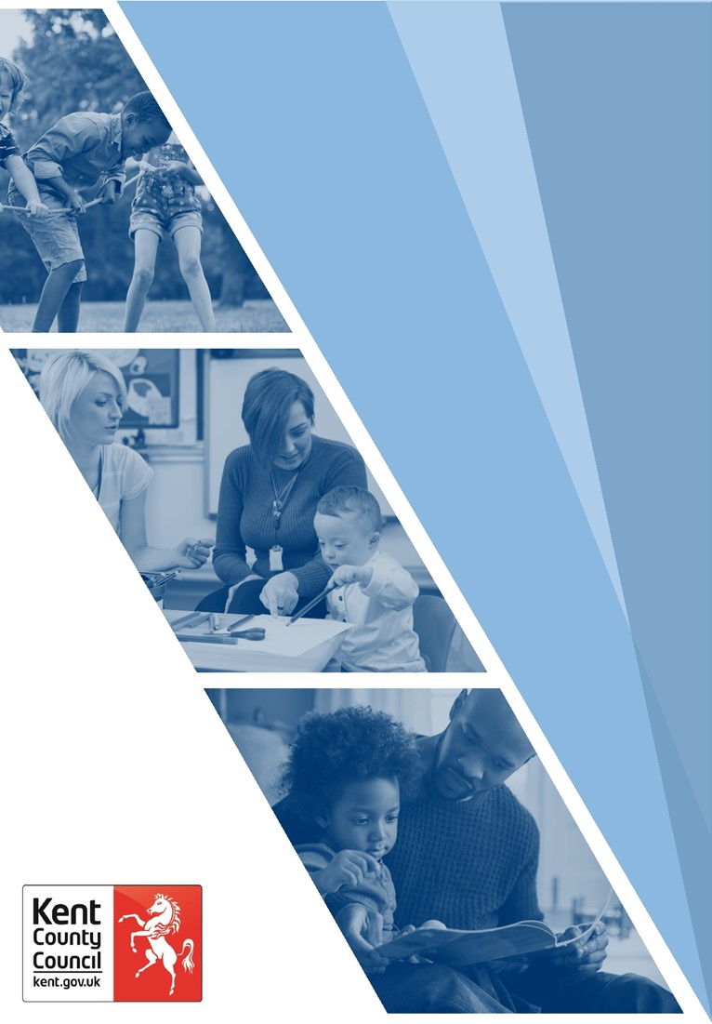 **Guidance for the use of Case Summaries, Chronologies and Genograms**

**Name of Author: Marie Boniface**

**Approved by: Hayley Bodiam**

**Date of Issue: August 2023**

**Date to be Reviewed: August 2026**

|  |  |
| --- | --- |
| Contents | Page |
| Case Summaries | 3 |
| What should a Case Summary include? | 3 |
| Suggested Case Summary Template | 4 |
| Case Summary Example | 4 |
| Recording Case Summaries | 5 |
| Chronologies | 6 |
| Definition of a Chronology | 6 |
| The Importance of Chronologies | 6 |
| When is a Chronology Required? | 7 |
| What should a Chronology Include? | 7 |
| Core elements of a Chronology | 8 |
| How can a Chronology support your Practice? | 9 |
| Recording Chronologies | 11 |
| Genograms | 12 |
| Top Tips for creating a Genogram. | 13 |
| Cultural Genograms | 15 |
| What are Cultural Genograms? | 16 |
| Why are Cultural Genograms needed? | 16 |
| Theoretical underpinnings of a Cultural Genogram | 17 |
| How to develop a Cultural Genogram | 17 |
| How can I evidence this work on the child/young person/young adult’s file? | 18 |
| Good Practice points | 18 |
| GenoPro | 19 |
| GenoPro – Step by Step Guide | 20 |

# Case Summaries

## What should a Case Summary include?

The case summary should provide the reader with an outline of the history of involvement with Children’s Services, the reasons for current involvement and the purpose of that involvement. It should also include any crucial information and/or key safety features to be noted by the reader - examples of these might include people within the friends/family network who should not be having any contact with the child/young person due to the risks they pose, or specific reference to the safety plan (and where this document can be located) or issues with regard to payments from Children’s Services. The case summary recording should provide a succinct summary of significant information about the child or young person and should also consider the most recent plan, next steps, family progress, past harm and risk alongside family strengths and safety. Within the case summary, it should note how well the child, young person and family are working towards safe outcomes and ensure that the child’s views or young person’s views, wishes and feelings and current lived experiences are captured.

All files should include a case summary and this should be completed on the day of allocation – initially using information from the referral and then updated following the assessment as more in-depth information is gained. Case summaries must be updated as an absolute minimum every three months or following a significant incident. Additionally, the case summary should be updated upon transfer to another worker or team or prior to closure and should always include the final agreed plan. The updated case summary should not just be the adding an extra paragraph, as this would make the case summary into a chronology rather than a summary. Instead, it should be an updated version of the child or young person’s circumstances. However, some content would need to remain in every case summary, such as the reasons why the child or young person became a Child in Care, when and why the child or young person became subject to a Child Protection Plan. The summary can help to ensure continuity and is an important source of information for colleagues and supervisors in the absence of the case holder.

The case summary should be written to the child or young person and directly related to the aims and objectives set out in the child or young person’s plan and can be a useful tool in setting out the tasks necessary to achieve the objectives. When recording is pitched to the child or young person’s age and understanding it can keep language sensitive and warm. When practitioners break down information and imagine they are having a direct conversation with the child or young person, they remove professional jargon and best explain why decisions and/or plans were made. This is particularly important if the child or young person decides to gain access to their records when they become adults. Completing, or sharing a case summary with a family offers an opportunity to reflect on progress over the period covered by the summary and discuss both achievements and difficulties. It should also assist the practitioner with an opportunity to reflect on the effectiveness of interventions and review progress towards agreed goals.

## Suggested Case Summary Template:

* Personal information to build a picture of the child, such as their identity, culture, hobbies. Not just a list but what this means for them.
* Case status - e.g. Early Help Case, Child in Care, Child in Need, Child Protection. To include most recent decision and dates.
* Significant information - including any information the Front Door Service or Out of Hours would need to know.
* What are the concerns (including past harm and risk)?
* What is working well (including existing strengths and safety)?
* The voice of the child or young person; how would they describe themself?
* Most recent agreed plan, progress, and contingency plan.
* Professionals involved.
* Significant contact details.
* Concentrated on the individual child (rather than on the family or sibling(s)) so that it is clear about their lived experience.

## Case Summary Example

|  |
| --- |
| Case Summary Example |
| A picture of Ndéla Fayen  Name: Ndéla Rae (pronounced na-dela r-ay)  Date of birth: 17/09/2008  Ndéla, you told me that you were born in Helsinki, moved to Luxembourg, then to Brussels and finally to Kent. Your mother is from Finland, and your father is from Senegal. We have talked lots about your identity and culture and you have said that although this can feel confusing at times, you are proud to feel ‘like a citizen of the world’. You love reading and play football at school. Your friends mean a lot to you. You do not live with Mum and Dad at the moment. You do not have any brothers or sisters. You attend Ashford School. You love living with your auntie and uncle Yolande and Christian. You feel safe with them.  Case status - Ndéla you are working with me (your Early Help Worker Jemima Lervik) at the moment after previous working with your Social Worker Raul Limington until the start of March 2023. We referred to you as a ‘Child in Need’ because you have been living in a home where there was domestic abuse by your mum towards your dad. Your dad also has some physical problems and has been diagnosed with depression and anxiety. Now that we have found a safe home for you to stay in, we have made the decision to move you to Early Help for ongoing support. This took place on 7th April 2023.  Ndéla, you have had a difficult time and sadly you have been sexual abused as a child. You are now safe, and we are working with you to get the help you have asked for. We are still worried about you sometimes and talk to you about this. We worry when you go missing from home and school but are pleased that this is happening less now that you feel safe where you live. We still have worries about some of your friends and think that they may be taking advantage of you by asking you to buy them alcohol and pay for everything. We are worried that when you have been drinking alcohol with your friends, it affects your judgement and the way you make decisions and we are going to work with you around this.  Ndéla we are so pleased with the progress you have made. Together we have made a plan to try to stop you from feeling like you have to go missing and to help you and professionals when you do. We call this a missing response plan and I have saved it in your documents and given you a copy. You have agreed to let Yolande and Christian know where you are by text message and ensure that your phone is charged when you go out. You have also agreed the time that you will be home by and know that Yolande and Christian may need to call the Police if you do not return when expected.  These are the professionals working with you:  Your Early Help Worker is Jemima Lervik - 01234567810  Your Social Worker Raul Limington – 01234567810  Yolande and Christian (your auntie and uncle) – 01234567810  Mum’s phone number - 01234567810 Dad’s phone number – 012345678910  Your school contact is Mrs Sheress (your Form Tutor and Head of Year) – 012345678910 |

## Recording Case Summaries

A copy of a case summary is recorded in the case notes automatically on the date it was written or updated so a copy of every summary is retained.

Please refer to the guides below for more information about recording onto our data management systems:

Early Help Module - [CYPE SharePoint - Case Summaries Guide - EHM](https://kentcountycouncil.sharepoint.com/sites/CYPEMII/User%20Guides/Forms/EHM%20General.aspx?id=%2Fsites%2FCYPEMII%2FUser%20Guides%2FCase%20Notes%20%2D%20Case%20Summaries%2Epdf&parent=%2Fsites%2FCYPEMII%2FUser%20Guides)

Liberi - [CYPE SharePoint - Case Summaries Guide - Liberi](https://kentcountycouncil.sharepoint.com/sites/CYPEMII/User%20Guides/Forms/Liberi%20General.aspx?id=%2Fsites%2FCYPEMII%2FUser%20Guides%2FCase%20Notes%20%2D%20Case%20Summaries%20%281%29%2Epdf&parent=%2Fsites%2FCYPEMII%2FUser%20Guides)

For Youth Justice staff – please use the Pen Picture Guidance available on the Kent Youth Justice Resource Hub on Microsoft Teams and ensure the following headings are completed:

* Speech, language and communication needs (SLCN)
* Strengths and positives
* Partners agencies and joint working
* Significant information and potential triggers
* Details of any contingency plans

For staff from the Strengthening Independence Service - for cases reviewed every 6 months, we would expect practitioners to update the Case Summary to reflect any changes and the most recent plan following the review.

# Chronologies

*Eileen Munro once said that “chronologies have become one of the most talked about and least understood tools in modern social work practice”.*

Certainly, when done well, the chronology is not just a process but a tool to inform our work with a child and family.

## Definition of a Chronology

A chronology seeks to provide a clear account of all significant events in a child or young person’s life to date, drawing upon the knowledge and information held by agencies involved with the child, young person and family. We use the term ‘chronologies’ in the plural as there is latitude for various models and requirements of a chronology depending on the intended scope and format adopted. However, the essential purpose of the chronology is to draw together important information and assist understanding, highlighting early indications of emerging patterns of concern.

## The Importance of Chronologies

It’s easy for professionals to misunderstand the nature and purpose of a chronology, mainly due to the learning and working culture around them that can see producing a chronology as an administrative ‘chore’. Chronologies are an essential part of any good assessment, a vital foundation for analysis, and a useful tool to help practitioners develop rapport and should be viewed as the start, and heart, of a good assessment. Creating the chronology at the start provides points of reference for your visits and highlights gaps in your knowledge, or any apparent contradictions or obvious mistakes (e.g., dates of birth that are inaccurate).

Recognising what has previously worked well with the family will allow practitioners to build on their strengths and the chronology should highlight what interventions have been tried before so that families are not experiencing repeating patterns and retelling their stories which may lead to frustration for them.

Doing this work first also helps counter some cognitive biases. We’re all prone to a ‘pictorial superiority effect’ (Nelson et al, 1976) where what we see with our own eyes becomes more prominent in our thinking than what we’ve read about. It’s easy to become preoccupied with the conditions we’ve seen in a family home, when we should be more focussed on events that happened within it but are unlikely to ever see first-hand. Linked to this, we also suffer an ‘availability heuristic’ (Tversky and Kahneman, 1973) where we privilege the information that is immediately available to us, rather than the information gathered by other people. Professionals can become fixated on relatively insignificant details because they represent first-hand information that they obtained themselves. While we’re all prone to these cognitive biases, we can partly counteract them by processing the information gained by others in a chronology, so that this frames how we plan and approach our visits.

In addition, a chronology is a tool which can show patterns of behaviour or incidents and the correlation between different factors, especially when information from different agencies is gathered into one document. For example, school absences which correlate to domestic abuse incidents.

Observation skills and interviewing skills are vital to good practice, but so are the skills of absorbing and analysing what other people have observed and heard. This also helps us to look beyond the referral information and into the underlying and long-term issues within a household.

## When is a Chronology Required?

Every child and young person currently open to Integrated Children’s Services must have a chronology and it must be updated every three months. This is an indication of good practice and should start from the day that the period of involvement starts. The previous history of significant events should be included too.

The following events may be classed as significant in most chronologies, depending on the age of the person: births; deaths; marriages; house moves; serious illness; changes in household composition; changes in legal status; arrests and court appearances; educational achievement; employment status; child protection case conferences.

A thematic chronology is a chronology about a specific issue or concern, such as domestic abuse incidents or sexualised behaviour or comments. This can help really focus the mind on risk and inform assessments and safety planning.

## What should a Chronology include?

Chronologies provide a key link in the chain of understanding needs and risks, including the need for protection from harm. Setting out key events in sequential date order, give a summary timeline of the child or young person and their family circumstances, patterns of behaviour, and trends in lifestyle that may greatly assist any assessment and analysis. They are a logical, methodical, and systematic means of organising, merging and helping make sense of information. They also help to highlight gaps and omitted details that require further exploration, investigation, and assessment.

Chronologies may be compiled and used on a single or multi-agency basis and be developed to assist in current and ongoing assessment and risk management, or as an aid to reviews of past events. Despite being applied to a range of situations with different focus and purpose, the basic approach is essentially the same. A good chronology is:

* A useful tool in assessment and practice.
* Not an assessment, but part of assessment.
* Not an end in itself, but rather a working tool which promotes engagement with people who use our services.
* Highlighting the strengths, the protective factors and the resilience in a child, young person or family.
* Accurate and relies on good, up-to-date case recording.
* Detailed enough but does not substitute for recording in the child’s file.
* Flexible so that detail collected may be increased if risk increases.
* Reviewed and analysed – a chronology which is not reviewed regularly is of limited relevance.
* Includes current and historical events plus highlights times of stability and positivity.
* Recognises that single-agency and multi-agency chronologies set different demands and expectations.

## Core elements of a chronology

* Key dates such as dates of birth, life events, moves.
* Facts, such as a child or young person has been brought to a Multi-agency Public Protection Arrangements (MAPPA) meeting, child or young person has been discussed at a Strategy Discussion.
* Transitions, life changes.
* Key professional interventions such as reviews, hearings, tribunals, court disposals.
* Significant events – for example, a fall downstairs, or coming to school with a bruise.
* The actions that were taken. Many chronologies list events and dates but do not have a column which enables the action taken to be recorded or, if no action was taken, to explain why.
* It should not include opinions – these may be for the case record, but the strength of chronologies lies in their reporting of facts, times, dates, risks and so on.

A chronology is NOT:

* Just a reference to events or contacts.
* A case narrative.
* Copied across from other data system.
* Repetition of case recording.

## How can a chronology support your practice?

Chronologies have a wider application than risk assessment and management. A chronology can be a valuable tool for planning and supervision. When staff are very busy juggling many different demands, progress in working with a child or young person may drift. Several months can pass without any action and such unacceptable delay is not always easy to identify from a record. A chronology of dates can help to flag up delay and drift.

Chronologies are a part of recording and should be available to the family they are about, unless there are justifiable reasons to withhold the information because sharing it would increase risks. The chronology should normally be shown to, and discussed with, the person it is about, or their parent in the case of a young child. Sharing chronologies and consulting families who use services is important in ensuring accuracy and by incorporating strengths and positivity families can be supported to be examine what has worked well for them previously so they can be the experts in their own solutions. Mistakes, particularly concerning dates of significant family events (such as dates of birth, dates when families moved home) where small can then be replicated over and over again in reports. Sharing chronologies can also help in working together and strengthening a sense of achievement and progress. Reviewing a chronology alongside a family can help to identify where they have succeeded, for example in reducing their drug dependency or improving the school attendance of their child.

To carry out an effective assessment it is essential to review and analyse the chronology. Chronologies are working tools, not an end in themselves and can support your work with children and families in several ways:

* Organising information.
* Inform planning.
* Provide an accurate picture of the young person’s journey.
* Highlights gaps that may need further assessment.
* Early indication of emerging patterns or concerns.
* Direct work with parent or carer to understand the impact of events on the family.

At the start of an assessment a chronology can help organise historical information gathered to assist in predicting future behaviours, areas of potential risk, risk heightening factors, protective factors, and parental capacity for change. Neglect by definition occurs over extended periods of time. The compilation of a timeline of events which may individually not give cause for concern may lead to an earlier identification of possible abuse or neglect.

Life story work – this should not be completed without a clear understanding of a child’s or young person’s history – the effective use of a chronology will help to minimise the emergence of unexpected facts in the process of the work. No chronology is going to be useful if it is not read and analysed. Keeping a chronology up to date whilst working with a child or young person and their family will provide valuable information when the case is reviewed.

Chronologies are a process and as part of a skilled and focused approach, these can be an essential tool in caring for and protecting children and young people by:

* Bringing together issues identified by different agencies and presenting them coherently.
* Contributing precise data which can help practitioners to identify patterns of behaviour which will contribute to an assessment.
* Recognising that a chronology is relevant in criminal justice work for assessing and managing people who constitute a high risk to themselves and/or others.
* Using their findings as an integral part of supervision and peer review.
* Strengthening the partnership between practitioners and people who use services.

As a chronology only contains a short description of facts, it differs from an assessment because it does not fully analyse the information. Whilst a chronology can be informed by the notes in a child or family’s record it does not replace these notes, which are likely to be more detailed and contain sensitive information.

The information within a chronology cannot only help us to discern patterns of risk and emerging needs but also areas of strength and times when things have been better for the child, young person and family. It can prompt questions around things we may not know and to think about what we need to find out.

Clear and complete chronologies are vitally important in understanding the journey and story of the child, and in turn all of us having access to the right information to make the best decisions for the children we support.

**Top Tip**: remember to look for chronologies on all data systems and to look for archived and thematic chronologies too. That way you have a full and integrated picture of the child or young person’s history.

Staff can learn more about chronologies by visiting [Delta.](https://www.delta-learning.com/course/view.php?id=1935) This resource elaborates on the following:

* Understand what a chronology is.
* Be aware of the importance of using a chronology in your day-to-day safeguarding practice.
* Identify some of the different purposes of chronologies.
* Consider what information to include in a chronology and how to produce on the system.
* Know when to start and review a chronology.
* [Writing chronologies](https://eur01.safelinks.protection.outlook.com/?url=https%3A%2F%2Fwww.ccinform.co.uk%2Fpractice-guidance%2Fwriting-chronologies%2F&data=04%7C01%7CMarie.Boniface%40kent.gov.uk%7Cbe5d031c1a1b4742337d08da10bfd0df%7C3253a20dc7354bfea8b73e6ab37f5f90%7C0%7C0%7C637840714245119479%7CUnknown%7CTWFpbGZsb3d8eyJWIjoiMC4wLjAwMDAiLCJQIjoiV2luMzIiLCJBTiI6Ik1haWwiLCJXVCI6Mn0%3D%7C3000&sdata=h56s5acbtD2cF%2FnMzWz7j0%2BbM3s2bbNq2OUBpuq2JMc%3D&reserved=0) is a Community Care Inform resource that gives practical tips to support practitioners in writing useful, person-centred chronologies and aid analysis.

Don’t have much time? Look at our [Breaktime Biteable](https://eur01.safelinks.protection.outlook.com/?url=https%3A%2F%2Fkentcountycouncil.sharepoint.com%2Fsites%2FKNet%2Fcype%2FPages%2FBreaktime-Biteables.aspx&data=04%7C01%7CMarie.Boniface%40kent.gov.uk%7Cbe5d031c1a1b4742337d08da10bfd0df%7C3253a20dc7354bfea8b73e6ab37f5f90%7C0%7C0%7C637840714245119479%7CUnknown%7CTWFpbGZsb3d8eyJWIjoiMC4wLjAwMDAiLCJQIjoiV2luMzIiLCJBTiI6Ik1haWwiLCJXVCI6Mn0%3D%7C3000&sdata=Z9z2yIhu%2F6EgrDqRuTfJc8MKWs%2BQmGcMk5wLSPoa0lM%3D&reserved=0).

## Recording Chronologies

A copy of the chronology should be added to the appropriate data management system, using the prompts as below:

* **Date or period of event** – here you record the date or period of each significant event, concern or strength.
* **Event details** – Here you should record the details of the significant event and the significance of the event. This should be factual, accurate, non-judgemental, and concise. Do not use jargon and write using plain English for children, young people, and families. You should record what the impact has been on the child, young person and/or family. What was the response of the parent/carer? What was the response of the other agencies, including you as a practitioner? If no action was taken, or you do not know if any action was taken, say so.

Here are some simple steps to help create and edit your chronologies on our data management systems:

### Creating a new chronology

1. In the history tab configure the chronology you require
2. Create chronology.
3. Edit any items that require updating.
4. Save your chronology immediately by using the archive link to prevent it being deleted.
5. Export your chronology if required.

### Updating/editing an existing chronology

1. In your chronology tab add new chronology items or edit any existing items as required.
2. Save your updated chronology using the archive options.
3. Export your chronology if required.

### Restoring a chronology

1. If the chronology is deleted, access existing chronology via Retrieve Archive function.
2. Restore chronology from Archive to make chronology editable again.

For more information about writing chronologies onto our data management systems, please refer to the guides below:

Early Help Module - [​pdf icon Chronology - How to Create a Chronology.pdf](https://eur01.safelinks.protection.outlook.com/ap/b-59584e83/?url=https%3A%2F%2Fkentcountycouncil.sharepoint.com%2F%3Ab%3A%2Fr%2Fsites%2FCYPEMII%2FUser%2520Guides%2FChronology%2520-%2520How%2520to%2520Create%2520a%2520Chronology.pdf%3Fcsf%3D1%26web%3D1%26e%3Dt2VRJr&data=05%7C01%7CMarie.Boniface%40kent.gov.uk%7Ced45ed72b92641d3c52c08db23ac49dd%7C3253a20dc7354bfea8b73e6ab37f5f90%7C0%7C0%7C638142995106015324%7CUnknown%7CTWFpbGZsb3d8eyJWIjoiMC4wLjAwMDAiLCJQIjoiV2luMzIiLCJBTiI6Ik1haWwiLCJXVCI6Mn0%3D%7C3000%7C%7C%7C&sdata=hl5h8LZsOA5reUDZAMe3h1YOXUgmH0jGpx0MO7WYOIA%3D&reserved=0)

Liberi - [CYPE SharePoint - Chronology Guide - Liberi](https://kentcountycouncil.sharepoint.com/sites/CYPEMII/User%20Guides/Forms/Liberi%20General.aspx?id=%2Fsites%2FCYPEMII%2FUser%20Guides%2FChronology%20%2D%20How%20to%20Create%20%28inc%20Court%20Chronologies%29%2Epdf&parent=%2Fsites%2FCYPEMII%2FUser%20Guides)

**TOP TIP:** While each system does not allow chronologies to be transferred across, they can be copied and pasted into one entry for ease. In addition, a copy could be added to documents.

# 

# Genograms

A genogram (or family tree) helps to provide a readily accessible picture of current family relationships over at least three generations. It provides information about key family members and shows how the child(ren) or young person sit within the complex dynamics of their families. It can help workers to:

* Know who is in the family.
* Explore family dynamics and relationships, i.e., violence and abuse (physical, emotional and sexual).
* Show any individual’s medical/health problem (i.e., depression, mental health) and learning needs.

Genograms provide us with an in-depth insight into the family network enabling us to find positive family members, familial links, health history, and patterns of behaviour. They can give young people and families an insight into their own situations too. They are a collaborative piece of work and should be the basis of our knowledge. This type of work is vital to help support a child’s or young person’s sense of identity and self-knowledge.

Genograms are a powerful starting point for exploration and a tool to initiate communication between family members. They represent a moment in time, a representation that can, and likely will, change. The various people represented may well see these relationships quite differently from each other, and from the practitioner drawing the genogram and these different perspectives can tell us a lot. Genograms can also be used as a tool for direct work and assessment with children, young people and families; encouraging curiosity and a strengths-based approach in understanding behaviours; they can inform and support planning; support the understanding of a child's identity and their relationships.

The [Core Skills Resource Book](https://www.delta-learning.com/pluginfile.php/75775/course/section/10386/Core%20Skills%20Resource%20Book%20V17.pdf) has a section on genograms. It highlights how they can help staff gain an understanding of the child or young person’s view of what is happening and what they would like to change as a central part of an assessment. Genograms help us to understand the child’s or young person’s family. It is a visual representation of the family that displays information on the quality of relationships and patterns of behaviour among the family. They help to unpack family dynamics and give the practitioner a good understanding of the people in the child or young persons’ life.

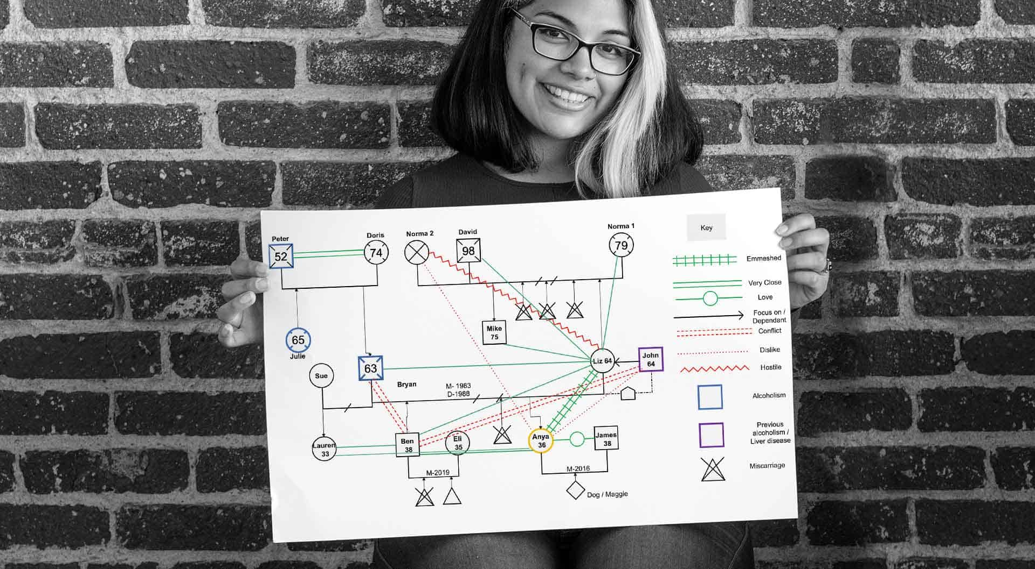

A genogram consists of various types of symbols that represent male, female, child, relatives, and more. These symbols help practitioners comprehend multiple aspects of a family, including emotional relationships, health status, medical issues, family relationships, and more. It consists of various lines and shapes depicting different relationships and family members' physiological and physical attributes. Only family members should be displayed on a genogram NOT friends as these should be on an ecomap. Genograms need to show name, date of birth (not ages), year of marriage, year of divorce (or separation) and date of death (although you may not receive this information from family members) and any other significant life events. For the layout of the genogram, the male is always at the left of the family and the female is always at the right of the family. A family is shown by a horizontal line connecting the two. The children are placed below the family line showing the oldest to the youngest (left to right). Each generation is on a separate line with the youngest generation at the bottom.

## Top Tips for creating a Genogram.

Here are some top tips for creating a genogram.

* Start with the oldest child.
* Work from left to right across the page.
* Highlight the key child.
* Go back at least three generations.
* Include a key.
* Use colour.
* Add as much detail as is relevant – age, culture, medical history etc.
* Group households together.
* Include anyone important to the children – including pets.

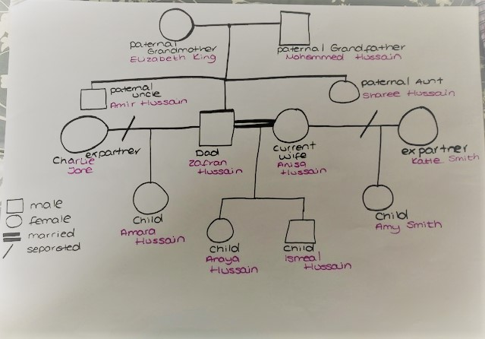

Genogram Symbols: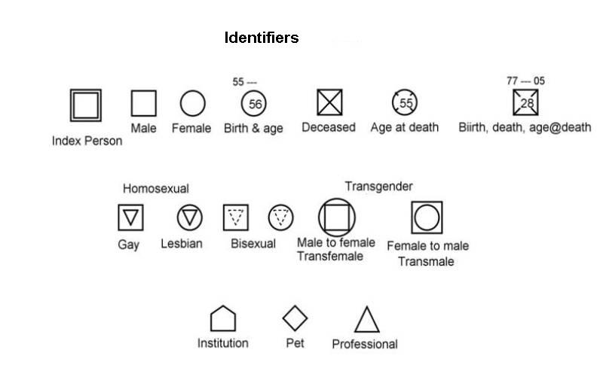

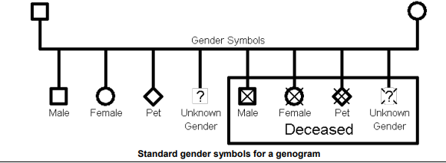

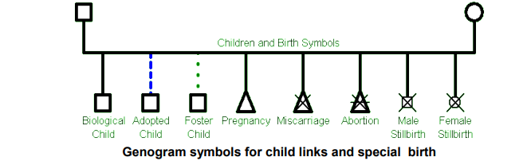

See here for a full list of [Genogram Symbols](http://wellsk.faculty.mjc.edu/GenogramDetailed.pdf).

Click [here](https://bit.ly/3QuMHp9) to watch a tutorial about how to draw basic genogram symbols. In this video, it will show you the different genogram symbols, including basic genogram symbols, such as birth and death, sexual orientation, pregnancy, and cultural background.

# Cultural Genograms

Place of origin, spoken language(s), male and female roles, jobs, and religion all help define culture. This information is sometimes most easily shared by a child or young person through the telling of their family stories that are passed down through generations. When you compile these stories and various categories of information about them, practitioners can produce what we call a “cultural genogram,” a snapshot of a child’s or young person’s cultural background. Looking at how culture has influenced them will help you be more sensitive. Every child or young person has developed a cultural heritage over time through family stories, experiences, and choices, all of which will form their “personal cultural journey”. This heritage influences their current beliefs, attitudes, judgments, and behaviours.

A diagram of a cultural genogram.


## What are Cultural Genograms?

A cultural genogram is a pictorial representation of the relationships and experiences within a family. It is a visual tool that enables engagement with the family and provides the practitioner with an overview of individual and group culture within a family.

A cultural genogram is created using a key agreed with the family, which can include a combination of text, symbols, shapes, colours, lines, and captions which capture the family and significant relationships over at least three generations. This key is used to depict a range of factors such as gender, the quality of different relationships and strengths. It can also be used to identify safeguarding concerns such as substance misuse, domestic abuse, sexual abuse, neglect etc. This is illustrated in the cultural genogram below:

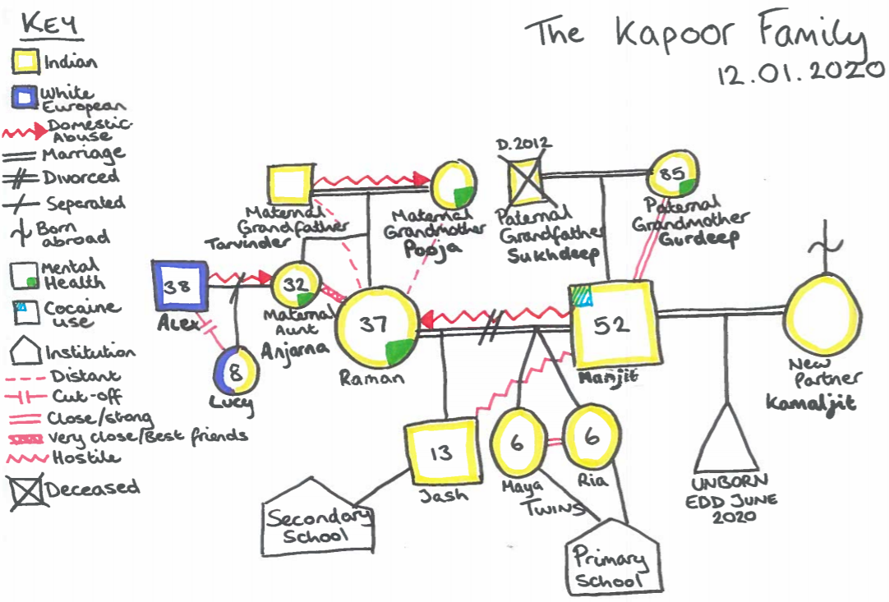

As can be seen above, a cultural genogram provides a range of information regarding who is part of the family, the quality of the relationships and how they function. This can be used to develop a better understanding of the family’s culture, identity, beliefs, traditions, and values. This needs to inform our assessments, plans, analysis, and decision making which will enable us to be culturally competent in the way that we practice.

## Why are Cultural Genograms needed?

Cultural genograms are an important part of our work with children and young people and families and a useful tool to explore identity. We need to ensure that when we build our relationship with the family and undertake our work with them, that our understanding and analysis of the family’s culture and identity is integral to the assessment, planning and intervention with them.

Creating a cultural genogram helps the family to tell their own story from their perspective, understand their network and explore how their network can positively influence the intervention and plan.

A cultural genogram also enables us as practitioners to talk about potential risks that might impact upon children or a young person in a more sensitive way. In some circumstances, these might also relate to intergenerational patterns within families. Exploring these relationships with families helps to map out patterns and themes in a visual way such as those relating to neglect, mental health, domestic and sexual abuse and contact with people that might pose a risk to children. This supports our families to see the reason for professional concerns and what changes are needed to reduce them. It also strengthens our knowledge about the family by using their voice which will enable more effective interventions due to focusing on both the presenting concerns and possible root causes. Working in this way is more likely to secure better outcomes for children and young people.

## Theoretical underpinnings of a Cultural Genogram.

Cultural genograms are developed using Social GGRRAAACCEEESSS. This acronym relates to Gender, Gender Identity, Geography, Race, Religion, Age, Ability, Appearance, Class, Culture, Education, Ethnicity, Economics, Spirituality, Sexuality and Sexual Orientation (Burnham 2013).

Using Social GGRRAAACCEEESSS supports us to recognise the importance of using a practice approach which recognises the different aspects of the identities of the families that we work with. Practitioners also need to be culturally competent when undertaking work with children and their families.

## How to develop a Cultural Genogram

A cultural genogram can take a few sessions to complete and each session you can bring back the version you had in the last session and build upon what we know already. We need to be mindful that culture is fluid and changes over time and as such, our genograms need to reflect these changes.

* Firstly, identify the ethnicity and religion and of everyone in the family and include this on the genogram using a symbol/key identified by the family (See Illustration 1).
* Identify who lives in which household.
* Identify patterns and themes in each individual’s history e.g., domestic abuse, mental health, etc.
* Include any previous professional involvement including Children’s Services, with everyone identified on the genogram.
* Discuss the quality of relationships between family members. This can be illustrated by a specific symbol (as shown in illustration 1).

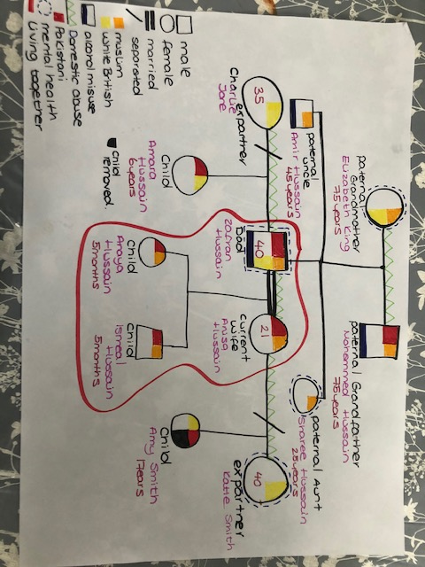

**Illustration 1**

Practitioners need to consider their approach when working with families to ensure that it is informed by a respectful stance, professional curiosity, and appreciative inquiry. Be mindful that different family members may have differing views on family relationships, family culture or strengths identified. This can then be used to inform the assessment.

Reflecting in supervision, group supervision and training is important to ensure that staff identify and address any assumptions or bias that might emerge due to our own value base as practitioners. Practitioners should consider other factors such as the impact of secondary trauma on themselves when creating genograms, where families may share emotive or adverse experiences.

## How can I evidence this work on the child/young person’s file?

* Cultural genograms created with the child, young person, parents, and carers to be uploaded onto documents linked to the visit case note providing an analysis of the session.
* Information obtained should be included in the case summary.
* Link information obtained from the cultural genogram to your assessment particularly the analysis and rationale for decision making.

## Good Practice Points:

Creating Cultural Genograms with the family will strengthen relationships with the family and ensure that both resources as well as risks are identified.

As the work with the child and family progresses and updated cultural genograms are completed, reflect on the differences in the genograms, what does this tell you about the family or individuals within it? How does this shape your planning?

Even if it done separately, try and engage a range of family members in the creation or updating of the genogram to ensure that it is holistic and inclusive.

Aim to identify areas of strength and resilience in a family, not just concerns.

# GenoPro

Some practitioners within CYPE use *GenoPro* which is a genealogy software for drawing family trees and genograms. It is available to be installed on laptops meaning that genograms can be written on it and transferred to a Word document then uploaded into documents. While handwritten genograms are good practice, Genopro gives an opportunity to add background information such as health and addictions and photographs and can make it easy to quickly build complex family trees.

See more information here:

* [GenoPro Introduction](https://youtu.be/MuXvG9tbUMs)
* Adoptive, and foster children, relationships and naming relationships: [GenoPro Video 1](https://youtu.be/MuXvG9tbUMs)
* More complex relationships – divorces and new relationships: [GenoPro Video 2](https://www.youtube.com/watch?v=dgHyTUfw3LQ)
* Printing and legend guide: [GenoPro Video 3](https://www.youtube.com/watch?v=BgZGuxlZdCo)

## GenoPro – Step by Step Guide: