Child Sexual Abuse Strategy 2023-2026

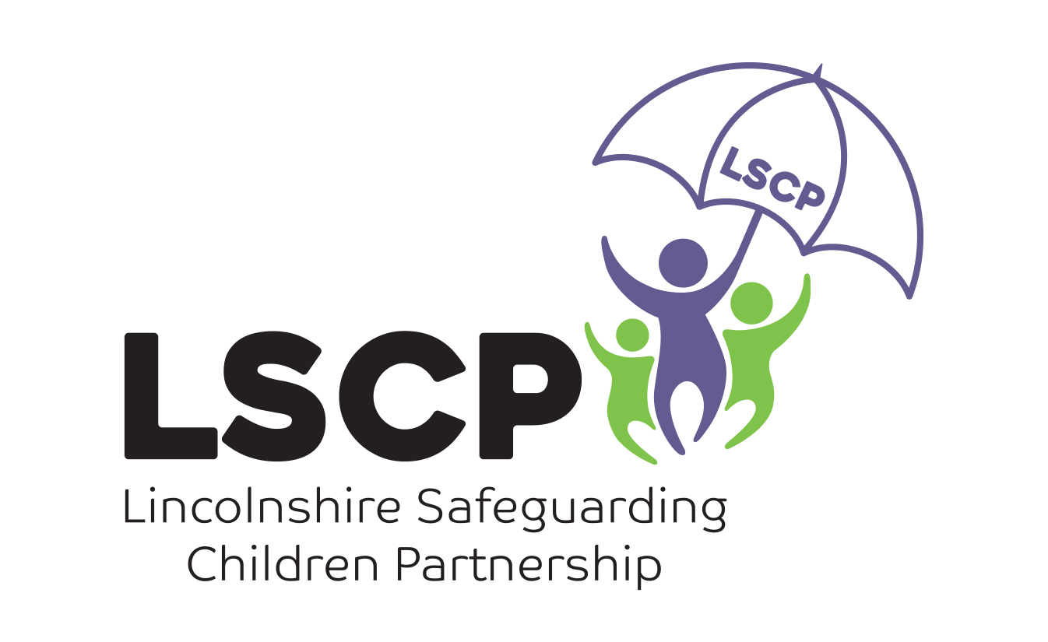
Contents:
Why do we need a CSA Strategy?
Local context
Overarching Strategic Principles
Operational Commitments
Key Indicators, Impact and Outcomes
“The only grown-up that spoke to me about what would happen if I spoke about my abuse was the person who was abusing me”
May Baxter-Thornton

Why do we need a Child Sexual Abuse Strategy?
“Child Sexual Abuse is a crime. Talking about it isn’t” The Reign Collective

In 2021, the Government published its strategy on Child Sexual Abuse; outlining its clear ambition to prevent, tackle and respond to all forms of child sexual abuse. With a focus on protecting children, tackling offending and supporting all victims and survivors, Government will hold itself accountable and learn from data and insights gathered across the system to demonstrably show they are:

- Drawing these hidden crimes out of the shadows by identifying more abuse and safeguarding more children through police recorded crime, children’s social care data and independent inspectorate reports
- Bringing more offenders to justice and increasing effective trials for child sexual abuse, based on data from across the criminal justice system
- Improving the quality and availability of support for victims and survivors, drawing on insight from delivery and third sector partners; and,
Preventing these terrible crimes from happening in the first place based on law enforcement threat assessments and survey data from the Office of National Statistics.

Lincolnshire partners have come together in a shared commitment to improve their identification, response and support for children who experience sexual abuse. In support of the national ambition to prevent, tackle and respond to all forms of child sexual abuse, the LSCP has identified a core aim that all children and young people who are being, or have been, sexually abused get support and protection that places their needs at the centre.

We want a strategy that will harness the collective commitment of all partners to:
- deliver an improved training offer across the whole partnership
- support the targeting of resources
- co-ordinate our offer to all children who experience sexual abuse or display sexually harmful behaviours, or both.

Lincolnshire partners have a shared ambition to
- improve the response to families of children who are sexually abused
- improve the way professionals identify child sexual abuse
- improve the way in which children who may be or are being sexually abused are supported and protected by professionals
- build on and improve existing multi-agency working
- embed the voices of victims and survivors in informing service response

A national snapshot of Child Sexual Abuse
- 15% of girls/young women and 5% of boys/young men are estimated to experience some form of sexual abuse before the age of 16.
- 1 in 4 of those who had lived in a care home reported experiences of child sexual abuse – almost 4x as many as those living with family/carers
- 92% of child sexual abuse images depicted girls only in 2019
- 92% of perpetrators of child sexual abuse are male
- 1 in 8 victims come to the attention of the authorities at the time of the abuse
- The most serious and repeated offences are more likely to be committed by known persons. For boys, abuse by authority figures is more common and for girls abuse by family members is more common.
- The likelihood of experiencing child sexual abuse does not vary significantly with ethnic group in England, but people from some minority ethnic communities face barriers to reporting abuse.
- The peak ages for when child sexual abuse started where when the child was 14 years old (15%), 12 years old (12%) and 8 and 13 years old (10%).
2,600 children on a child protection plan in England under the primary category of sexual abuse
30,460 children assessed at risk of sexual abuse in England
87,992 identifiable child sexual abuse offences recorded by the police in England and Wales.

[Cite your source here.]
Whilst child sexual abuse is prevalent in all communities in England and Wales, more children are experiencing abuse than services are currently aware of. It is acknowledged that this is reflective of the situation in Lincolnshire and this strategy aims to unite partners in supporting and protecting children and young people who are being, or have been, sexually abused, ensuring that their needs are placed at the centre of services and practice.

2020 – 2021 figures show that in Lincolnshire there were:

- 1521 identifiable child sexual abuse offences recorded
- 577 assessments identifying child sexual abuse as a factor
- Less than 5 open Child Protection Plans under the category of Sexual Harm
For the purpose of this strategy, the Lincolnshire Safeguarding Children Partnership defines child sexual abuse as:
…forcing or enticing a child or young person to take part in sexual activities, not necessarily involving a high level of violence, whether or not the child is aware or not of what is happening. The activities may involve physical contact (for example rape or oral sex), including assault by penetration or non-penetrative acts such as masturbation, kissing, rubbing and touching outside of clothing. They may also include non-contact activities, such as involving children in looking at, or in the production of, sexual images, watching sexual activities, encouraging children to behave in sexually inappropriate ways, or grooming a child in preparation for abuse. Sexual abuse can take place online and technology can be used to facilitate offline abuse. Sexual abuse is not solely perpetrated by adult males. Women can also commit acts of sexual abuse, as can other children.
Working Together 2018, p107
In summary, child sexual abuse, within the scope of this strategy incorporates:

- Sexual violence and harassment
Sexual violence is an all encompassing term that includes crimes like rape, sexual assault and sexual abuse. Sexual harassment is any kind of unwanted behaviour of a sexual nature that makes you feel humiliated or intimidated, or that creates a hostile environment.
- Intrafamilial sexual abuse (including sibling harm)
Refers to any connection between the victim and the perpetrator in a familial context i.e. abuse occurring with the family.
- Extrafamilial sexual abuse
Refers to any connection between the victim and the perpetrator outside of the family i.e. committed by anyone other than a member of the victim’s family.
- Online sexual abuse and harassment
Can take a number of forms, including, but not restricted to, the possession, production and sharing of indecent images of children; grooming; sexting; blackmail or exploitation.
- Harmful sexual behaviour by children and young people
Sexual behaviours in children and young people can be seen on a continuum ranging from ‘normal’ and developmentally appropriate, through ‘inappropriate’ and ‘problematic’, to ‘abusive’ and ‘violent’.
- Sexual exploitation
Where there is an in balance of power and the child is tricked, blackmailed or coerced into sexual activity. They may receive items they want or need as a result.

These are all contexts in which child sexual abuse can and does occur. Many overlap and can occur multiple times as part of the child’s experience of the abuse. Child sexual abuse within this strategy refers to all of the above and the many facets that it can take within and across these contexts.
Local recorded prevalence and response

 |  |  | Police Outcomes
Period  April– March | Incidents | Victims  Avg. incident per victim | Unresolved | Cancelled /  Transferred | 1-8 | 9-21 | % Positive Outcomes including unresolved
2022 - 2023 | 1310 | 815 (1.6) | 280  21% | 134  10% | 43  3% | 853  65% | 25%
2021 - 2022 | 1257 | 878 (1.4) | 72  6% | 97  8% | 60  5% | 1028  82% | 11%
2020 - 2021 | 869 | 636 (1.4) | 19  2% | 97  11% | 57  7% | 696  80% | 9%
2019 – 2020 | 1162 | 828 (1.4) | 21  2% | 123  11% | 81  7% | 937  81 | 9%

Period |  |  | Referrals
(April – March) | Incidents | Victims | PSARC | ChISVA
2022 - 2023 | 1310 | 815 | 65 (7.4%) | 291 (33.3%)
2021 - 2022 | 1257 | 878 | 49 (5.8%) | 267 (31.4%)
2020 - 2021 | 869 | 636 | 38 (6.5%) | 132 (22.7%)
2019 – 2020 | 1162 | 828 | 47 (6.5%) | 163 (22.5%)

Accounting for periods of lockdown and restrictions in 2020/21, there has been a year on year increase in the number of incidents reported to the police since 2019. Consistently, the most common offence types remain contact offences of sexual activity with a child under 16, sexual assault of a female over 13, sexual activity involving a child under 13, sexual assault of a female under 13 and rape of a female under 16. Of the 2898 victims during this four year period, 2379 were female children, accounting for 82% of identified victims. There has also been an increase in the average number of incidents perpetrated against victims, having previously been consistently recorded at 1.4 it rose to 1.6 in 2022.

In summary, since 2019, the number of incidents and the number of incidents per victim has gradually increased. Conversely, during the same period there has also been a reduction in positive police outcomes from 7% to 3%, despite the majority of investigation identifying a named suspect. Victims are more likely to be referred for support from the ChISVA, rather than for services through the EMCYPSAS

Assessment factors from Childrens Social Care records show that practitioners are identifying child sexual abuse, however as a result of a lack of specific guidance and dedicated training on this specific harm, interventions and support that follow aren’t as enhanced as they could be. Partners want to redress this and support a confident and skilled workforce to reduce the impact of child sexual abuse on an individual child level as well as a strategic partnership.

Partners recognise that the figures above account for only the incidents of child sexual abuse which are reported to services, the prevalence in the County is likely to be higher. In 2019, the Sexual Violence Needs Assessment, commissioned by the Police estimated significantly higher numbers of children who experience child sexual abuse annually in Lincolnshire (2019)*
Age | Population | Contact Sexual Abuse | Any Sexual Abuse (including non contact)
10 and under | 74,673 | 149 | 448
11-17 | 71,739 | 1363 | 6743
Totals | 146,412 | 1512 | 7192
*Lincolnshire Sexual Violence Needs Assessment Lime Culture Report

Overarching Strategic Principles

The focus for our strategy will include the early identification and intervention to both protect children and stop crimes and incidents of child sexual abuse.

Victim centred interventions | Safeguarding Children and Young People
 | The LSCP will drive better multi-agency working, with practitioners able to identify and intervene effectively in CSA cases.
 | Agencies and institutions that work with children prevent those that pose a risk of sexual harm from accessing children and identify and support those at risk.
 | Criminal Justice agencies have an understanding of safeguarding and vulnerability in order to support victims and survivors appropriately
 | Supporting Victims and Survivors
 | Child and adult survivors have access to the support services they need
 | Child and adult victims and survivors are better supported throughout the criminal justice system.
 | Targeted support for those at-risk
 | Agencies can identify and effectively support children, young people and families who are at risk, including those facing greater risk due to social and financial deprivation.
 | Giving children the best start in life, raising awareness amongst parents, carers and families, and protecting children and young people in their communities.
 | Perpetrators of child sexual abuse are less able to take advantage of children and young people through raising awareness amongst parents, carers ad families, and giving children and young people access to safe spaces and trusted adults.
 | Children are given the best start in life, including access to information and education around healthy and abusive behaviours.
Disruption focused interventions | Tackling and reducing sexual abuse
 | Intelligence is enhanced, ensuring resources are prioritised most effectively
 | Child Sexual Abuse is prevented through early intervention
 | The multi-agency response to disrupt and reduce child sexual abuse is strengthened
 | Bringing those who abuse to justice
 | The criminal justice system and wider agencies respond more effectively to all forms of sexual offending.
 | Deterring offending
 | Agencies understand and ensure there is an evidence base for preventative measures, including for harmful sexual behaviour and child on child abuse.
 | Agency understanding of offender pathways and motivations is developed and drives interventions to deter CSA in the first place.
All agencies share information effectively to safeguard children and tackle offending

Operational Commitments

Policies and Practices:
- To support and ensure partners develop and maintain robust and effective policies, practices and procedures to safeguard children and young people against child sexual abuse.
- To provide sufficient guidance to enable practitioners to respond confidently to the needs of children and young people who have experienced or are experiencing sexual abuse.
- To ensure that children and young people are supported to access the right support at the right time depending on their needs.

Education, Training and resources:
- To promote and support effective learning opportunities for all partners, and stakeholders, which recognise and address current and emerging child sexual abuse risks.
- To promote and support practitioners to have a common language and understanding of child sexual abuse and respond to disclosures of sexual harm in a child-centred way.
- To Think Family and promote confidence in practitioners responding to the needs of parents and siblings of children and young people who are being sexually abused.
- Campaigns and engagement are targeted at parents, carers and communities.

Leadership and Management:
- To ensure that internal systems and processes allow for the early identification of child sexual abuse.
- To ensure that mechanisms are in place to contribute intelligence and data to understand the profile and prevalence of child sexual abuse in Lincolnshire.
- To ensure that supervision and oversight of staff provides a safe and reflective space to work to improve the outcomes for children and young people at risk of experiencing, or who have previously experienced child sexual abuse.
- To embed quality assurance processes to ensure high standards of practice and services for children and families

Key Indicators and Outcomes – how will we know we have been effective?

- There is a measurable increase in the early identification of children experiencing sexual abuse, including through rising reporting rates from direct disclosures.

- Where child sexual abuse is an identified risk factor in an assessment, there is an increase in these children being supported through a multi-agency plan

- Staff and practitioners report an increase in confidence in identifying and intervening to support children who have experienced or are experiencing sexual abuse.

- Increase in appropriate referrals (including historic) to specialist services ensuring victims and their families get the right support for their needs.

- Children and young people in contact with services report positive change and have a say in how services are delivered to them.

- Parents and carers in contact with services report receiving support to effect positive and lasting change in response to concerns.

- There is an increase in the effective use of Sexual Harm Prevention Orders, Sexual Risk Orders and Child Abduction Warning Notices.

- There is an increase in the number of effective child sexual abuse trials and positive outcomes to reported crimes.

REIGN is a collective of adult survivors of child sexual abuse and exploitation from the UK. https://www.reigncollective.org.uk/
Child sexual abuse in England and Wales - Office for National Statistics (ons.gov.uk); Protecting children from harm | Children's Commissioner for England (childrenscommissioner.gov.uk); IWF Annual Report 2019 (yumpu.com)
Includes incidents prior to residency in a children’s care homes
Data will be updated annually to capture the most recent recorded prevalence.
Police (positive) Outcomes 1 – 8 – inc. Charged, summonsed, Cautions, Community Resolution
Police (negative) Outcomes 9-21 – inc. victim declines, evidential difficulties, withdrawn, no suspect identified.
Calculated on the hypothesis that the unresolved cases will be concluded with a positive outcome
East Midlands Children and Young People Sexual Assault Service
The Castle Service can accept self-referrals, although it is acknowledged these are quite rare.
Adapted from Tackling Child Sexual Abuse Strategy 2021 HM Government

