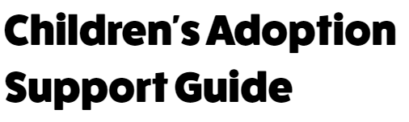

**To find out more or to ask for help if you live in or around Bexley, Kent, or Medway contact us**

Adoption Partnership

The Stable Block

Oakwood House

Oakwood Park

Maidstone

ME16 8AE

Telephone: 03000 422373

Email: [adoption.partnership@kent.gov.uk](mailto:adoption.partnership@kent.gov.uk)



**Children’s adoption support guide**

Adoption support can help you:

• talk about adoption

• understand your ‘life story’

• choose who to tell you are adopted, and how much to tell them

• stay safe and in control on the internet

• discuss worries about your birth family

• with contact arrangements

We will listen to you to find out what you need and help you and your parents discuss how you feel with someone who understands about adoption.

We hold family days during the year where you can meet up with other adopted children and their families.

**Here are some other places that can give you help and advice when you need it:**

Talk Adoption is a helpline and email for anyone under 26 for advice about

anything to do with adoption.

Telephone: 0808 808 1234 Monday - 9am to 6pm, Tuesday - 9am to 8pm,

Wednesday - 9am to 6pm, Thursday - 9am to 6pm, Friday - 9am to 4pm

Confidential email: [actionline@talkadoption.org.uk](mailto:actionline@talkadoption.org.uk)

ChildLine A free helpline for children and young people.

Telephone: 0800 1111 Website: [www.childline.org.uk](http://www.childline.org.uk)

Children’s Commissioner The Children’s Commissioner works to promote and

protect children’s rights in England. Our work focuses on making sure that adults in charge, or making decisions, listen to what children and young people say about

things that affect them.

For free confidential advice telephone 0800 528 0731

or email: [help.team@childrenscommissioner.gsi.gov.uk](mailto:help.team@childrenscommissioner.gsi.gov.uk)

Website: [www.childrenscommissioner.gsi.gov.uk](http://www.childrenscommissioner.gsi.gov.uk)

We want to make sure that we get things right for you but if something happens that you are not happy about please tell us:

Kent Children’s Social Services Customer Care

Kroner House, Eurogate Business Park, Ashford, TN24 8XU

Telephone: 03000 410304 email: [cscomplaints@kent.gov.uk](mailto:cscomplaints@kent.gov.uk)

Text 07860 008025 start your message with the word complaint.

We can help you put your complaint in writing or give you advice.

Young Lives Foundation Telephone: 01622 683815

or email: [advocacy@ylf.org.uk](mailto:advocacy@ylf.org.uk)

Website: [advocacy@ylf.org.uk](mailto:advocacy@ylf.org.uk)