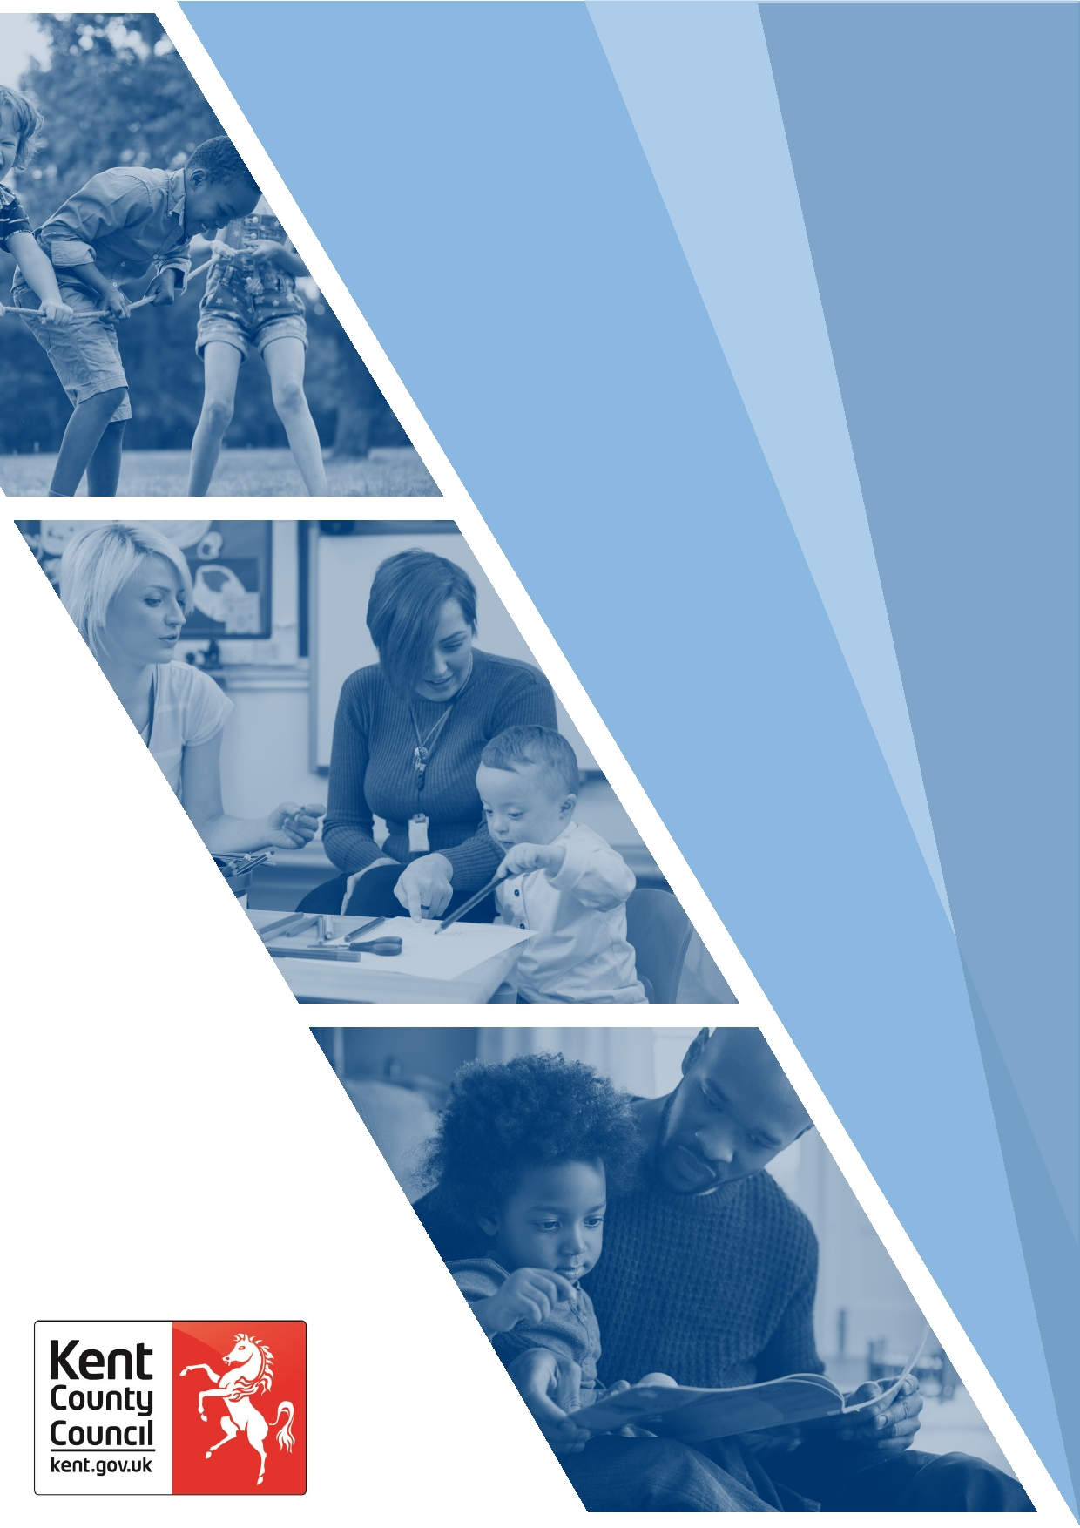
Purposeful Recording

Contents | Page
Introduction | 3
Purpose | 3
Key Points for Good Record Keeping | 3
Reason for Contact | 3
Detailed Notes | 3
Observations | 4
Progress and Actions | 4
Recording Analysis, Rationale and Decisions | 4
Conclusion | 4
The Purposeful Recording Template | 6-7

Introduction

The case file is the single most important tool available to workers and their managers when making decisions as to how best to safeguard the welfare of children. A well-crafted child’s record should be able to show what is happening for a child at any given time. This means that a manager, new worker or out-of-hours team can pick it up and immediately understand the needs of a child.
We know that lots of things happen in a child’s life. Not all of them need to be recorded in full but the most significant events should always be captured, so that the record properly reflects a child’s experiences and progress. Case notes should be much more than a description of the practitioner’s actions and the response of the service user - a good case note will record analysis and reflection. It should also acknowledge the range of evidence-based approaches within Kent's Practice Framework.
Purpose

The purpose of this document is to provide guidance and support workers to organise their thoughts clearly and succinctly to make sense of the ‘meaning’ of the visit that they have undertaken through the use of the Purposeful Recording Template. The template is not meant to be directive, rather its aim is to provide prompts to drive thinking and support meaningful recording.

Workers should use their professional judgement about how best to use this template and consider what works for them; for example, it can be used during a home visit, in between visits to capture thoughts, as a reflective tool, or as a helpful prompt when inputting case notes in Liberi or EHM.

Key Points for Good Record Keeping
As a general rule, case records should:
- Be entered in a timely way – this supports decision making and makes it easier as it is fresh in your mind.
- Enter statutory decisions on the day that they are made.
- Record the wishes, feelings and views of service users, wider family, and agencies.
- Reference relevant legislation and guidance i.e., around mental capacity or coercive control.
- Distinguish between fact, opinion, professional judgement, and hearsay.
- Use appropriate language that is non-judgemental and unambiguous.
- Clearly state the hypotheses - why you think X or Y rather than A or B.
- Explain how you arrived at decision by showing the ‘workings out’ – in other words, be defensible.
- Consider the level of risk in conjunction with the person’s desired outcomes.
Kent’s Recording Policy and Guidance can be found here for more detailed information on recording.
The following may be helpful to consider alongside the Purposeful Recording Template:
Reason for Contact

Include a purposeful heading, which may or may not be included in the chronology. Record how the aim/purpose of your visit links to the outcomes agreed in the family plan. These details will help anybody who has to pick the case up, to understand how it is progressing and what work remains outstanding.

Detailed Notes

Notes should record the venue, who was present, who was seen and where. If there are unknown adults in the household, workers should be curious about their association with the family in the context of the work being undertaken. Failed appointments and visits where there were no responses should also be included, together with any actions.

Observations

Whilst it is helpful to see children on their own with permission from parents/carers, unless the worker has good reason to believe that seeking permission may compromise their enquiries, it is also essential to see the child or young person in their environment and record observations accordingly.
Observing children and families in their home rather than just listening to what is being said, is an important way of gathering information. It can shed light on how people are living and the dynamics between them as well as confirm or contradict what has been said. More importantly it will help workers to build a picture of what daily life is like for the child. Observation of the physical home environment is also key when assessing what is good enough and what is safe enough.
Progress and Actions

Plans that are owned by the family and contain realistic actions which can be supported by the wider family, friends and community services are more likely to succeed. Whilst this is not always possible, particularly in the most complex cases, using a strength-based, ecological approach to assessment, plans and actions and focussing on what is strong rather than what is wrong, is considered an effective approach in social work and is integral to Kent’s Practice Framework.

Recording Analysis, Rationale, Decisions and Action
Recording analysis, rationale, decisions, and actions properly, fundamentally depends on the thinking having happened first. Without this, however good our professional writing skills are, recording is unlikely be fit for purpose. Workers should aim to explain their thought process and ‘show workings out’ in relation to the specific person, case, or situation.
As a general rule, when recording analysis, rationale, decisions and actions, you are seeking to explain:
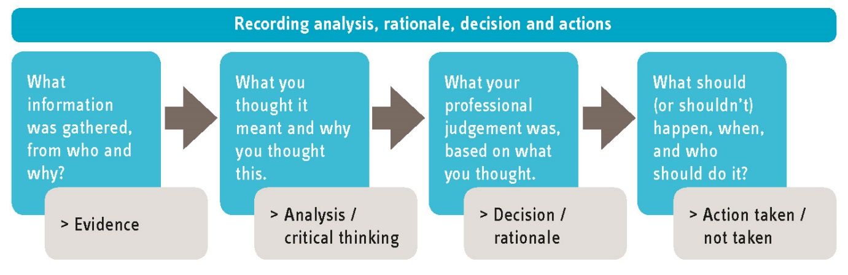
Analysis also takes place outside of day-to-day recording and is facilitated by specific formats such as assessments, genograms, ecomaps, social histories, and case summaries. These tools require workers to organise, manipulate and evaluate the information gathered in the case files and they provide an opportunity to assess the child's needs, monitor progress, evaluate the effectiveness of interventions, and to identify patterns that may not immediately be apparent.

Conclusion

Our systems must provide a full, thorough, and accurate view of our work with children and families that is fit-for-purpose otherwise we cannot evidence the work, assess its quality, or analyse its impact on outcomes for children and families. This system information is much more than just data… it is the child’s story, and as such we owe it to them to write it with them in mind, affording them the due diligence they deserve.
Purposeful Recording Template
Name and role of practitioner |  |  | Date
Liberi/EHM no |  |  | Venue
Were any issues raised during your last visit?  What has been done to rectify these? |  | Yes☐ ☐ No
Reason for Contact

What is the Aim/Purpose of this visit? |  | Is the Aim linked to the Plan? If it is or if it isn’t, record in your notes.
Detailed Notes

Visit Record - General  Who was present?  Who was seen?  Where? |  | If there were other people present during the visit, please state who and their role.
Visit Record – Child/Young Person  Was the child seen alone?  If not, why?  What did you discuss with the child or young person?  What is the child or young person’s views, wishes and feelings? What tools were used to gather this information?  Observations of the child or young person in their environment?  How does the child or young person engage with you? School/Nursery?  Any additional information? |  | What is day-to-day life like for this child? What have you observed? What has the child told you and what have others told you about the child’s experience? Remember to triangulate the information to support your analysis.
Visit Record – Parents/Carers

What did you discuss with the adults that support this child or young person?

What did you observe?

What did you observe about the way the adults interact with the child or young person?

Any non-compliance or engagement issues with the parents/carers?

Any additional information?

Visit Record – Progress  How is the plan progressing?  Are there any barriers? If so, what needs to happen to overcome them? |  | Plans should be owned by the family; they should be tangible and realistic for the family to achieve and sustain progress.
Analysis

Visit Record – Analysis  What is the impact on the child or young person’s lived experience?  What other sources of information do you have? How have you triangulated this information?  What is your hypothesis? | This is the “making sense of” or drawing out the “meaning” of all the information available for the child or young person and their family. Use the diagram in the guidance below to draw out your analysis.
Actions

Visit Record – Actions  What needs to happen?  Who is responsible for this?  When does this need to be completed?  How is this going happen?  Are there any barriers to making this happen? If so, what?  Are there any changes to the Plan?  How will this be measured? | Avoid service-led actions where possible and think ‘family-owned’. Remember to include actions which test your hypothesis.

Any other Relevant Information

Use this space to write/draw any other information which you feel is relevant and helpful for you case record.

