Working with Cultural Competence and Cultural Humility
May 2022
Author Michelle Coles, PDO
Introduction
Kent is made up of many diverse and culturally rich communities and it is our duty to provide fair and consistently good services to everyone we come across regardless of their religion, belief or cultural background. This guidance seeks to explore how we interact respectfully and knowledgeably with people from different cultures – people whose culture and worldview may be far removed from our own.
How do we use our differences to strengthen our relationships and support children, young people and the families we work with?
Cultural Competence
The term “cultural competence” was originally coined by healthcare providers in the 1970s who believed that if they could be more culturally knowledgeable, they could be more effective at providing care. In social work, the concept first appeared in literature in the early 2000s as ‘ethnic competence” (Gallegos, Tindall, & Gallegos, 2008).
Cultural competence is the ability to understand and interact effectively with people from other cultures.
It is often difficult to connect with people when we don’t understand their background. What we do understand though, is that culture and cultural identity are crucially important concepts in the work that we do in Kent - a family’s sense of identity may be so important to them that any attempt to build a relationship without considering the cultural implications will prove extremely difficult, if not impossible. Therefore, applying cultural competence is a step forward to connecting and building relationships.

Research and Practice suggest that there are levels of Cultural Competency:

- “Cultural knowledge” means that you know about some cultural characteristics, history, values, beliefs and behaviours of another ethnic or cultural group.
- “Cultural awareness” is the next stage of understanding – being open to the idea of changing cultural attitudes.
- “Cultural sensitivity” is knowing that differences and similarities between people exist without assigning them a value; positive or negative, better or worse, right or wrong.
- “Cultural competence” brings together the two previous stages and has the capacity to consider many different behaviours and attitudes and work to produce good outcomes.

This does not mean that professionals have to be highly knowledgeable about every cultural aspect of the family (indeed this would be impossible) but they must have the skills to approach differences with openness and respect, adopting a position of ‘not knowing’, acknowledging the family as the experts and applying the concept of relationship-based practice.

A culturally competent professional will seek to understand the family’s world view, they will understand their culture, and they will be able to work with it alongside the information they have about the child’s lived experiences.

Moving from Cultural Competence to Cultural Humility – What is the difference?

Cultural Humility seeks to go further than competence. It is about committing to an ongoing process of self-awareness and inquiry and is emerging as the preferred term.

The dictionary definition of humility is “the feeling or attitude that you have no special importance that makes you better than others.” Approaching our families with humility asks us to work alongside them, to learn from them as the experts on their own lives and importantly to be willing to discover where our own identities have shaped our views of what is ‘normal’, ‘healthy’, or ‘right’. In short, knowing ourselves and our biases is key.

In Kent, we strive for both cultural competence and cultural humility. Our underlying approach is based on 14 key principles:

- Spend time getting to know our families, do not rush meetings and interventions
- Adopt a position of openness and respect. Demonstrate an ongoing willingness to learn about different cultures.
- Understand that research suggests that those from racial minorities may expect to be negatively evaluated by the public systems that serve them (Williams, 1997) and may expect to experience discrimination – it is our job to reassure and help them to feel good about their interactions with frontline practitioners
- Ask the right people the right questions. Professionals should gain their cultural knowledge through direct work with the children, their birth families and parents/carers. They should not assume because something is recorded on the system it is how the family would view it. This is particularly important when placing and matching.
- Support foster carers and provide as much information as possible about the child’s background and culture, particularly if the culture is different from their own.
- Be self-aware – remember your personal cultural values and beliefs. Challenge our assumptions and biases. Use supervision as a means of support.
- Remember the child/young person/adult is the expert of their experience, adopt a position of ‘not knowing’ and be ready to learn.
- Explore and understand how cultural variations in parenting might be affecting the wellbeing of the children/young person – either positively or negatively.
- Reflect on the power of language. Language empowers and can also leave a person wounded.
- Do not make assumptions about those people we are working with because you perceive that they come from a similar background to others user or someone you know.
- Resist tokenism or simple ‘box ticking’ as a means of evidencing your cultural competence.
- Be flexible, not rigid, particularly when using existing frameworks and tools
- Understand and recognise the potential risk of adultification of young people. If professionals view some children as more ‘adult’ due to factors such as race, gender and class, their wellbeing, safeguarding needs and rights can be overlooked.
- Understand and reflect on the Social GGRRAAACCEEESSS model as an acronym that describes aspects of personal and social identity which afford people different levels of power and privilege and explore their own role within this.

Intersectionality

Intersectionality is a concept that extends our understanding of different cultures to include an appreciation of how one aspect of identity, such as ‘race’, can interact with other aspects of identity such as gender, sexual orientation or class. It allows professionals to think critically, widen their lens and see the world through the eyes of the families they support.

For example, a black woman may face discrimination due to both her ethnicity and her gender. Or perhaps a practitioner might think they have a good understanding of how to support someone who is LGBT+ but if they have based their assumptions on the experience of white LGBTQ people, they run the risk of not considering how race affects the experiences of LGBT+ people from non-white communities. Intersectionality acknowledges that everyone has a unique kaleidoscope of identities.

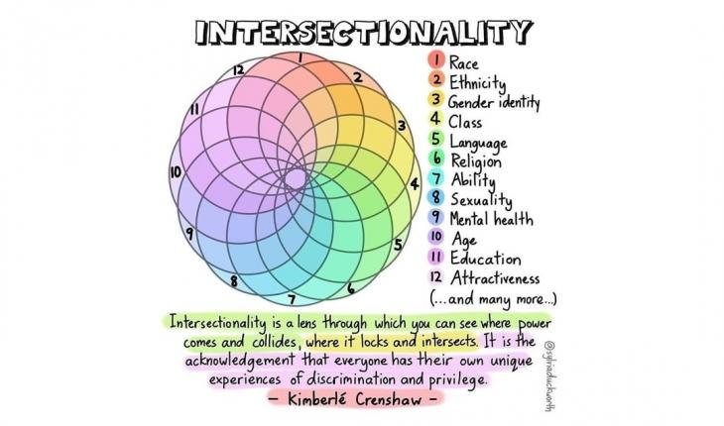
Intersectionality is a valuable tool for analysing how different forms of oppression interact and intersect to influence lived experiences – people’s combination of identities matter – and when we consider the multiple layers of identify it allows us to better understand a family’s needs and support them accordingly. It supports our assessments, risk assessments, care planning and reviewing.

More information on intersectionality can be found here.

Critical Cultural Competence in Supervision

Best practice in critically culturally competent supervision include:

- Supervisors using a strengths perspective, cultural humility, a culture of trust and safety, respect, individuation and having knowledge about the cultures of staff, children and families
- Having a commitment to addressing unequal relations in the supervisory relationship
- The supervisor creating an atmosphere of trust, safety, and shared leadership
- The supervisor being genuine, respectful, available, consistent, and humble
- The worker feeling safe from being criticised or shamed
- The supervisor being conscious of cultural issues and assessing the supervisee’s knowledge of other cultures and their biases
- Supervisors understanding the importance of exploring a supervisees self-awareness in supervision to recognise the power and control at play and endeavouring to reduce its negative impacts
.Reference List

Fong, R. (2009). Culturally competent practice in social work. In D. K. Deardorff (Ed.), The Sage handbook of intercultural competence (pp. 350–361). Los Angeles, CA: Sage.

Williams, C. (1997). Personal reflections on permanency planning and cultural competency. Journal of Multicultural Social Work, 5(1/2), 9-18.

