Contact: |  | Add your logo here
Direct Tel:
Fax:
email:
Your ref:
Our ref:

Private and Confidential
Add parent/guardian here if applicable
Add name here
Add address line here
Add address line here
Add address line here
Add post code here

Add date here

Dear Add name here

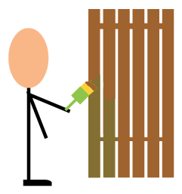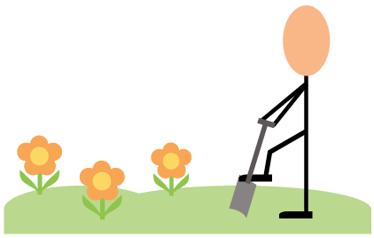 | Unpaid work

The court said you must do some unpaid work. This means you have to work and you will not be paid. This unpaid work is to help you to put things right.

Please come to do your unpaid work on:

 | Date: Add date here
 | Time: Add time here | To: |  | Time: Add time here
 | You will be collected from:
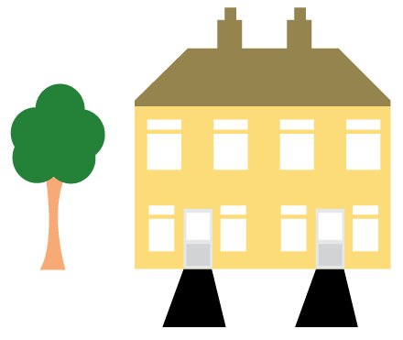 | Place: Add place here

Add ‘bring lunch if required’ here

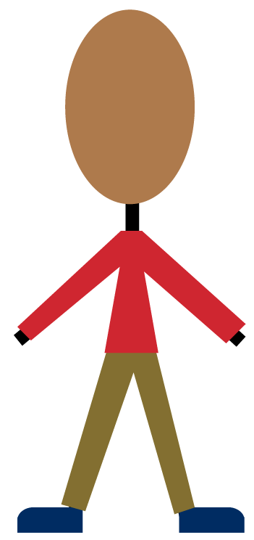 | Please wear sensible clothing and comfortable footwear.
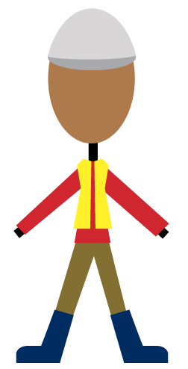 | We will get you any protective clothing or footwear needed for your unpaid work. This protective clothing and footwear must then be worn.

You must let me know first when you have a very good reason for not coming to your unpaid work.

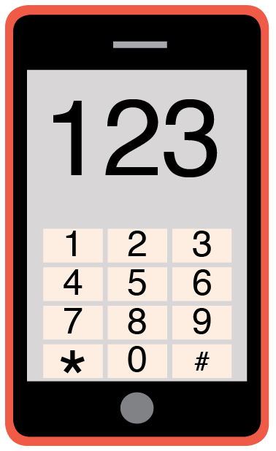 | Please phone me on Add phone number here to talk about any problems you have coming to this meeting.

Yours sincerely,

Add name here
Add role here

Add cc. Parent/Carer here

