Contact: |  | Add your logo here
Direct Tel:
Fax:
email:
Your ref:
Our ref:

Private and Confidential
Add parent/guardian here if applicable
Add name here
Add address line here
Add address line here
Add address line here
Add post code here

Add date here

Dear Add name here

Add court order / programme here Add type of warning here

This is an official warning letter.

The court gave you a Add court order / programme here on Click here to enter a date.

Your court order has rules.

You have not kept to the rules of your court order. On Click here to enter a date. You Add reason for warning here

This is not ok.

When you do not keep to your court order rules, you may Choose what may happen here or add own text.

The court/panel may see this official warning letter.

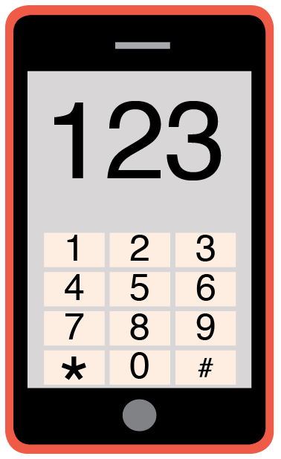 | You may have questions about this letter.  Please phone me on Add phone number here to talk about this warning letter.

Yours sincerely,

Add name here
Add role here

Add cc. Parent/Carer here

