Contact: |  | Add your logo here
Direct Tel:
Fax:
email:
Your ref:
Our ref:

Private and Confidential
Add parent/guardian here if applicable
Add name here
Add address line here
Add address line here
Add address line here
Add post code here

Add date here

Dear Add name here

 | Statutory Court Order: First Meeting

You went to court. The name of what you did wrong and against the law is: Add offence(s) here.

When you left the court there were court rules about what you can do.
One rule is that you have to work with Add organisation here.

I work for Add organisation here. I am your Supervising Officer.

We must talk about what the court says you must do.

Please come to a meeting with me:

 | Place: Add place here
 | Date: Add date here
 | Time: Add time here

You must let me know first when you have a very good reason for not coming to this meeting.

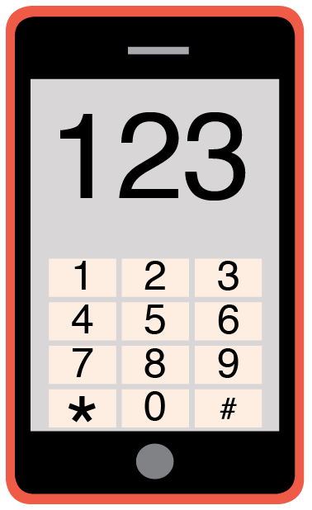 | Please phone me on Add phone number here to talk about any problems you have coming to this meeting.

 | When you miss the meeting and have no good reason you may get into more trouble with the court.

Yours sincerely,

Add name here
Add role here

Add cc. Parent/Carer here

