Contact: |  | Add your logo here
Direct Tel:
Fax:
email:
Your ref:
Our ref:

Private and Confidential
Add parent/guardian here if applicable
Add name here
Add address line here
Add address line here
Add address line here
Add post code here

Add date here

Dear Add name here

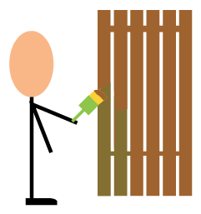 | Reparation

The court said you must do some reparation work. This is work you have to do because you did something wrong.

The work:

• Does something to help someone or a group of people
• Helps you put something right

Please come to do your reparation work on:

 | Date: Add date here
 | Time: Add time here | To: |  | Time: Add time here
 | You will be collected from:
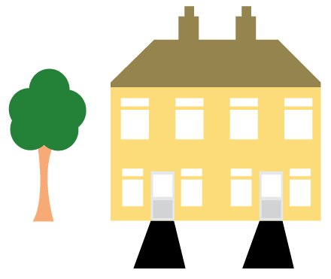 | Place: Add place here

 | Date: Add date here
 | Time: Add time here | To: |  | Time: Add time here
 | You will be collected from:
 | Place: Add place here

 | Date: Add date here
 | Time: Add time here | To: |  | Time: Add time here
 | You will be collected from:
 | Place: Add place here

 | Date: Add date here
 | Time: Add time here | To: |  | Time: Add time here
 | You will be collected from:
 | Place: Add place here

Add ‘bring lunch if required’ here

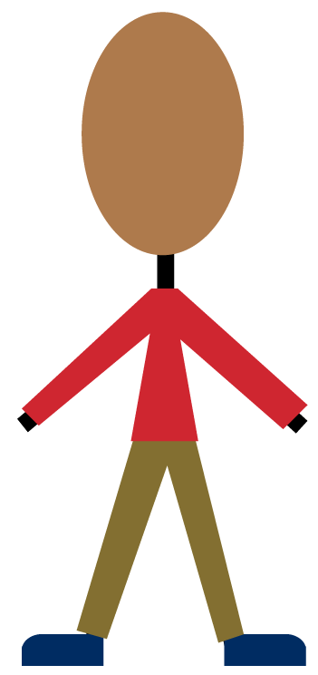 | Please wear old sensible clothing and comfortable footwear.
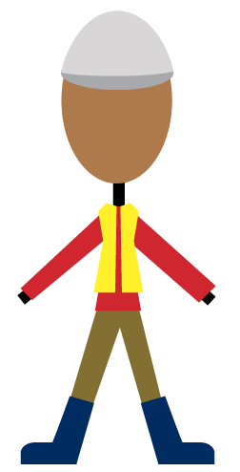 | We will get you any protective clothing or footwear needed for your reparation work. This protective clothing and footwear must then be worn.

You must let me know first when you have a very good reason for not coming to your reparation.

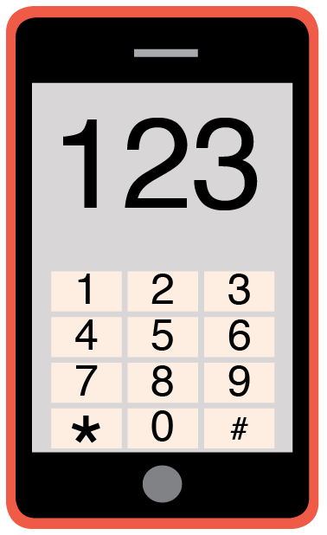 | Please phone me on Add phone number here to talk about any problems you have coming to this meeting.

Yours sincerely

Add name here
Add role here

Add cc. Parent/Carer here

