Contact: |  | Add your logo here
Direct Tel:
Fax:
email:
Your ref:
Our ref:

Private and Confidential
Add parent/guardian here if applicable
Add name here
Add address line here
Add address line here
Add address line here
Add post code here

Add date here

Dear Add name here

Referral Order Panel Meeting: Breach Meeting

I work for Add organisation here

The court gave you a Referral Order.

You have not done what you said you would do at your first panel meeting. This is called ‘a breach’. This letter is very important.

‘You must attend your Breach Panel Meeting’.

Your parent or carer must come to the Breach Panel Meeting too.

Your Panel Meeting is very important. You must let me know first when you have a very good reason for not coming to this meeting.

Place: Add place here
Date: Add date here
Time: Add time here

You can talk with a add organisation here person first. You will then go into your Breach Panel meeting.

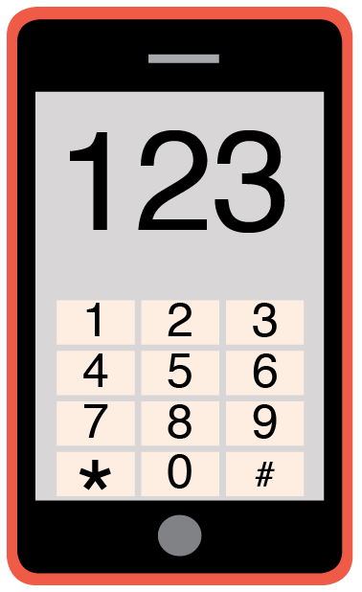 | Please phone me on Add phone number here to talk about any problems you have coming to this meeting.

Yours sincerely

Add name here
Add role here

Add cc. Parent/Carer here

