Contact: |  | Add your logo here
Direct Tel:
Fax:
email:
Your ref:
Our ref:

Private and Confidential
Add parent/guardian here if applicable
Add name here
Add address line here
Add address line here
Add address line here
Add post code here

Add date here

Dear Add name here

Referral Order Panel Meeting: Choose a meeting type.

I work for Add organisation here

The court gave you a Referral Order. Your Referral Order means that you must come to a meeting called a Choose a meeting type Panel Meeting.

Your parent or carer must come to the Panel Meeting too.

Please come to your Panel Meeting:

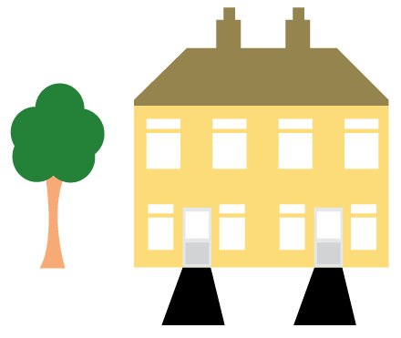 | Place: Add place here
 | Date: Add date here
 | Time: Add time here

You can talk with a add organisation here person first. You will then go into your Panel Meeting.

Your Panel Meeting is very important. You must let me know first when you have a very good reason for not coming to this meeting.

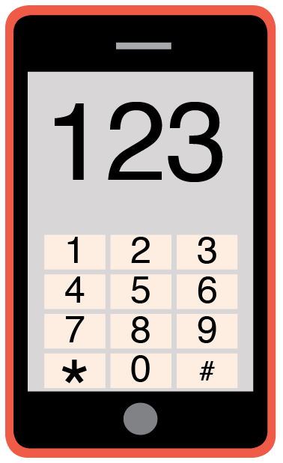 | Please phone me on Add phone number here to talk about any problems you have coming to this meeting.

Yours sincerely,

Add name here
Add role here

Add cc. Parent/Carer here

