Contact: |  | Add your logo here
Direct Tel:
Fax:
email:
Your ref:
Our ref:

Private and Confidential
Add parent/guardian here if applicable
Add name here
Add address line here
Add address line here
Add address line here
Add post code here

Add date here

Dear Add name here

Report Meeting: Meeting to write a report for Court.

I have to write a report about you for court. This report is called a Pre-Sentence Report (PSR). This report is very important. The court will use the report to say what happens to you.

I need to see you to talk about the report. Please come to a meeting:

Place: Add place here
Date: Add date here
Time: Add time here

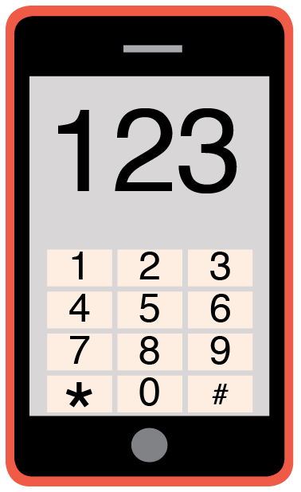 | Please phone me on Add phone number here to talk about any problems you have coming to this meeting.

Yours sincerely,

Add name here
Add role here

Add cc. Parent/Carer here

