Contact: |  | Add your logo here
Direct Tel:
Fax:
email:
Your ref:
Our ref:

Private and Confidential
Add parent/guardian here if applicable
Add name here
Add address line here
Add address line here
Add address line here
Add post code here

Add date here

Dear Add name here

Add out of court disposal here Add type of warning here

This is an official warning letter.

The police gave you a Add out of court disposal here on Click here to enter a date.

Your Add out of court disposal here has rules.

You have not kept to the rules. On Click here to enter a date. you Add reason for warning here.

This is not okay.

When you do not keep to your rules, you may get into more trouble with the police.

 | The police may think about sending you to court.
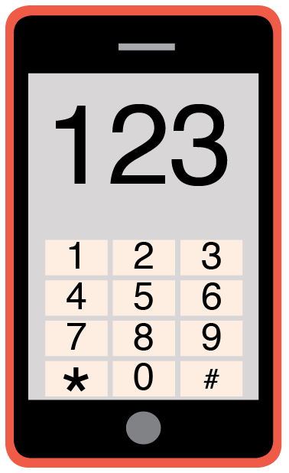 | You may have questions about this letter.  Please phone me on Add phone number here to talk about this warning letter.

Yours sincerely,

Add name here
Add role here

Add cc. Parent/Carer here

