Contact: |  | Add your logo here
Direct Tel:
Fax:
email:
Your ref:
Our ref:

Private and Confidential
Add parent/guardian here if applicable
Add name here
Add address line here
Add address line here
Add address line here
Add post code here

Add date here

Dear Add name here

Pre-Court Letter: Police Surgery Meeting

I am a Police Officer working with Add organisation here.
I need to see you for a meeting.

Your parent, carer or another ‘appropriate adult’ must also come to the meeting when you are under 17 years old. An ‘appropriate adult’ is someone:

- 18 years old or older
- Not part of what you did wrong and against the law
- Who checks you are ok in the meeting
- Who helps you understand what is said in the meeting

The work you did with Add organisation here means you may get a Add pre-court programme here. Add Police Officer name here can give you this at the meeting.

Please come to the meeting:

Place: Add place here
Date: Add date here
Time: Add time here

Please let me know first when you have a very good reason for not coming to this meeting.

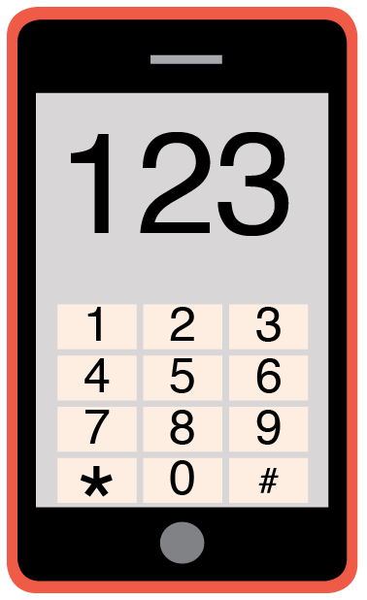 | Please phone me on Add phone number here to talk about any problems you have coming to this meeting.

When you miss the meeting and have no good reason you may get into more trouble with the court.

Yours sincerely,

Add name here
Add role here

Add cc. Parent/Carer here

