Contact: |  | Add your logo here
Direct Tel:
Fax:
email:
Your ref:
Our ref:

Private and Confidential
Add parent/guardian here if applicable
Add name here
Add address line here
Add address line here
Add address line here
Add post code here

Add date here

Dear Add name here

Pre-Court Letter: First Meeting

I work for Add organisation here . You said you will work with us on a Pre Court Programme.

I need to see you and your parent or carer for a meeting.

Please come to the meeting:

Place: Add place here
Date: Add date here
Time: Add time here

Please let me know when you can’t come to this meeting. You must have a very good reason for not coming to this meeting.

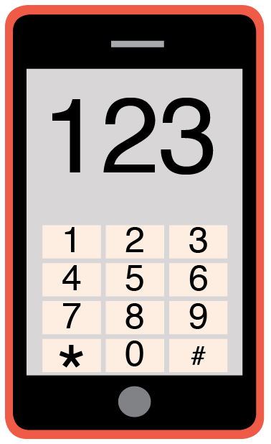 | Please phone me on Add phone number here to talk about any problems you have coming to this meeting.

Yours sincerely

Add name here
Add role here

Add cc. Parent/Carer here

