Contact: |  | Add your logo here
Direct Tel:
Fax:
email:
Your ref:
Our ref:

Private and Confidential
Add parent/guardian here if applicable
Add name here
Add address line here
Add address line here
Add address line here
Add post code here

Add date here

Dear Add name here

ISS Letter: First Meeting

I work for Name of Organisation. The court gave you a Court Order. The court said that you must do some work with us. This work is called Intensive Supervision and Surveillance (ISS).

I need to see you and your parent/guardian for a first planning meeting. In our first meeting we will talk about:

- The work you must do with us
- Any questions you have
- Our rules for the work

We will all make a plan. This will help us know what to do to help you.

The people who work with you may also come to the meeting.

Please come to the meeting:

Place: Add place here
Date: Add date here
Time: Add time here

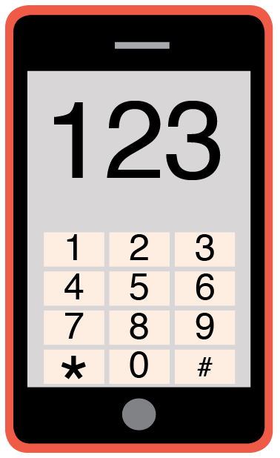 | Please phone me on Add phone number here to talk about any problems you have coming to this meeting.

Yours sincerely,

Add name here
Add role here

Add cc. Parent/Carer here

