Contact: |  | Add your logo here
Direct Tel:
Fax:
email:
Your ref:
Our ref:

Private and Confidential
Add parent/guardian here if applicable
Add name here
Add address line here
Add address line here
Add address line here
Add post code here

Add date here

Dear Add name here

Health Letter: Meeting with a Health Professional

I am a Health Professional Job Title working with Add organisation name here. I work for the NHS.

Add name here asked me to see you about your health. This may be about your physical (body) health and or your mental (feelings) health.

The meeting is confidential - what you tell me is private.
You say what information is ok for me to share with other people working with you.

Please come to the meeting:

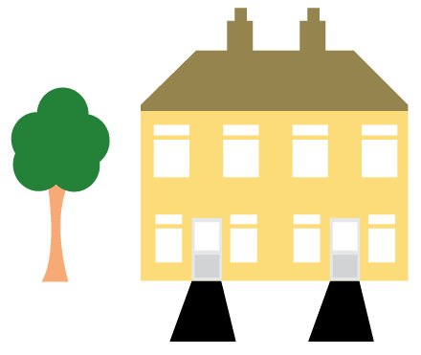 | Place: Add place here
 | Date: Add date here
 | Time: Add time here

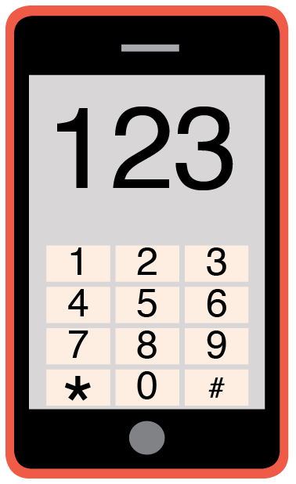 | Please phone me on Add phone number here to talk about any problems you have coming to this meeting.

Yours sincerely,

Add name here
Add role here

Add cc. Parent/Carer here

