Contextual Safeguarding May 2020
Reframing Language
Language should always consider young people's lack of ability to control exploitative situations and should recognise and be responsive to trauma resulting from the harm they have experienced. Describing children/young people’s experiences that implies that they are complicit or responsible for the exploitation they suffer or crimes they may be victim of, should always be challenged.

Definition of Contextual Safeguarding (Firmin, 2017)
Contextual Safeguarding is an approach to understanding, and responding to, young people’s experiences of significant harm beyond their families. It recognises that the different relationships that young people form in their neighbourhoods, schools and online can feature violence and abuse. Parents and carers have little influence over these contexts, and young people’s experiences of extra-familial abuse can undermine parent-child relationships. Therefore, children’s social care practitioners need to engage with individuals and sectors who
do have influence over/within extra-familial contexts, and recognise that assessment of, and intervention with, these spaces are a critical part of safeguarding practices. Contextual Safeguarding, therefore, expands the objectives of child protection systems in recognition that young people are vulnerable to abuse in a range of social contexts.

Extra Familial Harm is the term used
When young people's experience of harm is beyond their home, family or carers.
For example:
- Sexual Exploitation
- Criminal Exploitation
- Serious Youth Crime
- Radicalisations
- Bullying and Isolation
- Teenage Relationship Abuse

Introduction to Contextual Safeguarding Approach

Contextual Safeguarding is an approach developed by Dr Carlene Firmin and her team at the University of Bedfordshire to understand, and respond to, young people’s experiences or significant harm beyond their families.

Domain Four - Outcomes
How do we measure the impact of the work that we’re doing? Using a contextual
safeguarding approach, we are looking for the context to change not just the
behaviour of the individual.
The risk is reduced in the context where the harm occurs:
- School
- Peer group
- Park

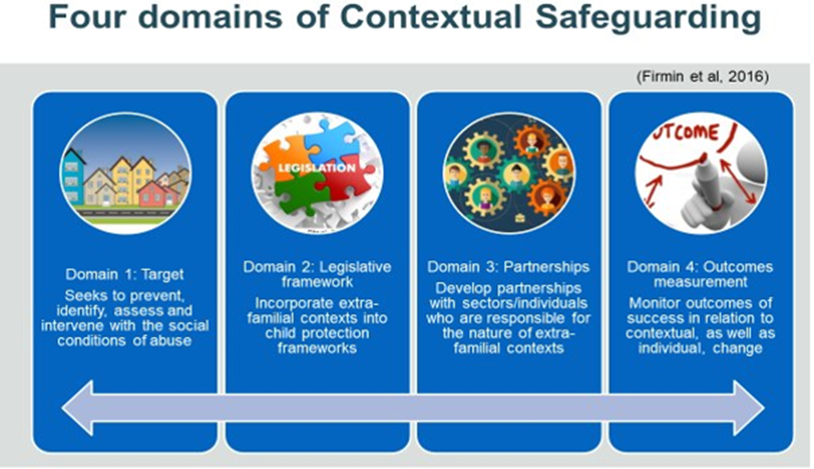
Domain One – Target: In a Contextual Safeguarding approach, the professionals target the context where children or young people are at risk of harm. They need to identify, assess and intervene within the context. For example, in a park, once assessed the intervention could possibly be detached youth work or a physical intervention such as improved lighting
Domain Two - Legislative Framework: In a Contextual Safeguarding approach to addressing extra familial harm it is important to recognise this is a child protection / safeguarding issue whether the abuse occurs in the family or on the street. Processes and frameworks should employ a welfare led approach

Domain Three – Partnerships: A Contextual Safeguarding approach assesses who has capacity to safeguard in the context where the harm is happening, creating potentially 'new' partners that can reach into contexts where young people spend time, such as young people's peers, bus drivers, teachers and rubbish collectors
Domain Four – Outcomes: Individual outcomes are important however outcome measurement in contextual safeguarding includes the context changing to become safer

Mesosystem — The second layer from the individual, surrounding the microsystem and encompassing the different interactions between the characters of the microsystem. For example, the relationship between the individual’s family and their school teachers or administrators. In order for an interaction to be considered part of the mesosystem, it has to be a direct interaction between two aspects of the microsystem that influences the development of the individual.

Definition
Take from sway

https://contextualsafeguarding.org.uk/
Contextual Safeguarding Interventions
Safety Mapping - Safety mapping helps practitioners to understand young people’s
experiences of places they feel are safe and unsafe and supports practitioners to create a safety plan with young people.

Peer Mapping - This is a tool that can be used flexibly with either a child or young person or within a professional risk management meeting to map and assess the context of peers, the aim being to draw out strengths, risks and vulnerabilities in the peer setting to ascertain information for an assessment and consider from that information what interventions would be useful in a plan to make this context safer.

Examples of Interventions with or by Partners
- Pop-up youth club in a library to engage young people using the library
for the wi-fi
- A deputy manager in a branch of a supermarket gave an example of a 15-year-old boy running into the shop with three stab wounds, she said local young people knew her by name and trusted that she’d act to keep them safe, she suggested that the shop had bright lighting and was open 24-hours which she felt meant young people felt safe
- Training to McDonalds staff around CSE and how to refer to social care
- Training of hotel staff in coastal towns to spot signs of sexual exploitation

for more information

