The following process can be followed by Foster Carers providing Staying Put to young people where it is agreed for the young person’s rent to be paid directly from Universal Credit.
- Go to the following website:
https://directpayment.universal-credit.service.gov.uk/

- Click on ‘Start now’ – the following page will show:

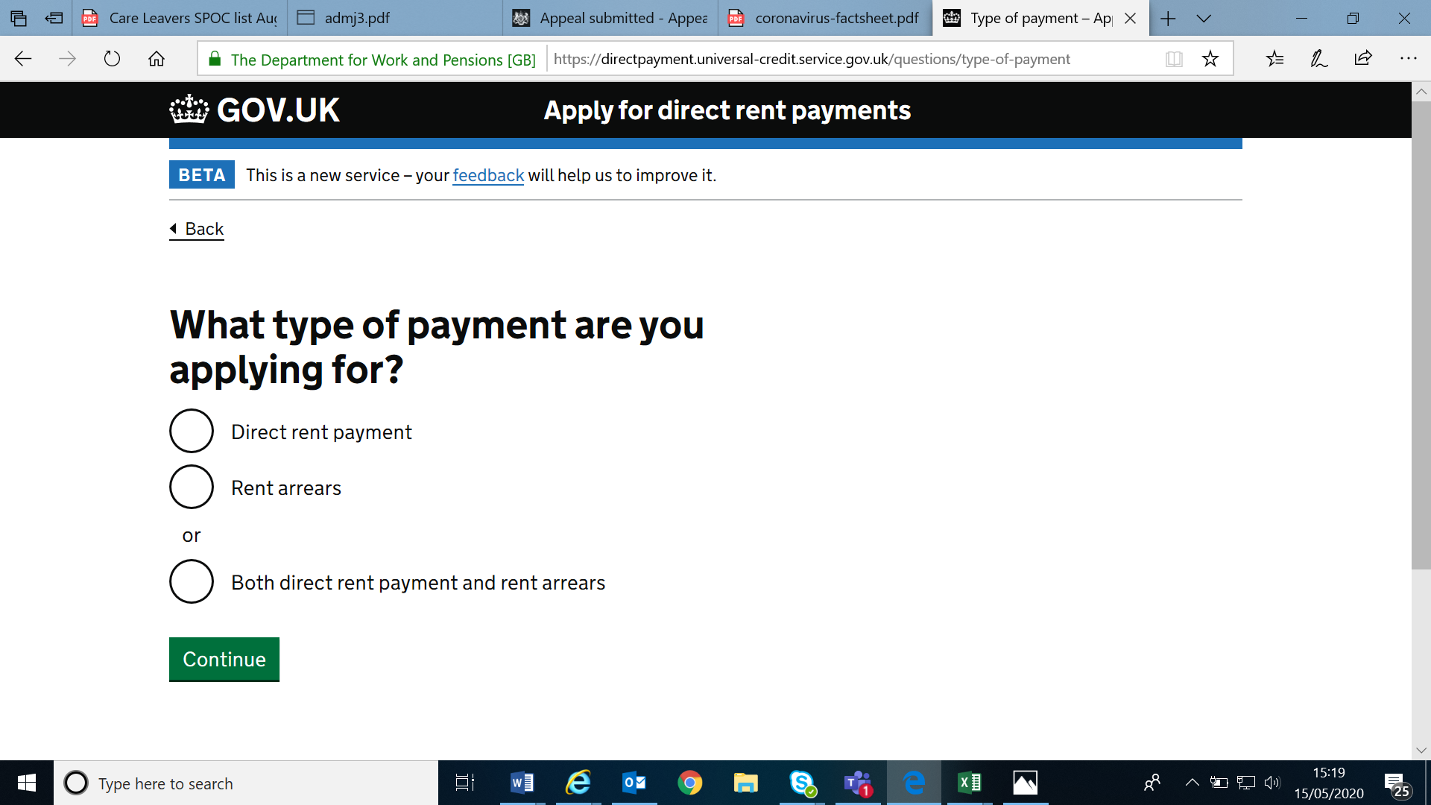

- You can either select ‘direct rent payment’ or ‘arrears’ or both and then click on continue
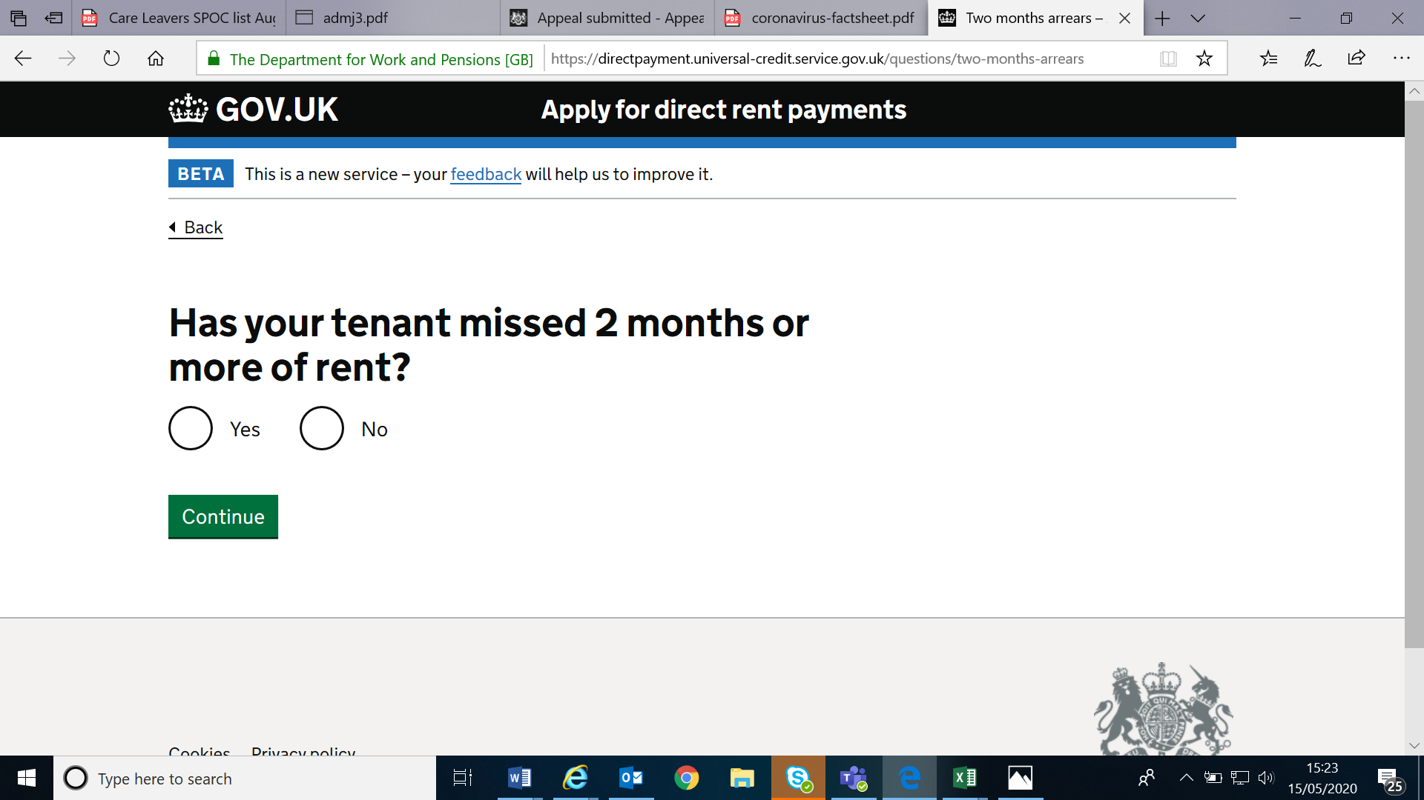
- If your young person isnt in 2 months rent arrears click ‘no’ and ‘continue’
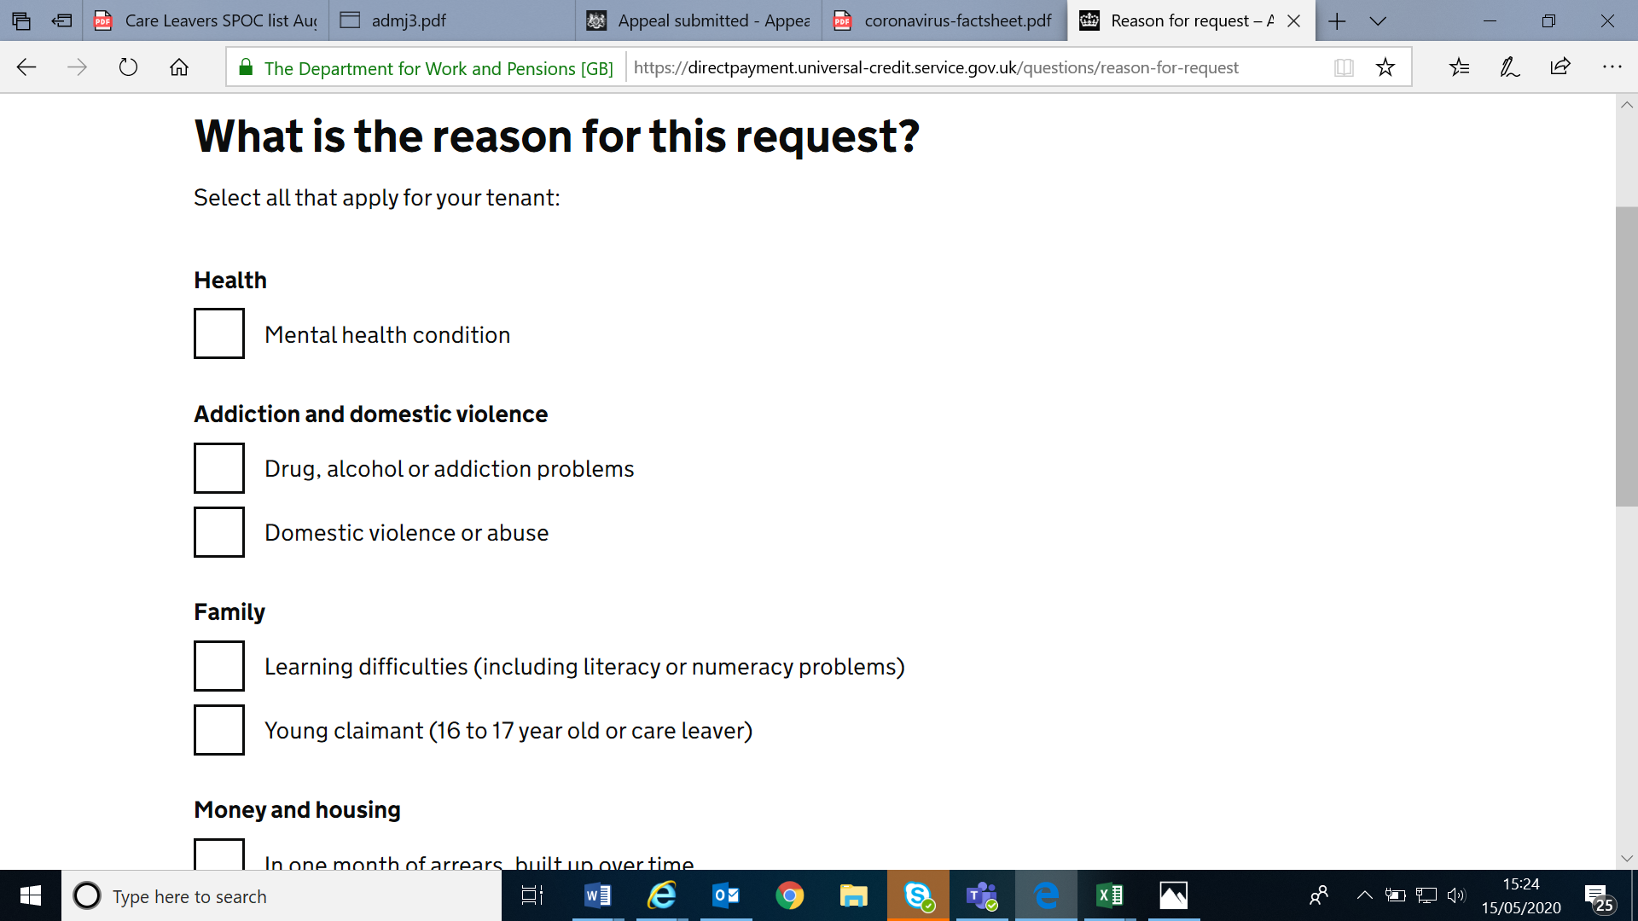
- Click on the ‘young claimant(16 to 17 year old or care leaver)’, scan down and click on ‘continue’

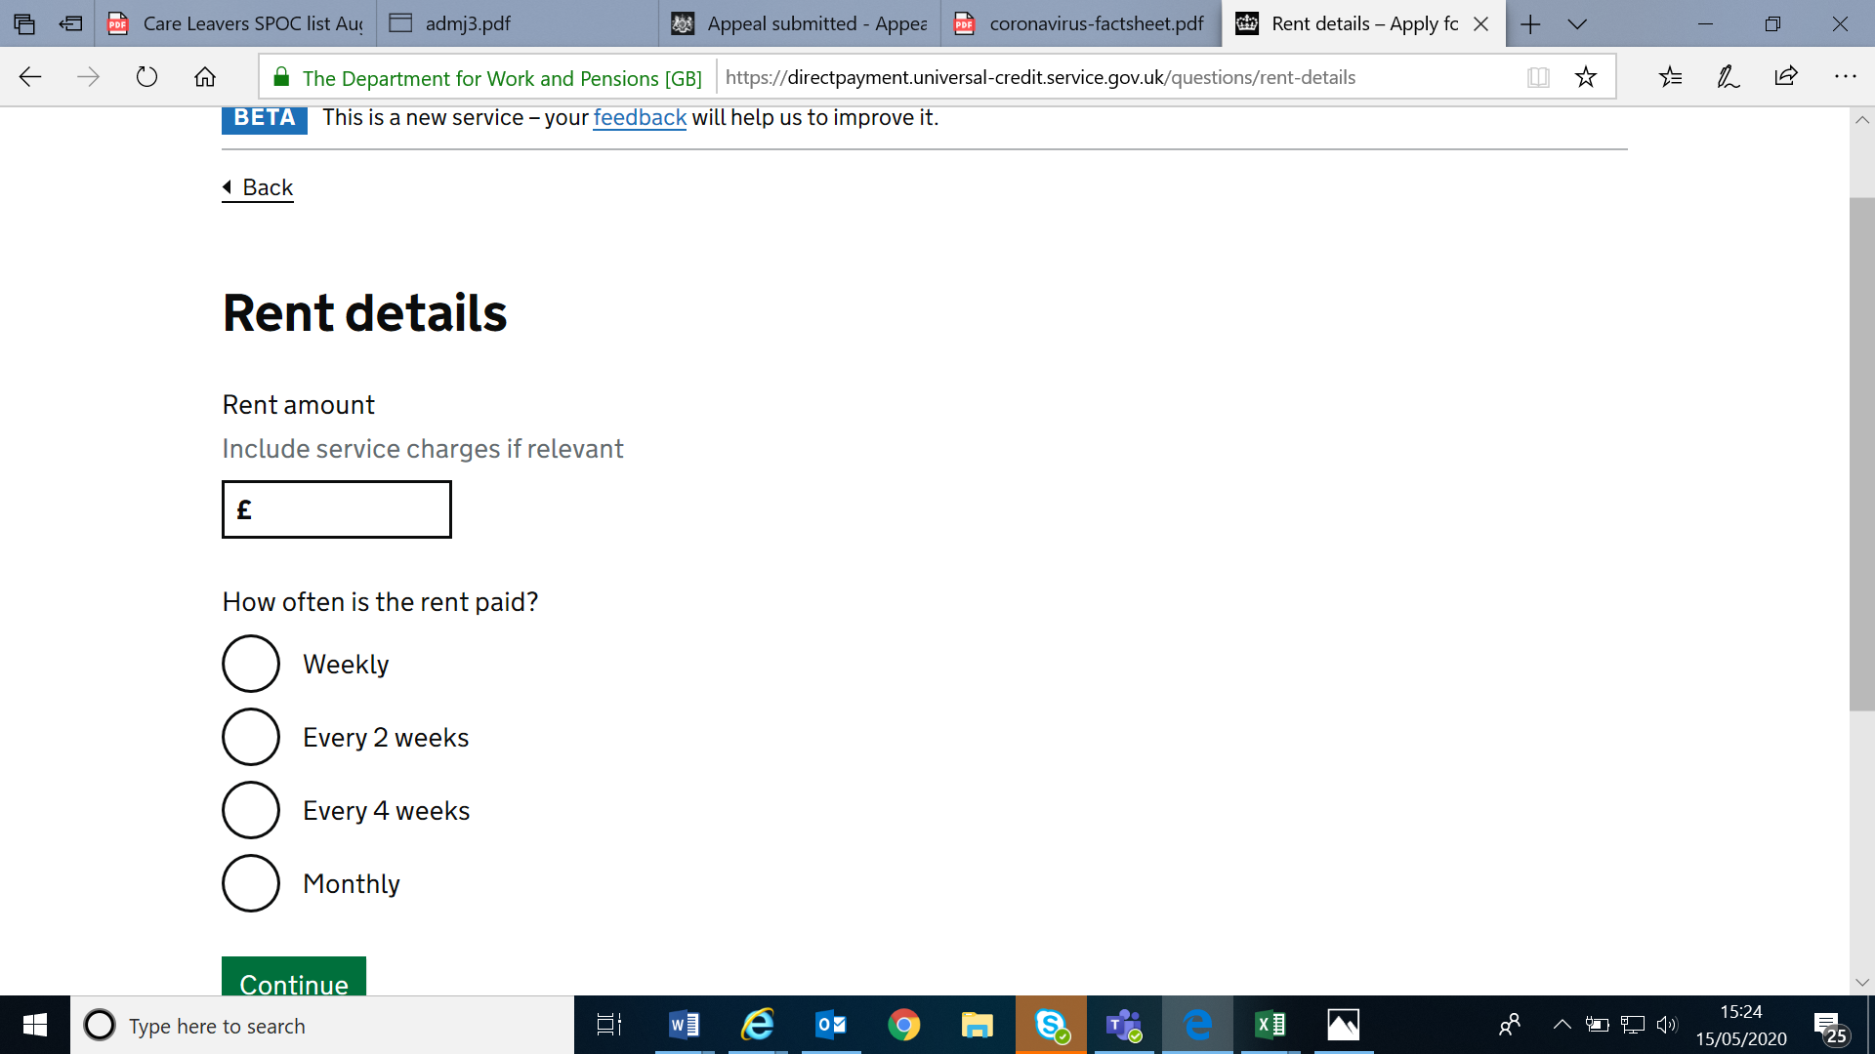
6. Put down the rent amount and period and click on ‘continue’
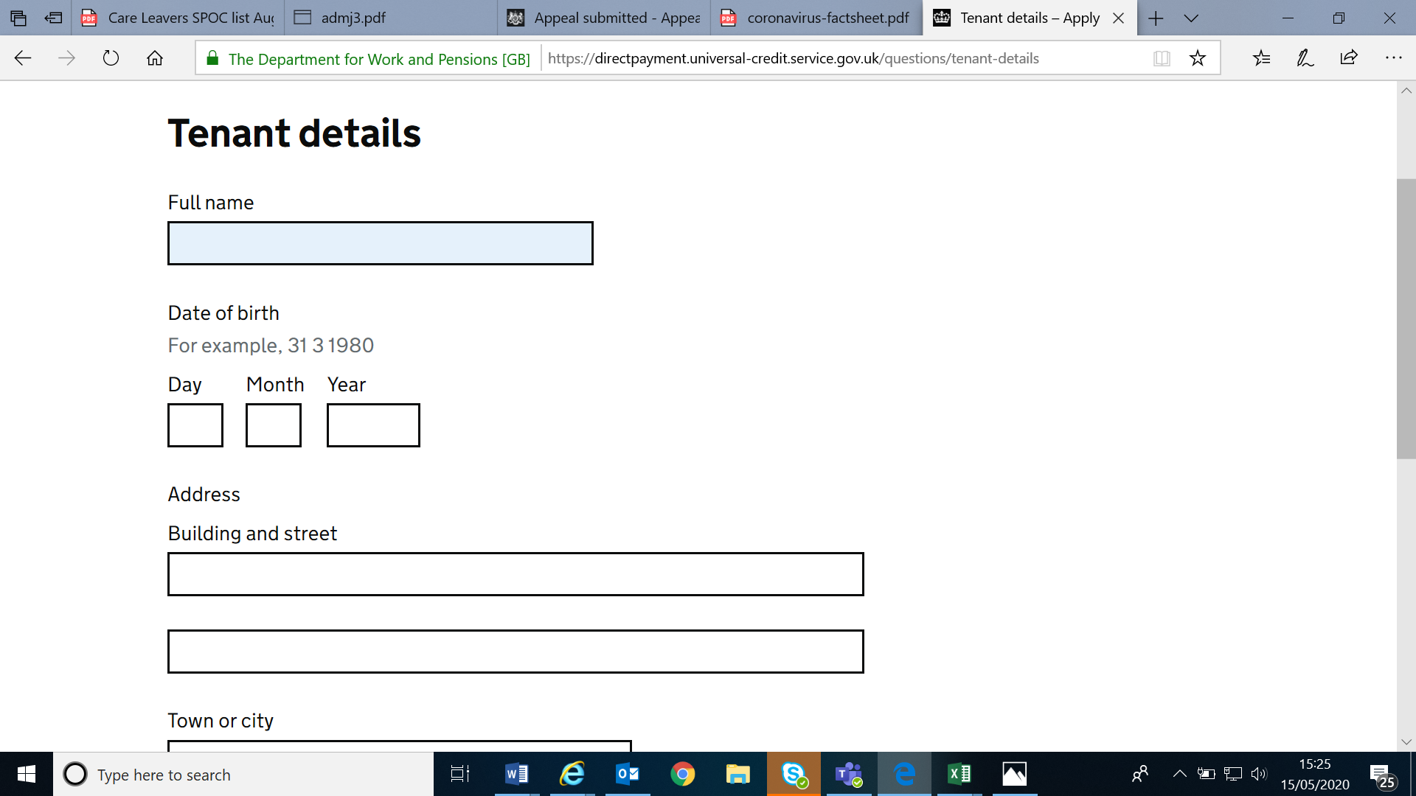

7.All the young persons details go on this page – name, address and date of birth – and click ‘continue’

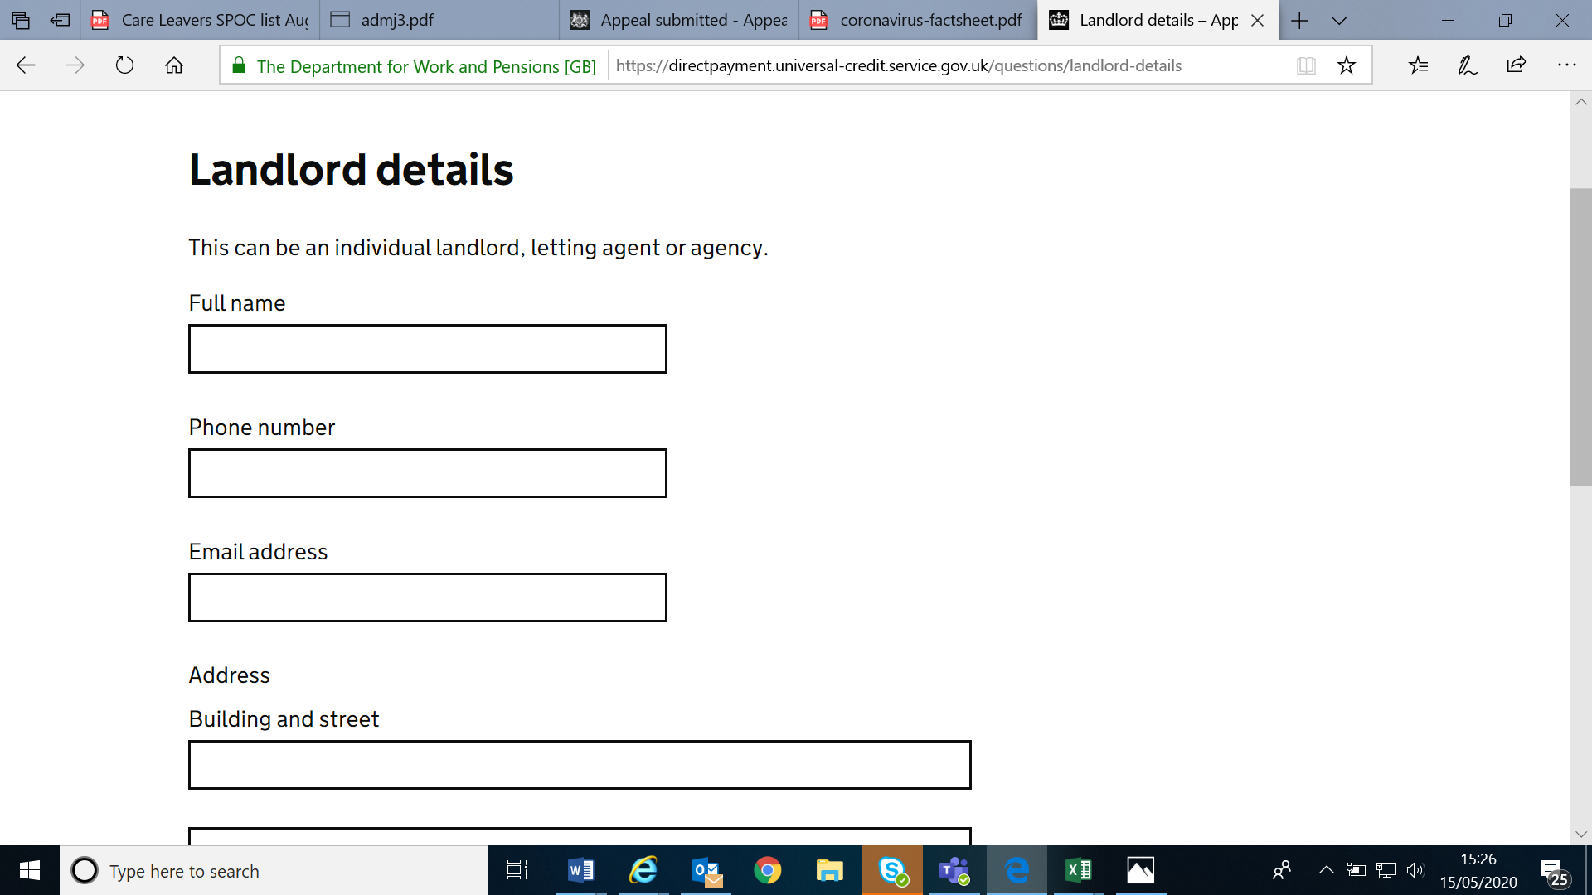
8.All your details go on this page – name, address etc – and click ‘continue’

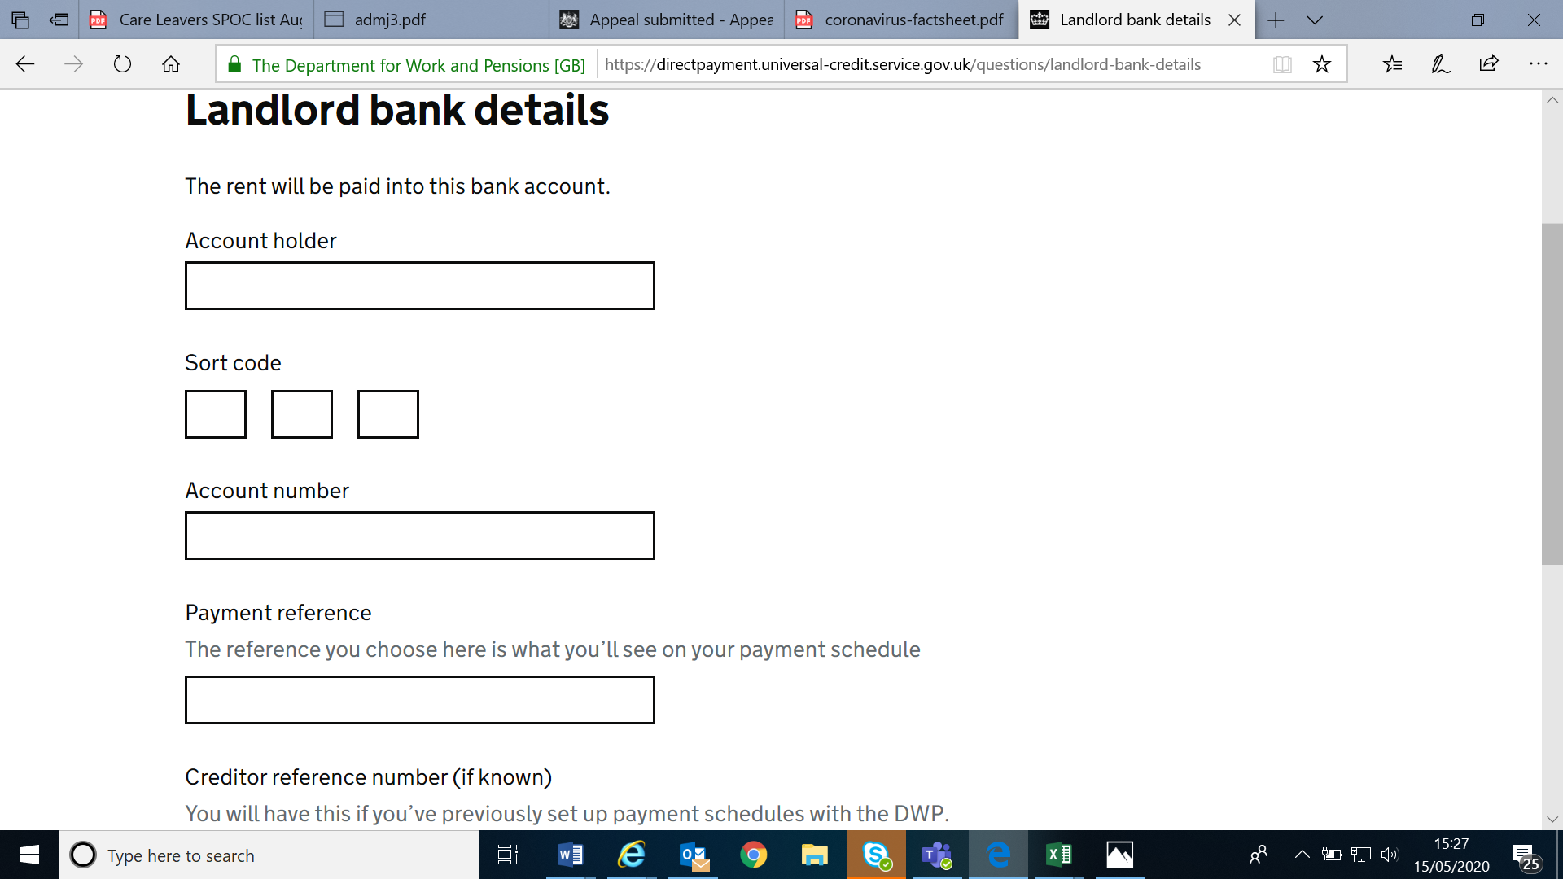
9. Your bank details go here. You can use any payment reference number you like. Leave the creditor reference number blank. Click ‘continue’
10. you can now check all your answers (make any necessary changes) and then press submit

