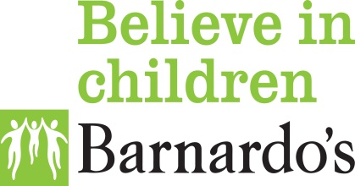
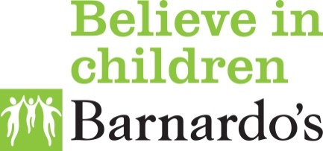

CAFIS- Connecting Adopted Families Independent Services on behalf of Kent Councy Council
Who am I? Some questions and answers for young people who wonder ‘who am I’.
Q. I often wonder about my birth family but I do not know how to mention them to my parents?
A. It is very common for adopted young people to wonder about who they are and who they look like but not know how to speak about it to their parents- you don’t want to upset them right! CAFIS can support young people and adopters look at getting information about their birth family and supporting in setting up contact. So call us and we will do our best to assist.
Q. Why do I care about my birth family, they abused me when I was little?
A. Your birth family are your birth family and it is very natural to feel ashamed or even angry at caring enough to know about them. It is also very natural to want to know who they are; getting to know someone is not just about how they behave. CAFIS can support you in asking questions that you would like answers to. CAFIS will work with you, your family and your birth family to try and get these questions answered.
Q. I have older siblings who are in care, I remember that they were the ones who looked after me, I want to see them and know they are okay but if I do my birth parents may find out and know where I live.
A. Before any contact is set up the situation for all is risk assessed, supervised direct contact can be as safe as indirect contact. We at CAFIS can support with this. CAFIS find that many young people in care do not have contact with birth parents and even if they do, they, like you, don’t want the birth parents having identifying information as they want to protect younger siblings.
Q. I have been contacted by someone on Facebook/Xbox/Instagram/other Social Media. I am sure it is my birth mother/father/sibling/other relative, I told them to go away but they keep messaging. I would like to have some contact but I think my parents would be very upset. Should I message in secret?
A. Contact is very complex and everyone has different needs and expectations. We at CAFIS have found that contact that is arranged without support is more likely to go wrong and relationships damaged. Even when adopted adults come to us and ask us to make contact with birth relatives, this is done in a planned way. Many adopted adults do not meet their birth relatives until they have been able to consider all of the reasons why they were adopted. Contact is supported until everyone feels comfortable with each each other and relationships are rekindled or established. Although you are related you may still feel like strangers and will need time to build a relationship again.
If you need help to talk to your parents then we can support you.
Q. I want to talk to someone about contact but I am really worried about my parents. How do I tell that I need to know more about my birth family whilst still loving and needing them?
A. You are not alone; many adopted young people have wishes and needs concerning birth relatives. If you don’t feel able to talk to your parents get a trusted adult to assist, a school teacher, counsellor an adult at a club you attend, post adoption support or us at CAFIS. You could even get a friend to call us on your behalf. Remember being curious about who you are is completely natural. There are many people who can assist you with what we call difficult situations; your parents will want what is best for you and to protect you.
If you have a question about current contact; setting up contact or looking at possible future contact, please do call or email us and we will do our very best to support you .
Our email address is cafiskent@barnardos.org.uk, this is our preferred method but you may also call us on 01795- 532081 and your details will be put on our duty system and an experienced worker will call you to discuss your needs in more depth.

