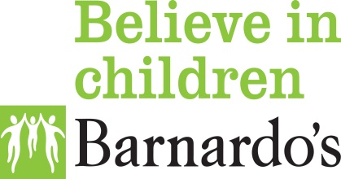
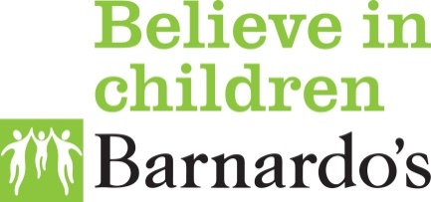

CAFIS- Connecting Adopted Families Independent Services on behalf of Kent County Council
CAFIS provides a number of services on behalf of Kent County Council. This leaflet concerns:
Indirect and direct contact:
Indirect and direct contact is usually set up for children who are subject to a Special Guardianship Order or Adopted to maintain links with their heritage. This can be between adoptive parents, children and birth relatives or someone else with whom they have a significant relationship. Usually contact is agreed prior to any order and set up fully once the order is granted. Sometimes contact is not set up at the beginning, but can be set up at a later date.
Support
CAFIS is made up of a small team of Social Workers, Project Workers and Administrators all of who are able to sign post you in regard to your enquiry so you get the support you need. This may be with writing a letter, looking at making changes to current contact arrangements or setting up new contact arrangements, or information about accessing more intensive support. Contact set up at the beginning often needs adapting as children get older, some may need a break whilst others need increased contact.
There are times when children and young people either make contact or are contacted themselves through Facebook, Xbox, Tik Tok, Instagram and other social media or gaming sites. If dealt with quickly and with support, arrangements can be made to ensure that any contact on-going is supported and the focus remains on the needs of the child/young person.
Contact is a complex issue and has many dimensions and facets. The contact journey can be an emotional roller-coaster for children, parents and others involved. We understand this at CAFIS and can assist you to support a smoother, less stressful journey.
If you have a question about contact please do call or email us and we will do our very best to answer them; whether this is about current contact, setting up contact or looking at possible future contact.
Our email address is cafiskent@barnardos.org.uk, this is our preferred method but you may also call us on 01795- 532081 and your details will be put on our duty system and an experienced worker will call you to discuss your needs in more depth.

