**Preparing for Adulthood team**

13 25

**-**

Young Person Disability Service

We offer information, guidance and

short-term assistance to support you to reach your ambitions.



www.southglos.gov.uk/PFA

The PfA team supports young people to achieve and sustain greater personal independence and access local provisions/services that keep young people living and thriving within their community.  We prioritise the young person’s voice, advocate for them and listen to their aspirations, whilst supporting the Local First framework.  Linking up with local resources, we provide signposting, to enable young people to achieve their goals.  Young people with an ECHP or social care practitioner can be referred to our short term service by a professional.



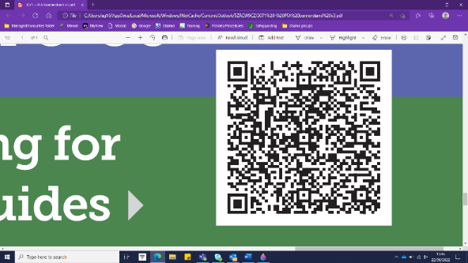

Scan me for the PfA booklets

The team works across the four pathways to adulthood to help young people:

Offer support and guidance when considering next steps. Gain skills and prepare for further education, employment, training or volunteer work.

Guide and support young people to develop skills that allow them to live independently.

* Help young people feel a part of their community, build confidence, and make friendships. Travel training is embedded in this pathway.

Guide young people to stay safe, maintain wellbeing and remain healthy.  Connect young people with health or wellbeing services where appropriate.

Travel training – PFA Team support young people to develop the skills and awareness they need to travel independently in a confident and competent manner. Travel training is practical, offered with 1:1 support, community based and specific to an identified destination. Routes may consist of walking, crossing roads and using public transport. To make an enquiry email: TravelTraining@southglos.gov.uk