[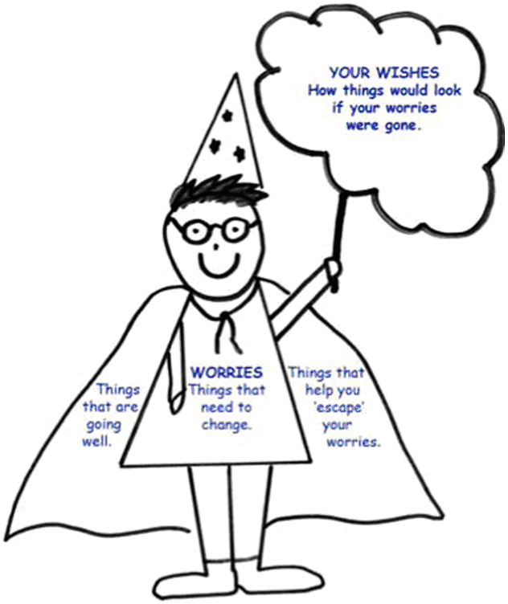](https://www.google.co.uk/url?sa=i&rct=j&q=&esrc=s&source=images&cd=&cad=rja&uact=8&ved=2ahUKEwjOk7KMhqneAhWQUlAKHfO0A3AQjRx6BAgBEAU&url=https://www.norfolklscb.org/children-young-people/signs-safety/&psig=AOvVaw1X0PNutBk7qknDIIUWWc-m&ust=1540813048477964)

[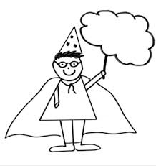](http://www.google.co.uk/url?sa=i&rct=j&q=&esrc=s&source=images&cd=&ved=2ahUKEwjE14enhqneAhVPKVAKHYcCBlUQjRx6BAgBEAU&url=http%3A%2F%2Fwww.bucks-lscb.org.uk%2Fwp-content%2Fuploads%2FProfessionals%2FEarly%2520Help%2520Toolkit%2FFINAL-VOICE-OF-CHILD-BOOKLET.pdf&psig=AOvVaw1X0PNutBk7qknDIIUWWc-m&ust=1540813048477964)