**LETS TALK ABOUT**

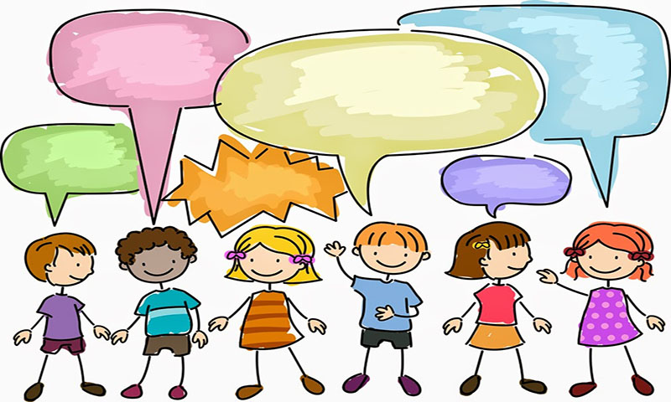

**ME**

These pages have been put together to help a child share information about themselves in a non-threatening manner.

They are also useful tools for practitioners to use to get to know a child, start difficult conversations, have fun and build a relationship with the child.

Over time these pages can be put together to make a book which the child can share with their family or carers.

The key message is that children are important and worth investing in. Sometimes their voices get lost amidst family chaos, providing them with regular space to have fun and undivided attention can act as a major boost to their self-esteem.

Sharing information about yourself can be helpful to a frightened child, however this should be neutral information which is appropriate to share ie I don’t like spiders

All About Me tools help to provide positives and strengths that can be built upon. These tools work well with Signs of Safety.

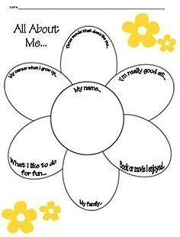

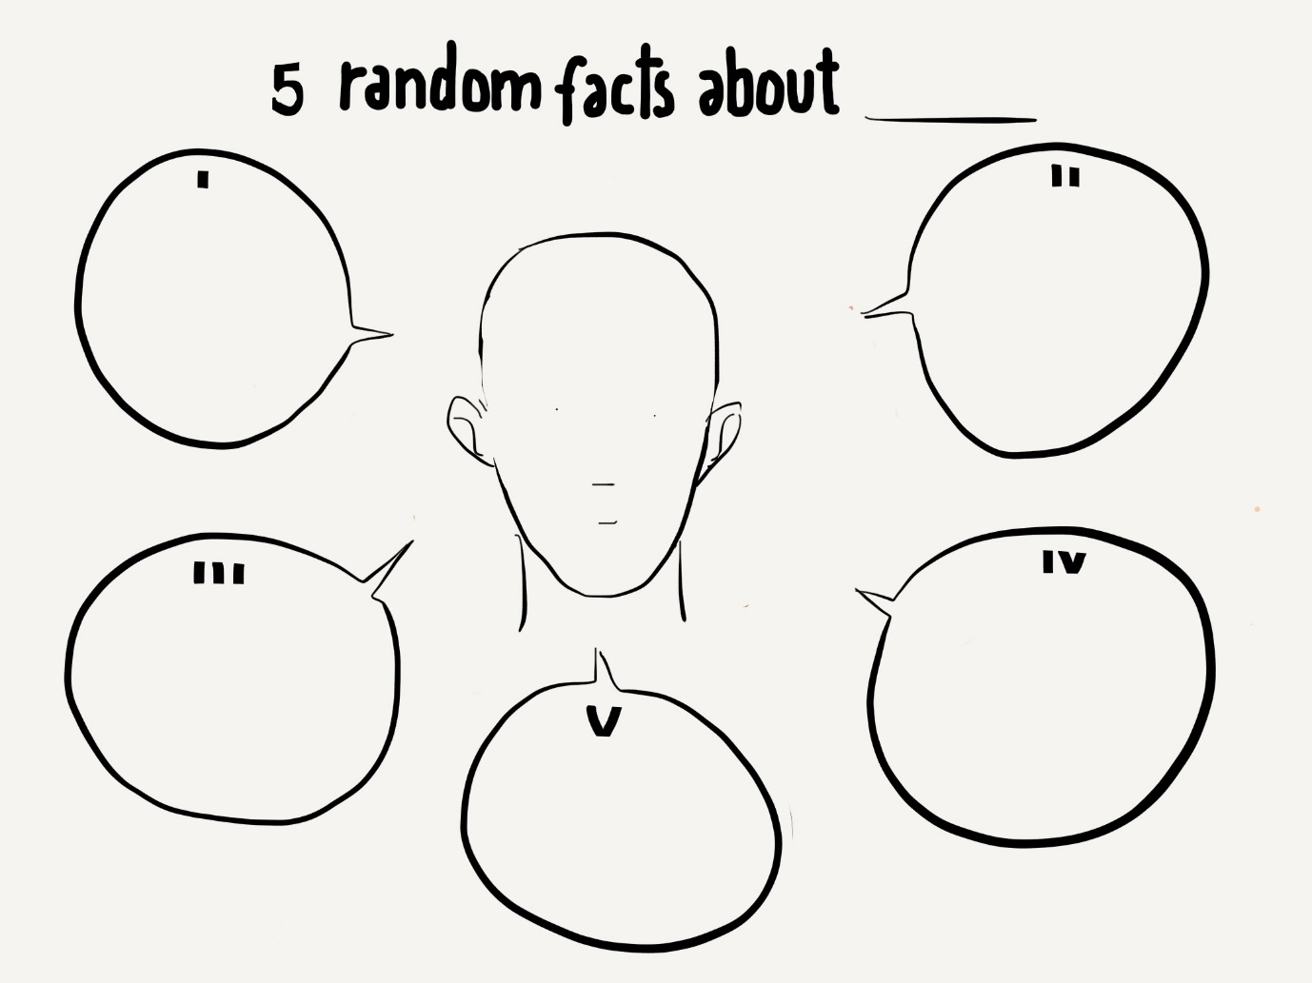

[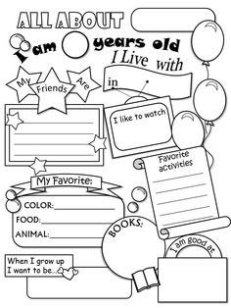](https://www.google.co.uk/url?sa=i&rct=j&q=&esrc=s&source=images&cd=&ved=2ahUKEwiNsbXVk6feAhURElAKHc3iCx4QjRx6BAgBEAU&url=https://twitter.com/socialworktools/status/723401297676791808&psig=AOvVaw0KlmUMjQGvV_bS5bV4Qwqh&ust=1540747965689023)

**[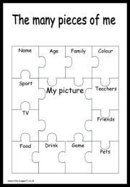](http://www.elsa-support.co.uk/the-many-pieces-of-me/)**  
[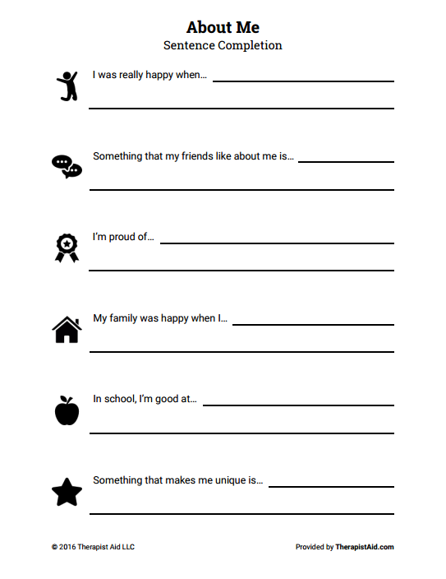](https://www.google.co.uk/url?sa=i&rct=j&q=&esrc=s&source=images&cd=&ved=2ahUKEwiJt4qZlafeAhXGPFAKHVzCC9wQjRx6BAgBEAU&url=https://positivepsychologyprogram.com/self-esteem-worksheets/&psig=AOvVaw2Tf2giZJ6B_VHEVzje6l2i&ust=1540748390990129)



