PRACTICE TIPS – DEVELOPING AN AWARENESS ON BRAIN DEVELOPMENT. – Feb 2019
This Practice Tip has been put together to assist you in your assessment of pre-birth and or post birth assessment. The aim is to provide an overview of research and findings with regards to understanding how care, lifestyle and environment can impact on the development of baby’s brains.
This Tip sits alongside other Impact Documents and the Toolkit for understanding Emotional Harm and Neglect
What and How?
Impairment of the brain can occur through maltreatment/harm. Early identification of this is essential if we are to optimise the child’s opportunities for recovery.
The brain is made up of millions of neurones. Synapses join the neurones to enable healthy brain functioning, ie the transmission and transference of information. Unhealthy brain functioning occurs when the synapses are broken and the brain cannot make sense of the information being provided.
As a small baby the brains main function is to enable survival, this includes breathing, eating sleeping, waking and interacting. Each experience strengthens and builds the synapses, thus facilitating brain development and even more awareness of the world, people and stimuli.
If these functions are interrupted or are not reinforced, the synapses become weak and break. Neglect and maltreatment are the main cause of this harm. Where Babies are repeatedly exposed to maltreatment their brain reverts back to survival mode and growth and development becomes impaired.
Brain function
Healthy Brain Functioning Unhealthy Brain Functioning
The inverted pyramid demonstrates how the brain functions when in a healthy state. There is capacity to use the brain to learn, develop, explore, socialise and interact with the environment. However the pyramid on the right demonstrates how the functioning changes within the brain when exposed to high levels of stress. The brains primary function at this time reverts to survival with limited capacity to develop other healthy traits.
In babies and children this heightened level of stress may be demonstrated via flight, fight or freeze. Observations play a major role in assessment in terms of how the baby demonstrates these responses and how long for. The frequency and intensity of this stress is what causes long term damage.
In order to grow and develop we know that Babies need reasonable levels of stress that they can manage, and learn coping strategies from, they need a safe secure base and an adult to rely upon. They need interaction with people and things, in order to develop curiosity and an understanding as to how the world functions. If this does not occur consistently the part of the brain waiting to receive this information starts to shut down, as a result the size and growth of the brain becomes compromised which affects future physical, emotional and cognitive development.
An X-ray to demonstrate the difference in brain size of a child with normal development and experiences versus a child that has been exposed to extreme neglect.
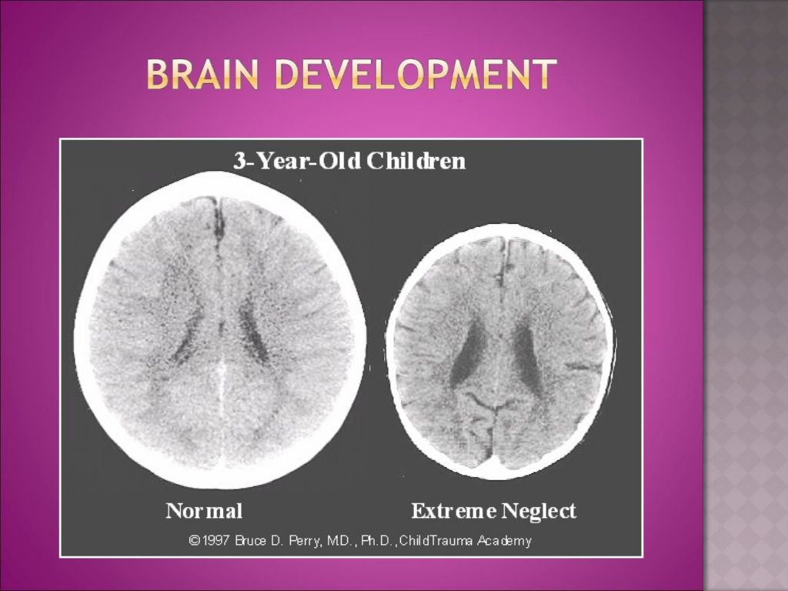

Response to Stress
We all need stress in order to learn how to respond to it. The Centre for the Developing Child at Harvard University has undertaken a number of studies into brain development and Adverse Childhood Experiences, and describes the impact of stress as below, using a traffic light system of Green- healthy a positive response, Amber – borderline as a tolerable response and Red – unhealthy, a toxic response.
Positive stress response is a normal and essential part of healthy development, characterized by brief increases in heart rate and mild elevations in hormone levels. Some situations that might trigger a positive stress response are the first day with a new caregiver or receiving an injected immunization.
Tolerable stress response activates the body’s alert systems to a greater degree as a result of more severe, longer-lasting difficulties, such as the loss of a loved one, a natural disaster, or a frightening injury. If the activation is time-limited and buffered by relationships with adults who help the child adapt, the brain and other organs recover from what might otherwise be damaging effects.

Toxic stress response can occur when a child experiences strong, frequent, and/or prolonged adversity—such as physical or emotional abuse, chronic neglect, caregiver substance abuse or mental illness, exposure to violence, and/or the accumulated burdens of family economic hardship—without adequate adult support. This kind of prolonged activation of the stress response systems can disrupt the development of brain architecture and other organ systems, and increase the risk for stress-related disease and cognitive impairment, well into the adult years.
When toxic stress response occurs continually, or is triggered by multiple sources, it can have a cumulative toll on an individual’s physical and mental health—for a lifetime. The more adverse experiences in childhood, the greater the likelihood of developmental delays and later health problems, including heart disease, diabetes, substance abuse, and depression. Research also indicates that supportive, responsive relationships with caring adults as early in life as possible can prevent or reverse the damaging effects of toxic stress response.
When planning for children we must consider their timeframe for recovery, plans need to be developed to reflect the child’s needs.
When undertaking assessments we must explore and evaluate the parents own childhood experiences to ascertain what adversity, if any they bring to the parenting role.
Other influences on the parent including stress, depression, Domestic Abuse, isolation, ill health, substance use etc may be a feature in their life and there is a risk they can be transferred onto the baby, therefore assessments must analyse current resilience and strengths, and how these can be developed and built upon.

ADDITIONAL INFORMATION
https://developingchild.harvard.edu/resources/inbrief-science-of-ecd/
https://www.childcare.co.uk/information/baby-brain-development
https://www.adam-mila.com/brain-development-children-0-6-years/

These tips sit alongside those relating to Emotional Abuse and Emotional Neglect, Attachment, Aces, Impact and Understanding Childhood Experiences, Domestic Abuse Toolkit

