LETS TALK ABOUT -
PLANS

One day there was a boy and a girl. The grown-ups who knew the boy and girl were worried because they did not think the boy and girl were happy, safe and well. | A social worker came to talk to the boy and  the girl. They talked about how the social  worker could help them and their family, so they could be safe, happy and well. | The social worker went to a meeting with all the grown-ups that knew the boy and girl.  The grownups talked with the parents and together they made a plan about how they could support them to look after the boy and girl and keep them safe and happy.
The plan explained what needed to happen next and who was going to help the family do the things that needed to be done | T  T  The social worker shared the plan with the boy and girl, and explained that everyone was working together to help their family keep them safe and happy | 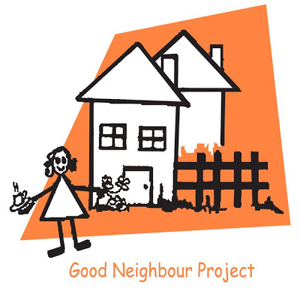  The social worker made a little plan with the boy and girl that if they were worried they could contact a special person. The boy and girl chose Annie their neighbour as the special person.

If you were worried, who could be your special person?.....................................
How would you let them know you had some worries?.....................................
What do we need to do to make that happen?.....................................................

March 2019.

