Passport to independence GUIDANCE

Introduction
This Guidance has been drafted to help young people, carers and professionals understand the principles and processes around competing the passport to independence.
This Guidance sits alongside the passport to independence template (revised June 2021).
Within this Guidance there is information for young people, carers, and professionals.
The primary aim of pathway planning and the passport to independence is to promote a gradual transition for young people from being Looked After to adulthood and independent living. This guidance alongside the passport itself focuses on how best to help young people successfully transition into independent living by enabling and supporting them in every area of their life.
This guidance highlights the core responsibilities of the corporate parent, and how in South Gloucestershire we work in a relationship-based manner to enable young people to achieve autonomy and positive outcomes within their lives.
This guidance includes;
- Passport to independence – Young persons guide
- Passport to independence -Roles and Responsibilities (information for workers and carers)
- Passport to independence - Process flow chart

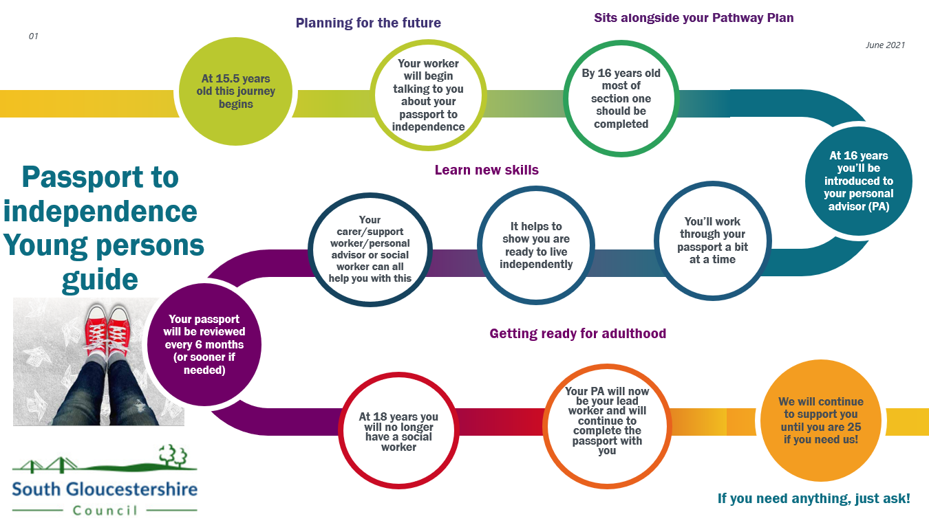

ROLES AND RESPONSIBILITIES RELATING TO THE PASSPORT TO INDEPENDENCE.

ROLE | RESPONSIBILITY
YOUNG PERSON | The young person has an active role in completing the passport to independence and will need to be able to demonstrate that they have successfully achieved each part as far as possible. Evidence could include feedback from their carer, or observations from the PA or Social Worker.
CHILD CARE SOCIAL WORKER | It is the childcare social workers responsibility to ensure that Section 1 – Personal Information & Identity, within the passport to independence is completed as far as possible by the time the young person turns 16 years old.  Childcare social workers should also ensure, as far as possible that young people have a clear understanding of their family and their care history, including life story work before they are transferred to the Transitions to Independence Team (TTI).  The passport to independence should be started alongside the first pathway plan (before the young person’s 16th birthday) and it should be a continual work in progress leading up to the transfer into the TTI team and beyond.  If a young person is 16 years old when they first come into care, then this must be started alongside a pathway plan within 3 months of the date the young person was accommodated.  The passport must be reviewed and/or updated at each pathway plan review with the young person every 6 months or earlier if there has been a significant change to their circumstances.  As stated in the Children and Social Work Act 2017, when a young person turns 16, they should be introduced to a personal adviser (PA) who will work alongside the childcare social worker until the young person reaches the age of 18. Once they turn 18, the PA will become the lead worker and they will no longer have an allocated social worker.
FOSTERING SUPERVISING SOCIAL WORKER | The Supervising Social Worker should explain and discuss the passport to independence guidance with all Foster Carers at the earliest opportunity in order that all Foster Carers understand what this entails.  The Supervising Social Worker is responsible for ensuring that any training or support needs of the Foster Carer are in place, so that the foster carer is well equipped to support the young people to feel confident in each area of the passport.  Supervising Social Workers should discuss the passport to independence during supervisions with the Foster Carers to ensure that they are supporting the young people to achieve the aims within it.
YOUNG PERSONS CARER/SUPPORT WORKER/RESPONSIBLE ADULT | Carers will support the continuation of independence and assist the young person to develop the emotional capacity and self-confidence to manage through to adulthood.  They will attend and support children looked after reviews and pathway planning reviews where agreed by the young person, and this will include reviewing the passport to independence.  Carers will have valuable insight to share in relation to section 2 of the passport to independence and should provide evidence for the young people in relation to the skills they have observed.  Carers can also support the young person to understand the information within section 3 before leaving care and discuss with professionals what work they have done around this as this will help to inform the passport to independence.
PERSONAL ADVISOR WHEN YOUNG PERSON IS 16 ONWARDS | PA’s will be introduced to the young person when the young person turns 16, as per the Children and Social Work Act 2017. They won’t be the lead worker until the young person turns 18, but they will work alongside the childcare social worker, beginning to build a relationship with the young person, and supporting the completion of the passport to independence, providing advice and support.  They will co-ordinate the provision of services to support the young person, advise and assist the young person with a housing benefit claim, and advise and assist the young person with any other benefit claims.  They will also advise and assist the young person with applications for move-on accommodation.  Good practice would be that the PA attends children looked after reviews whilst the young person is 16-18 years old.  PA’s will be able to support the young person by providing support and signposting in relation to section 3 (keeping healthy).  Section 4, 5, 6, 7 of the passport to independence will largely be completed between the young person and the PA, though options around accommodation upon leaving care needs to be discussed at the children looked after reviews post 16 years old. The Independent Reviewing Officer (IRO) needs to ensure that plans are in place, and contingency planning too.
INDEPENDENT REVIEWING OFFICER | The Independent Reviewing Officer will review the care plan/pathway plan and the passport to independence to ensure that actions taken by the Supervising Social Worker,carers, young person’s PA and Social Worker are in the young person’s best interests and that future planning is in place.

Passport to independence – PROCESS FLOW CHART

AGE OF YOUNG PERSON | STAGE OF PROCESS
- Before 16 and ongoing | - Pathway Planning commences with the young person. Part of this process is to explore the options available to the young person including their views around Staying Put. The Pathway Plan will be reviewed every 6 months.  - The Childcare Social Worker/PA will begin working together to support the young person to complete the passport to independence. This will be updated alongside the pathway plan and will continue for as long as the young person is receiving a service and at the young person’s pace.
- Age 16 | - PA is allocated and introduced to the young person and co working commences with the Social Worker.
- 17 ½ | - Looked After Review confirms the post 18 plans for the young person and reviews the passport to independence.  - The young person’s views are integrated into the future plan.
- 18 | - The PA becomes the young person’s lead worker, and the Social Worker ends their working relationship with the young person.
- 18 plus | - PA continues to work with the young person and offer a service up until the young person is 25, if they feel it’s needed. They will continue to review the passport to independence with every review of the pathway plan.

