LEARNING BRIEF – September 2019 - TRIGGER TRIO/TRILOGY OF RISK
This Learning Brief focuses on the learning and findings extracted from September Audits on Trigger Trio. The audit sample was small (7) this has made it difficult to extract any specific learning, furthermore the quality of the audits was variable with some sections of the audit lacking sufficient evidence to substantiate the judgement. – Therefore this Learning Brief will draw out some of the common themes as identified by the auditors.
Trigger Trio / Trilogy of Risk is a term that is used to describe the combined issues from Domestic Abuse, Mental Health and Substance use.- Time and again, it seems that the combination of problems is much more likely to have a detrimental impact on children than a parental disorder which exists in isolation – Cleaver et al 2011
A study by Brandon et al 2012, found that 86% of SCR contained one or more of these factors. – The significance of these factors is well known, that said 6 of the 7 audits moderated were judged to be Inadequate with regards to the response and identification of risk. – This is a worry.
What are we worried about?
Referrals were often viewed in isolation with little regard for family history or DASH reports.
Trio factors were viewed in isolation, losing the complexity in the interaction and dynamics between the factors.
Domestic abuse was often viewed as the main issue leading to inadequate assessments of risk.
Impact on the child was lost. Auditors often found the voice but there was little analysis of this or their lived experience.
Impact chronologies were not consistently used, this impacts on the quality of assessment and analysis of risk, and effective decision making. – Decision making in these audits was judged to be Inadequate x 4 and Requires Improvement x 3.
There was over optimism and over reliance on what was reported by the mother in terms of achieving safety due to the relationships ending and attending the Freedom Programme. On one case mother had attended the Freedom programme on 5 occasions, the analysis of how this led to safety was missing. On another case a mother was asked to self-refer and to request an assessment should the relationship resume. – the dynamic and fluid nature of risk was not understood.
There was a lack of professional scepticism present, particularly in relation to issues around disguised compliance and the triangulation of events and facts with other professionals.
The totality of risk and impact of the Trio on the child was not well evidenced, analysed or assessed within the assessments, plans or reviews. – Children appeared lost amidst the adult issues and there was little regard on outcomes for children into their adulthood. – ACES.
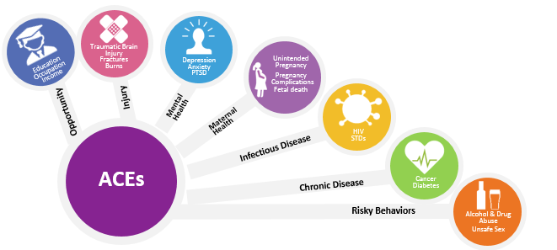

What’s working well?
There was some evidence of excellent Signs and Safety words and picture work with children to help them understand events and what was happening in their lives
Families actively participated in developing and owning the words and pictures work for the children.
Meaningful participation and partnership was evident in some families.
There was evidence of sensitive child centred practice.
Court was effectively used to provide children with permanence.
The quality and timeliness of court work continues to be recognised as a core strength.
So what’s next?
We need to
- Ensure referrals consider history as well as the presenting information
- Be actively curious about other factors and use research to guide our practice
- Provide active and early intervention in order to make a difference – monitoring is not an effective form of intervention.
- Maintain our sight on the big picture and not become distracted by small changes. – Apply optimism alongside healthy scepticism.
- Keep the child at the centre of all assessments and plans, reflecting on the question so what does this mean for the child?
- Apply equal weight to the Trio of risk factors – co-existence is likely to exist even if its hidden.
- Work with impact chronologies and family histories
- Have braver and more robust conversations about difficult issues.
- Be mindful to the fact that parental separation does not always generate safety. We need to work with families in a manner that reflects their culture and wishes.
- Seek collaborative ways of working with parents, extended families, other agencies and children.
- Identify strengths within the family network and incorporate these into a safety plan.
- Strengthen multi agency partnerships, remembering that everyone holds a different piece of the jigsaw which needs to be drawn together.
- Develop our methods and skills in working and communicating with children, they cannot be unseen or unheard.
- Develop a more ACE aware way of working which will enable our assessments and plans to reflect risks and what needs to be different in order to affect better future outcomes for children.
Useful Links
https://www1.bps.org.uk/system/files/user-files/Division%20of%20Clinical%20Psychology/public/ACES%20and%20social%20injustice%20_DCP%20SW.pdf Introduction to ACE’s
https://www.communitycare.co.uk/2018/03/05/toxic-trio-social-workers-need-know/ - article
https://ipc.brookes.ac.uk//docs/About%20IPC/News/Presentation%20to%20Community%20Care%20Live%202016%20Final%20Version%20May%202016.pdf - research
https://www.proceduresonline.com/southglos/cs/user_controlled_lcms_area/uploaded_files/Practice%20Tips%20-%20how%20to%20ask%20difficuilt%20questionis.docx - Tips

