**LETS TALK ABOUT**

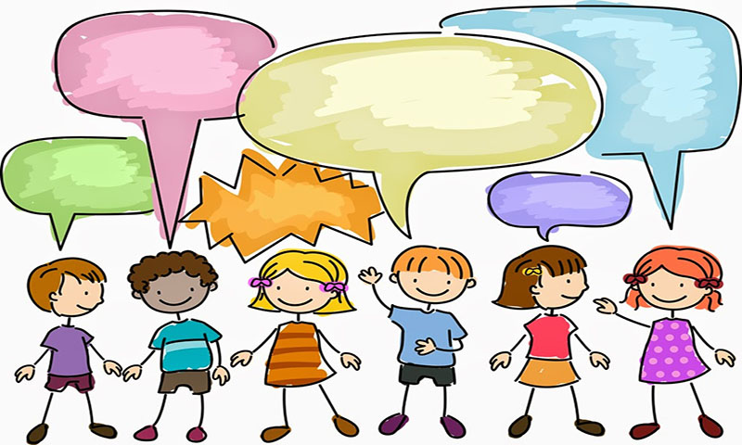

**WISHES**

PART 7 - WISHES

THESE PAGES HAVE BEEN PUT TOGETHER TO HELP CHILDREN TALK ABOUT THEIR WISHES FOR THE FUTURE

LISTENING TO CHILDREN IS CENTRAL TO EVERYTHING WE DO

THIS IS THEIR LIFES AND THEY HAVE A RIGHT TO SAY WHAT THEY WANT AND WHY

THESE WISHES ARE OFTEN INFLUENCED BY FEAR, LOYALTY, LOVE & THE UNKNOWN.

AS CHILDREN START TO UNDERSTAND THEIR LIFE STORY AND EVENTS THAT HAVE TAKEN PLACE, THEIR WISHES MAY CHANGE AND SO IT IS IMPORTANT TO REVISIT THIS AT DIFFERENT TIMES.

NOT ALL WISHES CAN BE GRANTED, AND SO IT IS IMPORTANT TO LET CHILDREN KNOW THAT THEIR WISHES MAY NOT BE POSSIBLE, AND IF THIS IS THE CASE WHAT ELSE COULD BE CHANGED.

NEVER MAKE PROMISES THAT CAN NOT BE KEPT OR THAT YOU HAVE NO CONTROL OVER. – CHILDREN WANT THE TRUTH AND SO BE HONEST EVEN IF IT IS NOT WHAT THE CHILD WANTS TO HEAR.





[](https://www.google.co.uk/url?sa=i&rct=j&q=&esrc=s&source=images&cd=&cad=rja&uact=8&ved=2ahUKEwiGycqZnKfeAhWObFAKHWcBDDIQjRx6BAgBEAU&url=https://www.pinterest.com/pin/530087818619804155/&psig=AOvVaw0_afllcGi4n1kQjs1HB6FW&ust=1540750213376189)

[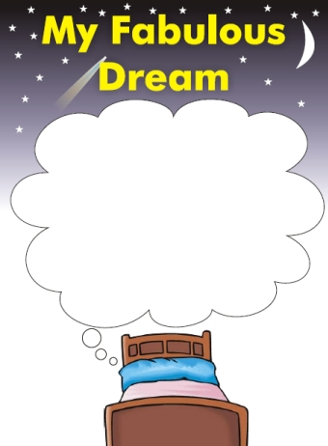](http://www.google.co.uk/url?sa=i&rct=j&q=&esrc=s&source=images&cd=&cad=rja&uact=8&ved=2ahUKEwiI8Ku4nKfeAhVNJlAKHQ_XAsIQjRx6BAgBEAU&url=http://www.sheffkids.co.uk/adultssite/pages/communicrateworksheets.html&psig=AOvVaw0_afllcGi4n1kQjs1HB6FW&ust=1540750213376189)

**[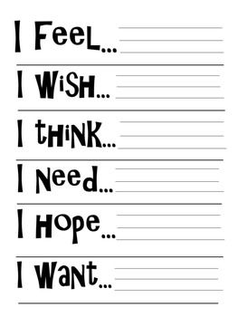](http://www.teacherspayteachers.com/Product/Journal-Pages-and-Cover-for-Middle-School-High-School-829526)**



OTHER IDEAS –

* SIGNS OF SAFETY – 3 HOUSES, FAIRY AND WIZARD
* MAGIC CARPET RIDE – WHERE AND WHO
* THE WISHING TREE – WISHES ABOUT ANYTHING
* 3 ISLANDS – WHO WHAT AND HOW
* HELPING HAND – WHO CAN HELP WITH WISHES
* PEOPLE, PLACES AND THINGS
* WHAT, HOW AND WHY
* ETC

