LEARNING BRIEF – PLACEMENT BREAKDOWNS – October 2019.
Placement breakdowns in South Glos are unusual, and therefore when they occur we need to be open to what learning can be gleaned from such experiences.
Following a number of placement breakdowns several themes emerged which we need to be mindful of in terms of supporting placements, and securing stability and permanence for children/ young people.
What did we find?
- Inconsistency in case recording both on the records for the child and foster carer.
- Inconsistency in supervision for both the Child Care and Family Placement SW
- Inconsistency in supervision for the Foster Carer (FC)
- FC reporting they felt unsupported with requests for help not acknowledged or responded to
- FC case logs not followed up or referred to in subsequent discussions or meetings.
- Evidence of stability meetings was not located on either the child or FC record
- Evidence of plans being discussed or followed up in supervision was missing
- Visiting frequency to the child and the Foster carer was sporadic
- Evidence of how placements were matched was limited. Consideration for the impact of trauma on newly approved foster carers was not located on their records until such time placements started to destabilise.
- Impact/ stress assessments were not found on the Foster carers records. There was little to no mention of impact on the fostering family and how they as a family could be supported during difficult times.
- Assessments for the reunification of siblings was missing- sadly the placement for the original child broke down.
Next steps
- Recording – compliance with recording processes need to be implemented ensuring that decisions can be made in a timely manner plus enable a clear narrative to be drawn from reports.
- Supervision - Compliance with the supervision policy for SW and FC needs to be applied in order that scrutiny, decision making and reflection can take place at regular consistent intervals as part of monitoring, and supporting a child’s journey through being looked after.
- Plans - if we are to measure our effectiveness in achieving stability for YP then plans need to be SMART and followed up in supervision both for the child and the FC.
- Support – Support measures and responses from CC and FP duty workers needs to be robust in order that we can de-escalate situations and ensure that support is provided to FC at the right time whether this be by phone or a duty visit.
- Support & escalation - Escalation process should be used if services ie respite or therapy, cannot be obtained for the child. Children in trauma cannot be left to suffer or wait. FC cannot be left to manage difficult and stressful situations without adequate support.
- Assessment – impact/ stress assessments for the fostering family should be considered when a yp is engaging in criminal behaviour and or is misusing substances. Fostering is a whole family experience and we need to remember to check in with the fostering family how they are managing difficult times and what impact this might have on them. Scaling questions can help us to track and review how people are feeling over a period of time.
- Assessment – sibling assessments should be undertaken prior to reunification in order that each child’s individual needs can be considered and assessed, reducing the risk of any further trauma and separation.
- Matching & Linking - Matching criteria should be made available on both the child and FC record. These should include consideration for preventative work at the start of a placement as opposed to support in response to a crisis
- FC logs – FP SW need to review and discuss these logs with the FC as often their tone and use of words contain clues around unspoken levels of frustration
- Training – We need to ensure that the training offered to FC is rooted in attachment, brain development and trauma. We also need to be mindful that at times of stress FC may forget aspects of their training and need support to see what is behind the actions. Revisiting aspects of training may help FC to feel better able to contain and mange difficult situations.
- Visiting – Securing stability and permanence for children is about how we build relationships with them. Visiting frequencies to children and their carers needs to be regular and consistent. Compliance by the CC and FP SW, with policy and procedure in terms of visiting helps to develop this.
- Words & Pictures - All children should have a basic words and pictures that can be referred to and built upon to help them understand how and why they are being looked after.
- Joint working – there needs to be stronger evidence of joined up working between the CC and FP SW on both the record of the child and the FC. IRO comments and observations need to be incorporated into the FC record as this can provide an additional layer of oversight and reflection.
- Audits - Audits / case file reviews need to look at how SWs build a Team around the Child and how they evaluate the effectiveness of these in terms of the Childs needs and outcomes, but also in terms of meeting the needs of the Placement and FC.
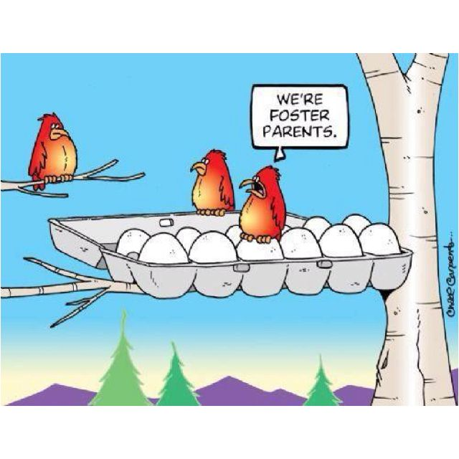
- Stability Meetings – we need to be more creative about when and how we use stability meetings, as these can be used to pause a situation enabling us to reflect what could be and needs to be different in order to prevent disruption.

Useful links & articles. https://www.proceduresonline.com/southglos/cs/user_controlled_lcms_area/uploaded_files/Stabilty%20Meeting%20format.docx – Guidance on Stability Meetings
https://www.scie.org.uk/publications/guides/guide07/placement/placement/ SCIE – Placement stability.
https://fosteringandadoption.rip.org.uk/wp-content/uploads/2014/10/DfE-14-Placement-stability-and-permanence_SB10514.pdf RIP – Placement stability and permanence

