**Shropshire Children’s Services Supervision Approach**

|  |  |
| --- | --- |
| **Title** | Supervision Approach |
| **Purpose/scope** | Outlines the approach for supervision for all workers across children’s services social care and safeguarding |
| **Subject key words** | Supervision, safeguarding, social care, social worker, reflective, safe, quality, management, development |
| **Council Priority** | Healthy people, Healthy organisation |
| **Lead author & contact details** | Donna Chapman, Workforce Manager |
| **Date Established** | November 2021 – adapted Nov 2022 to align Residential Childrens Services |
| **Date of Next Review** | January 2023 |
| **Legal Sign Off** | N/A |
| **Finance Sign Off** | N/A |
| **Approver and date** | SLT 9 Feb 2022 |

**‘Effective supervision is the cornerstone of safe social work practice. There is no substitute for it’ (Laming, 2003)**

At Shropshire we believe that robust, regular and reflective supervision keeps children safe. The aim of this document is to ensure that supervision for every worker within the organisation is of consistent quality with clear actions, expectations and demonstration of continuous reflection and learning.

**Contents**

* Key Principles of Supervision in Shropshire
* Our Approach to Supervision
* Our Agreed Expectations for Supervision
* The Supervision Contract
* Preparing for Supervision
* Frequency of Supervision
* Personal Supervision
* Group Supervision

**Key Principles of Supervision in Shropshire**

**Our Approach to Supervision**

Shropshire Children’s Services utilise what is commonly referred to as ‘**Morrison and Wonnacott’s 4x4x4 model of supervision**’ (2009) and have selected this model as it is focused on best outcomes for children. This model outlines the 4 functions of supervision, integrates these with 4 types of supervision and then focuses on the needs of the 4 stakeholders.

|  |  |  |
| --- | --- | --- |
| **4 Functions of Supervision** | **4 elements of the supervisory cycle** | **4 Stakeholders** |
| Management | Experience | Child |
| Mediation | Reflection | Worker |
| Development | Analysis | Organisation |
| Personal Support | Action Planning | Partners |

*Morrison and Wonnacott’s 4x4x4 model diagram*

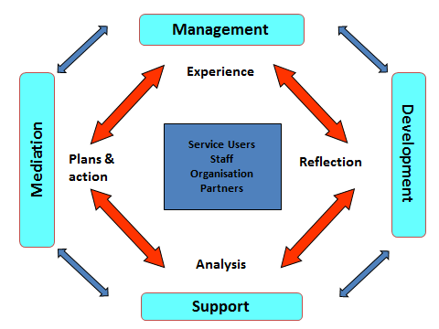

For Morrison, supervision is: ‘a process by which one worker is given responsibility by the organisation to work with another worker(s) in order to meet certain organisational professional and personal objectives which together promote the best outcomes for service users’.

The objectives and functions of supervision have been described by Morrison as:

* competent accountable performance (managerial function)
* CPD (developmental or formative function)
* personal support (supportive or restorative function)
* engaging the individual with the organisation (mediation function)

Full supervision training incorporating this model is provided for both Supervisors and Supervisees in Shropshire, along with opportunities to develop supervision skills further, such as observation and feedback.

**Our Agreed Expectations for Supervision**

**The Supervision Agreement**

The relationship between the supervisee and supervisor is an important one, and clear expectations should be agreed at the start of this relationship. A Supervision agreement should be drawn up when a new relationship between supervisor and supervisee is established and it should be reviewed and updated regularly during the supervision relationship.

When reviewing the Supervision agreement the following questions should be considered by the supervisor and supervisee:

|  |  |
| --- | --- |
| **Key questions to be reviewed:** | **Notes** |
| Is supervision meeting my learning and developmental needs? |  |
| What needs to be added or removed from the agreement? |  |
| What have I learnt during this period? |  |
| How has this made a difference to my work? |  |
| How has supervision helped me to develop? |  |
| What do I like about supervision and what don’t I like? |  |
| What feedback do I want to give during supervision sessions? |  |
| What are my current goals and how should they be documented in the new agreement? |  |

**Preparing for Supervision**

*Supervision is a two-way process, both supervisor and supervisee must prepare for it, helping to ensure learning is maximised by making the best use of the available time.* (PSDP 2020)

Preparing for supervision is key to creating the right environment for an effective session and where possible, an agenda should be agreed in advance. For case supervision, it is expected that case summaries are updated in advance of the session, to support the manager’s understanding of the circumstances of the child.

This tool can be used to help supervisees prepare for supervision:

|  |  |  |  |
| --- | --- | --- | --- |
| **What is worrying me and others?** | **This is what is working well for you (the child)** | **This is what I have decided to do** | **This is the issue I am asking for support with today** |
|  |  |  |  |

**Frequency of Supervision**

A key principle of supervision in children’s social care is that it takes place on a regular basis. The frequency and duration of supervision should be specified in the supervision agreement and the minimum recommended frequency and duration are set out in Appendix 5.

For all case-holding staff, this should take place on a monthly basis, and should be booked in advance by the manager – with each child on a worker’s caseload being subject to a reflective discussion every 8 weeks (minimum). Some workers may require more frequent supervision e.g. this may result from the supervisee being to the post, where the supervisee requires additional support and for those completing their Assessed & Supported Year in Employment (ASYE).

In addition to formal sessions, informal or ‘on the spot’ supervision is likely to be required. This may result from the need for staff to ‘check something out’ or gain direction and/or permission for a course of action. All decisions should be recorded appropriately on Liquid Logic and these conversations should not be regarded as a substitute for time-tabled formal supervision.

If a supervisor is absent from work for more than one month, their line Manager should ensure that arrangements are made for the effective supervision of the staff for whom they are responsible.

More information on the frequency of supervision is in **appendix 5**.

As outlined above, every child open to Shropshire Children’s Services must be discussed, with the discussion being recorded as a Case Supervision, every 8 weeks as a minimum. Additional, more frequent, discussions may be required where there is a change of circumstances or risk levels are heightened – this is at the discretion of the supervising Team Manager, with the allocated Social Worker ensuring that the Team Manager is kept abreast of any changes or issues which may require additional Supervision discussions.

Within the Leaving Care Team, young people may be discussed every 12 weeks, where their circumstances are stable and the package of support minimal. The supervising Team Manager will, in conjunction with the allocated worker, rate each Care Leaver against a RAG system in order to agree the required frequency of Supervision and the RAG rating will be reviewed and amended where required.

Fundamentally, it is important that every child and young person open with active involvement to Shropshire Children’s Services is considered and discussed through effective and reflective supervision with a level of frequency which reflects their individual situation. Effective supervision enables children and young peoples’ plans to be progressed and developed without drift and delay, in a focused ‘space’ where the allocated worker can reflect, discuss and test out hypotheses with a more experienced and senior member of staff.

**Personal Supervision**

Personal supervision should take place at least once per quarter and should be focused on the development of the worker. A model for individual supervision is developed by Sonya Wallbank (2016) and supports a restorative and supportive conversation in individual supervision sessions.

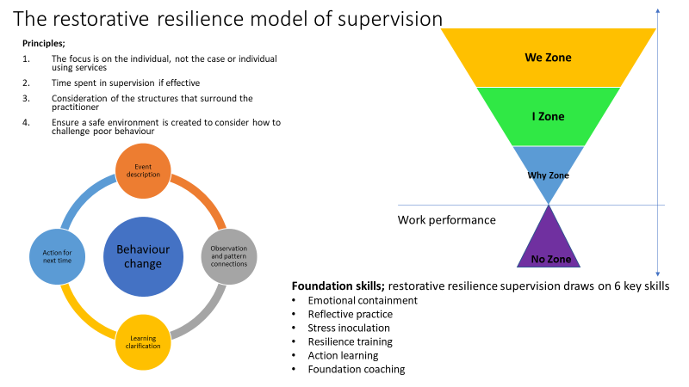

*See appendix 2 for further information*

**Group Supervision**

Group supervision is available to all staff who have case holding responsibilities. There are different forums across children services and there are various models utilised within these. The philosophy behind making group supervision available is that a safe reflective space is conducive to continued learning. That peers will encounter similar issues so the learning from this format is wider than one worker presenting one family / issue. nd that we recognise and value the multiple possible solutions that might make a difference and that there isn’t one answer.

Group Supervisions are held within teams as well as other groups within children’s services. Some are targeted / closed groups, others are open forums. This policy advocates that all should have access to the benefits of peer supervision. Some established groups include:

* Problem Solving Circle – open access (this draws on restorative approach)
* ASYE Programme Peer Supervision – closed group (this supervision group is monthly for people in their first year of employment. This draws from systemic approaches, and the work of Kolb (reflective cycle)
* Trainee Social Worker Peer Supervision – closed group (this supervision group is monthly for apprentices and is drawn from systemic approaches and the work of Kolb (reflective cycle)
* Teams independently have peer learning. Some are part of team meetings, some are particularly focused discussion groups. These vary from team to team.
* Action Learning Sets – closed group (this supervision group is set up for a specific group of people to solve a problem or embed learning and draws on the work of Revan’s; experiential learning theory, Goleman; emotional intelligence and Grint’s wicked problems.

Any team who does not have an active peer supervision group can request support to establish one, from the Practice Learning Hub.

**Children’s Residential Service Supervision**

In recognition of differing regulatory requirements within Children’s Homes, the supervision for Children’s Residential Service workers is set out in Appendix 6. Whilst the supervision agenda differs, the fundamental components of this policy remain in place as set out in the policy chapters. The ‘*residential service supervision agenda guide’* should be read in conjunction with the Residential Service *supervision agenda* and can be found here-

Supervision Agenda

Frequency for full time Residential Service worker supervisions is set out in Appendix 5; 4 weekly for 90 minutes. Part-time Residential Carers should receive supervision at least 6 weekly for 90 minutes. Agency carers and Casual carers should receive supervision based on the number of shifts worked through the month. If completing full time or part time hours then frequency should be as above, if shifts are less than 5 per month then formal supervision should take place a minimum of every 12 weeks, supported by regular informal discussions as appropriate to ensure adequate communication and support is in place.

**Future Development of Supervision**

As part of professional development, all supervisors will have an opportunity to have their supervision observed, and gain feedback. The structure of the observations has been developed in line with Morrison and Wonnacott’s 4x4x4 model of supervision and that of Wallbank.

Professional constructive feedback will be provided on each of the functions of supervision and the quality of what is observed, to develop Supervisors and Supervisee’s Supervision practice, immediately after the observation.

**Resources to support effective supervision;**

[Reflective supervision: Resource Pack (2017) (researchinpractice.org.uk)](https://www.researchinpractice.org.uk/children/publications/2017/april/reflective-supervision-resource-pack-2017/)

**Appendix 1: Case Supervision Recording**

Case supervision should be recorded within Liquid Logic as follows:

|  |
| --- |
| **Case Update –** (what do we know and how do we know it?)  **Reflection -** (Possible hypotheses, what do we need to be sure of?)  **Actions –** (What needs to happen, by who and when?) |

**Appendix 2 – Personal Supervision Agenda**

|  |  |
| --- | --- |
| **Social Worker;** | Discussion |
| **1. Competent, accountable performance**  *(Managerial Function)* |  |
| **2. Continuing professional development** *(Educational/Development Function)* |  |
| **3. Personal support**  *(Supportive Function)* |  |
| **4. Linking the individual to the organisation**  *(Mediation Function)* |  |
| **5. Actions;** what needs to happen, by who and when? |  |
| **Date;** | Signatures; |

**Appendix 3: Supervision Agenda for Workers**

|  |  |  |
| --- | --- | --- |
| **Shropshire Children’s Services**  **Practitioner Template** | | |
| **Name of supervisee:** | | **Designation:** |
| **Name of supervisor:** | | **Designation:** |
| **Date of Supervision:** | **Date of Last Supervision:** | Comments if significant delay since last meeting |
| 1. **Staff Welfare (including Annual Leave / Flexi)** | | |
|  | | |
| 1. **Review of last meeting and matters arising:** | | |
|  | | |
| 1. **Workload Management – Current Caseload and Workload** | | |
|  | | |
| 1. **Individual High Risk / Need cases Discussed** | | |
|  | | |
| 1. **Compliments and Complaints** | | |
|  | | |
| 1. **Supervisee Learning & Development: Review of standards, objectives, core qualities, leadership and managerial framework to inform appraisal** | | |
|  | | |
| 1. **Health & Safety / Risk Assessments** | | |
|  | | |
| 1. **Any Other Business:** | | |
|  | | |
| 1. **Date / Time and Venue of next session:** | | |
|  | | |

**Appendix 4: Supervision Agenda for managers**

|  |  |  |
| --- | --- | --- |
| **Shropshire Children’s Services**  **MANAGERS SUPERVISION AGENDA/TEMPLATE** | | |
| **Name of supervisee:** | | **Designation: Team Manager** |
| **Name of supervisor:** | | **Designation:** |
| **Date of Supervision:** | **Date of Last Supervision:** | Comments if significant delay since last meeting |
| 1. **Staff Welfare (including Annual Leave / Flexi)** | | |
|  | | |
| 1. **Review of last meeting and matters arising:** | | |
|  | | |
| 1. **Budget & Financial Management** | | |
|  | | |
| 1. **Team Performance data / Management information** | | |
|  | | |
| 1. **Inter and Intra agency issues Practice / Learning and development for the team** | | |
|  | | |
| 1. **Staffing, Employment and HRE issues** | | |
|  | | |
| 1. **Individual High Risk / Need cases Discussed** | | |
|  | | |
| 1. **Complaints** | | |
|  | | |
| 1. **Supervisee Learning & Development: Review of standards, objectives, core qualities, leadership and managerial framework to inform appraisal** | | |
|  | | |
| 1. **Health & Safety / Risk Assessments** | | |
|  | | |
| 1. **Any Other Business:** | | |
|  | | |
| 1. **Date / Time and Venue of next session:** | | |
|  | | |

**Appendix 5**

**Recommended Minimum Frequency of Supervision**

|  |  |  |  |
| --- | --- | --- | --- |
|  | Type | Duration | Frequency |
| **Strategic Leads/Service Managers** | Individual | 90 minutes | 4 weekly |
| **Team Managers /Leaders** | Individual | 90 minutes | 4 weekly |
| **Children’s Case Management Social Workers** | Individual | 90 minutes | 4 weekly |
| **Other Social Workers – case holding** | Individual | 90 minutes | 4 weekly |
| **Other Social workers – non-case holding** | Group or Individual** | 90 minutes | 4 weekly |
| **ASYE * see notes below** | Individual | 90 minutes | 4 weekly |
| **Targeted Youth Workers** | Individual | 90 minutes | 4 weekly |
| **Support Services case holding (including FSW)** | Individual | 90 minutes | 4 weekly |
| **Support Services Non case holding (including residential)** | Group or Individual** | 90 minutes | 4 weekly |

*Note; 4 working weeks taking into consideration sickness, annual leave, absence.*

**ASYEs**

* Newly qualified Social Workers (NQSWs) in their Assessed and Supported Year in Employment, (ASYE) must receive supervision every week for the first 6 weeks and then every 2 weeks for the first 6 months.
* Where Group or Individual supervision can be provided, group and one to one supervision supervision should take place on an alternate basis.

**Case Holding Staff**

* Staff who have case management responsiblility must discuss every case for whom they have responsibility, every two months as a minimum standard.

**Non case-holding staff**

* All non caseholding staff should receive monthly supervision or 121s.
* They should also be able to attend group supervision.
* This group would include Information Coordinators and Administrators.

**Appendix 6: Supervision Agenda for Residential Service**

