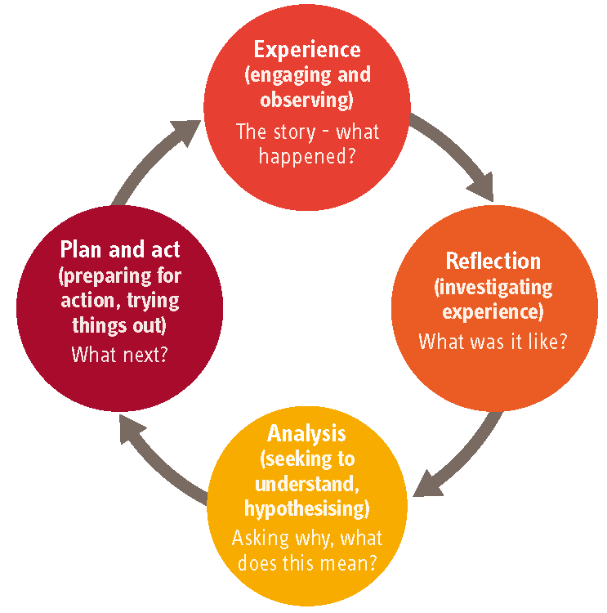
Supervision Agenda for Residential Carers

Name of Supervisee: | Name of supervisor:
Date of Supervision: | Last Supervision Date and comments if significant delay since last meeting:
Agenda Items: | Actions from Previous Supervision:
- Carer Welfare

- Reflect on what’s gone well

- Reflect on areas that have been difficult

- Professional Development and Feedback

- Our children’s progress

- Adoption of Models and Vision, Mission and Values (PARENTAL)

- Safeguarding (Concerns, Complaints, Whistleblowing)

- Any Other Business

Agreed Actions

Date of Next Supervision

Supervisee Signature

……………………………………………………………………. Date …………………………………

Supervisor Signature

……………………………………………………………………. Date …………………………………

