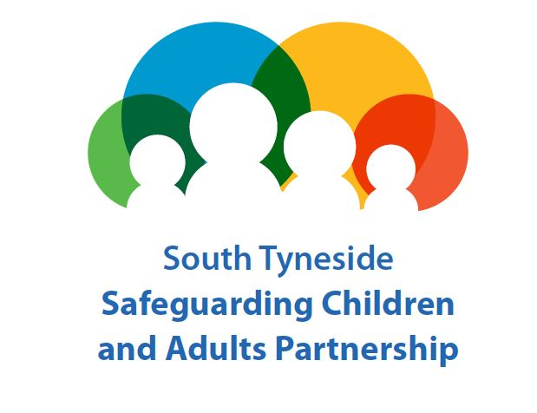
STSCAP Missing, Slavery, Exploited and Trafficked (MSET) Sub Group
A Quick Guide

What is the aim of Pre MSET and MSET?
Pre MSET and MSET are responsible for coordinating and ensuring the effectiveness of multi-agency arrangements for safeguarding and promoting the welfare of children and young people who go missing and/or are at risk of Exploitation (Child Sexual, Criminal and Slavery) and/or trafficking. MSET is not about care planning but does have the added value to reduce risk and provide oversight of patterns and trends. The Pre MSET group links into the full MSET sub group

Pre-MSET
The Pre-MSET panel considers the paperwork received by the STSCAP to make an informed decision on whether the case needs input from the full MSET panel.
The panel is made up of:
- STSCAP Business Manager
- Police – Missing from Home Coordinator
- Children and Families Social Care
- Adult Social Care
- Services for Young People (Missing from Home Coordinator)

The Pre MSET meeting will also consider missing episodes and request attendance at MSET if additional concerns/risk factors are identified.

Meetings are held monthly, 2 weeks prior to a scheduled MSET meeting

MSET Sub Group
The group has multi-agency membership and is chaired by Detective Inspector John Connolly from Northumbria Police and the Vice Chair, John Lambert, Service Manager for Children and Families Social Care, Integrated Safeguarding and Intervention Team (ISIT). Representation includes: Children and Families Social Care; Adult Social Care, Police, Health, Third Sector, Education (including Tyne Coast College), South Tyneside and Sunderland NHS Foundation Trust (including Sexual Health Services and the Looked After Children’s Nurse), Matrix , Youth Justice Service, South Tyneside Council - Services for Young People and Cumbria, Northumberland Tyne and Wear NHS Trust. Regulatory Services may also be invited to attend in particular circumstances (for example if there was an issue relating to licensing)

How often does MSET happen?
MSET takes place once a month as required

How does a case get into MSET?
Any professional can complete a Stage One Screening Tool where they feel there are exploitation concerns. This should be completed without delay and sent to the STSCAP Business Unit via email: STSCAP@southtyneside.gov.uk.

Where the risk is identified as Medium or High the following documents should also be completed but should not delay the submission of the Stage One Screening Tool:
- Stage 2 Initial Assessment and
- Stage 3 Safeguarding and Disruption Activity documentation

Further guidance can be found in the MSET Framework

What is the role of professionals attending MSET?
Complete the relevant paperwork and submit to the STSCAP Business Unit. Attend the meeting at the agreed time and give a brief and succinct overview of the case paying particular attention to the concerns identified on the screening tool and the rationale for the score. MSET members will share any information they may have related to the case. Professionals presenting a case may be offered some challenge and further questions in order to determine the next steps. Each agency is then offered the opportunity to suggest any additional support in relation to the Exploitation/Missing/Trafficking concerns. This is captured on an MSET action plan. Dependent upon the level of risk identified a collective decision will be made to either discharge the case or bring it back into MSET for an update/progress on the reduction of risk.

What happens after MSET?
• Social Workers will receive a copy of the action plan, which includes minutes of the discussion held
and the rationale for the decisions/actions identified
• Where cases are open to Children and Families Social Care it is the responsibility of the Social
Worker to update Liquid Logic/upload the action plan
• All agencies must share and update their records with the information from MSET

Useful Documents

