Section Five

Evaluating and Measuring Progress

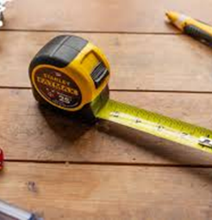Tape Measure
Being able to effectively evaluate practice is so important for workers in terms of their work with families and for a Local Authority as a whole. There are tools which Local Authority leaders can utilise to evaluate how effective services, procedures and actions are within their area; this self-evaluation can support constructive feedback, identify gaps and support changes to improve and innovate.

Social Workers and other professionals working with families and children need tools which can support everyone around the child and family to know what is working well, where there may be need for change and to build on success. Dependent on the practice model in each Local Authority there may be a different approach to how progress and change is measured; the important aspect is that you feel equipped to do this.

“Social Workers need practice models which support professionals and the family to measure change, progress and success; Local Authorities need overarching systems to evaluate practice and what works well”

Your Tools:

Area of Practice | Document | Source/ author | Link | Ease of reading
Evaluating your Local Authority | Self-Evaluation Tool  (SEF) for Local Authority. | Essex County Council – adapted for Regional use. |  | Complex
Evaluation of effectiveness | How do we know if children’s social care services make a difference? Development of an outcomes framework – Summary Report | Nuffield Foundation |  | Complex
Motivation to change | The Cycle of Change | Prochaska and DiClemente |  | Easy
Scaling (SOS) | One minute briefing – Scaling (SOS) | LCC (Sam White) Regional Collaboration |  | Easy

We hope this will be a helpful Toolkit for you when navigating pre-proceedings and proceedings.

Please provide us with anonymous feedback via this link:

https://forms.office.com/Pages/ResponsePage.aspx?id=klvgtM74tUabJJm6XBHl6Tq8j3aIZ6BFja7ygLmdFOhUQ0tVVUJVTEJPR1pBUFpPTVkzV1FKUjFZSy4u

