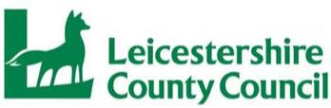
 | Action/Date
Title/Status- | DOLS Consent Form
New document or revised | Revised
Responsible Head of Service | Head of Service Fieldwork
Date SMT approved. | May 2019
Next review due | 30th September 2023

CONSENT TO DEPRIVATION OF LIBERTY AND PLACEMENT RELATING TO CHILDREN AND YOUNG PERSONS.
REGARDING ( insert full name, DOB and addresse of relevant child.)
- Consent to Placement
I/We, ( insert full name(s) of all adults concerned).............................who have
parental responsibility for ( insert full names of child)
agree to Leicestershire County Council looking after
under Section 20 Children Act 1989.
- Details of Placement
I/We, understand that will be cared for at: -
( insert full details of placement address, organisation,)
1

and that the following restictions amounting to a deprivation of liberty will be in place at least until ( insert review date) –
( insert precise details of each restriction.)
I/We, understand the details of the placement and agree to all the restrictions detailed above being placed upon (insert name of child).........................I/We understand that I/we will receive a copy of the Placement Plan for
I/We
I/We, confirm that in light of the above I/we make informed consent to the deprivation of liberty, on the basis of the restrictions detailed in this document, of ( insert childs
full name
Signed
Full name in capitals
Relationship to child
Dated
2

