What We Can Offer?  A SAFE SPACE TO  - Talk about how you are feeling about what is happening  - Help understand what an SGO means for you and your child/children  - Ask questions (which we will do our best to answer as quickly as possible)  - Help understand the contact system  - Support to share important information about you and your child’s history and how it will be used.  You’ll get 6-8 sessions set at your pace and follow up calls if you need them |  | How to Contact Us  There are 2 ways to access this service:  - A referral via your Child Care Team Social Worker.  - Self-Referral:  Call  0116 454 6540  Email  Post-Adoption-CFST-Duty@leicester.gov.uk  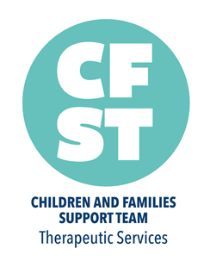 |  | 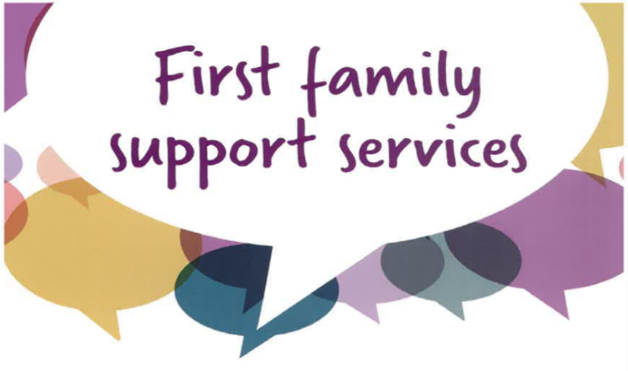  INDEPENDENT & CONFIDENTIAL SUPORT FOR BIRTH PARENTS OF CHILDREN WHOSE PLAN IS SPECIAL GUARDIANSHIP

WHY FIRST FAMILY SUPPORT?  We know this period can be both confusing and distressing. First Family Support can help. The service is  - Free  - Confidential  - Independent (not involved in Court Proceedings)  First Family Support is for birth families (and their immediate families) whose children are being considered/placed for Special Guardianship Order by Leicester City Council.  You can access this service at any point before, during or after the adoption has been made. |  | What We Cannot Do  - We cannot change the plan for your child or stop the SGO  - We cannot keep information confidential if it relates to the past or current concerns about the safety of children.  - We also cannot represent you in court or give you any legal advice. However, we can advise you who to speak to about particular issues. |  | What Happens Next  First Family Support is provided by the Children and Families Support Team  We will offer you an appointment for your first session. This can be online, at our office in Leicester, a venue near where you live or even in your own home it’s appropriate.  If a Social Worker is still involved with your child, we will speak to them to get a better understanding of your situation and court case.

