Education and Childrens Services

SOCIAL CARE AND EARLY HELP
SINGLE ASSESSMENT SERVICE

PRACTICE STANDARDS

2016

OUR MISSION:

‘To improve children and young people’s lives by working in partnership to raise aspirations, build achievement, and protect the most vulnerable’

Introduction
Leicester City Council is committed to achieving excellence through continual improvement where children and their families are at the heart of everything that we do. Therefore, we need to provide improved and sustained early help, safeguarding and child protection, looked after services which facilities a focus on supporting and promoting the interests and welfare of children and young people in Leicester City.

In order to achieve our aim for our services to children and families to be of high quality, easy to access and provided by skilled staff, Leicester City Council’s Children Services is undergoing a realignment of services at the point of front door. A new Single Assessment Service is being created to add resilience to the existing Duty and Advice Service and the Child In Need Service and provide without delay the required assessment, support and intervention to children and families.

Service’s Aims
The Single Assessment Service will deliver the first response to all referrals that meet the threshold for a Social Work Assessment by carrying out all new assessments and enquiries under S17 and S47 of the Children Act 1989.

The service will comply with the current legislation and government’s guidance by ensuring that all children, young people and families (CYPF) who are referred to the authority are provided with appropriate help/protection which is proportionate with the needs/risks that have been identified. The overall aim of the service is to ensure that children and young people identified as requiring help and protection receive a swift, responsive and effective service that protects them from harm.

Routes of referral
A child or young person can be brought to the Local Authority’s attention as possibly requiring safeguarding or protection via the Local authority’s 24/7 Duty and Advice Service (DAS). The DAS is required to respond to all initial contacts (99% received via telephone calls) relating to children within the borders of Leicester City within 24 hours from the time of the contact.

All initial contacts are received and processed by qualified Social Workers, trained and experienced to discuss with other professionals concerns that they may have about children and to identify the best way to meet their needs.
Where referrals do not meet the threshold for social work services the work is directed to Early Help Services where appropriate, which sits within the Duty and Advice Service.

When initial contacts are escalated to referrals the DAS Team managers oversee the social work activities undertaken by the DAS Social workers. All referrals are scrutinised and the outcomes endorsed by the DAS Team Managers with clear decisions and rationale being recorded on the Liquid Logic system.
If a referral meets the threshold for a further statutory assessment (via Section 17 or Section 47 or the Children Act 1989) the case is transferred to the Single Assessment Service.

Guiding principles
All decisions made by the DAS practitioners and managers are based on the guidance provided by the ‘Thresholds for access to services for children and families in Leicester, Leicestershire & Rutland’ March 2015 found at this link: LLR LSCB procedures manual.

- Single assessments
In reaching a decision as to whether or not to undertake a statutory assessment the DAS practitioners and manager must consider all available evidence. In this context consideration must not only be given to the exceptional nature and circumstances of an individual case but also the evidence submitted for consideration must be substantive and all available options, by way of universal and targeted provision, must have been exhausted over a reasonable period of time. If the concerns identified in relation to the children at the point of referral require further exploration via a single assessment the case is transferred from DAS to the Single Assessment Service.

- Section 47 Enquiries
Under Section 47 of the Children Act 1989, if a child is taken into Police Protection, is the subject of an Emergency Protection Order or there are reasonable grounds to suspect that a child is suffering or is likely to suffer Significant Harm, a Section 47 Enquiry is initiated. This is to enable the local authority to decide whether they need to take any further action to safeguard and promote the child’s welfare. This will occur following a multi-agency Strategy Discussion, with contributions from social care, police, health, education (if applicable) and other relevant professionals involved.
The Service’s Key responsibilities
- Provide caring and inclusive services to children and families, taking into account particular factors such as the child's race, ethnicity, language, disability or any other special needs (e.g. interpreter);
- The qualified Social workers will complete comprehensive and analytical assessments of needs/risks, detailed plans of intervention to help families to achieve positive change.
- Management oversight and scrutiny will be applied at the point of case allocation within the service. Further checkpoints will be applied at Day 5 of the section 47 Enquiry and Day 10 of the Single assessment to ensure the case progresses and appropriate and proportionate levels of intervention are provided to the children and families.
- All strategy discussions occurring during the core working hours (Mondays to Fridays; 08:30 am – 5 pm) will be chaired by the Single Assessment Service Team Manager within 4 hours of referral. All Section 47 Enquires must be completed within 15 working days of the Strategy Discussion (see Appendix A).
- All children identified as requiring further intervention under Section 17 of the Children Act 1989 will have their Initial Child In Need Plan meeting by day 15 - 20 of the single assessment.
- The Single Assessment Service will work closely with Early Help Services and other partner agencies to ensure children, young people and their families receive the most appropriate level and nature of support at the right time.
- The EH Services will be involved as soon as the need for their intervention has been identified (this could be at the point of initial visit and joint home visit/ meeting involving the SW and the EH practitioner, during the SA or at the end of SA when a plan for step down has been agreed).
- The outcomes of the Single Assessment Service’s assessment/intervention will be communicated to the families/child and other relevant professionals in writing (emails between professionals are acceptable) within 48 hours of completion.
- The LCC ‘10 Safeguarding Practice Standards’ (July 2015) (Appendix E) and DfE ‘Working Together to Safeguarding Children’ (WT2015) provide the guidelines and auspices of all activities undertaken by the Single Assessment Service’s practitioners and managers.
- The Single Assessment Service will consider, advise and make recommendations about Leicester City Council’s responses to changes in policies, National and local Serious Case Reviews, guidance affecting the front line service delivery.

Output from Single Assessment Service
Children and families identified as requiring further statutory intervention from Children’s Services will transfer from the Single Assessment Service into CIN services with up-to-date assessments and plans (CIN, CP or Care Plan) at agreed points:

- At the Initial Child in Need Meeting (Appendix B)
- At the Initial Child Protection Conference. (Appendix C)
- At the first hearing in the Family Court where the Local Authority applies for parental responsibility (ICO).
- At the Placement Planning Meeting for children and young people looked after under S20 Children Act 1989.

It is the responsibility of the Single Assessment Service to organise and attend the initial meetings and prepare and share with the child/family the required documentations within the statutory timescales. A plan of actions/intervention will be formulated and agreed by the family/child and professionals group during the first multi-agency meeting.

Children and families identified as requiring further targeted intervention from the Early Help Services will be stepped down using the agreed step down pathway. (Appendix D)

Children and families identified as requiring no further action from Children’s Services will be notified in writing, alongside all the other professionals who have contributed to the assessment process.

All children at the point of transfer/ closure from Single Assessment Service will have:
- A completed assessment;
- Updated chronology;
- Updated genogram;
- SMART Plan (if applicable)

Children and Young in Special circumstances
- 16/ 17 year old young people presenting as homeless. The SA will be undertaken by
The Single Assessment Service jointly with the Housing Department. Based on the level of risks/need identified a decision will be made regarding case progression. The current 16/17 year old YP Homeless protocol will be followed;
- Young carers - The SA will be undertaken by the Single Assessment Service and based on the level of risks/need identified a decision will be made regarding case progression (EH/CIN/CP);
- Disabled children – The SA will be undertaken by the Single Assessment Service and based on the level of risks/need identified a decision will be made regarding case progression (EH or disabled Children Team);
- Step parent adoption – transfer from DAS directly to the Adoption Team;
- Unaccompanied minors – transfer from DAS directly to the Looked After Children service
- Relinquished babies will transfer directly from DAS to the Single Assessment Team
- Section 7 and 37s requests will be transferred to the CIN services at the point of referrals from DAS
- Referrals relating to unborn babies meeting the threshold criteria for statutory intervention will be accepted at the point of initial notification (this applies to pregnancies in the first trimester of gestation)
- Request for a Receiving In Conference will be immediately processed by the DAS and transferred to the Single Assessment Team for an assessment ( Receiving –In Conference pathway will be selected as the outcome of the Referral)
- Request for Step Parent adoption assessment will be transferred from the DAS to the CIN service via a single assessment.

The current Transfer Policy will be amended to reflect these changes and shared with all practitioners and managers.

Governance and accountability
The practice and functioning of Single Assessment Service is overseen and supported by the following governance arrangements:

- The Single Assessment Board to remain in operation with regular meetings being held on monthly basis. Any decisions/amendments required to be taken in relation to DAS, SAT and/or CIN services will be considered and recommendations will be made by the Board to the Directors
- A range of performance reports will be produced on weekly basis to assist in providing the quantitative data required to understand the functioning of the service (input – throughput; S47s, SAs, EH etc.). Case and activity level data will be made available to the Service Manager, SAT Team Managers and Advanced Practitioner, alongside all members of the SA Board who will address areas of concern based on the targets and expectations set.
- Monthly performance Update Reports will be made available for scrutiny and challenge from the Education and Children’s Services’ Departmental Management Team

Appendix A
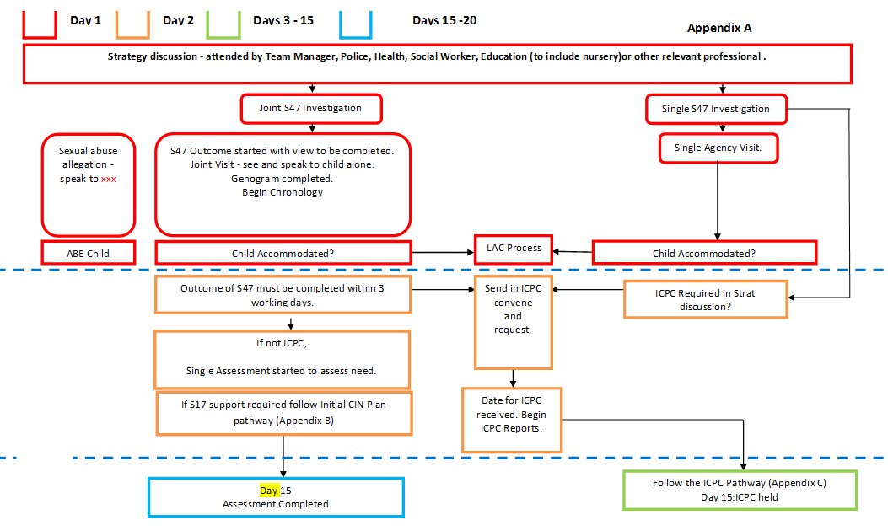

Appendix B
Initial Child in Need Pathway - Effective June 2016

Social worker undertakes SA identifying and agreeing with the family/child the core professionals involved with the family

Single Assessment identifies family support required under Section 17
Management endorsement and oversight recorded in the SA and on LL. Recommended CIN Plan reviewed and QAed

List of attendees provided to Business support who arranges Child In Need Planning Meeting to be held within 5 working days from the decision made

Business Support sends an electronic appointment to the CIN Services

Child In Need Planning Meeting held. Senior Practitioner/Team Manager chairs and meeting is recorded

Child In Need Plan with SMART actions and targets is further developed and agreed during meeting identifying resources and services needed, timescales applicable and persons responsible for actions
Poor attendance by professionals is addressed by Team Managers and any ongoing concerns escalated to Service Managers (Escalation routes to be agreed)

Parent/carers and child (if old enough) sign Action Sheet Template. Case transfers to CIN services
Transfer completed on LL

Chair distributes Child In Need Plan & minutes to parents, child (if old enough) and agencies/professionals within 5 days of the Child In Need meeting

Appendix C – Initial Child Protection Conference Pathway
Appendix D – Step Down to Early Help Pathway
Day 3 - Section 47 Outcomes identifies children to be referred to ICPC
List of attendees provided to the Safeguarding Unit
CIN Services informed
Initial CP Social worker report completed and sent for authorisation by day 10
Day 11 – CP SW Report authorised and endorsed by the TM
Day 12 – CP Report shared with the family and child (if old enough)
Management endorsement and oversight recorded in the Record of S47 Outcomes and on LL/consultation with SU
Social worker undertakes the Section 47 Enquiry
Day 15 – ICPC held – case transfers to the CIN Service; SA SW updates LL with the outcome of the ICPC and case transfer

Day 15 – ICPC held – case transfers to the CIN Service; SA SW updates LL with the outcome of the ICPC and case trasnfer

