# **Developing Confidence in Offering Context:**

# **Attachment and Trauma Informed Placement Searches.**

**A Brief Overview of Attachment Theory.**

Attachment can be defined as a reciprocal relationship. In parenting (or child development) it generally refers to the relationship that develops first between the infant/child and his primary caregiver (often Mother). The quality of this attachment impacts the child’s physical, emotional, psychological and cognitive development. This primary relationship shapes the child’s basic ability to trust and how positively or negatively he views the world, himself and others. The quality of this first attachment impacts all other relationships.

When an infant experiences consistent care where his/her needs are met, he/she internalizes three things:

* I am safe
* I am heard
* I am valuable

With this as the foundation, a child can then develop other healthy relationships, in attachments theory, this is referred to as having a 'secure attachment'.

Psychoanalyst John Bowlby is considered the father of attachment theory, his definition of attachment is 'the affectional tie between two people'. It begins with the bond between the infant and mother. This bond then represents how the child’s life relationships will be formed. Bowlby stated, 'The initial relationship between self and others serves as a blueprint for all future relationships'.

Bowlby believed that there are four distinguishing characteristics of attachment:

* **Proximity maintenance**: The desire to be near the people we are attached to.
* **Safe haven**: Returning to the attachment figure for comfort and safety in the face of a fear or threat.
* **Secure base**: The attachment figure acts as a base of security from which the child can explore the surrounding environment.
* **Separation distress**: Anxiety that occurs in the absence of the attachment figure.

Attachment style affects more than just future healthy relationships, it also impacts a child’s ability to self-regulate. When an infant’s needs are met by a nurturing primary caregiver, the infant’s emotional dysregulation is calmed. Over many repetitions of an infant feeling stress, expressing distress and receiving a nurturing response, the child is able to integrate this pattern as self-soothing during stressful times. This is important as the child matures into an adult who is able to handle disappointments, opposition and stressful situations by remaining regulated.

There are four recognized attachment styles, each a response to the child's experience of having their need either consistently or inconsistently met.

|  |  |
| --- | --- |
| Please watch this video to understand the difference between these attachments styles. | <https://youtu.be/o-IYlkDlkgk> |

Recent research into attachment shows that there is a neurological and sensory link as well - activities often attributed to “normal” parenting of an infant, such a rocking, bouncing, swinging, patting (burping) an infant activate the baby’s sensory system, and the positive sensory input becomes connected to the nurturing acts. These are referred to scientifically as 'serve and return' interactions.

|  |  |
| --- | --- |
| Watch this video to learn more about the importance of 'serve and return' interactions. | <https://youtu.be/m_5u8-QSh6A> |

Children who have not had normal sensory input are at increased risk of not only attachment difficulties, but developmental delays, social impairment and having a difficult time with change.

**The Secure Base model: A Model to Support Caregivers in Overcoming Attachment Difficulties.**

As noted by Bowlby above, a secure base is at the heart of any successful caregiving environment. A secure base is provided through a relationship with one or more caregivers who offer a reliable base from which to explore and a safe haven for reassurance when there are difficulties. Thus a secure base promotes security, confidence, competence and resilience.

The Secure Base model has been developed through a range of research and practice dissemination projects led by Professor Gillian Schofield and Dr Mary Beek in the Centre for Research on Children and Families at the University of East Anglia, UK. This model is used as a basis for training foster carers and was subsequently incorporated in the Skills to Foster preparation programme, produced by the Fostering Network (2009, 2014) and all Lancashire Foster Carers receive this training.

The model is drawn from attachment theory, and adapted to include an additional element, that of family membership, for children who are separated from their birth families. The model proposes five dimensions of caregiving, each of which is associated with a corresponding developmental benefit for the child. The dimensions overlap and combine with each other to create a secure base for the child, as outlined in the video below:

The Secure Base model provides a positive framework for therapeutic caregiving which helps infants, children and young people to move towards greater security and aims to build resilience. The model focuses on the interactions that occur between caregivers and children on a day to day, minute by minute basis within the caregiving environment, but also considers how those relationships can enable the child to develop competence in the outside world of school, peer group and community.

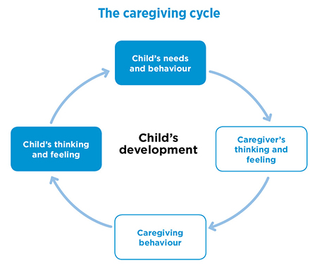

This caregiving cycle encompasses the many interactions of family life or life in a residential care setting. These range from the moment to moment exchanges over breakfast to managing major emotional or behavioural crises. Each interaction conveys a number of messages to the child and has an incremental effect on the child's beliefs about him or herself, beliefs about other people and the relationship between self and others. These internal working models will influence the child's functioning and development.

For the purposes of the Secure Base Model, caregiver/child interactions are grouped into five dimensions of caregiving. Each of the five caregiving dimensions can be associated with a particular developmental benefit for the child, as shown in the table below.

|  |  |
| --- | --- |
| **Caregiving dimension** | **Developmental benefit** |
| [Availability](https://www.uea.ac.uk/web/providing-a-secure-base/availability) | Helping the child to trust |
| [Sensitivity](https://www.uea.ac.uk/web/providing-a-secure-base/sensitivity) | Helping the child to manage feelings and behaviour |
| [Acceptance](https://www.uea.ac.uk/web/providing-a-secure-base/acceptance) | Building the child's self esteem |
| [Co-operation](https://www.uea.ac.uk/web/providing-a-secure-base/co-operation) | Helping the child to feel effective - and be co-operative |
| [Family membership](https://www.uea.ac.uk/web/providing-a-secure-base/family-membership) | Helping the child to belong |

It is important to bear in mind that the dimensions are not entirely distinct from each other. Rather, in the real world of caregiving, they overlap and combine with each other. For example, a caregiver who is playing with a child in a focused, child-led way may be doing so with sensitivity and acceptance as well as demonstrating availability and promoting co-operation. Research (Beek and Schofield 2004) has demonstrated that, over time, positive caregiving across the five dimensions of the model provides a secure base from which the child can explore, learn and develop in a positive direction toward developing secure attachments.

|  |  |
| --- | --- |
| Watch this video to understand how the Secure Base Model is used in practice. | <https://youtu.be/KnRDobbxg00> |

**A Brief Overview of Childhood Trauma.**

**Understanding Adverse Childhood Experiences (ACEs).**

ACES are traumatic events which occur before a child turns 18. A landmark study (Feletti, et al., 1998) found a significant relationship between the number of ACEs a person experienced and a variety of negative outcomes in both the short-term, and into adulthood; including poor physical and mental health, substance abuse, and risky behaviors. There are 10 types of childhood trauma measured in the ACE Study, five are personal — physical abuse, verbal abuse, sexual abuse, physical neglect, and emotional neglect and five are related to other family members: a parent who misuses substances, a mother who is a victim of domestic violence, a family member in jail, a family member diagnosed with a mental illness, and the disappearance of a parent through divorce, death or abandonment. There are of course many other types of childhood trauma but t**he ACEs Study included only those 10 childhood traumas because these were the most common themes identified by the 17,000 participants in their study.** Each type of trauma counts as one ACE and the more ACEs experienced, the greater the risk for the long term outcomes of the child.

By definition, children receiving support from Children's Social Care have suffered at least one ACE. A recent longitudinal study in America (Clarkson-Freeman, 2016) has shown that, in comparison to the general population, care experienced children are far more likely to have experienced at least four ACEs (42% vs. 12.5%). There have been numerous other studies which have found similar findings including in England and Wales.

|  |  |
| --- | --- |
| Watch this video to see how ACEs can affect a child throughout the life course. | <https://youtu.be/XHgLYI9KZ-A> |

**What causes this? - The Link between ACEs and Toxic Stress.**

In the early 2000s, the [National Scientific Council on the Developing Child](https://developingchild.harvard.edu/science/national-scientific-council-on-the-developing-child/) coined the term '[toxic stress](https://developingchild.harvard.edu/science/key-concepts/toxic-stress/)' to describe extensive, scientific knowledge about the effects of excessive activation of stress response systems on a child’s developing brain, as well as the immune system, metabolic regulatory systems, and cardiovascular system. Experiencing ACEs triggers all of these interacting stress response systems. The [Council](https://developingchild.harvard.edu/science/national-scientific-council-on-the-developing-child/) also expanded its definition of adversity beyond the categories that were the focus of the initial ACE study to include community and systemic causes—such as violence in the child’s community and experiences with racism and chronic poverty—because the body’s stress response does not distinguish between overt threats from inside or outside the home environment, it just recognizes when there *is* a threat, and goes on high alert.

It is important to distinguish among three kinds of responses to stress: positive, tolerable, and toxic, these three terms refer to the stress response systems’ effects on the body, not to the stressful event or experience itself

**Positive stress response** is a normal and essential part of healthy development, characterized by brief increases in heart rate and mild elevations in hormone levels. Some situations that might trigger a positive stress response are the first day with a new caregiver or receiving an injected immunization.

**Tolerable stress response** activates the body’s alert systems to a greater degree as a result of more severe, longer-lasting difficulties, such as the loss of a loved one, a natural disaster, or a frightening injury. If the activation is time-limited and buffered by relationships with adults who help the child adapt, the brain and other organs recover from what might otherwise be damaging effects.

**Toxic stress response** can occur when a child experiences strong, frequent, and/or prolonged adversity—such as physical or emotional abuse, chronic neglect, caregiver substance abuse or mental illness, exposure to violence, and/or the accumulated burdens of family economic hardship—without adequate adult support. This kind of prolonged activation of the stress response systems can disrupt the development of brain architecture and other organ systems, and increase the risk for stress-related disease and cognitive impairment, well into their adult years

W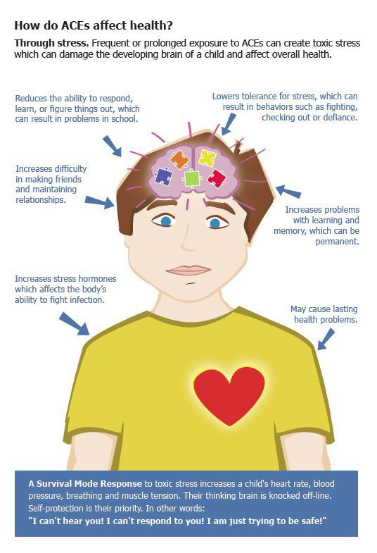hen toxic stress response occurs continually, or is triggered by multiple sources, it can have a cumulative toll on an individual’s physical and mental health. The more adverse experiences in childhood, the greater the likelihood of developmental delays and later health problems. This is because stress chemicals, such as cortisol and adrenaline, can severely affect brain development. So, the in Child's brain chemistry, can have a significant impact on the child’s ability to attach to their caregiver.

Children who have experienced toxic-stress can grow up with life-long difficulties; including chronic feelings of shame, an inability to manage stress and difficulties trusting others for guidance, comfort and support. They will often have difficulty developing healthy relationships with peers and establishing attachments with caregivers. To relieve their anxiety, depression, guilt, shame, and/or inability to focus, some turn to easily available biochemical solutions — cigarettes, alcohol, cannabis - or activities in which they can escape their problem engaging in high risk behavior, unhealthy relationships appearing moody or withdrawn, going missing and become increasingly vulnerable to predatory and exploitative adults.

|  |  |
| --- | --- |
| Watch this video in summary of the impact of ACEs and Toxic Stress on a Child's neurological, physical and behavioral development | <https://youtu.be/W-8jTTIsJ7Q> |
| Watch this video for a more detailed overview of the neuroscience that supports these theories. | <https://youtu.be/ZLF_SEy6sdc> |
| You might find it useful to Print this infographic and display it around your workspace to remind you of these principles when calling Foster Carers. |  |

**What do we mean by Trauma, and how does it connect to ACEs and toxic stress?**

Psychologists will often refer to Children and Young People who have been exposed to prolonged toxic-stress as a result of ACEs to be experiencing 'developmental' or 'complex relational' trauma. While trauma has many definitions, typically in psychology it refers to an experience of serious adversity or terror—or the emotional or psychological *response* to that experience. Trauma-informed practice/care is characterized by an understanding that problematic behaviors may need to be treated as a result of the ACEs or other traumatic experiences someone has had, as opposed to addressing them as simply willful and/or punishable actions.

As discussed above, when children are overloaded with stress hormones, they go into fight, flight or freeze mode (some of have gone further to suggest fight, flight, freeze, feed, flop and fawn). Research had identified that the result of which can lead to:

* Difficulty in the child forming and maintaining positive attachments.
* Impairment of biological processes such as difficulties with sleeping, eating, and increased health needs;
* Development of regulation problems that mean the child either dysregulates - finding it hard to calm when arousal becomes too high (such as getting excited or distressed) or dissociates (the process of shutting down to manage the high arousal);
* Impact on behaviour control - when the child finds it hard to manage their strong feelings and impulses and this leads to behaviours that are challenging for themselves and others;
* Impaired cognition – impacting the ability to think things through, understand what might happen as a consequence of what they are doing or generally struggling to make sense of their experience, may impact educational attainment and ability to engage with schooling;
* Poor self-concept - many of the children affected by trauma grow up with a sense of 'being bad' and unlovable

**Why aren't all children adversely affected by trauma?**

It is true than an experience of trauma (no matter how profound) is only one aspect of a child’s identity. Understanding why some children do well despite adverse early experiences is crucial, because it can inform more effective responses and help more children reach their full potential.

Multiple factors such as culture, gender, social or economic status, sexuality and education are also important. These factors may increase or otherwise compromise a child’s resilience to adversity. In addition these factors will shape each individual response to traumatic experience, and we should avoid making narrow assumptions when a group is affected by trauma about how each person will respond. For example, siblings who have experienced the same lived experience might have a range of responses to adversity and may not agree on what support is required from their foster carer to help them recover.

**Is there any hope for the Child's Future when they have experienced Childhood Trauma?**

Of course there is! Child and young people who have experienced significant adversity (or many ACEs) are [**not irreparably damaged**](https://developingchild.harvard.edu/science/key-concepts/resilience/). The key to overcoming trauma is to develop resilience.

|  |  |
| --- | --- |
| Watch this video to hear the stories of young people who have overcome their ACEs. | <https://youtu.be/-pnhFmdz-ig> |

Research demonstrates that [supportive, responsive relationships](https://developingchild.harvard.edu/science/key-concepts/serve-and-return/) with caring adults as early in life as possible can prevent or reverse the damaging effects of toxic stress response fortunately, brain chemistry, structure and function can be altered (this concept is referred to as neuroplasticity)

|  |  |
| --- | --- |
| Watch this video to understand the science supporting the theory of neuroplasticity. | <https://youtu.be/ELpfYCZa87g> |

Young children who have been exposed to adversity or violence do not invariably develop stress-related disorders or grow up to be violent adults. Although children who have these experiences clearly are at greater risk for adverse impacts on brain development and later problems with aggression, they are not doomed to poor outcomes. Indeed, they can be helped substantially if [reliable and nurturing relationships with supportive caregivers](https://developingchild.harvard.edu/science/key-concepts/serve-and-return/) are established as soon as possible and appropriate treatments are provided as needed.

**The single most common factor for children who develop resilience is at least one stable and committed relationship with a supportive parent, caregiver, or other adult.** These relationships provide the personalized responsiveness, scaffolding, and protection that buffer children from developmental disruption. They also build key capacities—such as the ability to plan, monitor, and regulate behavior—that enable children to respond adaptively to adversity and thrive. According to research, this combination of [supportive relationships](https://developingchild.harvard.edu/resources/wp1/), adaptive skill-building, and positive experiences is the foundation of resilience*.*

Children who do well in the face of serious hardship typically have a biological resistance to adversity *and* strong relationships with the important adults in their family and community. Resilience is the result of a combination of protective factors. Neither individual characteristics nor social environments alone are likely to ensure positive outcomes for children who experience prolonged periods of toxic stress. It is the [interaction between biology and environment](https://developingchild.harvard.edu/science/deep-dives/gene-environment-interaction/) that builds a child’s ability to cope with adversity and overcome threats to healthy development.

The capabilities that underlie resilience can be strengthened at any age. The brain and other biological systems are most adaptable early in life. Yet while their development lays the foundation for a wide range of resilient behaviors, it is never too late to build resilience. Age-appropriate, health-promoting activities can significantly improve the odds that an individual will recover from stress-inducing experiences. For example, regular physical exercise, stress-reduction practices, and programs that actively build executive function and self-regulation skills can improve the abilities of children and adults to cope with, adapt to, and even prevent adversity in their lives. Adults who strengthen these skills in themselves can better model healthy behaviors for their children, thereby improving the resilience of the next generation

Resilience research shows that the appropriate integration of resilience factors — such as asking for help, developing trusting relationships, forming a positive attitude, listening to feelings — can help people improve their lives, as outlined in the video above.

[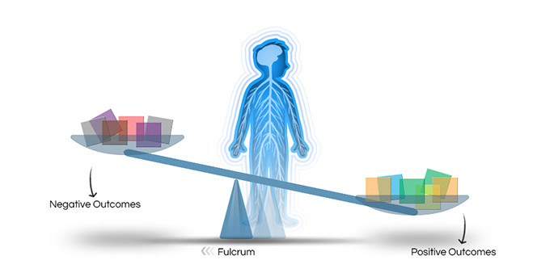](https://46y5eh11fhgw3ve3ytpwxt9r-wpengine.netdna-ssl.com/wp-content/uploads/2015/03/fulcrum-shift.jpg)**Understanding How to Develop Resilience.**

One way to understand the development of resilience is to visualize a balance scale or seesaw. Protective experiences and coping skills on one side counterbalance significant adversity on the other. Resilience is evident when a child’s health and development tips toward positive outcomes — even when a heavy load of factors is stacked on the negative outcome side.

Over time, the cumulative impact of positive life experiences and coping skills can shift the fulcrum’s position, making it easier to achieve positive outcomes

|  |  |
| --- | --- |
| Watch this video to learn more about the science of resilience. | <https://youtu.be/1r8hj72bfGo?list=PLWYnPkn8czzFfwpkTyoGcMpQFcbZwI3bL> |
| Watch this video to learn more about practical ways to develop resilience in children. | <https://youtu.be/sOvj9J51XuY> |

**How do Foster Carers establish meaningful relationships that develop resilience in children affected by attachment difficulty and trauma?**

As outlined earlier in this guidance, all Lancashire Foster Carers are trained to understand and implement the Secure Base Model; this is one approach to therapeutic parenting. In addition, our Foster Carers through the assessment process and subsequent training opportunities are also skilled to provide parenting that is categorized by playfulness, acceptance, curiosity and empathy PACE. PACE is a second, but complementary therapeutic parenting approach. The PACE principles of parenting can be a great resource for parents or foster carers looking for guidance on interacting with children and young people in care, particularly those who have experienced trauma. The approach was developed by Dr. Dan Hughes, a clinical psychologist based in the United States, who specializes in the treatment of children and young people who have experienced abuse and neglect.

According to Dr. Hughes all children need love, but for troubled children a loving home is not always enough. Children who have experienced trauma need to be parented in a special way. PACE was developed as a way of thinking, feeling, communicating and behaving that aims to make the child in care feel safe. With PACE, the child can start to look at themselves and let others start to see them, or get closer emotionally. In short, they can start to trust again.  
  
**Playfulness**  
The principle of **playfulness** is about creating an atmosphere of lightness and interest when you communicate. It means learning how to use a light tone with your voice, like you might use when story-telling, rather than an irritated or lecturing tone. It’s about having fun, expressing a sense of joy and being spontaneous. A playful attitude implies that the strength of the relationship between the parent/carer and child is larger than any minor irritations. Family members with a playful attitude don’t take themselves too seriously and are able to laugh at their mistakes. The primary goal is to invite children and young people into the parent/carers experience – to simply enjoy being together, with no spoken or unspoken goals. Playfulness is a clear example of a 'serve and return' interaction discussed earlier in this guidance.

**Acceptance**  
Unconditional **acceptance** is at the core of a child’s sense of safety. It’s important to accept the child or young person’s feelings and emotions, but not the unwanted behavior. For true acceptance to take place, it is important that the parent/carer has a routine of viewing the child or young person beyond the behavior. If a child expresses distressing emotions about themselves or others (e.g. “nobody loves me”, “I’m stupid”, “I’m bad”, “you hate me”) don’t challenge them as being wrong. Accept those feelings and acknowledge them using curiosity and empathy.  
  
**Curiosity**  
It is important to be curious about the child in your care’s thoughts, feelings, wishes and intentions. **Curiosity** is also important for discipline to be effective. If a child behaves inappropriately ask what they are feeling. Curiosity involves a quiet, accepting tone that conveys a simple desire to understand the child: “what do you think was going on?”, “what do you think that was about?” or “I wonder what…?”  
  
**Empathy**  
**Empathy** lets the child in care feel your compassion. Being empathic means actively showing the child that their inner life is important to you and that you want to be with the child in hard times. Understanding and expressing your own feelings about the child or young person’s experience can often be more effective than praise. For example, if a child says “you don’t care”, you can respond by saying “That must be really hard for you. I feel sad that you experience me as not caring”.

|  |  |
| --- | --- |
| Watch this short video to understand the difference between empathy and sympathy. | <https://youtu.be/1Evwgu369Jw> |

**Managing those challenging moments**  
Dr. Hughes stresses that PACE focuses on the whole child, not simply the behaviour. It helps children be more secure with their parents/carers and reflect upon themselves, their thoughts and feelings. Through PACE parenting, and as they begin to feel safer, children discover they can now do better.  
For parents/carers, using PACE can reduce the level of conflict, defensiveness and withdrawal that tends to be ever present in the lives of children who have experienced trauma. Using PACE enables the parent/carer to see the strengths and positive features that lie underneath the more negative and challenging behaviours.

PACE is almost a 'way of being' rather than a technique to be used on occasion. It stems from a premise that the caregiver wants to be with, and to understand the child, without an immediate motive to change him. PACE allows the adult caregiver to get alongside the child and to support and share the experience the child is having. Over time the child develops a new understanding about himself and expectations of others because of this experience. Notice that PACE is not about trying to change behaviour, it is concerned with understanding the child and helping him or her to transform his understanding of past and current experience. The fundamental aims of these interactions are to increase the protective factors in a child's life to develop their resilience.

|  |  |
| --- | --- |
| Watch this short video to understand in more detail ***how*** PACE is an effective approach to parenting children affected by Trauma. | <https://youtu.be/pAn9mi627JU> |

**Why is this relevant to my role in undertaking Placement Searches?**

When reading a placement request form (PL1), there will be some information about the quality of child's family and social relationships. The social worker may even have made reference to the child's attachment style and it is important that you understand what is meant by this information. You may recognize that multiple placement breakdowns have impacted the child's ability to establish secure connections and may need the support of a therapeutic parent to overcome some of these difficulties. When you convey the content of the PL1 to the Foster Carer, you may be able, from your knowledge of attachment theory, be able to hypothesize that's the child's behavior may be due to difficulties in establishing attachments.

You may read a PL1 that outlines behaviour in the Child that traditionally may have be considered 'challenging'. Your role is to recognize that a child from an adverse background is highly unlikely to be willful in their perceived misbehavior – you need to encourage carers to remember that a child's behaviour is much more likely to be a result of their experiences – or a trauma response. You know that with reciprocal, therapeutic relationships, children from these backgrounds can thrive. It is your role in the phone call to advocate for the child, challenge foster carers assumptions if they have any, and reduce further stigmatization for the child.

When reading a PL1 you are absolutely encouraged to refer to your knowledge of child development and provide where possible context to the child's needs.

You may or may not be aware that Lancashire's **Foster Carers are trained to understand this information** and sometimes you need to remind them of their knowledge. All mainstream foster carers are required to undertake the Skills to Foster Training as part of their approval. Within this training, they are taught about child development theories – including attachment and trauma, they are also provided with skills to overcome some of these challenge. As part of their initial training all Lancashire Foster Carers receive training in relation to the Secure Base Model and develop their understanding of parenting through PACE.

There are numerous additional training opportunities that Lancashire Foster Carers are also expected to attend to fine tune their skills in these areas, it is worth remembering that the National Training and Development Standards for Foster Carers sets out clear requirements for Foster Carers to 'Understand the Development of Children and Young People' (Standard 5). As such, don't be put off considering our in-house carers when PL1's specify a need for a therapeutic placement. Also encourage carers when approaching them to consider a placement to reflect on their already developed skills and lean in to this to bolster their confidence.

Always encourage Carers to think about why they became Foster Carers, the most likely reason was to help children who have experienced adversity - remind them how they are able to influence positive change.