Complex Safeguarding
Protocol
2020

-

2022

Children's Social Care

Contents

INTRODUCTION

................................
................................
................................
......

3

Complex Safeguarding Definition

................................
................................
..

3

Complex Risk

................................
................................
................................
.

3

Contextual Safeguarding

................................
................................
...............

4

An integrated approach

................................
................................
.................

4

Child Sexual

Exploitation definition

................................
................................

6

Child Criminal Exploitation definition

................................
..............................

6

Modern Slavery definition

................................
................................
..............

7

REFERRALS TO COMPLEX SAFEGUARDING TEAMS (CST's)

..........................

8

CONSULTATION WITH LOCALITY TEAMS

................................
..........................

9

ROLE OF THE COMPLEX
SAFEGUARDING TEAM

................................
............

10

Prevention, Education and Awareness

................................
........................

11

Safeguarding and supporting vulnerable people, groups and communities

.

11

Effective
leadership and governance

................................
...........................

11

Disrupt and Prosecute

................................
................................
.................

12

Communication, Engagement and Empowerment

................................
.......

12

COMPLEX SAFEGUARDING ASSESSMENTS

................................
....................

13

MACE

................................
................................
................................
.....................

13

CHILDREN PLACED WITHIN LANCASHIRE

................................
.......................

14

COMPLEX SAFEGUARDING TEAM (CST) CASE PATHWA
Y

...........................
.

1
5

APPENDICES

................................
................................
................................
........

16

INTRODUCTION
All agencies across Lancashire are fully committed to safeguarding children and young people from being exploited in any way. This includes sexually and criminally and includes modern slavery, whilst disrupting and prosecuting individuals who have exploited them. This Protocol provides a set of multi-agency principles for tackling Child Exploitation across Lancashire and outlines how through our partnerships we assess, challenge and provide an enhanced, effective service to reduce the risks and to ensure that interventions are focussed, co-ordinated and have a positive impact on outcomes for children and young people.
Lancashire's three multi-agency complex safeguarding teams are co-located and based in the North of Lancashire, between South King St and Lancaster Police Station. In Central Lancashire at Preston Police Station and in the East of Lancashire at Greenbank Police
Station. These teams are made up of Children's Social Care (including Blackpool and Blackburn with Darwen Unitary Authorities), Lancashire Police, and Health partners along with close working relationships with education, YOT the voluntary sector and commissioned services.

Complex Safeguarding Definition
- Complex abuse as defined in Working Together to Safeguard Children (2018) “abuse involving one or more abusers and a number of related or non-related abused children and young people. The abusers concerned may be acting in concert to abuse children, sometimes acting in isolation, or may be using an institutional framework or position of authority to recruit children for abuse.“

- Complex safeguarding refers to criminal activity (often organised), or harmful behaviour associated with criminality, involving children, young people and adults with multiple vulnerabilities where there is exploitation, a risk of exploitation and / or a clear or implied safeguarding concern which is likely to lead to a serious and sustained negative impact on Children & Young People

Complex Risk
During adolescence the nature of the risks faced by young people, and the way that they experience these risks, often differs from earlier childhood – as do their needs. Young people may be faced with a new set of complex risks, ones not posed by families, but instead by peers, partners and adults unconnected to their families.
These risks:
- often manifest in extra-familial environments including schools, public spaces and online platforms
- are informed by peer norms and relationships
- often feature grooming, coercion, criminality and serious risks of significant sexual and physical harm that create climates of fear and reduce engagement with services
- are beyond the control of parents and rarely instigated by parents
- continue into adulthood and particularly for young people during the 18-25 transitional period

Contextual Safeguarding
Contextual safeguarding which includes child sexual exploitation, peer on peer violence and abuse (including gangs), modern slavery, harmful sexual behaviour, criminal exploitation, and going missing should not be seen in isolation as they often overlap, creating a complex set of harmful circumstances and experience for children, young people, families and communities.

(Firmin, 2017)
Contextual Safeguarding is an approach to understanding, and responding to, young people's experiences of significant harm beyond families. It recognises that the different relationships that children form in their neighbourhoods, schools and online can feature violence and abuse. Parents and carers have little influence over these contexts and young people's experiences of extra-familial abuse can undermine parent-child relationships.
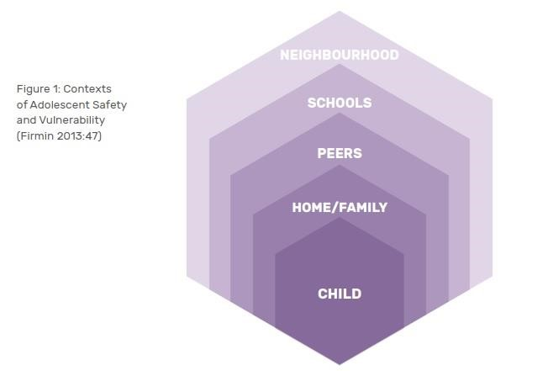

An integrated approach
The importance of an integrated approach to complex safeguarding through multi-agency working is well recognised. Supporting exploited young people and disrupting perpetrators are complex processes that require appropriate interventions from a range of stakeholders.
Multi-agency approaches enable organisations to contribute their specific role whilst also developing shared actions to protect young people and pro-actively investigate abusers.
Each agency will bring expertise to multi-agency working and the ability to access young people in different contexts. When organisations are able to learn from and professionally challenge each other’s practice, this can lead to enhanced responses. The best multiagency approaches are those that are child-centred and involve a range of agencies and practitioners.
All partner agencies commit to this approach. And consider the following principles for multi-agency working:

- Integrated working (e.g. co-location) – Close collaboration in multi-agency working is essential in identifying those who are at risk of being exploited by sharing information at an early stage and developing ‘real time’ Complex Safeguarding Assessments to enhance decision making. A truly integrated approach helps to break down cultural barriers, leading to greater understanding and mutual respect among different agencies.

- Multi-agency complex safeguarding assessment – to be completed alongside a Child & Family assessment by the locality social work teams; these ensure clear and sufficient information about particular cases and joint plans for individual interventions.

- A victim focused approach – the needs of the victim must be at the forefront of our approach not systems and processes.

- Effective leadership & clear governance – strong leadership can often bind different organisations together to develop a shared culture.

- Frequent review of operations – to continue to drive improvement of the service.

- Work within the community to support families, parents and carers to care for their child and reduce harm where the child’s exploitation is contextual.

- To investigate, prosecute and disrupt perpetrators.

- Promote positive physical and emotional health and well- being - of individuals identified as being at risk of child exploitation.

- Apply pro-active problem solving to address the risks associated with victims, perpetrators and locations - to ensure the safeguarding and welfare of children who are or may be at risk from exploitation.

- Take proactive action against those who are intent - on sexually or criminally abusing and exploiting children and young people.

- To develop a shared picture - of child exploitation intelligence across Lancashire

Child Sexual Exploitation definition

Child sexual exploitation is a form of child sexual abuse. Sexual abuse may involve physical contact, including assault by penetration (for example, rape or oral sex) or nonpenetrative acts such as masturbation, kissing, rubbing and touching outside clothing. It may include non-contact activities, such as involving children in the production of sexual images, forcing children to look at sexual images or watch sexual activities, encouraging children to behave in sexually inappropriate ways or grooming a child in preparation for exploitation.
The definition of child sexual exploitation developed by the UK National Working Group for Sexually Exploited Children and Young People (NWG) and used in statutory guidance for England is:

Sexual exploitation of children and young people under 18 involves exploitative situations, contexts and relationships where young people (or a third person or persons) receive 'something' (e.g. food, accommodation, drugs, alcohol, cigarettes, affection, gifts, money) as a result of them performing, and/or another or others performing on them, sexual activities. Child sexual exploitation can occur through the use of technology without the child's immediate recognition; for example being persuaded to post sexual images on the Internet/mobile phones without immediate payment or gain. In all cases, those exploiting the child/young person have power over them by virtue of their age, gender, intellect, physical strength and/or economic or other resources. Violence, coercion and intimidation are common, involvement in exploitative relationships being characterised in the main by the child or young person's limited availability of choice resulting from their social/economic and/or emotional vulnerability

Child Criminal Exploitation definition

Criminal Exploitation involves exploitative situations, contexts and relationships where young people (or a third person or persons) receive 'something' (e.g. food, accommodation, drugs, alcohol, cigarettes, affection, gifts, money) as a result of them completing a task on behalf of another individual or group of individuals; this is often of a criminal nature.

Child criminal exploitation often occurs without the child's immediate recognition, with the child believing that they are in control of the situation. In all cases, those exploiting the child/young person have power over them by virtue of their age, gender, intellect, physical strength and/or economic or other resources.

Violence, coercion and intimidation are common, involvement in exploitative relationships being characterised in the main by the child or young person's limited availability of choice resulting from their social/economic and/or emotional vulnerability.
County Lines County lines is the police term for urban gangs supplying drugs to suburban areas and market and coastal towns using dedicated mobile phone lines or “deal lines”. It involves child criminal exploitation as gangs use children and vulnerable people to move drugs and money. Gangs establish a base in the market location, typically by taking over the homes of local vulnerable adults by force or coercion in a practice referred to as ‘cuckooing’. County lines is a major, cross-cutting issue involving drugs, violence, gangs, safeguarding, criminal and sexual exploitation, modern slavery, and missing persons.
Organised/Networked exploitation or trafficking Young people (often connected) are passed through networks, possibly over geographical distances, between towns and cities where they may be forced/coerced into sexual activity with multiple men. Often this occurs at ‘parties’ and young people who are involved may recruit others into the network. Some of this activity is described as serious organised crime and can involve the organised ‘buying and selling’ of young people by offenders. Organised exploitation varies from spontaneous networking between groups of offenders, to more serious organised crime where young people are effectively ‘sold’. Children are known to be trafficked for exploitation and this can occur anywhere within the UK, across local authority boundaries and across international borders

Modern Slavery definition

"The recruitment, transportation, transfer, harbouring or receipt of a child for the purpose of exploitation."

This definition comes from the United Nations Palermo Protocol, which the UK and the majority of countries around the world have adopted, making it the internationally accepted definition of human trafficking and in UK trafficking is regarded as a form of modern slavery.

Legal definition
A person commits an offence if the person arranges or facilitates the travel of another person (“V”) with a view to V being exploited.
- It is irrelevant whether V consents to the travel (whether V is an adult or a child).
- A person may in particular arrange or facilitate V‟s travel by recruiting V, transporting or transferring V, harbouring or receiving V, or transferring or exchanging control over V.
- A person arranges or facilitates V‟s travel with a view to V being exploited only if— the person intends to exploit V (in any part of the world) during or after the travel, or the person knows or ought to know that another person is likely to exploit V (in any part of the world) during or after the travel.
- “Travel” means- arriving in, or entering, any country, departing from any country, travelling within any country. (Modern Slavery Act 2015)

REFERRALS TO COMPLEX SAFEGUARDING TEAMS (CST's)
Internal referrals from social workers to the teams should be completed through a complex safeguarding referral form;
- If a child is presenting with signs of being exploited or a victim of exploitation MASH managers will allocate cases to locality assessment teams and send a complex safeguarding referral to the appropriate Complex Safeguarding duty tray; Exploitation Central Exploitation North Exploitation East

- For open cases, the locality social worker completes a complex safeguarding referral and sends to the Complex Safeguarding Locality team mailbox when they have identified exploitation concerns as part of an ongoing assessment or while supporting a child on a statutory plan.

- In either of the above circumstances an assessment meeting, including partners when necessary (physical or virtual), is to be convened to co-ordinate action planning, joint visits and assessments.

- Where the CST identify other young people potentially at risk of exploitation through their assessments/meetings a referral should be sent to MASH (child closed to CSC).

Where a referral has been received in the complex safeguarding duty tray the CST Manager will review the referral and allocate a worker as appropriate. Where the manager does not approve the referral a discussion will be held with the locality team within 24 hours of receipt.

The outcomes of these discussions will be recorded by the CST manager on an LCS case note and shared with the locality manager to ensure timely and effective planning. A CSE, CCE, and/or Modern Slavery/Human Trafficking hazard will be added to the young person's LCS record at point of allocation by a complex safeguarding worker.

The CST's will:
- Complete a complex safeguarding assessment within 30 days,

- Share the assessment and recommendations with the locality team and a joint decision will be made if the child is to become subject to a statutory plan,

- Where complex safeguarding needs are identified, a CST worker will co-work alongside the allocated locality social worker to complete the complex safeguarding actions incorporated into the child's plan. The plan will include ways to strengthen the child's resilience and protective factors as form of 'pulling them away' from the exploitation risk.

- Where a child is made subject to a statutory plan following assessment this will remain with the allocated locality social worker, however the complex safeguarding worker will attend all meetings and contribute to all plans to ensure they are holistic and child focussed.

- Any direct work identified through the complex safeguarding assessment will be detailed in the statutory plan.

CONSULTATION WITH LOCALITY TEAMS
For all open cases there will be collaborative working.
Complex safeguarding teams will offer monthly clinics to allow for opportunities for locality Social Workers to consult CST Social workers in relation to CE concerns.

These clinics should be aimed at developing;

- Improved understanding of the referral pathway and assessment threshold.

- More appropriate referrals, suitably recorded to meet threshold.

- Greater volume of referrals for children already open to CSC.

- Improved lines of communication between locality and complex safeguarding teams.

- Ensure that Complex Safeguarding is understood by the workforce and embedded across LCC

- Share info on hotspots, themes and trends in relation to Complex Safeguarding.

- Deliver briefings to raise awareness of the complexities of Complex Safeguarding.

ROLE OF THE COMPLEX SAFEGUARDING TEAM
- Following a referral to the CST where a child is already open to locality a complex safeguarding worker will be allocated and will complete a complex safeguarding assessment to support the delivery of the child's plan (which will include a contextual plan). Where a new referral has been allocated to a locality social worker and complex safeguarding social worker a joint approach will be planned.

This will allow for children and their families to have a clearer understanding of roles and responsibilities undertaken by professionals assigned to the case.

- All strategy meetings to be convened by the allocated locality social worker, but the complex safeguarding social worker and line manager should be notified and will attend and contribute to all action planning.

- Where a child is part of a police operation, which may involve multiple children and/or adults countywide, it has been agreed that a complex strategy meeting will take place.

- An IRO or Q&R manager will be responsible for chairing a complex strategy meeting (Multiple perpetrators/Victims; Example: organised abuse; complex criminal or sexual exploitation).

IRO Strategy Meeting Request Form 2020

Once an assessment has been completed and needs identified, the complex safeguarding social worker, alongside the locality social worker, will agree a plan in partnership with the child and primary carer to reduce risk and build on positives and strengths in their lives. The plan shall be agreed and reviewed according to statutory procedures.
The complex safeguarding social worker will use a range of different interventions to engage the child and family and to address the areas of risk which have been identified. They will use creative and innovative approaches wherever possible and tailor these interventions to the individual needs. Support and intervention will be timely therapeutic support, engagement model of support particularly recognising the vulnerability of young people.
The starting point for delivery of interventions will be the building of a relationship with the child and their family through positive activities and understanding the interests, wishes and feelings of the child and the push and pull factors that may be present. Such actions will allow for trust to develop and allow for a more structured and child focused approach of direct work being undertaken.
Parental support will be based on four areas:
- Their relationship with their child, and particularly understanding teenage development, what makes their child vulnerable, how perpetrators groom and control, their role as parents, and how parenting can help.
- Their own emotional needs, including dealing with trauma of exploitation, the impact of their own past experiences, and parents' relationships with each other.
- Dealing with the systems, including understanding how police, legal and child protection systems work, and having some to advocate on their behalf.
- Building their resilience, including identifying sources of support in the wider family and community, and accessing the professional and peer support they need.
All direct work sessions completed will be recorded under a 'direct work session' case note.
The CST will continue to support any child open to CSC placed out of the county in order to provide consistency of support and maintain developed relationships; however in some circumstances it may be deemed appropriate for the case to be reallocated to another district if it is felt that this is in the best interest of the young person and retains a child focused and holistic approach to the child's plan and offers the best outcome for the child and their family.

Prevention, Education and Awareness
- Working closely with key stakeholders to understand and respond to a range of risk and vulnerabilities
- Raising awareness amongst all communities, parents, carers and potential perpetrators
- Training for professionals to enable identification, understanding and responding to range of risk and vulnerabilities
- Make contacts count - There are many points where support for a child or family can reduce the risk of them becoming a victim. At each of these points there are services tasked with working with these families, and the key is ensuring these services are used.
- Focus upon all schools, colleges and alternative educational provision.
- Inform training and development opportunities that support agencies and practitioners to recognise that children can simultaneously be both a victim and perpetrator of exploitation, harm and abuse and therefore responses, assessments and interventions must child centred

Safeguarding and supporting vulnerable people, groups and communities
- Ensure that there is appropriate information to advise and access identified support
- Develop effective information sharing to identify and inform gaps in service provision
- Protect vulnerable locations – places where vulnerable young people can be targeted, including pupil referral units and residential children’s care homes,
- Focus upon transitional arrangements – ensure appropriate arrangements are in place to support and protect children who have been assessed as increasingly vulnerable
- Recognise and respond to the children with multiple vulnerabilities – including mental health, alcohol and substance misuse, and domestic abuse

Effective leadership and governance
- Ensure that the local multi-agency response is informed by national / local research and learning and an understanding of the wider context of risk and harm
- Effective systems around the Front Door/ MASH and associated processes for both children and adults
- Encourage statutory and non-statutory partners to work together to develop and strengthen collective safeguarding efforts
- Quality assurance of improved outcomes for children
- Developing best practice and learning
- Multi-agency training at all levels – including specialist and non-specialist practitioners and linking with established programmes to widen knowledge of exploitation.
- Improving outcomes and reducing harm to young people and vulnerable adults who are at risk of exploitation and victims of exploitation

Disrupt and Prosecute
- Improve intelligence and information sharing and analysis, to assist local disruption plans and the prosecution of people and businesses where appropriate (mapping)
- Making best use of licensing laws, Child Abduction Warning Notices, Sexual Harm Prevention Orders, Slavery and Trafficking Risk Orders and other relevant legislation available to address offences to close down premises, deter perpetrators and prevent violence and abuse from occurring, escalating and /or recurring
- Collaborative working with law enforcement and criminal justice agencies
- Ensure a proactive response to prevent crimes and harm
- Supporting children through all aspects of the criminal justice system including court processes to improve their experiences and help minimise re-victimisation created by the process/system including the often difficult court process and help achieve successful prosecutions of those who exploit, harm and abuse families.

Communication, Engagement and Empowerment
- Develop a coordinated programme of information and education for all partners.
- Developing awareness messages/campaigns about what to look for, and how to report concerns, in order to enhance not only the identification of people but also places of concern
- Create public facing campaigns and user friendly materials to effectively signpost children, young people, families and communities to appropriate advice, support and services, to develop community resilience to empower and involve communities
- Provide clear and unambiguous deterrent messages to perpetrators including campaigns to reach diverse groups
- Ensure effective internal communications to professionals across the partnership (MACE, MFH meetings)
- Maximise on-line and social media opportunities and campaigns
- Coordinating clear pathways to centrally collate feedback received from children and families; to enable children’s and service users experiences inform and enhance strategic knowledge.
- Listening to the voice of children and making safeguarding personal for service users to inform thinking and future planning.

COMPLEX SAFEGUARDING ASSESSMENTS
In cases where there is concern that a child is at risk of child exploitation, the complex safeguarding assessment will be completed and reviewed following any significant event (change of statutory plan) or within 12 months by the complex safeguarding social worker in conjunction with the child, family, other professionals, and the allocated social worker.

All complex safeguarding assessments to be completed within 30 working days and reviewed by the complex safeguarding line manager.

All complex safeguarding actions shall be incorporated into the child's Plan with clear and readily identifiable actions and outcomes; all of which shall ensure that the Plan remains child centred and holistic.
The completed complex safeguarding assessment, which will include an action plan, will be sent to the allocated case worker and the actions must be incorporated into the child's plan.
When the assessment has been completed a case note will be entered onto LCS by the manager and added to Documentum. The case note will clearly identify the outcomes and recommendations.

The CST manager will be responsible for sharing the document with the CST BSO for filing on Documentum. The assessment will also be shared with partners on the team e.g. locality team, police, health etc.

An updated complex safeguarding assessment will be completed prior to closure to the complex safeguarding team.

MACE

A MACE meeting will provide the framework to allow regular information sharing and action planning to tackle CE from a range of statutory, voluntary and community sector agencies.

North, East and Central areas hold monthly MACE meetings to discuss multi-agency progress against plans for the most complex cases.

New referrals to MACE to be agreed by complex safeguarding manager 5 days prior to each meeting.

Complex safeguarding workers to ensure monthly case updates are provided on all open MACE cases by agreed deadlines.

Attendance at these meetings to be requested:
- LCC CSC complex safeguarding team
- Local complex safeguarding police team
- CSC Locality representative
- Children's Society
- YOT worker (if relevant to any high risk cases)
- Education (Virtual School, Pupil Attendance Officers, SENDO's)
- Residential Care Homes (if relevant to any high risk cases)
- Fostering/Adoption representative (if relevant to any high risk cases)
- Children & Family Wellbeing Service
Complex safeguarding Social workers will be expected to record on an LCS case note a brief overview of any details and actions. This will be shared with the locality social worker and the both respective managers.
In the absence of the complex safeguarding social worker the complex safeguarding manager should record the case note and share with the locality social worker.
This meeting, in conjunction with looking at individual cases of child exploitation, will be the forum for information sharing to increase the understanding of the threat posed by child exploitation across Lancashire and will discuss 'Hotspot' areas and potential perpetrators or persons that may pose a risk to children.

CHILDREN PLACED WITHIN LANCASHIRE

The home authority to be notified if a child placed in Lancashire by another authority is discussed on MACE and details and outcomes sent to their allocated worker by the complex safeguarding manager.
Safeguarding, Inspection and Assessment (SIA) team to forward copies of all notifications to the Authority of CP and CLA cases being placed in Lancashire where complex safeguarding needs are identified.
Information to be shared with locality teams via Managers – partners may be aware of the cases through health practitioners or police, but if not, partner agencies should be briefed.
These cases will be closed once notification is given that the child is no longer placed within our area.

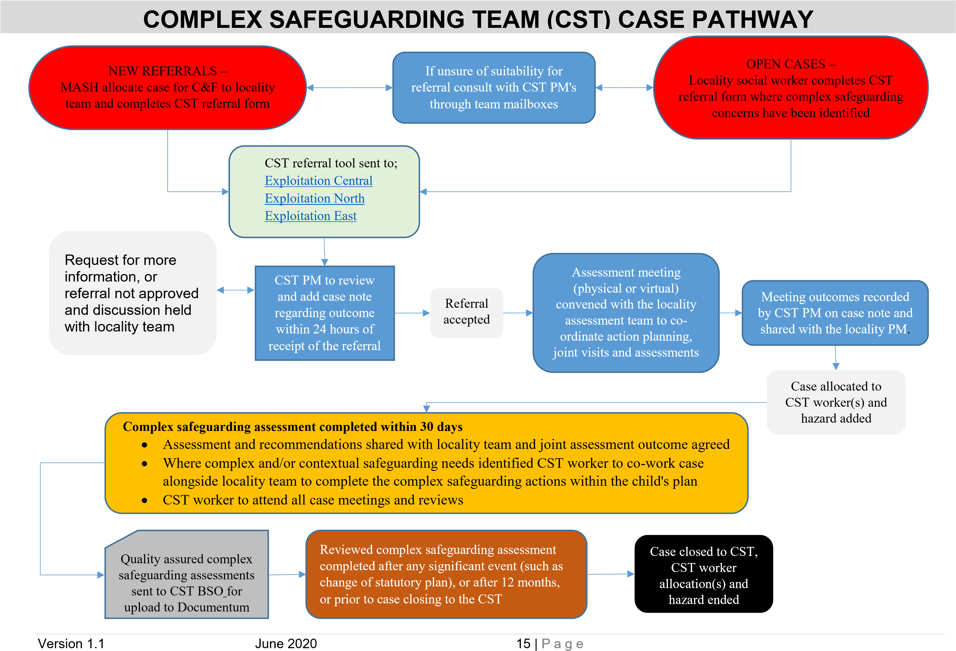

APPENDICES
The links to the documents below are currently within the CST network folders pending inclusion on TriX – please request a copy from a CST team member

CST Referral Form
Forms\CST Referral form.docx

CST Assessment
Lancashire CST Assessment v1.docm

CST assessment CF attachment v1.docm

Assessment Guidance
Supporting documents\Lancashire Assessment Framework Guidance (v2).docx

Child Exploitation Language Toolkit

https://www.csepoliceandprevention.org.uk/sites/default/files/Guidance%20App%2 0Language%20Toolkit.pdf

Version 1.1 June 2020 16 | P a g e

