LANCASHIRE ASSESSMENT & PLANNING FRAMEWORK
Updated January 2022

POLICY INFORMATION SHEET

Name of Document | Lancashire Assessment and Planning Framework
Service area | Children and Young People
Target Audience | All staff working with children and families
This document was approved by | Children's Social Care Senior Management team
Date policy is effective from | April 2014
Date policy updated | January 2022
Date review due | January 2023
Status:  - Mandatory (all named staff must adhere to guidance)  - Optional (procedures and practice can vary between teams) | Mandatory
Location of Document | CSC Procedures Manual Local Resources;  Lancashire Safeguarding Children Board Resources
Related document(s) | Children's Social Care Procedures;  Pan Lancashire Policy and Procedures for Safeguarding Children
Responsible officer(s) | Director of Children's Services
Any other relevant information

Contents Page

Introduction Page 3
The Purpose of Social Work Assessments Page 4
Statutory Assessments under the Children Act (1989) Page 4
Assessment and Analysis Page 5
The Role of Planning Page 7
Assessment - Timely, Transparent and Proportionate to Need Page 8
Assessment Checkpoints Page 8
Practice in all Assessments Page10

Introduction

  - The Working Well with Children and Families in Lancashire (Continuum of Need – CON) sets out the importance of working with families to build on their strengths and come together across agencies with children and young people at the centre of our work. It is designed to ensure that we give families who are experiencing challenges the advice, information and support they need to help them make a positive difference to their lives. It highlights and supports the emphasis on both assessment and planning when working with children and families and focuses on empowering families by working alongside them to build strong foundations and develop the strengths and resilience they already have so that children and young people can thrive.

Click here for the Working Well with Children and Families Lancashire Guidance.

  - The Lancashire Assessment and Planning Framework sets out how, in Lancashire, we will provide an open, honest and transparent approach when working with children and families. Solution-focused and evidence-based interventions will be provided as early as possible and there will be a joint working approach to assessments, support and intervention. This framework is equally applicable to all open cases, for example, children subject to a an Early Help Plan, children with a Child in Need plan or Child Protection plan and Children Looked After, where ongoing assessment and planning is essential to informing plans for children, avoiding drift and ensuring timely decision making based on effective, evidence based assessment.

  - If children and families are to receive the right help, everyone who comes into contact with them – midwives, health visitors, GPs, early years’ professionals, teachers, youth workers, police, voluntary and social workers – have to play a role. By identifying strengths within the family; protective factors; the views of children, young people and their family; any worries; and by sharing information – we can work together to provide the right support at the right time.

  - Concerns about a child’s welfare may arise in many different contexts and the nature of these concerns will vary greatly from child to child. What is important is that support is provided at the earliest opportunity so that a problem does not escalate. It is also essential that families are included within the assessment process and they are supported to identify their own family strengths, but also areas they wish to change.

  - Understanding families and the experiences of children within them can be complex, however by working in a strengths-based way, professionals can support families to identify their own strengths and areas they wish to change. This promotes positive working relationships and ensures families receive the right level of support at the right time. Professionals working in universal services – health, education, police and early years – have a responsibility to identify the early signs of need, abuse and neglect, to share that information, and work together with families to provide children with the help they need.

  - Assessment should be a continuous process which has the needs of the child at the centre. The assessment completed by a Social Worker will therefore build on information already known as a result of early help to the child and their family and previous or ongoing involvement with Children’s Social Care.

The Purpose of Social Work Assessments

  - The purpose of an assessment is to gather information and evidence about a child and their family. The assessment should identify strengths of the family, protective factors, areas the family wish to change, the views of the child and family, views of wider support networks and also areas in which the family need support. An assessment is not an end in itself but the means of informing the delivery of effective services for children and families. An assessment must be completed by a qualified Social Worker. The assessment must be based on a sound knowledge of child development and be seen in the context of the child’s family and their environment. The Social Worker leads the assessment which must be informed by the child and their family members and by other professionals who know them, including teachers, health visitors and the police.

Statutory Assessments under the Children Act (1989)

  - A statutory assessment under the Children Act (1989) will inform decisions about whether a child is a child in need or is suffering, or likely to suffer, significant harm as defined in section 17 and 31 of the Act.

  - A child in need is defined under Section 17 of the 1989 Children Act as a child who is unlikely to reach or maintain a satisfactory level of health or development, or their health and development will be significantly impaired, without the provision of services, or children who are disabled. In these cases, assessments by a social worker are carried out under section 17 of the Act. The purpose of these assessments is to gather information about a child’s developmental needs and the parents’ capacity to meet these needs within the context of their wider family and community, highlighting strengths, protective factors and areas of change. This information must be used to inform decisions about the multiagency help needed by the child and family.

  - If the social worker believes that the child is suffering, or likely to suffer significant harm, then the local authority under section 47 of the Act is required to make enquires to decide what action must be taken, with partners, to safeguard and promote the welfare of the child. There may be a need for immediate protection whilst the assessment is carried out.

  - Following an application under section 31A of the Act, where a child is the subject of a care order, the local authority, as a corporate parent, must assess the child’s needs and draw up a care plan which sets out the services which will be provided to meet the child’s identified needs. Where possible, the child and their family should be included within the development of the care plan, highlighting their views. Where a child is accommodated under section 20 of the Act, the local authority also has a statutory responsibility to assess the child’s needs and draw up a care plan which sets out the services to be provided to meet the child’s identified needs. Again, including the child and family within their care plan.

  - Where a child becomes looked after, the assessment will trigger other assessments to plan the long-term care of the child, including the possibility of returning home. The single assessment will be the means by which to decide whether the necessary changes and improvements have been made to ensure the child’s safety when they return home. Lancashire Children's Social Care will endeavour for all children to remain at home, or return home, where it is safe to do so.

Assessment and Analysis

  - The assessment should be based on Working Together, our statutory guidance for assessment and use the following framework to gather information:

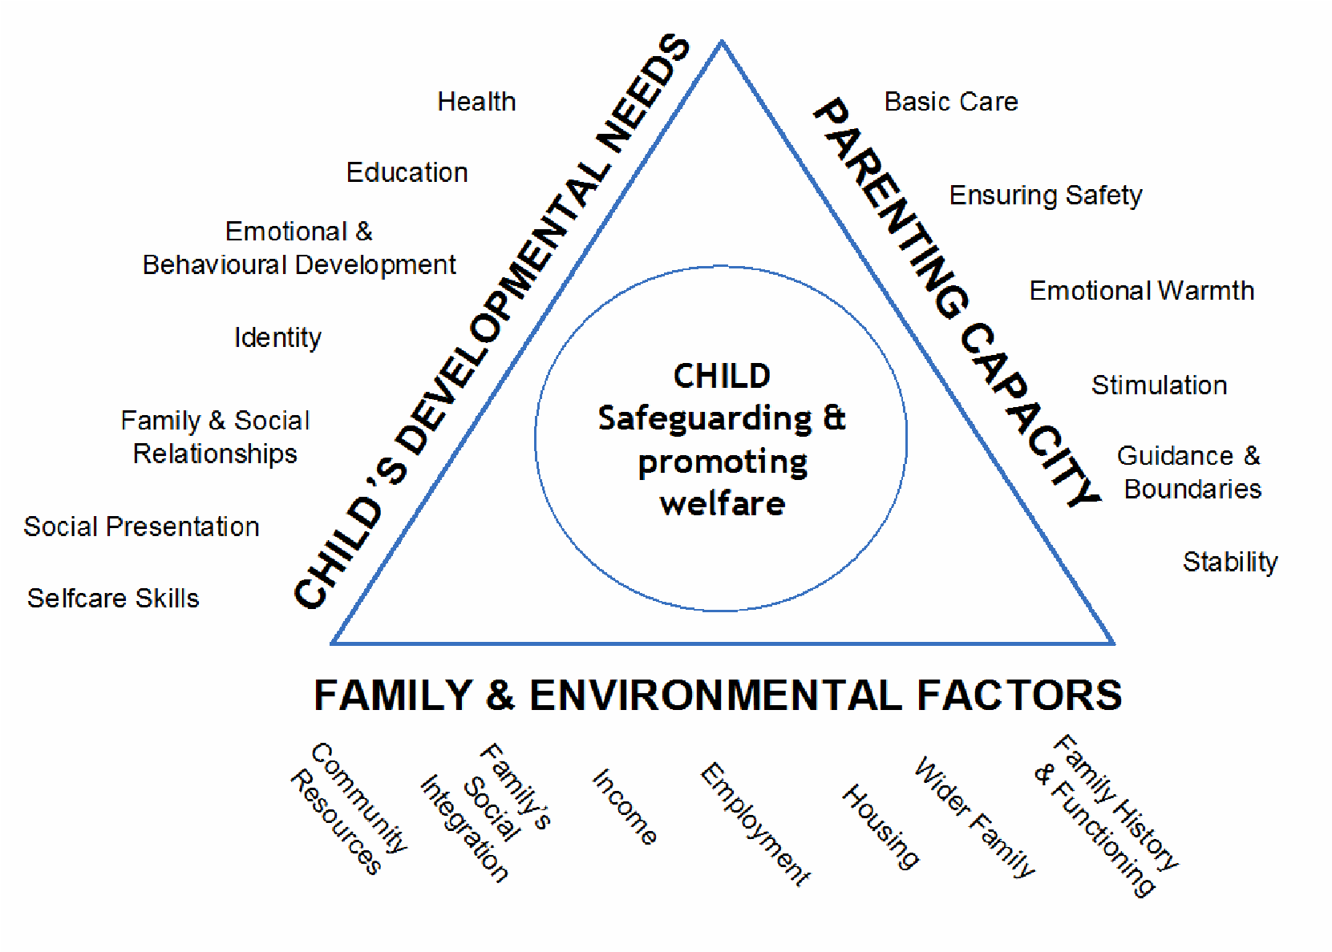
  - An effective assessment process means gathering good evidence:

- Use existing/previous information that we and other agencies have. Set this out in the assessment and draw out patterns in their history.
- Explore services, work, and support that has previously been offered and consider what change and difference this made for the child and family, and how well the family engaged with this, if it was not successful, why not?
- Spend time with the child or young person gathering their views, wishes, feelings and opinions. Assume children can share these and try to gain them. If children are pre- or non-verbal, observe them and complete other activities to understand their world. Go beyond just gaining a child's 'voice' – seek their opinions about what is going on in their life.
- Observe the child or young person's key relationships with their parents or main carers, peers, or other important family members. Record and describe what you have seen of these relationships in the assessment. Try and give a sense of their lived experience.
- Use direct work tools, approaches, or structured pieces with the child, young person or adults in the family to inform the assessment process.
- Consider and record any barriers to engaging/working with the family.
- Set out a clearly each child or young person's specific needs.
- Take a strengths-based and collaborative approach with the family, seek and record their views/opinions, particularly their views about plans and solutions to the needs and challenges they have.
- Gain information and views from other agencies/professionals, including asking them to identify the strengths of the family. If other agencies or professionals have completed assessments of pieces of work with the child, young person or family make sure you use this to inform the assessment and coordinate the work that is going on around a family to best support the family to avoid duplication or professional conflict.
- Record any differences of opinions you have found.
- Consider and record your view of the strength of the evidence/information you have set out. State the source, quality and accuracy of this information.
- Triangulate information/evidence – join the dots and make links in the evidence to develop confidence in the professional view you then set out.
- Make use of current research and approaches and reference these in the assessment.

  - Completing assessments is a dynamic process and we need be flexible, inquisitive, reflective, and open to challenge – a process that requires support from managers and supervisors who provide and protect time and space to reflect. Managers should take time to support staff and help them develop their analyses, these may be anything from ad-hoc spaces to formal supervision. Managers and supervisors should use their own tools and take a planned and structured approach to supporting their practitioners and team as a whole in developing assessment and analysis skills to produce the highest quality work that informs best use of resources to support positive impact for children, young people and their families.

  - Our analyses are written in many different places in children and young people's records and there are a range of formats and forms that we use. The structure of a specific analysis might vary but should be led be the needs of the piece of work that contains the analysis and the needs of the child or young person, ensuring that the analysis helps in summarising their lives and supports effective decision making. In general, it is helpful to think of structuring an analysis into the following three sections with the following content to have a good analysis:

1st Section – A summary of known information:

- State the reason for this analysis or our professional involvement
- Summarise the known history
- Summarise the key evidence and weigh up the strength of that evidence
- Set out the main concerns and strengths
- Give a clear sense of the child or young person's lived experience and their core needs

2nd Section – Exploring the current dynamics, hypotheses, and progress:
- Set out the dynamics/patterns around the child or young person
- Set out at least one hypothesis
  - Ideally explore different hypotheses, and
  - Ideally give the parents/carers and child or young person's views of these hypotheses
- Consider progress, or lack of progress, in current work – including a view on where a parent/carer (or young person) is on the cycle of change and capacity to change

3rd Section – A clear professional view, the impact for the child or young person, and what next:
- Focus on, and clearly state the impact/outcomes for the child or young person – what all this information/evidence/analysis means for them
- Set out a clear decision/professional view (particularly on threshold – e.g. is the child suffering significant harm)
- Set out a brief plan/action/next steps (be SMART) and contingency plan if needed

  - When reflecting on the analysis some useful questions to consider include:

  - Have you answered the question(s) you set out to explore?
  - Is the analysis just a re-description, or have you gone further?
  - Have you explored dynamics/patterns around the child or young person?
  - Have you taken a balanced view with the strengths and concerns?
  - Are you taking a holistic view, have you considered all the evidence (including weighing up its relative strength) to inform you professional view?
  - Is there a hypothesis – a professional view why this child or young person is in this situation?
  - Have you thought about any assumptions you might be making?
  - Are you being over-optimistic?
  - Have you considered confirmation bias?
  - Are you writing in an absolute way, with too much certainty? Have you given a view on how sure you are about any professional view or hypothesis you are making?
  - Have you considered and recorded where the parents/carers are on the cycle of change and what their capacity to change is?
  - Are you focused on the impact for child or young person? Have you set out what all of this information actually means for them?
  - Have you set out a clear professional view that you own?
  - Have you reviewed and edited your work to ensure it reads clearly and will make sense to other people reading it, including the child, young person and family?

  - When determining what level of support is appropriate for the child, the Level 3 and 4 Thresholds guidance is helpful.

  - This also can be used in conjunction with the Working Well with Families in Lancashire (CON) tool. With this in mind, Social Workers and other professionals must make decisions with the best interests of the child in mind and within a timescale which has the child’s safety as its paramount concern. Consideration must be given to the findings of any specialist assessments being undertaken alongside the single assessment (e.g. SEN, EHC plans, CAMHS, youth justice, young carers); these must be considered and inform the outcome of the assessment.

  - The Role of Planning

  - The Lancashire Assessment and Planning Framework ensures that the child and family experience a single assessment and planning process. Active planning with families at the earliest opportunity should identify and put in place services or interventions which will deliver the right help to children and families at the right time. This framework should develop a robust understanding of the child’s journey to date and evidence the impact of existing plans in place at the point of referral and during subsequent assessments. The use of chronologies and the child's lived experience should inform planning, interventions and the approach to assessment. Early planning will complement and inform a process of robust assessment, but changes in circumstances should prompt a proportionate review of current interventions and not lead to ‘open-ended’ assessment. Professional judgement and management oversight should identify when reassessment or a change in plan should be triggered. Examples where a reassessment may be considered include:

- When considering whether to enter a pre-proceedings process;
- When required by Public Law Outline in respect of children in proceedings.
- If the child has come into care or is at risk of coming into care.
- If in the Team Managers or Independent Reviewing Officer's professional judgment further assessment is required.
- If a S47 Enquiry is instigated;
- If there has been a significant change in the child's circumstances or living arrangements, including a change of placement for a child looked after or if they return home from care to live with their families;
- When considering whether to recommend ceasing of the child protection plan
- If there has been no assessment in the past twelve months for open cases including children looked after. For children open to the Family Safeguarding Team, the modules within the workbook are an assessment tool. However, there needs to be clear evidence of this assessment being completed and updated on a regular basis.

  - Planning and assessment should support the family and professionals to create an agreed plan with clear outcomes which can be measured as part of formal review and performance management arrangements

- Assessment – Timely, Transparent and Proportionate to Need

  - How quickly an assessment is carried out after a child has been referred to Children's Social Care, will be determined by the needs of the child and the level of any harm being suffered. This will require judgments to be made by the Social Worker in discussion with their manager on every case and should be clarified by the manager at the point of allocation.

  - Assessments must be transparent and open to challenge by professionals and by children and families; complaint procedures must be accessible.

Assessment Checkpoints
  - In Lancashire the following timescales have been set as ‘checkpoints’ in the children’s social work assessment process. In relation to the process for arranging and recording a C&F checkpoint, it is the responsibility of the Social Worker with support of the Team Manager to arrange checkpoints using their online calendar at the relevant "days". At the checkpoint, it is expected, and a case discussion will be held, that the actions agreed at allocation will be reviewed and further direction/actions will be given. The C&F checkpoint will be recorded by the Team Manager on a case note – under supervision. In addition, the checkpoint tab on LCS will be updated to reflect that a checkpoint has been held.

  - Within 1 Working Day

- Within one working day of a referral being received, the Social Worker and their manager must make a decision about the type of response that is required.
- The Team Manager will set a timescale at the outset of the assessment process for its completion. This date will be shared by the Social Worker with the child/family and relevant partners.
- Where a child is suffering or likely to suffer significant harm the child must be seen by a qualified Social Worker immediately (within a maximum of 24 hours) to assess their welfare.

  - Within 10 Working Days
- Children requiring a 10 day assessment should be completed by the social worker and sent for authorisation no later than day 8. This allows time for the Team Manager to quality assure the C&F assessment and allows time for any updated information to be obtained, and any required amendments to the assessment to be made.
- 10 day assessments will not require a C&F checkpoint, unless the C&F assessment has not been completed by day 8 or in the event that the timescale for a C&F assessment is to be extended. In these cases, the C&F checkpoint should be held by day 9/10.
- Managers must review the progress of the assessment on day 8. The manager must enter the date they reviewed the assessment and any comments on the child's case record. The manager and Social Worker should agree at this point the date by which the assessment should be completed, (if not already completed) and if the case is to remain open as a Child in Need, the date for the Child in Need meeting must be agreed.
- The child must be seen by a qualified Social Worker as soon as possible following a referral. Professionals involved with the child and family must make a decision on the timing of this visit, based on their assessment of the child’s needs. In all cases this will not exceed more than 10 working days.

If the assessment is exceeding 10 days, this is checkpoint 1.

  - Within 20 Working Days

- Children requiring a 20day assessment should have a checkpoint undertaken by both day 9/10 and day 15. The C&F assessment should be completed by the social worker and sent for authorisation no later than day 18. This allows time for the Team Manager to quality assure the C&F assessment and allows time for any updated information to be obtained, and any required amendments to the assessment to be made.
If the assessment is exceeding 20 days, this is checkpoint 2.

Within 30 Working Days
- Children requiring a 30-day assessment should have a checkpoint undertaken by day 9/10, day 15 and day 25. The C&F assessment should be completed by the social worker and sent for authorisation no later than day 27. This allows time for the Team Manager to quality assure the C&F assessment and allows time for any updated information to be obtained, and any required amendments to the assessment to be made.
If the assessment is exceeding 30 days, this is checkpoint 3.

Within 45 Working Days
- No social work assessment should take more than 45 working days to complete.
- If in exceptional circumstances the assessment is likely to take more than 45 working days, this must be approved by the Senior Manager.
- For Child in Need cases a planning meeting will always be held between the 15th and 45th day.
- Children requiring a 45 days assessment should have a checkpoint undertaken by day 9/10, day 15, day 25 and day 35. The C&F assessment should be completed by the social worker and sent for authorisation no later than day 40. This allows time for the Team Manager to quality assure the C&F assessment and allows time for any updated information to be obtained, and any required amendments to the assessment to be made.
- For further information and guidance, please click here - Allocation and Assessmentdocx

Practice in all Assessments

  - Feedback must be given to the referrer on decisions made and the action being taken. The child and family must be included, where possible, in the decision making and be included in determining the support they require.

  - Where possible, child/ren and their families should be involved in co-producing their assessments. Direct quotes, views, wishes and feelings should be clearly recorded throughout the assessment.

  - The child’s wishes and feelings and the families views must be taken into account when deciding what services to provide.

  - Where a child/ren is referred that may constitute a criminal offence, the local authority must discuss it with the police at the earliest opportunity. The police have a duty to carry out a criminal investigation.

  - Delay in providing services, or initiating care proceedings when this is required, has a detrimental impact on a child’s development. It is vitally important for their development that children have their needs met at the right time throughout their lives. Professionals must not wait until the assessment reaches a conclusion before providing services to support the child and their family.

  - The Social Worker must discuss the child/ren and family with other professionals – teachers, health and early year’s staff, police - and agree how quickly meetings should be convened so that children are kept safe and help is provided which meets the needs of the child and their family.

  - It is the responsibility of the Social Worker clearly outline to children and families how the assessment will be carried out and when they can expect a decision to be made on next steps. The conclusions of any assessment must be shared with the child and their family and parents must always be given a copy of the assessment documentation and they should always have an opportunity to add their views and comments.

  - It is important that children and families understand their role within the assessment and that the assessment will be completed with them in order to ensure their needs are identified and that they along with other partners, where it is safe to do so look at solutions to meet the identified needs and improve outcomes.

  - To assist with the assessment, social workers and other professionals should use direct work tools with the child/ren and family where possible. Any hard copies of direct work can be added as an attachment to the assessment and can be referred to within the assessment.

